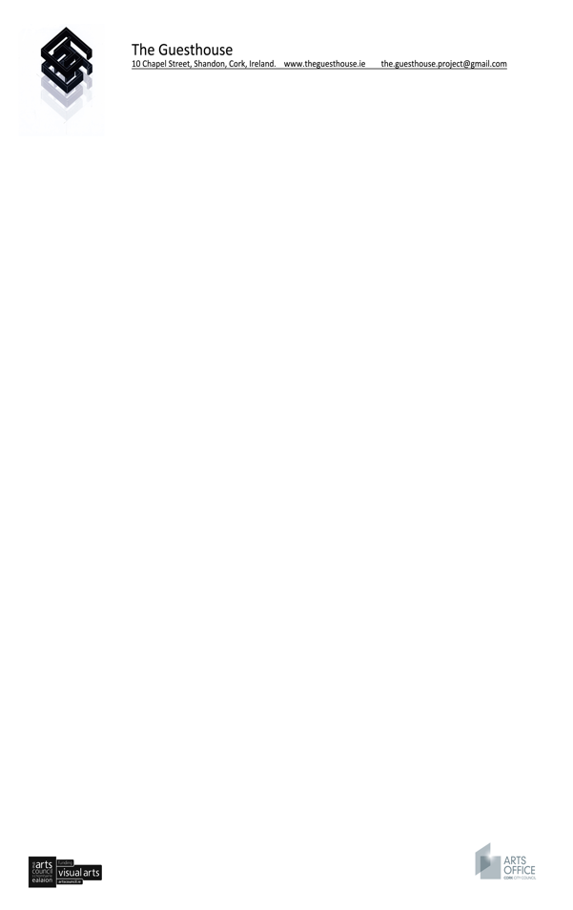

16th January 2017

To whom it may concern,

We are delighted to invite Thai curator Chumpon Apisuk
to stay at the Guesthouse Project between the 31st of March to 4th of April 2017.
The Guesthouse Project is an experimental and residential project space that is a meeting point for local and international artists from different disciplines.
We have supported a range of Irish and international artists, researchers and curators from Korea, Japan, Poland, Australia, America, England, Northern Ireland, Germany, Iceland, Sweden and Holland. The project works towards fostering networks and relationships within the context of a social setting.
During the residency we will offer free accommodation, the use of our project and performance space and administrative assistance.
We look forward to working with Chumpon Apisuk.
Kind regards,
Irene Murphy
Director

