10 April 2019
RE: Invitation to LAPI 2019, Bangkok
Dear Xiouhan Han
Live Action Poetry International, Bangkok is honoured to invite you to take part in our first event organize in Thailand. The event will take place in a Bangkok’s old cinema turn hotel – Prince Rama Theater. On Saturday 27 July 2019, (please see program attached).
Live Action Poetry International 1/2019 aims to promote new ways of expression and presentation of poetry. Poetry is more than words and languages, it is international, universal expression through voice and sound produced to open up more free communication, people’s emotion, passion, compassion, etc. Language, on the other hand create sounds, different sound, different ways of express sound, and emotional appreciation. When listen to poetry, we hear sounds, while sound creates poetic appreciation.
Poets/artists invited for this first event are: Eduard Escoffet /Spain escoffet@propost.org, Bartolome’ Ferrando/Spain, Jittima Pholsawake/Thailand, Sriprae Mekalai/Thailand, Patcharida Smitthinet/Thailand and yourself.
Since we are artists run project, and not for profit, we, unfortunately, cannot support your international airfare. However with the generous support of the Prince Theater Heritage Stay we are able to accommodate overseas artists, from 17-21 July 2019. All artists will receive artists fee of Baht 2,000.00 each. The organizer will organize a few visits to other art events and meeting with local artists and poets, as well as give you enough free time to explore Bangkok metropolitan.
Please do not hesitate to write me if you have any questions or inquirees. I hope to see you and work with you in Bangkok. Thank you very much.
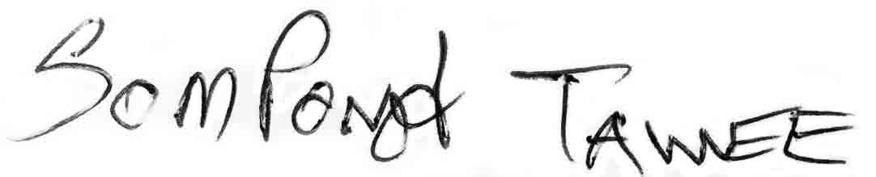
Best Respect,

Sompong Tawee Director

Contact: Chumpon Apisuk / International Coordinator <concretehouse@empowerfoundation.org>

