
THREE VIEWS TO PERFORMANCE IN FRANCE, ITS PLACES, PROCESSES, FILES
THREE LOOKING AT PERFORMANCE IN FRANCE, ITS PLACES, PROCESSES, FILES
Author:
Mildred Durán Gamba
Edition:
ERRATA # 15: PERFORMANCE, ACTIONS AND ACTIVISM
INTERVIEW
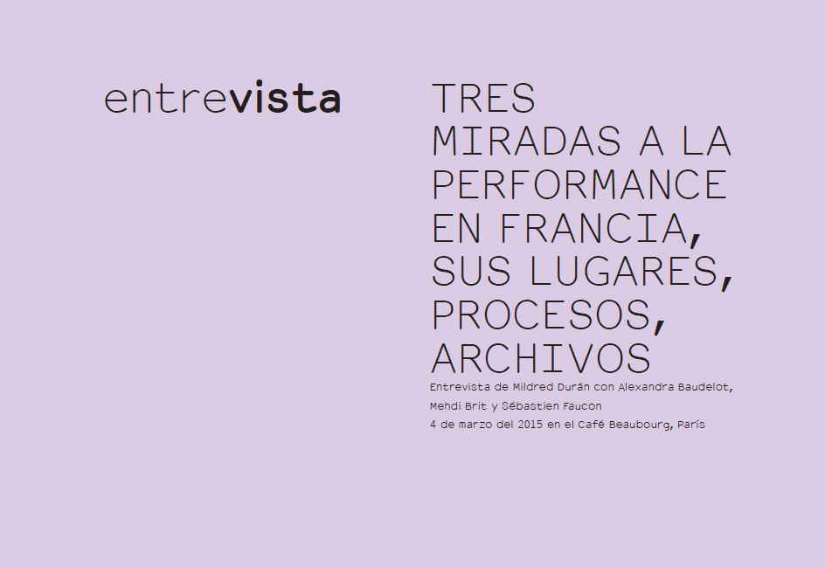
There is a great effervescence at the level of artistic practice, of the study and academic analysis, of the diffusion, exhibition and institutional preservation of the discipline of the performance in the French artistic scene. After having such a strong record in the sixties and seventies, the performance has gained new impetus in the current conjuncture, and especially since the year 2000, when, as well as consolidating a field of creation, different spaces and actors dedicated to the dissemination, support and research of these practices. We could say that 2006 is a date that marks the turn in the diffusion and questioning of this discipline, when the dancer and choreographer Anne Dreyfus creates the Générateurin Gentilly, Paris, one of the first spaces that opted for programming and performance support at a time when this practice was still marginal and ignored by artistic, academic institutions and the art market. That same year coincides with another great exception: "The living monnaie", an itinerant exhibition made in different spaces and cured by Pierre
Bal-Blanc in the Center of Contemporary Art of Brétigny in the same region. This project of great interest is one of the first that seeks to question the new performative practices confronting them with the contemporary dance, which was marked since the nineties by what Bal-Blanc calls a "zero degree of its practice": the absence of movement and rejection of the pose (Bal Blanc 2007). At that time almost no young artist was fully proclaimed as performeur artist ; in this context, it is worth mentioning the work of Santiago Reyes, an Ecuadorian based in Paris, who was one of the first to affirm himself and lead the performative practice, placing it as the decisive axis of his artistic work.
In order to confront the richness and peculiarities of this scene with the Latin American scene, I wanted to invite to this special edition of Errata # on performance three figures who exercise specific roles within the aforementioned French scene, to reflect with them on how they have been these processes have evolved, how performative practices have evolved and especially their influence on the modes of diffusion and the movements that exert at the expositive and curatorial level.
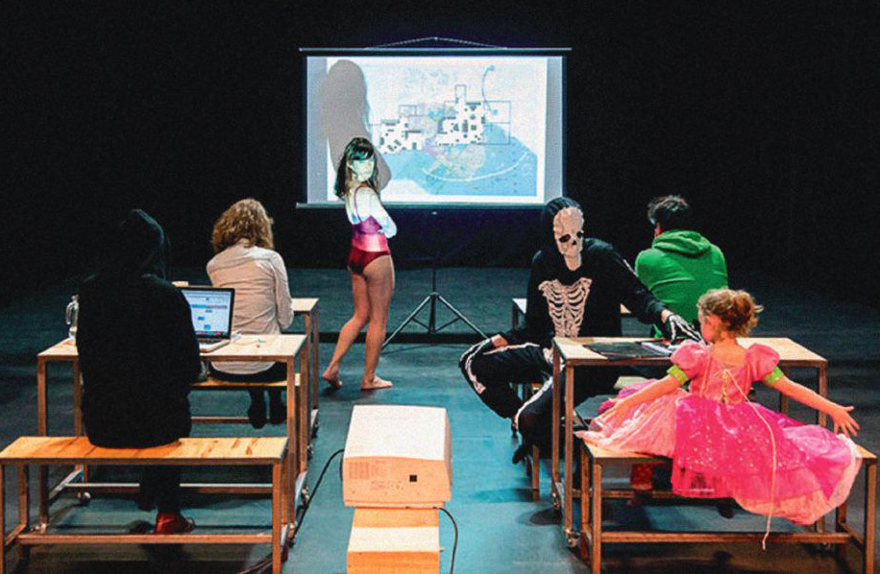
Seminar imagined by the choreographer Adva Zakai and Abake (February 2014). Photo: Soussi-Chiadmi Sound.
Since it is very difficult to bring together all the relevant figures, and privileging the institutional analysis - which here we confront the different artistic practices already discussed in this edition of Erratum - I decided to call Alexandra Baudelot (co-director of the Laboratories of Aubervilliers, Mehdi Brit (associate curator of different spaces and events, including the Louis Vuitton Foundation and Fiac) and Sébastien Faucon (responsible for the collections of fine arts of the CNAP of the French Ministry of Culture and Communication), who agreed to discuss these issues.
Mildred Durán Thank you, I am very happy that we are gathered here. Before starting, I would like to review with you a very important point regarding terminology. Is used in France for quiteago while the term "performance" and start talking now increasingly performing arts ( arts vivants ), especially regarding your exposure ₁ , Sébastien. But I would like to clarify its meaning a little more. In England it is called " live art ". What are your perceptions regarding this topic of terminology?
Sébastien Faucon With the recent evolution of certain performative works, specifically the delegated performances, as those of Tino Sehgal ₂ , we were sliding towards a system where we are almost obliged to speak of live arts. The mechanisms necessary to activate these works are increasingly linked to those of the live shows. The very notion of 'living arts' is actually quite imprecise and there are many criticisms or at least some debates about it, which to me personally seems a little excessive. It would rather be that we will collectively agree to change our point of view. In this way, I would reverse the problem of this attempt of definition, proposing to look at the whole set of art through the prism of performance. This is the very origin of the project that we started with Boris Charmatz in 2014. ₃
MD He makes me think of Michel Journiac; he has always rejected the term "performance," he preferred the term "action," as did Richard Martel in Canada, who is a great theoretician. Tania Bruguera, in turn, refers more to an "art of behavior", and is the idea that she pursues here in her studio at the School of Fine Arts in Paris. This was only to avoid and limit confusion, because in any case, it is a very difficult term. There is no consensual definition.
Alexandra Baudelot I would prefer to raise the issue from the point of view of what we defend in Laboratories [de Aubervilliers]. ₄ Action art is related to a historically oriented performative movement, which comes in particular from the influence of Richard Martel of Canada, body art or live artin England, which evoke the relationship with the body. These movements put into play the forms of ritualization of the body. The action art is closely linked to this and to the fact that the body is an instrument in itself to express an artistic form, state the forms of behavior and an existential critique. The question of performance interests me in the extent to which it refers to a relatively vague term and it is well that it be so. When artists are invited from a more defined creative environment, such as the plastic arts, literature, choreography or others, at a given moment there is also the possibility of escaping the initial terrain of these artistic forms and see how it can be given a spatial, temporal positioning, and thus reconsider the formats a bit. This gives some freedom and allows to generate other formats. It can be said that this then creates performative forms.
MD I also thinkof Ester Ferrer'sidea of attitude or definition, which is really pertinent: for her "performance is a matter of space, presence and time". He does not even mention the body. You have a very precise role today in the French scene. I would like to understand how they became interested in this subject.
Mehdi Brit First of all it is an encounter, a partnership and a search. My artistic and curatorial approach is located at the junction between the history of art and theater. I pose the practice, the writing and the theory within a same work, as much in the hybrid as in the liberation of the borders. The performance has allowed me to combine two points of view, two experiences, two desires, two disciplines, to face these new forms both in practice itself and in theory. As for the previous question, the artist's point of view is extremely important: returning a valuable expression to Orlan ₅, I understand performance as an open body, a framework in which each artist gives their own definition and tries to rethink a context by reinventing their space and their temporality. My role as curator is to accompany the artist from the genesis to the completion of his project and give that new color to the performance.
SF Throughout various meetings, I also became interested in fields related to sound poetry, with John Giorno and, more profoundly, by the performative presence of the new media, particularly when working at the Pompidou Center. I then found, when I came to work at the National Center of Plastic Arts (CNAP), that the works involving the performative, the immaterial, the experimental were not very present and were little apprehended, perhaps because of their fragility, by the way in which we can or can not assume them, to collect them, to activate them. Then, a little by osmosis, we try to constitute a corpus that could lead us to think more deeply about the point or the margins where contemporary art, choreography and sound are crossed and revitalized. The CNAP has also organized several projects for the exhibition of its own collection, for example "Diagonales", in 2010, focused on the theme of sound and music in association with some fifteen organizations in France and abroad; «Des choses en moins, des choses en plus», at the Palais de Tokyo around protocolary and immaterial collections; and finally, "La permanence" in cooperation with the Musée de la Danse in Rennes, which I created together with Boris Charmatz. However, we can not forget the work carried out for many years, by the Frac in the Palais de Tokyo around protocolary and immaterial collections; and finally, "La permanence" in cooperation with the Musée de la Danse in Rennes, which I created together with Boris Charmatz. However, we can not forget the work carried out for many years, by the Frac in the Palais de Tokyo around protocolary and immaterial collections; and finally, "La permanence" in cooperation with the Musée de la Danse in Rennes, which I created together with Boris Charmatz. However, we can not forget the work carried out for many years, by the Frac₆ in Lorraine, who was the forerunner on this subject and who opened a path at a time when no one considered these forms of creation.
MD Yes, of course. Before addressing the interest in the dematerialization of the artistic object and the acquisition of this kind of works, I would like to make a brief historical review of the evolution that the performance has experienced in France, without necessarily speaking of the avant-gardes. What are the strongest moments for you, those that have marked you the most?
MB Mildred, evokes all a historiographic work that begins in 1979. It is very interesting to recall the historiographical dimension of the past decades, giving a look at the cultural and artistic enterprises managed by a number of artists. Important projects appeared, such as the International Symposium of Performance Art of Lyon (1979-1983), the Polyphonix Festival, International Encounters of Contemporary Poetry and many other events in France that merit mention in this story. Artistic personalities such as Julien Blaine, Orlan and Joël Hubaut should be included, since they were the engine, but also the actors regarding the diffusion of the performance in France since the seventies. I mean Dock magazine (s), created by Julien Blaine, which was extremely important for the knowledge and local diffusion of contemporary contemporary poetry. Then the great exhibitions, such as "Hors limit" ₇ , "Art au corps" ₈ , "Poésure et peintrie ₉Came later in the 1990s. Today bold projects are taking shape and performance is already fully integrated in the institutional sphere. However, during a good part of the eighties until the middle of the nineties, the performance remained outside the institution, although there is a story in the shade. If one is interested in the historiographical aspect of the French scene, there is little information on the subject, and the researcher who wants to understand a little better this whole story must go through the archives, find new sources and find these artists again.
Like an archaeologist, he must scrutinize, because it is very difficult to find sources; must truly immerse himself in the universe and the artist's workshop, and the research becomes very stimulating.
SF One of the keys to understanding all these artistic forms lies perhaps in the work of Jacques Rancière, Le maître ignorant (published in 1987). We start with the logic of Guy Debord and then focus on an actor / subject audience and the way in which it is given a certain authority.
MD For some years, and especially nowadays, it is evident that there is no manifestation or event that does not include performance. They are now seen everywhere. There are programs with performance presentations in completely different places; that is, from galleries, bars such as Silencio, to museums or art centers such as the Macval ₁₀ or the Palais de Tokyo. There are also international situations that set precedents, such as the Tino Sehgal award at the Venice Biennale in 2013. How could they explain this growing interest in this kind of expression?
AB What interests me is the place of performance in the institution, not so much the theme of the programming of performances. Sometimes there is the impression that they are programmed to animate and give added value to a specific event. Not always, of course. I mean that in the animation is not considered the work process or the context that leads to the performance, at that public time of the performance. On the contrary, there are performances conceived by the artist and which are inscribed in a real temporal and spatial relationship within the institution itself, also creating a specific relationship with the public (as in the case of Tino Sehgal or Eszter Salamon with his performance Eszter Salamon 1949, presented for a month at Jeu de Paume last year;Rétrospective by Xavier Le Roy, exhibited during three weeks at the Pompidou Center). The performance is actually put to the test in time and space that allow the audience to live the experience of the performance process as such. She is not only a moment that surrenders, it is a process. It is certainly complicated, because that means that we must integrate a whole logic of the show live in the institutions linked to the visual and visual arts. That costs a lot, and the idea is to present them in museums, art centers or galleries that do not necessarily have the means to do so.
Reflect on the theme of the performance itself today implies a mood, a particular performance at work, which allows open to formats that do not obey the modes of "traditional" running of the institution. Very often we are told that the work we bring to the Aubervilliers Laboratories is very close to performance. I think it's because we try to work this way, ie, getting involved in all levels of work, building in close connection with the artists. Which in turn entails, at some point, that the process is just as important as the result. This is really a point that we try to highlight. Sometimes I think there is a misunderstanding with the performance: it is true that she is nice during an evening, that gives her an artistic touch, until sensational, but, what is before ?, what is there after? Sometimes a performance is fully justified especially when it falls in relation to the presence of a job, or as an extension of a work of the artist present in the exhibition. A lot of work I have trouble programming fairs like FIAC [Foire internationale d'art contemporain], which does not detract from the quality of schedule as such; my problem is the initial demand and intention. which does not detract from the quality of what is programmed as such; my problem is the initial demand and intention. which does not detract from the quality of what is programmed as such; my problem is the initial demand and intention.
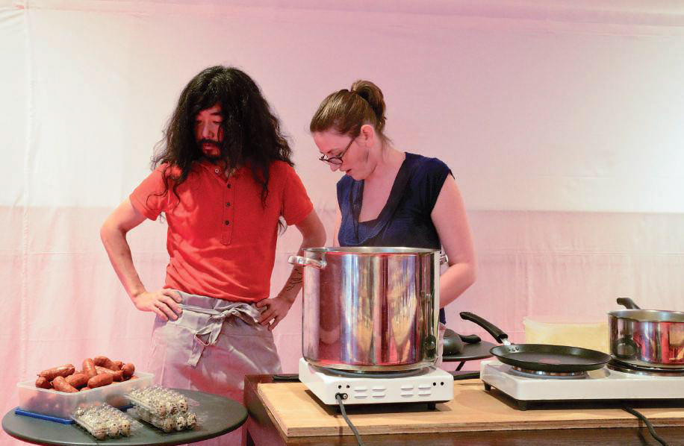
Abake, Jumeaux, 2014. Collection Center national des arts plastiques, part of the exhibition "La Permanence", Musee de la Danse, Rennes. © Nyima Leray.
MD Mehdi, how has it been possible to find this type of program within the highest banner of the art market in France? What is the process through which Fiac decides to present a performance schedule?
MB A curatorial project of performancese thinks in the context, with respect to its history and its spaces. In this way, the new aesthetic bets cross a terrain revisited by multiple points of view. The Fiac represents for the art market much more than a simple quote. It is also a vector in dialogues and meetings between contemporary and public creation or, I should say, audiences. In fact, «In Process» ₁₁ had been conceived as a map, a crossing between the Grand Palais ₁₂and the outdoor sites that surround it, which proposed to the artists to apprehend and revisit the spaces of reflection and creation from a common theme. It is not a question of "scheduling a space", but of accompanying the artist in a project from its genesis to its result. From then on the creation processes are developed several months before the fair. This investment in the preparation of the performances is what allows to feed the reflection on each project and to enrich this exciting dialogue between the artist and his curator.
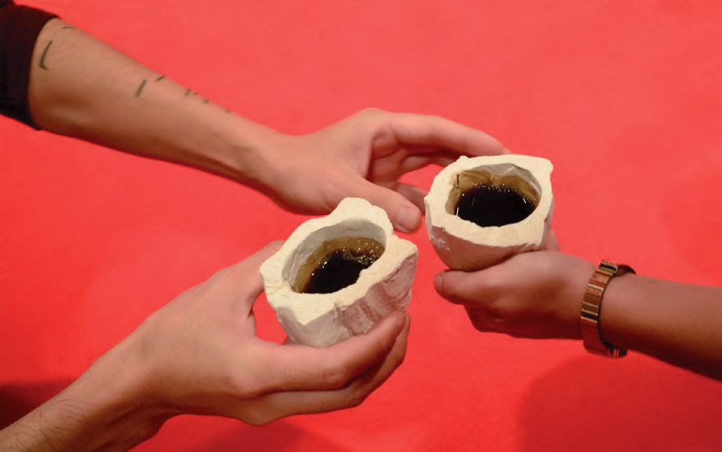
Abake, Jumeaux, 2014. Collection Center national des arts plastiques, part of the exhibition "La Permanence", Musee de la Danse, Rennes. © Nyima Leray.
Whether in the museum institutions (Hunting Museum, Printemps de Septembre ₁₃ , etc.), as in a fair (Fiac) or in a private space (Silence, Louis Vuitton cultural space, etc.), my role as curator is to conceive a project, a platform, a parenthesis where the artist can consciously build the project he wants. Therefore, the process is a fact and performance can not be seen as a one-day event, but certainly as a creation.
In the framework of "In Process", each artist is invited to work on a creation around a common theme. Since the start of the project, in 2013, this accompaniment to the artists in the reflection on a theme and a defined argument was among the essential points of the program. We can imagine it as a kind of book in which, every year, when we read it we discover a new chapter.
MD How is the process carried out within the framework of Fiac? That part of the research is not so visible.
MB What is bothering is that this takes place at a fair? Is it related to the art market?
MD No, it seems interesting to me that it is a space at the fair, but it also seems to me that there is a contradiction with the very spirit of the fair.
MB La Fiac is positioned with its market, with the presentation of its Parisian and international galleries, but also offers the possibility of discovering forms and practices that are normally at the margin or that escape from the art market.
The Fiac gives international visibility to these projects and allows visitors to discover new perspectives that young generations propose about performance. That is why it seems to me important to develop a work of prospecting in foreign settings, in order to discover, show and defend young artists, whose practices must be shown in France and in a framework such as Fiac: Walid Al Wawi ( Sharjah), Pablo de Laborde Lascaris (Mexico), Natsuko Uchino (Japan). Thus, these artists can appear next to other well-known ones, as for example Alexander Jodorowsky. "In Process" attempts to bring together artistic identities in order to show the public the diversity of the approach, of the points of view and of the work processes or the reflections of these figures that emerge from so different cultural horizons. This transversality of cultures, and approaches to performance, reveals numerous conceptual and visual experiences that share the collective encouragement of a curatorial project or a programming such as "In Process".
MD Alexandra, can you tell us about the Laboratories of Aubervilliers?
AB What I find interesting is this point of research and creation from the multidisciplinary; experiment with the formats, let the artists develop their projects while accompanying them in what refers specifically to space and specific audiences. What is striking is how the art scene has evolved over the past twelve years. The Laboratories of Aubervilliers opened in 2003. Certainly, at that time the place where the most formal questions were questioned was in contemporary dance - with Claudia Triozzi, for example, or with Marco Berrettini; I cite only the choreographers who were then working at the Laboratories. However, there were also projects that were experiencing, beyond the limits of what an artistic project could or could do in a specific context,Musée précaire Albinet , by Thomas Hirschhorn. Then I would also say that everything depends obviously on the work of the artist, the choice of one or another artist invited to the Laboratories is not done innocently. With Thomas Hirschhorn there was a clear association, quite evident, since he had and still has his workshop in Aubervilliers and he wanted to make his museum precarious just there. There is another star project and very representative: the permanent Théâtreof Gwenaëlle Morin, where it is also experienced in a specific context, seeking to exploit from within the format of the theater itself and the institution. This was also constantly renewed in its inscription with space: the participating actors never stopped: during the day they distributed leaflets, they made workshops with the inhabitants, thus putting the conditions so that a true relationship between them was created, which never results easy to pass Aubervilliers.
In Laboratories, we are always aware of the invited artists, the ways they want to explore, the processes in which they have been working. I think that today the issue of performance is more forceful in the work that certain plastic artists can do - we invite more women than men, which reflects more our choice than a militant will. Nowadays explorations in the field of performance, the ways in which artistic work from this universe operates are more powerful than those of dance. In contemporary dance the theme of questioning form was installed, to the point of becoming almost a convention. I think we have reached the limit of the live show. A choreographer works in a very structured framework: a company, an administrator, a diffuser, a network of co-producers. The work of the choreographer is thought of as a whole enterprise, which encloses a number of things and limits the possibilities of exploration. The example of Tino Sehgal is very interesting: he comes from dance and invented a system - artistic, legal, commercial - whose very structure has led him to leave the arena of dance. He was able to do all the work we know because he exploited those limits.
MD Speaking of Tino Sehgal, it is impossible not to evoke the immateriality or invisibility of such works, as well as the valuable experiences of the Frac in Lorraine, led by Béatrice Josse, one of the first to affirm this interest in the preservation and conservation of these intangible works. Also note the interest in the archive. (Nathalie Boulouch is one of the first to work on performance files in France) and CNAP's interest in acquiring this kind of intangible works. In an interview Sébastien emphasized that there was a journey, an evolution. In the sixties, the museums acquired the traces (the traces, traces), that is to say what remained of that ephemeral moment. Today, however, you see the artist differently ... and you mentioned the interest of the Center for this kind of works that must follow a performative protocol or that remain in time. Sébastien, could you tell us about the intention of the CNAP to acquire this kind of works?
SF I think that the role of the National Center of Plastic Arts should first be defined. The CNAP is an institution without a space for exhibitions, which has a great double mission: to support creation by granting scholarships so that artists and professionals can develop their projects, researches, productions; and, on the other hand, to carry out the acquisitions on account of the State. Its collection, which today has more than 95,000 works, has consolidated over more than two centuries. It was created during the French Revolution, in 1792, with the spirit of acquiring works of living artists. This mission has remained unchanged for 220 years and has been open to the international scene. In addition it has been able to host in parallel dozens of different forms of creation such as design, video or photography, which was already fully considered as a work of art in the eighties of the twentieth century. All the works that the Center acquires go to the different French museums and the Frac. In 2009, when I arrived at the CNAP, I realized that (as in all public collections) the performance was mostly represented by its traces: the photographs of Gina Pane, the Viennese shareholders ... Even if the collector or the artist then decide to revalue the character of these documents, we must understand that most of these works are originally testimonies. Performance, specifically that of the 1970s, was built outside institutions, often even against them. All the works that the Center acquires go to the different French museums and the Frac. In 2009, when I arrived at the CNAP, I realized that (as in all public collections) the performance was mostly represented by its traces: the photographs of Gina Pane, the Viennese shareholders ... Even if the collector or the artist then decide to revalue the character of these documents, we must understand that most of these works are originally testimonies. Performance, specifically that of the 1970s, was built outside institutions, often even against them. All the works that the Center acquires go to the different French museums and the Frac. In 2009, when I arrived at the CNAP, I realized that (as in all public collections) the performance was mostly represented by its traces: the photographs of Gina Pane, the Viennese shareholders ... Even if the collector or the artist then decide to revalue the character of these documents, we must understand that most of these works are originally testimonies. Performance, specifically that of the 1970s, was built outside institutions, often even against them. the Viennese shareholders ... Even if the collector or the artist later decide to revalue the character of these documents, we must understand that most of these works are originally testimonies. Performance, specifically that of the 1970s, was built outside institutions, often even against them. the Viennese shareholders ... Even if the collector or the artist later decide to revalue the character of these documents, we must understand that most of these works are originally testimonies. Performance, specifically that of the 1970s, was built outside institutions, often even against them.
Nowadays one may wonder what happens with certain re-enactments of "historical" performances that completely modify their initial protocols. There is practically a transvestism of the work in its reinterpretation. The challenge is to ask how feasible it really is to get the living into the CNAP collection. Probably the acquisition of Tino Sehgal's Kiss Kiss in 2004 is what marked this real opening: this work inevitably prompted the institution to question itself, since it leaves all our protocols of acquisition, documentation and dissemination.
MD Yes, completely. That is where the contextual argument comes into play.
AB Just as the trail can find its place in a museum space, you can also muse the performance, specifically as Marina Abramovi'c does with the retrospective that took place at the Guggenheim Museum, where she reactivates all her performances by taking them of the original context. There was a performance museification, it was very strange and it did not work.
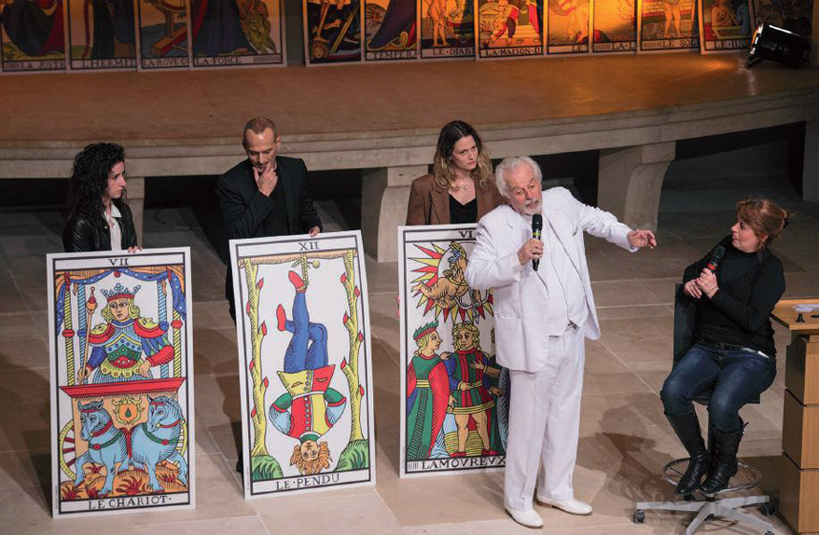
Alejandro Jodorowsky, Performance with tarot, 2014. In Process, Fiac. Photo: Marc Domage.
MB Although the project and the position of Abramovi'c were interesting, outside their context those works do not work. It was a good try.
MD If we talk about re-enactment , there is an element, however, very powerful when it is carried out with another perspective, and that goes beyond a simple reactivation in time - is not as simple as "reactivate" . I think that here would perhaps be a reference to the criterion of the selection of pieces that you mentioned. You spoke, Sébastien, of the choice of the works, starting from four criteria ...
SF Yes. These are not criteria that would serve the acquisition, they are rather four criteria of interpretation. It is a very personal cartography. In fact, I distinguish works related to the notion of replayor "re-play", those based on the active participation of the public or on a principle of delegation to an interpreter, which are two concepts developed by Claire Bishop; a last concept, less treated, is that of the permanence and the potential disappearance of the work. Perhaps the latter is the most complex point of view to understand for a public collection. In fact, it is always fun to remember that French [public] collections are inalienable and imprescriptible. From the moment a work reaches a collection it is considered to be for eternity. Somehow the work is paralyzed. But can we admit that one of these works can at the same time continue to evolve and potentially disappear?
The acquisition in 2014 of Refus , by the Brazilian artist Maurício Ianês, is a very beautiful example on this point. The piece will disappear with the death of the author and his footprints are nothing more than documentation, but in no way a work.
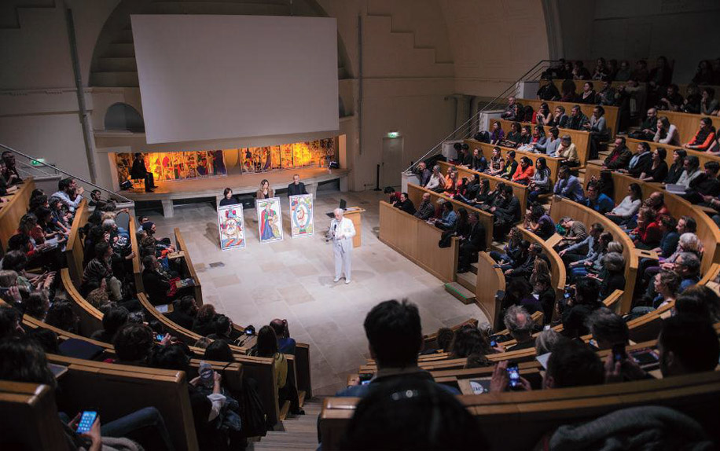
Alejandro Jodorowsky, Performance with tarot, 2014. In Process, Fiac. Photo: Marc Domage.
AB There is the life and death of a work. When acquiring a work that is known to be disappearing puts into perspective something that goes beyond simple acquisition. This also includes the willingness to inscribe it into a specific artistic stream. With all those networks with which you (the CNAP) are connected, sometimes certain works are set aside. You are a sort of place of condensation capable of creating one of the synergies that are played today in the artistic field. Perhaps later this will be better historicized, and it will be easier to return to all of this if these questions have been raised before. There is a gesture of an almost historiographic implementation.
MD The question of time is essential in this clasede works: it is a moment, and there is the life of the work, but there is also the survival of that moment; and we must also talk about its reactivation.
AB If there is talk of reactivating the work there are at the same time other possibilities, another kind of reactivation. Like those works that revive artists from other generations. There you see a willingness to understand how a piece can resonate differently in a different context from the one who saw it born and this is something that can also work.
MD I would like to return to the exhibition of the Palais de Tokyo, "Des choses en moins, des choses en plus", which you, Sébastien, presented with Agnès Violeau. In an interview [see Faucon 2004] you said that you wanted to avoid reproducing or re-creating a relational aesthetic and that the goal was rather to give preponderance to the performing public.
Why avoid this relational aesthetic and how to consider that aspect of the performance public?
SF The comment that was made in that interview dealt with the relational aesthetic as it had been theorized Nicolás Bourriaud, esthetic that marks a generation of artists, a type of work and context.
The project at the Palais de Tokyo with Agnès Violeau was not within this conceptualization, but in relation to the writings of Guy Debord and Jacques Rancière, and wondered how the public could politically understand the exhibition at a time when culture became a consumer good. We wanted to offer the public the possibility to build the project and say: this exhibition exists for you and for you; you can walk past a play and watch it just for what it is, or begin to wonder how it can be appropriated. The works were, therefore, very changeable and totally dependent on the attitude of the public.
MD I would like to talk about this issue regarding the public. I was at Riap 2014 [Rencontre international d'art performance de Québec] in September of last year and was surprised to discover a very critical, knowledgeable and very reactive public. It could have been that emancipated public of Rancière - and this I could verify it in the performance of Mideo Cruz, of Philippines: at a given moment, the public can not more and tries to prevent the action, until finally a couple forces Mideo to to end the performance by destroying one of the central objects of his action, which the artist carried over his head. This audience maintains contact after many years with the performative proposals.
Last year, the Riap celebrated its 30th anniversary. Then it is an audience that knows this type of manifestations and the level is not the same as in other places. How did you think, Sébastien, the reaction of the public in the frame of your exhibition?
SF The reactions of the public were very varied. Each one has a unique vision of the exhibition, according to its own route and its implication. There were no negative reactions or vandalism. There were no very problematic situations, not even when the work of Ester Ferrer Intime et personnel was reactivatedon the measures of the body - one of the first performances of Ferrer (1967) that she initially made on her own body. Neither Esther nor Agnès nor I wanted to fall into simple reenactment . We imagine, rather, that the work could be reactivated byperformersvolunteers, who would then effectively take over the work, and supplementary protocols would be invented as to the annotation of measures on the floor, the wall ... Spontaneously the people of the public began to undress and measure their bodies, as well as those of other people. I also remember another day, when I arrived at the exhibition and one person read aloud the texts inscribed on the work Imposteurs de Gens D'Uterpan; ₁₄ which is a monograph printed on a textile and arranged by Vier5 graphic designers. It was a beautiful moment. One could think that it was something planned by the curator or the artist, but in fact it was only someone of the public who appropriated freely of the space.
AB It's beautiful. There is always a relationship with the work, whatever the relationship of intimacy with it.
MB We are talking about performance, that is, of protocols and inscriptions in space, many times unique. The public reacts differently depending on the context and the proposals. For the sample two examples: on the occasion of the Nuit européenne des musées,in 2014 within the Museum of Hunting and Nature, we realized with the artist Natsuko Uchino a creation of three hours (with ten actors, among comedians, dancers and performers) on the character of Dionisio, which was deployed through various actions throughout the space of the museum. And the majority of the two thousand visitors that the museum has loved to discover their collections in a different way. If I take the example of the Fiac in the framework of the performance of Laure Prouvot, the children-actors directly addressed the audience, who was completely fascinated. I think there is a real curiosity and real interest on the part of the spectators for these hybrid and experimental forms.
MD Alexandra, how do the inhabitants of Aubervilliers react? Are they involved and involved?
AB In this project, which works since 2013, we are attentive to the population getting involved in the process itself of the work; that is involved very actively and of course voluntary. However, this does not happen by accident. We can host artists like Katerina Seda or Marinella Senatore, who will work directly in the public space, with people who will participate in the project, and also others who will not voluntarily do so. Things will happen, but you can not predict what is really going to happen. Marinella Senatore plans to set up a huge project, but equally, people will then decide whether to participate or not. There is an active part that is consented. The spectator enters a process of work for a relatively long time and builds the work, since the work does not exist at the beginning. Here is the difference, as I said before: the spectator is linked to the process itself; does not relate to a work that already exists, but is called to reappropriate it or to experiment with it.
MD I think this idea of ​​the lectures that you propose and that are open to everyone is interesting.
AB You mean the reading workshops? Yes, but let us not deceive. Unfortunately, reading workshops are rarely frequented by the inhabitants of Aubervilliers. People come from Paris with a middle-class profile, white, French, interested in art and culture. The Laboratories are frequented by a very different public thanks to its multidisciplinary character and the efforts that we make to involve specific publics that live or work in Aubervilliers. We work hard with associative structures, corporations, neighborhood administrations, which are based in Aubervilliers. We locate the people of the neighborhood through these structures, which are very important networks for us, since the people who work there understand and defend the work of the Laboratories; they will really support the space and encourage others to participate in a given project, to meet with us, to get caught up in the game. As a result there is a real human relationship in joint construction, allowing people to get out of the daily routine they are in ... something that for most is very difficult. There are Maghreb women who have no right to leave their homes; then they say that they are going to take a literacy course to learn to read and so their husbands accept that they participate and the workshops allow them to open up to something else. And this is how they end up participating in the Feldenkrais workshops, 15 which would normally be improbable. Then, in the workshop they are submerged in a true artistic exchange. All this is possible only from the moment that there is an entire management that goes beyond the artistic proposal to enroll in a real relationship in the field and taking into account how the issue develops. The relationship of the public with the Laboratories works at different levels. They are the construction of the project, first, and the times of opening to the public, then, which offer different forms of restitution of work: from exhibition, a book, a symposium, a performance or a theater function, to dance, etc. . 15% of the public is part of the community of Aubervilliers, and 85% are Parisians interested in art. The relationship of the public with the Laboratories works at different levels. They are the construction of the project, first, and the times of opening to the public, then, which offer different forms of restitution of work: from exhibition, a book, a symposium, a performance or a theater function, to dance, etc. . 15% of the public is part of the community of Aubervilliers, and 85% are Parisians interested in art. The relationship of the public with the Laboratories works at different levels. They are the construction of the project, first, and the times of opening to the public, then, which offer different forms of restitution of work: from exhibition, a book, a symposium, a performance or a theater function, to dance, etc. . 15% of the public is part of the community of Aubervilliers, and 85% are Parisians interested in art.
MD Sébastien, could you tell me a bit about the project "La permanence" with Boris Charmatz at the Museum of Dance?
SF "Permanence" is in part a continuation of the exhibition "Diagonales" (2010). The exhibition projects are increasingly conceived as a way of experimenting and re-reading the CNAP collection. In 2010 I attended "Expo zéro", an exhibition that Boris Charmatz had organized in Utrecht, in BAK [Basis voor actuele Kunst]. It was an exhibition without object, constructed from the presence of artists occupying the space through their bodies. I already knew the manifesto written by Boris on dance (2009), so I contacted him in 2012 and we started our collaboration very quickly. With "La permanence", we wanted to get out of the logic of the event [ évènementielle] to enter into a wider time, to move from one's own impermanence to temporary exposure and dance. The exhibition was open from January to December of 2014 in the spaces of the Museum of the Dance of Rennes, and in other associated sites. We had the idea of ​​opening "La permanence" in the manner of a union, where anyone could come and follow the day-to-day evolution of the project.
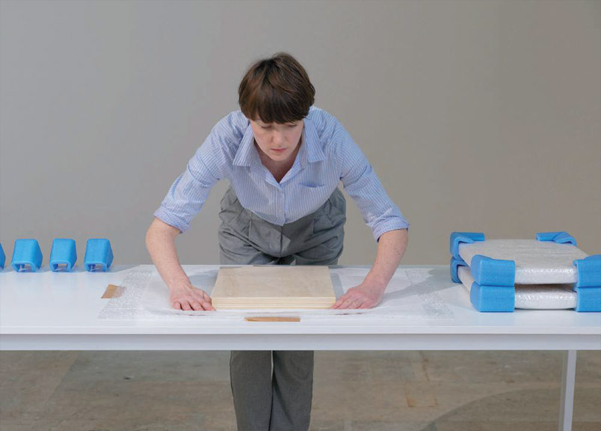
Béatrice Balcou, Untitled, Performance # 02, 2012-2014. Collection Center national des arts plastiques, part of the exhibition «Des choses en moins, des choses en plus» at the Palais de Tokyo, Paris. © Aurélien Mole.
MD It is a "live" project in the whole sense of the term.
SF Yes, we had planned four cycles over the course of the year around repetitions, reading and movement, from the flip bookand organic. We did it with very reasonable resources. The money was used to get the artists to come, to reflect with the university and the art school in colloquiums and projection sessions, to be able to count on associated places such as the Rennes Museum of Fine Arts or the 40mCube art center. Taking into account its duration and its articulation, this project was in itself experimental and it tried to prove the limits of the exhibition. During the first cycle the works were changing. The exhibition had to be rearranged at all times. During the second, we transformed the exhibition into a succession of workshops where the productions were added ...
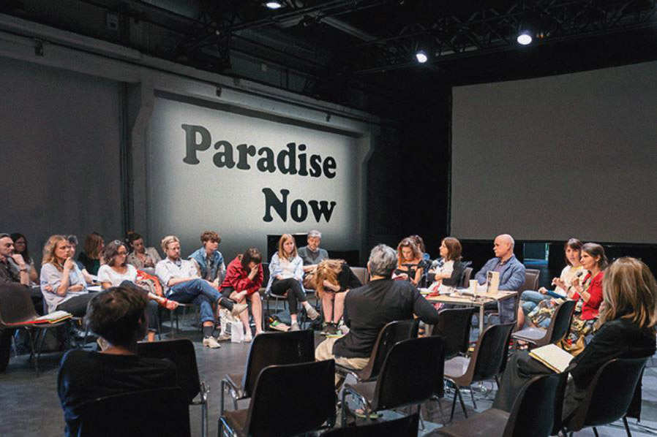
Printemps des Laboratoires, Performing Opposition, 2015, Third edition. Discussion image Communities, deliberation and networks. Photo: Soussi-Chiadmi Sound.
AB This is also a performative dimension, in the sense of experiencing formats including presentation modes. I think it's equally interesting: the performance within the performance.
SF Indeed, although the works presented were not performances. In fact, we take stock of the photography collections of Viennese shareholders, John Coplans, John Giorno's textual drawings, videos and films of Aernout Mik or Joachim Koester. We also wanted to show how all these works can interact with the public and at the same time come crossed by ideas related to the performance for its duration, its gesture, its attitude. Equally important was the fact that the project was carried out in the Museum of Dance, which is not a museum but a national choreographic center. Boris Charmatz proposed renaming it as a "museum", thereby raising the question of memory and transmission. After all, this project could only be done there.
MD I would like to return to the topic of the theory and historicity of these practices. There is a lot of valuable ground in the new pedagogy: Michel Journiac taught in Paris I, where he gave classes and seminars on body art; Jacques Donguy also gave courses and workshops on body art and performative themes for decades; the University of Rennes plays a very important role, since 2007 they have a performance laboratory and in 2005 they organized a conference on the subject of which there is a publication: The performance. Between archives et pratiques contemporaines (Bégoc et al 2010). We also found Marie de Brugerolle at the Superior School of Fine Arts in Lyon, who organized the meeting with Dora Garcia and her Post Performance Future. There is also the seminar in the Villa d'Arson, where, you Mehdi, you have spoken of your book Interwiewer the performance (2014). As for these pedagogical topics or theoretical encounters, are there moments that have caught their attention?
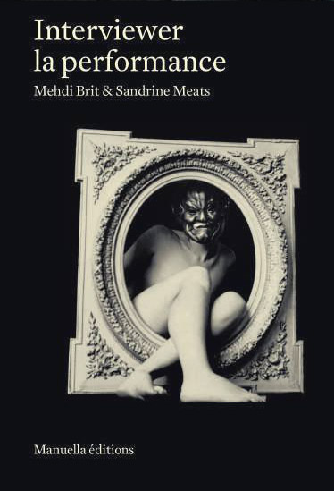
Book Cover by Mehdi Brit and Sandrine Meats, Interviewer Performance. Regards sur la scène française depuis 1960 (Paris, Manuella Editions, 2014).
MB I think that in recent years a very important energy has been created by artists, researchers, curators, universities and public around the theme. Since the investigation you have named Janig Bégoc. I would also mention Patricia Brignone, Sophie Delpeux, Eric Mangion, Chantal Pontbriand and David Zerbib. They are extremely important in France, represent points of view and analysis that contribute a lot to research and theory. In recent years, a number of symposia have been held on performance: at the University of Strasbourg, at the Higher Institute of Fine Arts in Besançon, at the Villa d'Arson in Nice or at the AixMarseille University. In November of 2013, the University of Paris I organized a colloquium on the animal and the performance in the Museum of the Chase.
MD There is a certain porosity ... and to continue with the academic idea, the publications have been related to university research laboratories, as happened in Rennes, with the aforementioned work, or in Villa d'Arson on the same subject. It can be said that in France there is a great interest in archiving and conservation, but also in the image of the artist and the relation with him, the role of photography in his performative practices, as can be seen in the book of Sophie Delpeux , Corps camera (2010). Before that there was little. They were rather translations of publications or books of monographs of artists. And since last year is your book Interwiewer the performance(Brit 2014), but earlier there were very few books written by the artists themselves and they talked about their own practices; the exception is Arnaud Labelle Rojoux. There was no particular interest in the in-depth study of these practices.
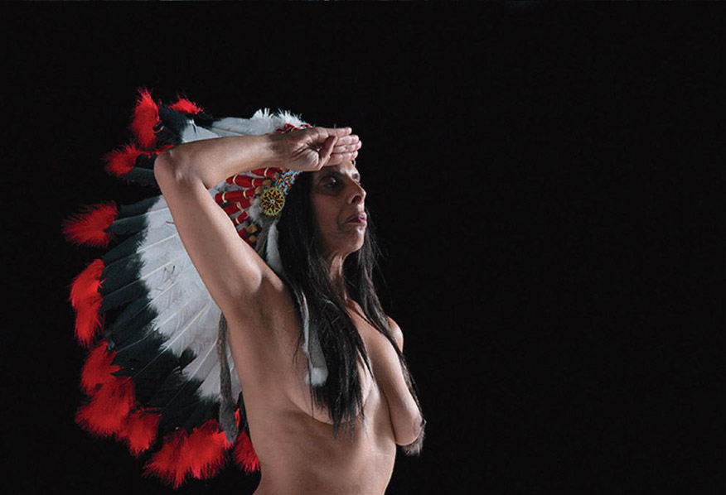
Latifa Laabissi, Des figures Toxiques, 2006. Les Laboratoires d'Aubervilliers, Paris. Photo: Nadia Lauro.
SF L'acte pour l'art (Labelle Rojoux 1988) is a truly amazing work. It allows reading about the 20th century from the Dadaists like Arthur Cravan until the 1980s, and now is the updated version of the 2004 edition. I reviewed it again these days and I realized that the forms have evolved a lot. Today we are less and less in this aesthetic of art action that evolves, especially in France and Europe, with more participatory forms with the public, or using the body of interpreters (performance delegated). It is normal, the performance is transformed just like any other artistic medium.
AB We can also cite L'art au corps (1996) and the book by Laurence Louppe Poétique de la danse contemporaine(2004). I was quite influenced by the catalog of the exhibition "Gutaï", which took place in the Jeu de Paume in 1999 and which revealed work modes of incredible news. The book by Simone Forti Handbook in Motion (1974) and Luisa Nelson Vu du corps (since 2001 - a work in process), fed me a lot at one time.
MD There is also this beautiful catalog "Anna Halprin à l'origine de la performance" (2006) from the exhibition by Jacqueline Caux on the work of Anna Halprin, which took place in Lyon.
SF The catalog of the exhibition "Move ChoregraphingYou" that took place at the Hayward Gallery in London at the end of 2010 is a beautiful way to get into the subject. On the other hand, there are the writings of Claire Bishop, who are very important, know how to structure very well the current thinking and explain what the works are treated in France and abroad.
AB As for the participatory dimension, you have the latest book: Artificial Hells . Participatory Art and the Politics of Spectatorship (2012).
MD Could you tell us a little about your book, Mehdi?
MB Interviewer performance (2014) describes for the first time the panorama of performance in France from its emergence in the sixties until today. It is composed of an essay and twelve interviews with artists who have marked the history of this form of expression, and gathers and confronts a plurality of definitions, forms, intentions and invites a very varied reading on this artistic medium throughout history.
MD Thank you very much.

References
AA.VV. 1996. L'art au corps Le corps expose de Man Ray a nos jours. Marseille: Mac, galeries contemporainesdes musees de Marseille, 6 juillet-15 octobre.
Bal Blanc, Pierre. 2007. The living monnaie , Stuk Theater, Leuven, Belgique. Catalog available at: <http: // www.cacbretigny.com/inhalt/pictures/MV2/ MonnaieVivante_ParisBt.pdf>. Consulted on August 20, 2015.
Bégoc, Janig, Nathalie Boulouch and Elvan Zalbunyan (dirs.) 2010. The performance. Between archives et pratiques contemporaines . Paris: Presses Universitaires de Rennes, Archives de la critique d'art. Brit, Mehdi, and Sandrine Meats. 2014. Interwiewer the performance. Regards sur la scène française depuis 1960 . Paris: Manuella Edditions.
Bishop, Claire. 2010. «Notebook: Delegated performance: subcontracting authenticity», in: Another Part. Journal of Arts and Letters , No. 22. FranciscoAli-Brouchoud and Silvina Cucchi (trans.). Buenos Aires. Available at: < http: // revistaotraparte . with / n% C2% BA-22-summer-2010-2011 / notebook-performance-delegated-subcontracting-authenticity>. Consulted on August 20, 2015.
Bishop, Claire. 2012. Artificial Hells . Participatory Art and the Politics of Spectatorship . London: Verse.
Caux, Jacqueline. 2006. Conversations avec Anna Halprin.
Exhibition catalog. Lyon: Editions du Panama.
Charmatz, Boris. 2009. Manifeste pour un musée de la danse . Available at: < http: //www.museedeladanse.org/fr/articles/manifeste-pour-un-musee-de-la -... . Consulted on August 20, 2015.
Delpeux, Sophie. 2010. Corps camera. Le performer et son image. Paris: Textuel.
Faucon, Sébastien. 2014. «Des choses en moins, des choses en plus. Entretien avec Agnes Violeau »in: Inferno Magazine Art Attitudes , 28 février. Available at: < http: //inferno-magazine.com/2014/02/28/des-choses-en-moins-des-choses-en ... , consulted on August 20, 2015.
Forti, Simone. 1974. Handbook in Motion. Halifax: The Press of the Nova Scotia College of Art and Design.
Labelle Rojoux, Arnaud. 1988. L'acte pour l'art . Paris:
Editeurs Evidant.
Louppe, Laurence. 2004. Poétique de la danse contemporaine . Paris: Contredanse.
Nelson, Luisa et al. 2001. Vu du corps. Mouvement et perception . Bruxelles: Nouvelles de Dance.
Rosenthal, Stephanie (dir.) 2010. «Move Choregraphing You», exhibition catalog. London: Hayward Gallery.
Tàpies, Antoni, et al. 1999. "Gutaï", exhibition catalog.
Paris: Galerie nationale de Jeu de Paume.

1. "Des choses en moins, des choses en plus", exhibition held at the Palais de Tokyo in Paris from 14 February to 2 March 2014.
2. Tino Sehgal is a training dancer of Anglo-German origin whose performative work won the Golden Lion at the Venice Biennale of 2013. For a broader explanation and a critical approach to performance delegated as a methodology of the arts alive, see Bishop 2010 and 2012.
3. Refers to the Performative Exhibition Project "La Permanence" which took place in 2014 at the Museum of Dance in the city of Rennes. Boris Charmatz, a French dancer and choreographer of contemporary dance, is regarded as one of the undisputed figures of the new generation and of the non-dance movement born in the mid-1990s. In 2008, he is appointed director of the National Choreographic Center of the city of Rennes, center that he will transform into the Museum of Dance; however, the term 'museum' should not be understood here in the traditional sense; the intention of Charmatz is more experimental, since he seeks to establish a living museum in the movement of these unstable and unstable disciplines.
4. Experimental laboratory of contemporary arts located in Aubervilliers, north of Paris directed from 2013 by Dora Garcia, Mathilde Villeneuve and Alexandre Baudelot.
5. Mireille Suzanne Francette Porte, Orlan , a plastic artist born in 1947 in Saint-Étienne.
6. French acronym for the Fonds régional d'art contemporain, created in 2003; a fund dedicated to the promotion of the creation of plastic and digital arts, through the purchase of works and the circulation of collections.
7. "Hors limits. L'art et la vie 1952-1994 "was exhibited at the Georges Pompidou Center from November 1994 to January 1995. The curator was Jean de Loisy who is currently the director of the Palais de Tokyo in Paris.
8. "Art au corps: le corps exposé de Man Ray à nos jours" ("Art and Body: Man Ray's Exposed Body to Today") was presented at MAC, Contemporary Galleries of the Museums of Marseille, from July to October 1996. The catalog was coordinated by Véronique Legrand and Philippe Vergne.
9. 'Poésure et peintrie: d'un art, l'autre', held at the Center de la Vieille Charité in Marseilles (1993); the title of the exhibition plays with the French words for "poetry" and "painting", mixing one art with the other.
10. The Silencio club was founded in 2011, aimed at a new genre of creative communities, and was designed in its interior by David Lynch; the Macval is the acronym of the Musée d'art contemporain du Val de Marne.
11. Name of the performance program conceived and directed by Mehdi Britz at Fiac, held in October in Paris.
12. The Grand Palais is one of the places in Paris where Fiac is held.
13. The Festival Printemps de Septembre is a free annual festival that takes place in different historical places of Toulouse. Since 2016, the festival has been considered as a biennial dedicated to contemporary creation.
14. Literally "the people of Uterpan"; term conceived by Annie Vigier and Franck Apertet, in a process of creation that progressively exceeded the strictly choreographic field.
15. Method or system of somatic education created by Moshe Feldenkrais.

