SPONTANEOUS, CAOTIC AND DEMOCRATIC
Author:
Ericka Florez
Edition:
ERRATA # 15: PERFORMANCE, ACTIONS AND ACTIVISM
IN
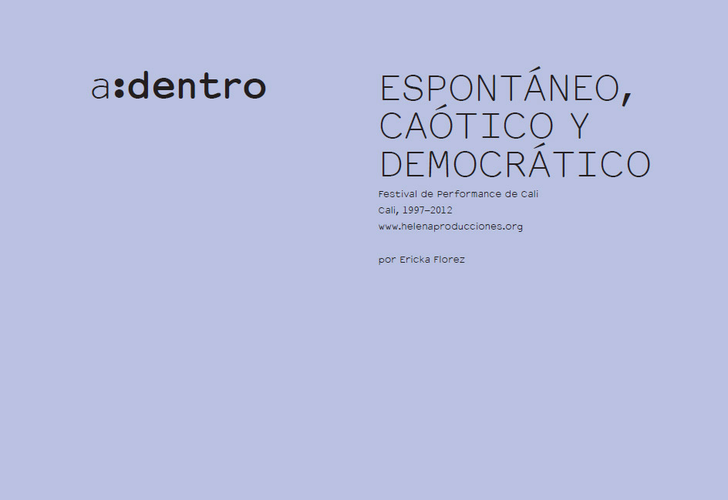
Perhaps the three of the title are the adjectives that come to mind more recurring when trying to describe the Festival of Performance of Cali. While some see these three characteristics as indicators of lack of rigor, seriousness and professionalism, others might think that it is these qualities (not only the most visible but, in fact, structural) that have made it one of the platforms that the better the local context of art, and the better it has put him in dialogue with historical particularities of the region and with different international contexts.
This is what Michele Faguet says in his article "Me voy pa 'Cali: Reclaiming Regional Identity and Practice", which states that although some things have changed over time from the team that organizes it, Helena Producciones, and the festival itself, "its spontaneous, democratic and sometimes chaotic character has remained "(2012). Faguet also believes that the festival helped "revive the vitality and status of the cultural scene of a city that at one time contributed greatly to the artistic and cultural heritage of the country." And he continues: "economic nature and the element of surprise inherent in the medium of performance ... have proven to be the most appropriate for such an unstable and precarious context as life in Cali" (2012). This statement leads us to ask: what has the medium of performance allowed this group?
l
One would dare to say that the name of "Performance Festival", which received from its beginnings, in 1997, ₁perhaps it did not respond so much to an explicit and specific interest in this particular artistic genre. The impression, however, that its founding members decided to call it this way because this allowed them to group a wide range of manifestations that had not yet been fully codified. This made the festival from the beginning a plural event, establishing crosses between different ways of approaching the concepts of representation and scene, and different ways of assuming art in general. Dramatic Performances Versus. performances that challenge the classical statutes of drama and representation; actions that denounce a political versus. actions that denounce the art that pretends to denounce; actions that start from the idea that nudity, tearing and suffering are inherent in the medium of performance versus nonchalant actions. Conversations about the role of theater in political activism during the sixties, followed by a concert of punk.
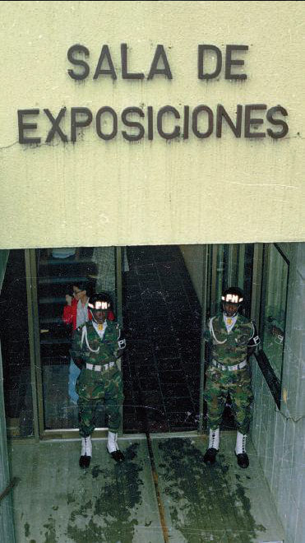
Giovanni Vargas, Contact Points, 1999. Third National Performance Festival, La Tertulia Museum. The artist located two uniformed soldiers of a military regiment (PM) at the entrance of the museum, monitoring and requisitioning all the people who entered the room. The requisition was made in a brusque and soft way, like a manoseo, thus making a seduction and at the same time a kind of abuse. Photo: Helena Productions archive.
A gentleman cuts a finger in front of everyone, while outside the room there is a go-kart race.
ll
This event does not privilege a certain vision of the medium of performance, but rather seeks to be a platform to put into crisis what the term itself means. One of the characteristics that makes this festival so powerful is its ability to put together things that would seem irreconcilable, and, through its curatorial choices, to create a tension between democracy and antagonism through which the different positions on art relativize without neutralizing each other.
In these festivals, the pamphlet and propagandistic character of some actions (one of the most emblematic, that of the artist Pierre Pinoncelli ₂ ) is relativized by actions that are ironic with respect to the political reaches of art as a denunciation (as Miki Guadamur ₃ ) . The solemn performances are relativized, in turn, by the desecrating attitudes of other actions; those closest to the theatrical logics are contrasted by those who see art as a way of circulating and mimicking the everyday flow of things, rather than as the act of creating something or representing something; and those who care more for the economy of the spectacular are called into question by those who criticize the implications of this type of logic.
The medium of performance has allowed Helena Producciones to create a democratic event, not in the "representative" sense (which builds false consensus: one voice represents all others and cancels the difference), but in the sense of recovering the possibility and the power of antagonism within the plural. ₄ In this way, what gives the character to the Performance Festival is not so much a static image of the type of performance that thecollective preference, but the creation of a tone that does not represent anyone but includes them all without neutralizing their differences. What seems to suggest the tone of this festival is the importance of vitality and dissent, which they manage to use in their favor and create new possibilities from spontaneity, chaos, and a certain very particular way of understanding the possibilities of democracy.
lll
Another of the characteristics of the festival organized by Helena Producciones is the ability to bring contemporary contemporary art issues to a close with very local peculiarities and to communities in the region that are far from art. Perhaps the clearest example is the inclusion of the machete fencing school at Puerto Tejada (Cauca) at the 2006 festival. The school is made up of
descendants of slaves, who use the machete in their daily lives as cane plantation workers [...] the machete was frequently used as a weapon throughout Colombian history [and] is loaded with a very powerful symbolism. During the War for Independence, slaves were trained in the art of fencing and were sent to battles with this tool. Many of those who survived were able to escape, and the practice of this once aristocratic activity was secretly appropriated and transmitted from generation to generation. (Faguet 2012)
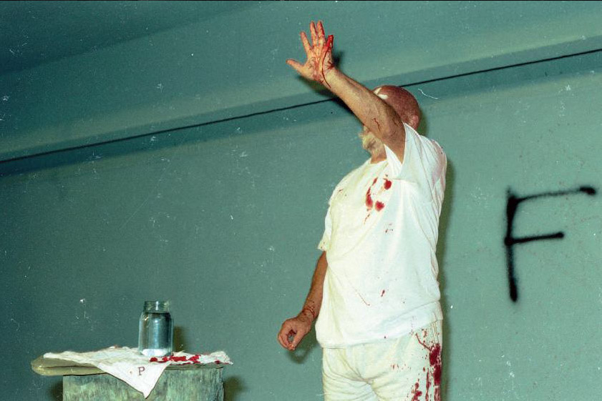
Pierre Pinoncelli, A finger for Íngrid, 2002. V Cali Performance Festival, La Tertulia Museum. Prior to his arrival, the French artist announced by national broadcasters that he would follow in the footsteps of the kidnapped Íngrid Betancourt. His work included print, a somewhat theatrical action performed in the theater of La Tertulia, and a second part in the Museum, much more dramatic and real, in which he cut a finger with an ax.Photo: Helena Productions archive.
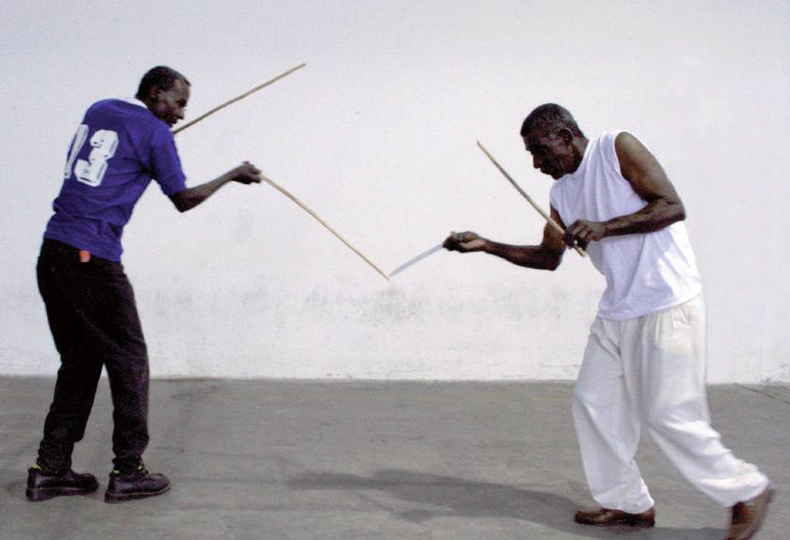
School of Fencing with Machete of Puerto Tejada, 2006. VI Performance Festival of Cali, Ancient Licorera del Valle. Fencing with machete is a practice of the Afro-Colombian community, handed down from generation to generation, through practice and using manuals with drawings. They say that Africans learned it from the Spaniards, and by using their instrument of labor, in exchange for swords the machete, developed this syncretic art. Photo: Helena Productions archive.
Another example is the invitation, during the most recent version of the Festival in 2012, to a group of actors of the theater active for decades to reflect on the relationship so strong that there was in the 1960s in Cali between theater and political activism.
Before Helena Producciones, perhaps no platform in Cali had called from the plastic arts to this type of community outside the countryside, and perhaps so far none has done so much as this collective: beyond the pamphlet, beyond activism without civic imagination, and not from the place - so well known - of the philanthropic artist who wants to bring some art to a community that has not asked for it. One of the curatorial skills with which the Cali Performance Festival is built is knowing how to identify the poetic thinking behind the ways of operating in the communities with which you choose to work. Helena integrates this type of communities into the artistic event because they may give insights into processes of self-organization, appropriation, participation,
Showing that the performance is not only shows, mini-shows or pseudo-shows offered to a theatrical spectator or theatrical post, the collective shows that the performance may also have to do with what is simply alive with what pulsates without drama or representation, and with what which questions the distance or the limit between execution and presentation. Not explicitly stated in its texts, this festival brings to the public different ways of using the scene that mobilize the traditional discussion about what the performance is, to a discussion about what the concept of performativity means and what implies and how it can affect our way of understanding and seeing art in general, not just performance.
lV
Now there are many platforms in Cali that propose activities and content, but during the 1990s and the beginning of the 2000s, before the Internet, before there was a doubt, and that it became fashionable among international agents to give a looking at the vitality and the managerial force of what is produced in the province, before all of that, Helena Productions fought alone in a state context that does not give a weight to the artists. In addition to its management capacity and duration, this group has been very insightful in the way it has taken juice to performance, as it has exploded until it explodes, that is, until it is expanded, until it gives all of itself, in the middle of a environment characterized by a rather positivist vision in its way of assuming the relations between reality, representation, language and art.
The medium of performance has allowed this group to create a context to put into circulation ideas and ways of operating in art that may not circulate - or circulate very little - within the local art schools (especially in the two previous decades , without this meaning that in the last years great advances have not been made).
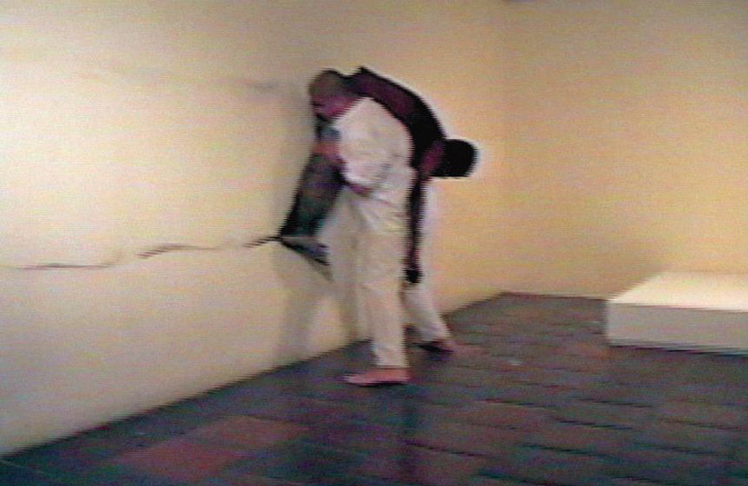
Rósemberg Sandoval, Mugre, 1999. Third National Performance Festival of Cali, La Tertulia Museum. Dressed in white and carrying on the shoulders of a homeless man, the artist goes to the museum room; makes a line on the wall with the dirt accumulated in the man, using it as charcoal, and then a white square in the floor. Photo: Helena Productions archive.
From its eclecticism, or from its democratic model based on antagonism, the Festival has managed to put into question and relativize ideas (quite widespread in most classes of these schools) of an art based on grandiloquence, genius, originality, the aura, and has also managed to put into perspective the discussions that divide art into techniques and qualify it from the craftsman's craftsmanship; these, among many other issues that constitute the prehistory of contemporary art, but which in art schools seem to be a novelty invented yesterday, or an idea that does not yet exist.
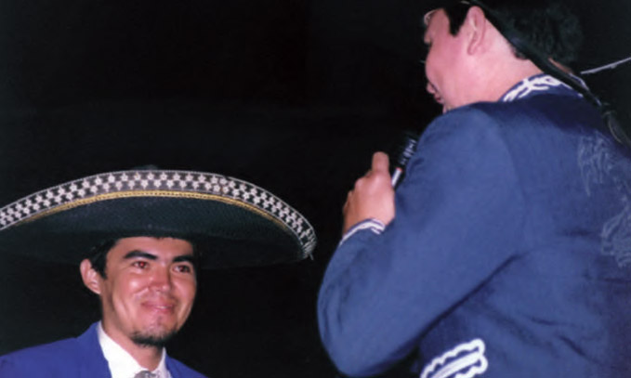
Wilson Díaz, Untitled, 1998. II Cali Performance Fair, Santa Librada College Coliseum. The artist hires a group of mariachis and gives a serenade to the public. Photo: Helena Productions archive.
On the other hand, the strategy of bringing together antagonistic manifestations has succeeded in making works that we conceive as conventional get infected with the vitality that other works can transmit to them; Likewise, the politically correct, spectacular or pamphleteering character that may have some perfomatic, community or activist practices may be put in question because they cohabit with others who precisely question these values.
In that sense, during the 1990s and early 2000s, the Cali Performance Festival was perhaps the only platform for circulating ideas associated with contemporary art in the city. In this way, and unintentionally, it worked (and continues to function) as an experiential school, like a school in the form of a festival.
Currently the Festival continues to operate in the same way and with the same vitality; and although it still stands out widely for its ability to address the local context, it is no longer the only platform, indicating that its existence and persistence has provided the ground for new generations of independent managers.

References
Faguet, Michèle. 2012. "I'm leaving for California: Reclaiming Regional Identity and Practice." In Diquinzio Apsara, Six Lines of Flight. Shifting Geographies in Contemporary Art. Berkeley: University of California Press. Available at: < www.helenaproducciones.org/english_text_michele_faguet.php >, accessed July 28th, 2015.
Lind, Maria. 2010. Selected Writings. Berlin: Stenberg Press.

1. Helena Producciones made the first Festival in 1997, and since then has organized seven more editions: 1998, 1999, 2001, 2002, 2006, 2008, and 2012.
2. Who cut the little finger with an ax in front of the public and with the blood that came out of the wound wrote in
the Farc wall (Revolutionary Armed Forces of Colombia); his performance titled A finger for Íngrid was a commentary on the kidnapping of Ingrid Betancourt.
3. The artist appeared on an empty stage, dressed in sports clothes and wearing a helmet on his head. There were some audio tracks, like gymnastic music, and at the same time that he made typical aerobic class movements, the artist sang some lyrics that denounced international economic and social situations.
4. Maria Lind in her text "The Curatorial" proposes curatorial thought as one that creates frictions, dissensions, rhythms, turns and tensions between different materials; and that he thinks 'from afar, with and against' works of art. For her the idea of ​​the curatorial operates in parallel with Chantal Mouffe's notion of politics, in which, in the search for a model that is not representative of democracy, one proposes one where "the opposition is appreciated and consensus is seen as something quite problematic. " In this sense, "the political develops beyond the antagonistic opposition between friend-enemy.The political is an aspect of life that can not be distinguished from divergence and dissent, the antithesis of consensus "(Lind 2010, 64).

