HOW IS THE ART OF PERFORMANCE IN THAILAND POSSIBLE TODAY?
Author:
Chumpon Apisuk
Edition:
ERRATA # 15: PERFORMANCE, ACTIONS AND ACTIVISM
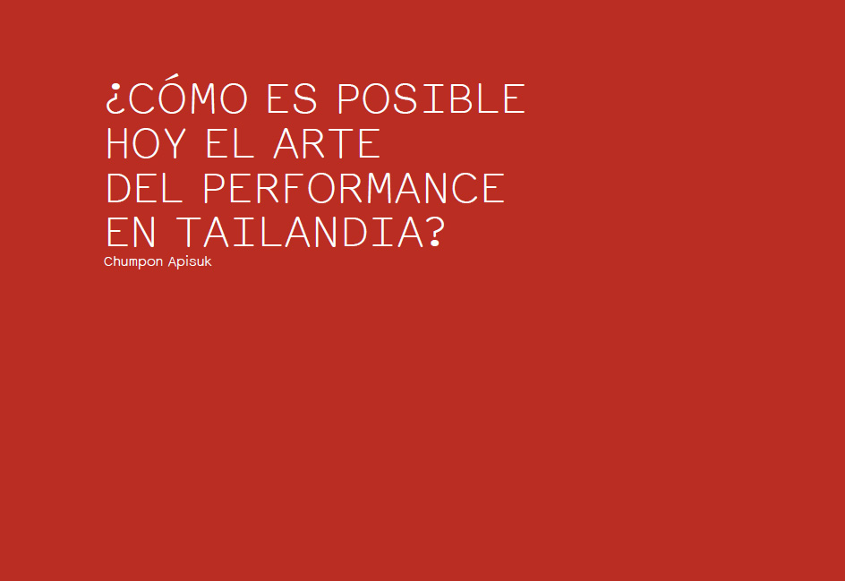
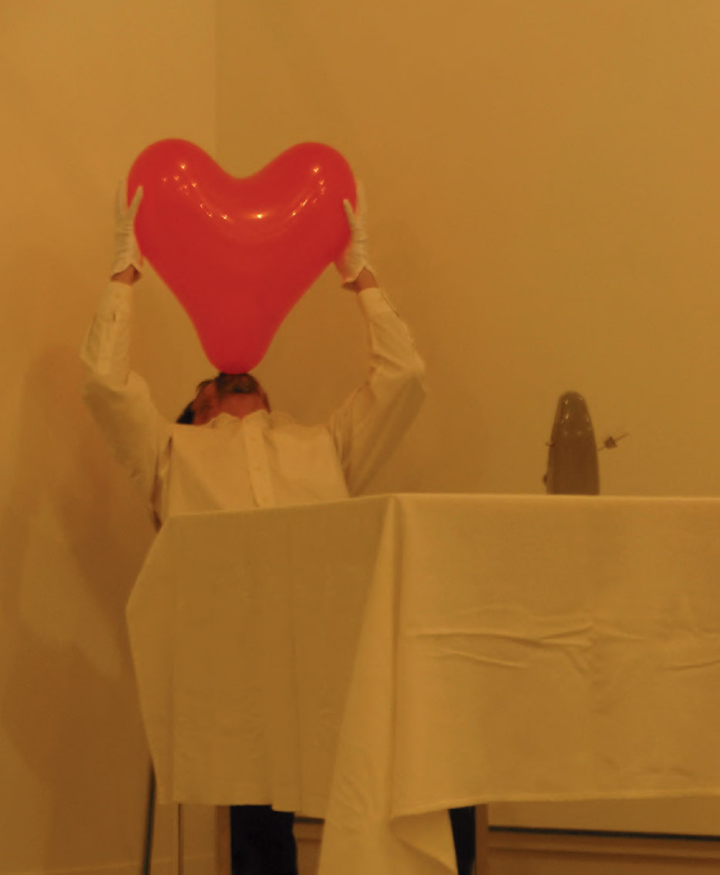
Chumpon Apisuk, Hearts, 2010. Chicoutimi, Quebec. Photo: courtesy of the Nomad Festival.
Thai art and sociopolitical context
Thailand has a rich history of religious murals in its temples which, in reality, are all a self-sacrifice to religion. Traditionally artists could gain support from the community or the benefactor of temple royalty, but there was no state funding to carry out their works. We have never had a tradition of state funding for the arts. On the other hand, "art" was not the right word; it was a sacred act for a person to make images and pay his work to the temple or community. It is revealing how in Thai we have different words to refer to the painting in each region, but in the language of Bangkok I never knew that there was any term to refer to those paintings of the temples, until we knew the word "art".
Thailand is a very traditional country and has a solid independent culture, as it has managed to escape the colonization of Asia. Both the people and the government have preserved culture and tradition to protect and promote their sovereignty. The school of modern art in Bangkok was founded with the help of an Italian sculpture professor (Corrado Feroci), who later, some eighty years ago, adopted the Thai name of Silpa Bhirasri. He was hired by the royal government of Siam to make statues in Bangkok; the school was created to train the local craftsmen who would be its helpers, later becoming a modern art school, the University of Silpakorn, where I studied between 1970 and 1971.
Between 1969 and 1970 I had studied with a poet and painter of Thai-Chinese action in Thailand. We worked together every day creating poetry, painting and reading books, both art and poetry; we discussed the events we read in the newspaper, and in the end I helped him finish the Thai translation of a book on the Tao Te-Ching. With him I learned a lot about art and about the question of what art is. He taught me that artists should not make art that others have done in the past, but should try to find our own answers to the question of what art is for us; each artist must do a different art. In fact, I wondered if only artistic objects were art: are art only the final products of artists? Where is art in painting, in sculpture, in poetry, in songs? I think it was this idea that finally led me to this point: to be a performance artist.
For a long time in Thailand we were totally isolated from the rest of the world, but in the late 1960s, when it became possible to go abroad to study, many Thai artists traveled to that end to the United States. At that time I learned about Western art, especially the American, in the library of the Information Services of the United States or in the library of the British Council. So I was able to catch up with what was happening outside of Thailand.
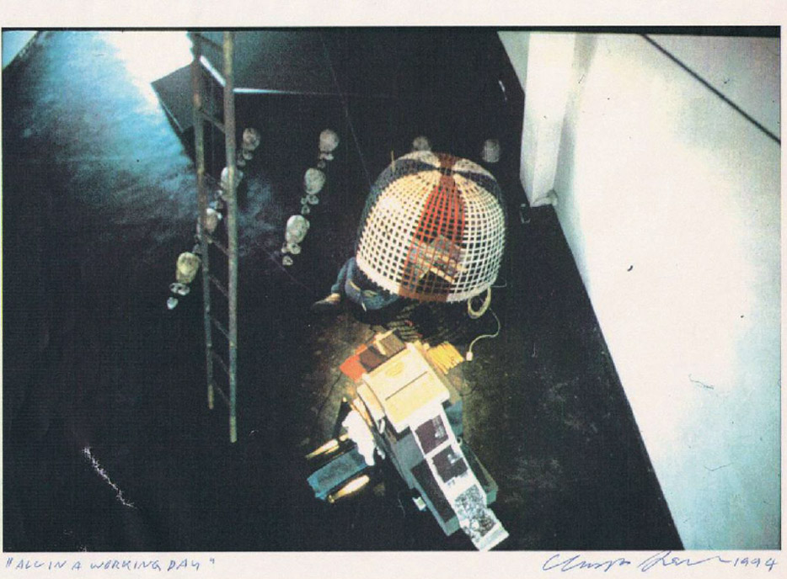
Chumpon Apisuk, All in a working day, 1994. Toxicity International Fax Art, Concrete House. Photo: Noi Apisuk.
Between 1976 and 1982 the country went through a civil war, in the middle of a power struggle between the Communist Party and its national fronts against the royal military government. Intellectuals, as well as artists, had to decide either to join the struggle of the people or to maintain a low profile in the institutes. When reconciliation arrived in 1983, most of the former students, progressive intellectuals and artists returned to the city. I returned to Thailand in 1984. Old friends were able to meet for the first time after many years of difficulties, and so positive activities that included performance events began to emerge.
My experience in the United States and China
Although I was in New York for many years (1976-1982), I did not live there as an artist; I even announced that I would leave the art in a Thai newspaper that was published in Los Angeles. As I mentioned earlier, when talking about the military coup and repression of the left-wing intellectual sectors in 1976, many artists and intellectuals joined the armed struggle against the government. At that time I was working abroad with a clandestine student movement, as the coordinator of the Thai student democracy union. I maintained political activism until 1982, when the reconciliation process began in Bangkok.
My time as an artist in the United States came later, and spent in Boston, while studying at the Museum School of Fine Arts. ₁At that time I tried to continue doing my revolutionary paintings but stay in Boston I kept isolated from all sources of information. Until little by little I began to take up some contact in the Red Book, a bookstore that was like a meeting place for people of the left, who were mainly engaged in discussing the theory of Marxism but did not have time to actually work by the people, as I expected. So I felt like I was wasting my time there, disappointed with the people around me, and I started looking for what I wanted to do, something that was worth it.
He had had contact with avant-garde events at the MIT (Massachusetts Institute of Technology) a couple of times, when the ZAJ group from Spain and Fluxus held an event there. I did not understand what it was; but it was very useful because today I am clear how it feels to see a performance for the first time. After this, I attended a series of discussions about the films of Bergman and the German futurists who also served me. The new ideas began to catch my attention and it was then that I realized that I had forgotten my interest in the avant-garde movement. So I started reading books about Joseph Beuys, Dadaism, Surrealism, Anarchism, Beatnik Poetryand Allen Ginsberg and the British pop movement; all interspersed with Chomsky, Soviet futurism, the poetry of Mao and Ho Chi Minh. I went back to writing for a while and it helped me settle things down. However, when the incident of October 6, 1976 in Bangkok, occurred _{in February} my wife and I went to New York and never returned to Boston.
In 1982 I realized that I wanted to go back to Asia, I left New York and I went to work in Hong Kong. We rented a house in the middle of a rice field, near some Chinese villages on Lantau Island. There I began to experiment with the performance on my own and started to make installations on the roof of my house. I also read a book about the happening in New York, this time in earnest.
I believe that the enriching experiences I had in Asia at that stage (Hong Kong and Beijing3) gave me the impression that all the parts of the world needed a new movement, a change; that both ancient and modern art were dead. Then I returned to Bangkok with my old name and the story of the young and active explorer, but I felt like a new person with the vision of a different movement. Art was not my quest, but the energy of sharing and sharing was something that mattered to me and I care a lot. He glimpsed new activities on the horizon, but he was not sure they were "art."
My role as a performance artist. Art, activism and community
I do not see that the role of artists, and my own as an artist, is different from that of other professionals, architects, engineers, doctors or farmers. We are all responsible for the task at hand. I do not want to call workto what professional people do, I prefer to see it as a task, as something that incorporates more social sensibilities and challenges the fragmentation of our society. The artist is a professional who brings positive energy and makes possible the impossible. It is a work that combines ideology, philosophy, the conceptual; which fits between senseless and senseless; which questions our being, our relationships, our spiritual existence and our absolute freedom. Art must be free of politics, free of marketing, free of negotiation, free from good and evil. And thanks to this, art is part of our lives; our existence is linked to art in this society. I do performance because I want people to get rid of art, from the confinement of an art that distinguishes between art and life.
About forty years ago, when I was at university in Thailand, the art community complained that the government did not support art. There was a constant struggle in which artists begged the government to support the arts. In 1986 I was deputy director of a non-profit art center in Bangkok, the Bhirasri Institute of Modern Art. There I started a vanguard program with my colleagues Vasan Sitthiket, Suvanij Surojanaraksa (already deceased) and Chatvichai Bhrammdhattaveti (the director). The program had considerable assistance and was the topic of conversation in the city. The media supported the event and helped make it even more important. The idea suggested a new form of art in which the audience and the artists could interact; many people remember him to this day. The event, somehow, inspired some support from the university and since then there have been many public events. Then, in 1988, I founded an independent art space in a small community near the University of Chiang Mai, which brought together many artists and social activists. The free spirit of the art exhibited there, and the activists working together, opened the eyes of many young people to different situations and social problems in Thailand. The Tap Root Society, opened the eyes of many young people to different situations and social problems in Thailand. The Tap Root Society, opened the eyes of many young people to different situations and social problems in Thailand. The Tap Root Society,₄ so I called the art center became a community of progressive people.
Going back to the years between 1973 and 1982, when I lived and worked between Boston and New York, I was part of the union of Thai students for democracy. At that time the democratically elected government in Bangkok was overthrown by a military dictator, plunging the nation into civil war. Many of my comrades were imprisoned and many others joined the communists in the jungle. My activism, "I learned doing it," started there. So, after that, being able to keep people together is part of my mission. That is why when I returned to continue artistic life in Thailand my idea was to work in groups and organize political events with art, or art events with political and social themes, whether to make statements or to attract the attention of the public and the press . And I think I've had some success with those kinds of events, which have become something like my signature. Anyway, I consider that art, life, society and politics are one thing, and that when organizing art events or political events there is only one purpose, which is to give power to the people.
Despite this, Thailand has yet to achieve public programs for the arts. Today we have a Ministry of Culture that, rather than supporting creativity, controls cultural life, and has worked hard to win the favor of the public by organizing its own events. We have made some progress: although the money has not yet reached the hands of the people, it is evident the recognition that the artistic creation of the people has been receiving by the government. But we need more time to work.
Concrete House
In 1990 my wife and I found a building and we wanted to create a meeting place for artists, writers and activists; after the closure of the Bhirasri Institute of Modern Art in Bangkok this space became Concrete House. The festive atmosphere took over every weekend of this coarse-looking building without furniture or decoration, and despite its location to twenty kilometers from the center of Bangkok. On the other hand, that year marked the beginning of the challenge that AIDS represented to the health system in Thailand. In the beginning, a public hospital near Concrete House was the only center of attention for the seropo-sientes, and every day people went there that needed a health examination or medicines. Many of them came from far away, so we decided that this empty concrete house might be a good place for people who needed a place to spend the night. So Concrete House became a mix of people who embraced artists, poets, musicians, AIDS activists and people living with HIV.
Our first art exhibition was in 1992, with an exchange between an Australian artist (Juliet Lea), a Filipino (Alwin Realmillo) and two Thais (Paisan Plienbangchang and Anurak Chattanan). Then we had a visit from Lee Wen and Koh Nguan How, Singapore artists, who came with two German artists, Helmut Lemke and Veronica Radulovic. The Yellow Man (Lee Wen) walked around Concrete House and scratched its walls, while Helmut Lemke, a sound artist, turned it into its sounding board. A few days later, we went to join the popular gathering at Thammasat University in Bangkok, where all of us, Thai, Singaporean and German artists, performed together.
In 1993 I organized an international poster exhibition to present different perspectives on HIV / AIDS. The exhibition marked the first anniversary of a newsletter we had published with my wife to promote coexistence with people with HIV / AIDS, named Naam Chewit (meaning Name of Life in Thai). The publication became an important source of information for the first movement of people with HIV / AIDS in Thailand at that time.
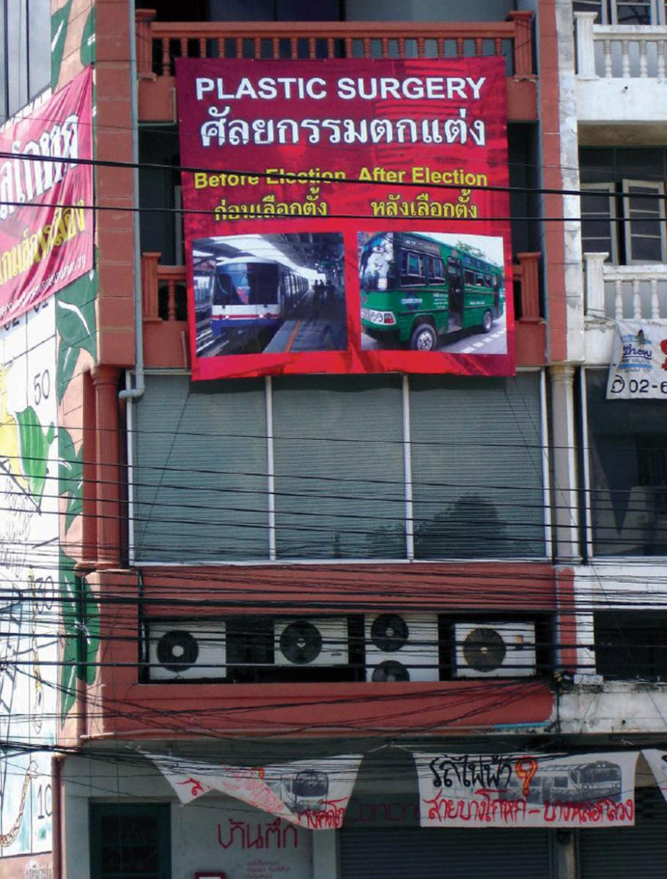
Facade of Concrete House in 2005, when Apisuk joined the community campaign against the construction of the metro
elevated in the area under the motto "The Government Lies". Photo: courtesy of the artist.
One of the main events we had at Concrete House was an international fax art event whose theme was "Toxicity": eight Thai people, including performance artists and poets, took turns every day to receive the faxes that arrived during the first week; the sample lasted three weeks. ₅ In 1996, I helped found a group of artists called Bangkok Art League, along with Santi Isrowuthakul, Suraphol Panyawachira, Kamol Phasawasdi and Vasan Sitthiket. We did some performances together in different social events, especially in public spaces, or in art exhibitions in some lobbyof hotel, since at that time it was common to hold exhibitions in this type of places. Later we organized "Live Art" an open performance event that was the first platform for Thai performing artists, prior to the founding of the International Festival of Performative Art - Asiatopia, in 1998.
In 1997, Concrete House hosted an International Per-Formance Encounter organized by ASA (Boris Nieslony) and Ultimate Akademie (Rolf Interecker), Cologne, Germany. The meeting dazzled many Thai artists in performative art, and was another lesson for me on this type of art and learning how to organize these events. It was an inspiration for Asiatopia the following year.
In addition to being an artistic gathering place, Concrete House was also home to the Empower Foundation, created by my wife Noi Apisuk. As one of its members, I have worked for this organization since its founding in 1986, and from the beginning to the present I have assumed the role of editor, communications and media producer, and sometimes I have been an art instructor for young people which are linked. Today, when Bangkok's art circle has no need for an alternative space such as Concrete House, the building has become a headquarters of Empower, where we participate in the design of a museum that will show the history of sex work in Siam (now part of Thailand),
Throughout my artistic life I have depended on the development of community projects to get my own salary. And I work only with the Empower Foundation, so my income is based on what I publish for them, on workshops with sex workers I give, on theater classes, or on the help I give them with the design of their programs of action, as you can see in the museum. This is my way of living, it is not art.
Asiatopia
My interest in organizing festivals is to demonstrate the existence of a community of performance artists within the broader global community. As a community we actively interact, share and learn from each other. Unlike other types of art festivals, where the focus is to show a product while presenting the artist as an outstanding individual, in performing art we are all together sharing the process of creating our personal presentations as an exchange. There is an atmosphere of friendship, respect and professionalism among all, and even when everyone goes home, friendship grows and communication expands, the network expands; the interaction increases among artists who are members of the community, who are always doing something together.
All my friends and co-workers have supported me with Asiatopia to get to this point. I could not have done any of this alone. When we started the festival in 1998, everyone thought we were doing live theater, or dance, or music. When people saw a performance for the first time they had no idea what it was or how to take it.
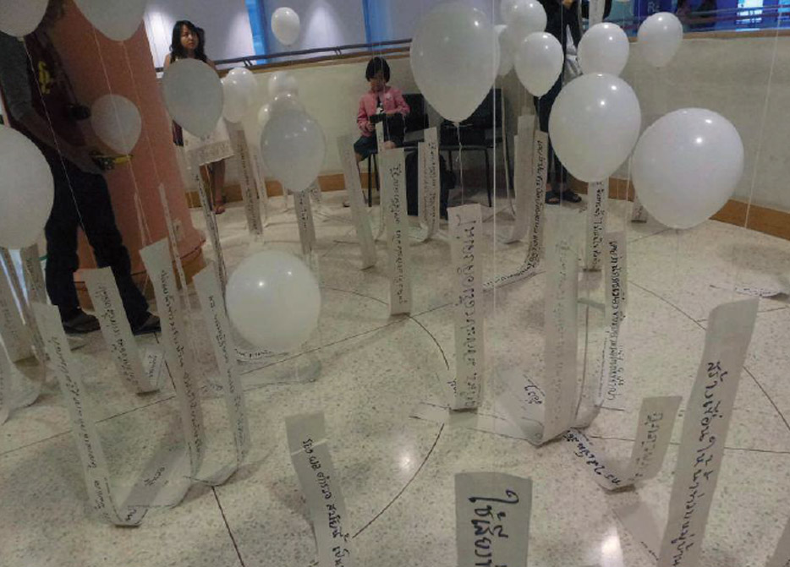
Chumpon Apisuk, 100 reasons I do not like the government, 2013. Asiatopia. Bangkok Art & Culture Center. Photo: courtesy of the artist.
I think what makes Asiatopia different from other performative art festivals in the region is that we are a collective, not an administrative organization or based on curators. The reason we have to maintain this collective spirit may be that we do not have a lot of annual budget, and often there is no money at all, so we need all those who can help us or offer any kind of contribution to the festival. Another of the most important characteristics of Asiatopia is that we are probably the only performing arts festival organized in a country where there are no public funds for the arts. And in our sixteen years of experience only the first four festivals were supported by the Bangkok administration. ₆The artistic community managed to install a Ministry of Culture for the first time in the political history of Thailand between 1998 and 2000; and, nevertheless, the winds of the policy changed after a few years and the minister turned his back on the artist community. In 2001, the new governor-elect of Bangkok threw out the project for a new art center and proposed replacing it with a shopping center. The artists became angry and with the Asiatopia group we declared that we would stop the festival that year to dedicate ourselves to organize a protest of full-time artists. I was nominated by my colleagues to be the general secretary of the Thai Artist Network. The network led the campaign by creating four thousand paintings of one square meter. We went to all art schools in Bangkok and organized painting events with public participation; and in September of 2001 we arranged the paintings for four kilometers, the same distance from Bangkok's mayoralty to the site of the proposed art center. More than two hundred artists took the paintings through the streets of Bangkok and laid them on the ground to cover the entire lawn in front of the City Hall. Our campaign won, because the administration stopped the project of the commercial complex and put again on the table of projects the first Center of Art and Culture of Bangkok. Since its foundation in 2008, financial support for Asiatopia has been secured with them. because the administration stopped the project of the commercial complex and put again on the table of projects the first Center of Art and Culture of Bangkok. Since its foundation in 2008, financial support for Asiatopia has been secured with them. because the administration stopped the project of the commercial complex and put again on the table of projects the first Center of Art and Culture of Bangkok. Since its foundation in 2008, financial support for Asiatopia has been secured with them.
Today it is evident that Asiatopia has gained great relevance. We have had incredible experiences, if we consider the results and the little money we had. The truth is that often art can not prosper, not because of economic or political issues, but because of the culture and tradition of the country, and the way it has developed. The mandate of the Ministry of Culture today is to establish an official art form instead of seeking to recognize the current artistic community. Therefore, I think we should continue to ask ourselves why we do performative art. And at the same time, we have to accept a variety of performance types, in order to allow for different and new practices.
For many of us Asiatopia is not a festival: it is a performance school, a political organization of artists, a movement led by performative art in Thailand. Although we have not used the name Asiatopia for other activities that are not performance festivals or related, many members of our collective often participate in political rallies or popular movements. We do not focus on the curatorial technique nor do we base our festival on artistic curation. And because we do not have enough budget to pay the participating artists, we rely heavily on those who can manage their own resources to come. This is a limitation for Asiatopia, because sometimes invited artists can not participate if they do not get funding to travel.
As part of the program, each year we guide the participating artists with a statement conceived before the festival; to do this we discuss events or situations in Thailand, the world or the region, and then this political statement orients somehow the direction of performances and the selection of artists. This is not to say that it is a thematic festival: we have never imposed our declaration on artists, we are only looking for them to have an idea of ​​how we see the world each year. As part of the response to the problem of the year that we define key by consensus, we print a particular slogan on shirts that artists are wearing during the festival and is more like a reminder of how we felt this year _{in July} . In the past, many artists from Singapore and some artists who passed through Bangkok as part of a longer trip have participated. But since we have the support of the Center of Art and Culture of Bangkok we try to invite at least two artists from other sources. So we already have a significant number of artists from the region in exchange with artists from around the world; this is probably what has made us a regional festival, which is not limited to Thai art.
In my position as a performance artist working in Thailand and Southeast Asia (a region where performance is barely growing), I believe it is important for artists to consolidate a platform for performing performance art, as well as to publicize the practice. In the region there are very varied local traditions. In the past rituals were observed as part of ancient forms of religion in which a certain type of animism was still intermingled in religious worship. Perhaps that explains why many performersAsians have begun their practice in the form of ritual actions developed in response to today's society. In Thailand, in general, artists and cultural preachers locate art alongside ritual and the teaching of morality. This attitude is increasingly emphasized in order to combat the invasion of foreign cultures. I do not believe in this, but fighting against it is crashing against a wall. So I consider, as an organizer of performance festivals, that we need to introduce many other individual practices into the medium. I want to encourage each performance artist to develop their own live visual practices and not to mix art with religion or moral teaching, because art does not play the same role as preachers or monks. I think this is the mission of Asiatopia.
In the conception of Asiatopia they also inspired me and I learned much of the international art events that I had visited previously. ARX ​​in Western Australia (1987 and 1989) allowed me to be a member of their committee, and with them I learned about the nature of an international art event and about the attitude, the friendly atmosphere and the opportunity to share among the participants. After ARX came the Nippon (Nippon International Performance Art Festival), by Seiji Shimoda, a great artist and organizer, with the energy and passion that so much value them: this festival is organized obstinately twice a year since 1993 in one of the most expensive countries in the world, Japan. Boris Nieslony and Rolf Hinterecker allowed me to be part of the International Performance Meeting in 1997, where I received lots of positive energy from participants from all over the world. There was a dynamic of exchange from sun to sun, in and out of the place: anything was possible. The Performance Art Archive that Boris has compiled may be the spiritual sanctuary for the most special performance I've seen in the whole world.
Asiatopia is not an isolated festival; is the most enduring survivor of Southeast Asian performance festivals, but he is part of a great performative art movement. And we are no longer alone in Southeast Asia: we have Future of Imagination and Fettersfield in Singapore; the Performance Klub in Yogyakarta, Indonesia; Tupada Action and Media Art (Tama) and the APO Art Space International Performance Art Festival in the Philippines; Zero Art Space and Beyond Pressure in Burma, not including small independent events in places like Bundung, Manila, Mandalay, Vietnam or Malaysia. It is a great honor for Asiatopia to be part of this regional energy.
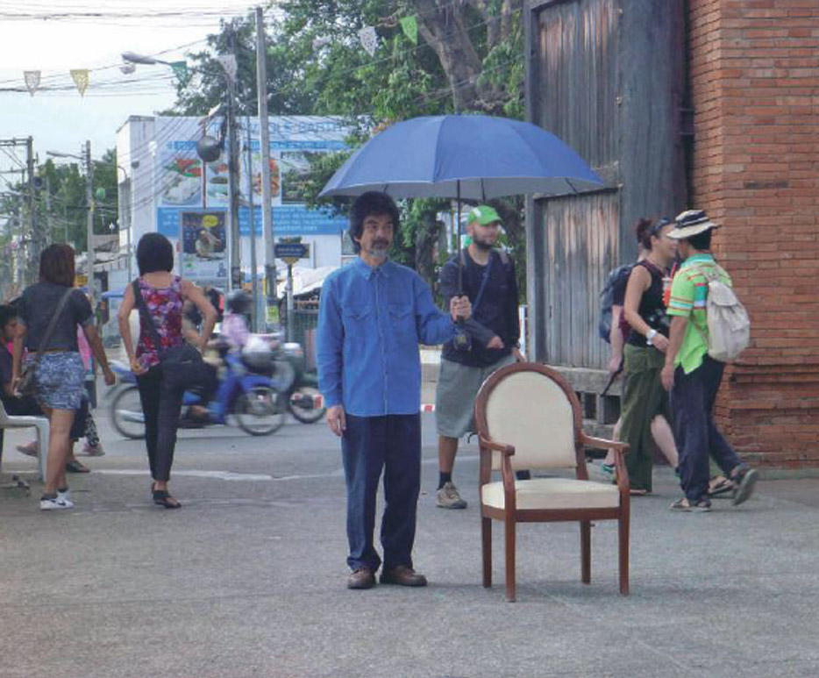
Chumpon Apisuk, Standing, 2010. Asiatopia, Chiangmai. Photo courtesy of Asiatopia.
Throughout this process I have met and met with outstanding performance artists from Southeast Asia: Lee Wen, Tang Dawu, Amanda Heng, Jason Lim, Jeremy Hiah, Angie Seah, Kai Lam, Lynn Charlotte Lu, Arahmaiani, Iwan Wijono, Willem Christiawan, Yoyoyogasmana, Ray Langenbach, Tran Luong, Richard Streitmatter, Moe Satt, Aye Ko, Aung Myin, Chow Ei Thien, Yuan Mor'O Ocampo and Mideo Cruz, among many others. Now they are my friends, my colleagues. I feel very comfortable between them.
Of course I also mean all Thai artists. ₈ I have also met and made friends with great artists and wonderful human beings in Japan, China, Korea, India, Egypt, Palestine, Israel, Europe and Eastern Europe, North America, South America, Australia, Africa ... Friendship is very important in the performative art movement. They speak all the languages ​​of the world, I do not understand the majority, and I am very happy that Asiatopia is our bond.
Collaboration Networks and Asiatopia Challenges
I have learned many things in the process of founding and during the organization of Asiatopia. But one important thing was to understand why art is impossible in Thailand. It is a fact that the Thai government system is not ready for human progress: it is a machine to manage and control our society, in which we are only citizens in the measure that we are subject in the spaces controlled by the government. But I believe that art is a weapon to fight against this dehumanized machine by incorporating more human events into local life. When the Bangkok Art and Culture Center opened to the public in 2008, we were able to celebrate the tenth anniversary of Asiatopia. The festival ran for five weeks and featured 89 participating artists and 103 performances. This was the first art event in Bangkok that brought together so many international artists. Asiatopia then became a symbol of the future of art in Thailand, just as the perfor-mance came to be seen as the art of tomorrow. A few years later, the University of Silpakorn integrated the studies of performance arts as subject of its curriculum, and in the opening of the course the university invited me to speak on the performative art.
After Asiatopia took several years to complete, the people in the art circuit began to recognize the performance, and now we have managed to organize workshops a couple of times, including artists' labs. We have managed to get here, but it is still not enough.
Asiatopia is not just a festival; also has a role in the changing art world of Thailand. When I met Arahmaiani in Dresden in 2000, after having seen each other several times in Japan and elsewhere, we wondered why we had to meet in other places. Was there any chance that Asian artists would meet in Asia? I had already organized Asiatopia by then, Arahmaiani had organized the International Festival of Performative Art in Jakarta (Jipaf, 2000), and we had already met on our land. However, the discussion expressed the lack of opportunity for artistic exchange or, rather, it showed how "the environment" had not been right for us for many years.
It is hard to believe this from Southeast Asia, whose history is culturally rich and where our creativity is admired by many Westerners. But there is not enough interest in our governments - by state policy - to support contemporary artistic practices. I believe that we, as people from Southeast Asia (or Thailand), are living in States where stability and economic prosperity are the only concern. Our state and government are one power that can not be separated. Our countries have been manipulated by the politicians on duty in each government, and the government controls the state. In Thailand, we are still in the process of drafting the national Constitution and defining it as a legitimate means of setting limits on governments. But it also happens in other contexts: one of the arguments that gave us an institution of mixed economy - which used to finance Asiatopia in Nan - so as not to continue to support them, was that our program was not promoting tourism in the province. We may have used money from institutions that are not ideal, but it was the only one available. It was not worth complaining about.
The States of the West have a long history of support for art, and their obligation has been to give it continuity in order to maintain its history. Art has been a fundamental part of European history and the development of its society; in contrast, in Southeast Asia our history was truncated by Western colonization. Although we were not colonized in Thailand, our monarchs and state directors rewrote the history of the country with imported art and crafts so that their images would resemble European culture, and hired Western artists and architects to make Bangkok look like Paris and Rome . This national "foundation" is becoming a problem in today's changing democratic society. Thailand needs a culture that is democratic, not political.
Artistic expression is necessary for a democratic society where freedom of expression is respected. It is an obligation of the State to guarantee this freedom that allows people to create a dynamic society.
The main focus of our curatorial strategy from the outset has been the strong connection we have with Southeast Asia. Unfortunately, Singapore alone has a solid art council that supports artists to work abroad, while in other countries there is no such fund. That's why almost every year artists come from Singapore. Currently, with financial support from the Center for Art and Culture of Bangkok, we can invite some additional artists from the Ansa region (Association of Southeast Asian Nations). As for other regions, we are now trying to reach East Asia, countries like China, Japan and Korea. We have created very strong links with several artist networks in Japan, Hong Kong and Korea, and we are also working recently with groups of artists in China and Taiwan. But it is also important that we connect with the West. We are focusing on the exchange with other countries in order to strengthen our ties, something that we find closer to a cooperation strategy than to curatorial reasons. However, we are fortunate that the connections we have so far have been very good and artistic positive.
This means that we are not doing our own curatorship of individual artists, but instead rely on the networks and points of contact we have established in other countries and regions.9 We are not so strong in South Asia (India, Bangladesh, Pakistan, Sri Lanka, Nepal, etc.), the Middle East, Latin America and France; however, we have gradually revisited and evaluated our previous programs and tried to bring different artists who can redefine what is performative art with its various forms and practices. On the other hand, Asiatopia has an art workshop for young people and people interested in developing their experience with performance. It is organized in September, so each year we have to help each other to find artists who make the workshop. Since 2011, we have had artists such as Monika Günther and Ruedi Schill, Morgan O'Hara, Sinead O'Donnell, Melati Suryodarmo and Randy Glehill. We hope to soon have great artists and teachers to hold a workshop with young local artists; people like Marilyn Arsem, Boris Nieslony, Alastair MacLennan, Roi Vaara or Lee Wen.
One thing that makes the performative art movement so rich on a global level is that the spirit of friendship and solidarity is very high. Asiatopia is indebted to all the artists in the world who make us feel part of a network. It is so spiritually motivating when one sees the file of Boris Nieslony ... And in Le Lieu, in Quebec, in a space where so many performances have taken place, one feels the energy in the air when entering: in the library, in the video file , in people ...
It's like what you feel when you go through a street under construction: life, work, sounds, smell, dust, ... that working-class spirit that is so strong. The Lee Wen Independent Archives in Singapore is not a big place, but it contains much more than any building - and a man named Lee Wen, no less. And every time I look up from the first floor room at Concrete House I feel the same. I think this kind of spirit makes performance art networks different.
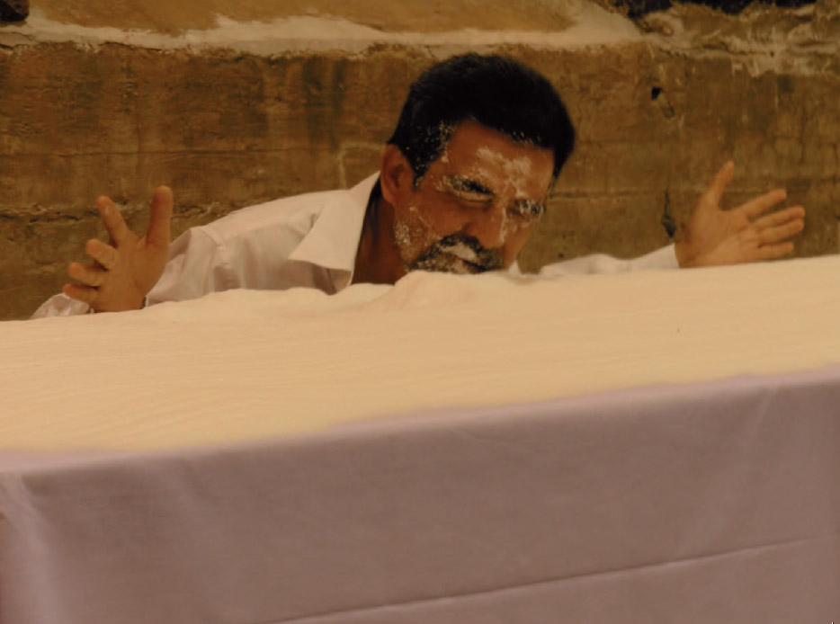
Chumpon Apisuk, Silent Salt, 2009. Quebec. Photo: Monika Gunther.
The Empower Foundation has been our main support when we did not get funding (as I said, that means that most of the time we work without receiving a payment and in several years we could not pay for the artists' participation because there were no resources), and I have received support from the Rockefeller Foundation to organize the regional meeting and for performance research in Thailand. Sometimes we take our festival to Chiang Mai to escape expensive places like Bangkok. And now that the Bangkok Art and Culture Center is creating funds to support artists and can offer a minimum payment; we know that the collection is underway, although we have not received the money yet. I am very grateful to all the foreign artists who have been so understanding and who, when looking for their own funding to come and present at our festival, have helped a lot for Asiatopia to move forward. We still have to work very hard on these support funds for artists in our country.
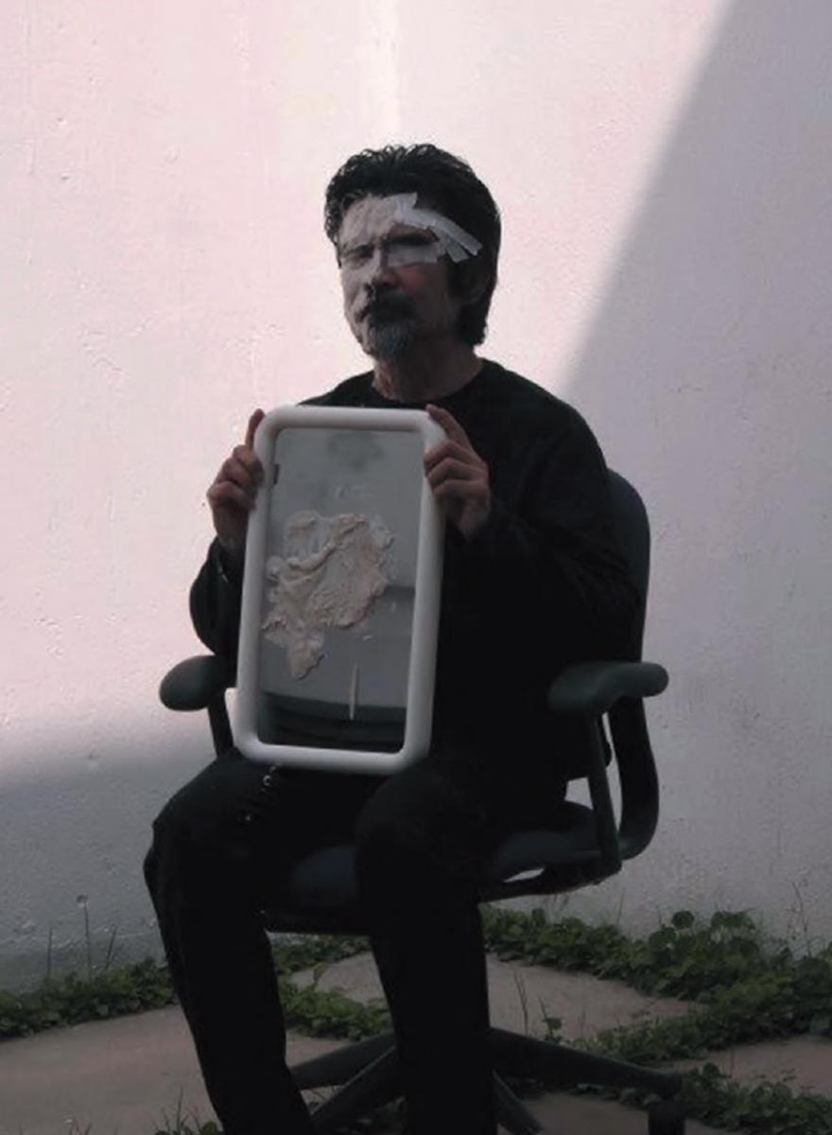
Chumpon Apisuk, I am not doing this for my country, 2014. Hong Kong. Photo: courtesy of the artist.
About my own process in the light of these meetings. Performance and time I would like to talk a little about what has happened to my practice of creating the performance in parallel to all these developments and exchanges that were possible with Concrete House and Asiatopia, as I do not see them as two separate processes.
In 2009, when I performed the Silent Salt performance , dedicated to my mother, I realized that I was breaking with my previous style, that I was no longer performing a kind of performance guided by a political or social conscience, but trying to establish a position and talk about who I am and what is what worries me.
I have reached a point where I am not happy with so many objects - objects that one usually puts there to convey a message to the public - because I think they control my movement and my time. Now I try to minimize the use of objects at the most essential to be able to say more. I must give time and space to the public to think through my action, instead of guiding it with my objects. I believe that the experiences that have been experienced by the majority of the public, at least of Thai, have been similar to mine - although if they live in Southeast Asia is not that there is too much difference. Presenting my body is like representing them, I think; then what I want is for the public to see my performance and feel their experiences, not to understand what I do or why I do it.
In Europe and other places in the West the majority of the audience is more familiar with art and performance, so they can receive and find something in my actions that they can follow. It does not always work that way, of course. During a couple of performances I did in 2013 and early 2014, I used lime powder to paint myself in white. It was understandable in the West, where white skin has been used as a flag of colonialism and the dominant culture; but in Asia the lime in the face evokes only a disguise that hunters used to hide their body odor. And yet it was okay to let the public interpret it in its own way: whether they took me for political activist, or for shaman, the others, they all felt moved by action.
On the other hand, when doing the work with fewer materials, the public needs more time to follow my action, to think about it. In that case, I must become a kind of reflection of the public mind. I recently analyzed the time required for my performance in front of an audience, and it turned out to be about twenty to twenty-five minutes, which is good enough for a festival-format work.
However, when I have more time, I like to carry out works of longer duration, of more than an hour, in non-artistic places, or even in public areas.
When I try to initiate this communication, time becomes very important to be able to relate to people; time is fundamental to catch the hearts of those present. This is the case when performing a performance for an audience where the contact is more interactive and there is more confrontation. But when I do long-lasting works in public space there is not a single group all the time; then people are passing through and action based on time becomes the object itself. They do not expect actions or movement, they only generate curiosity what I do and why, and then they go their way. So, there are many people who are left alone with a glimpse of my performance, each of about two or three minutes. The longer I stay there, the more people will see it. Public action then becomes a kind of temporary statue, an image of the instant that retains each person when he sees my performance. And there is also outlined a certain theory of time recording.
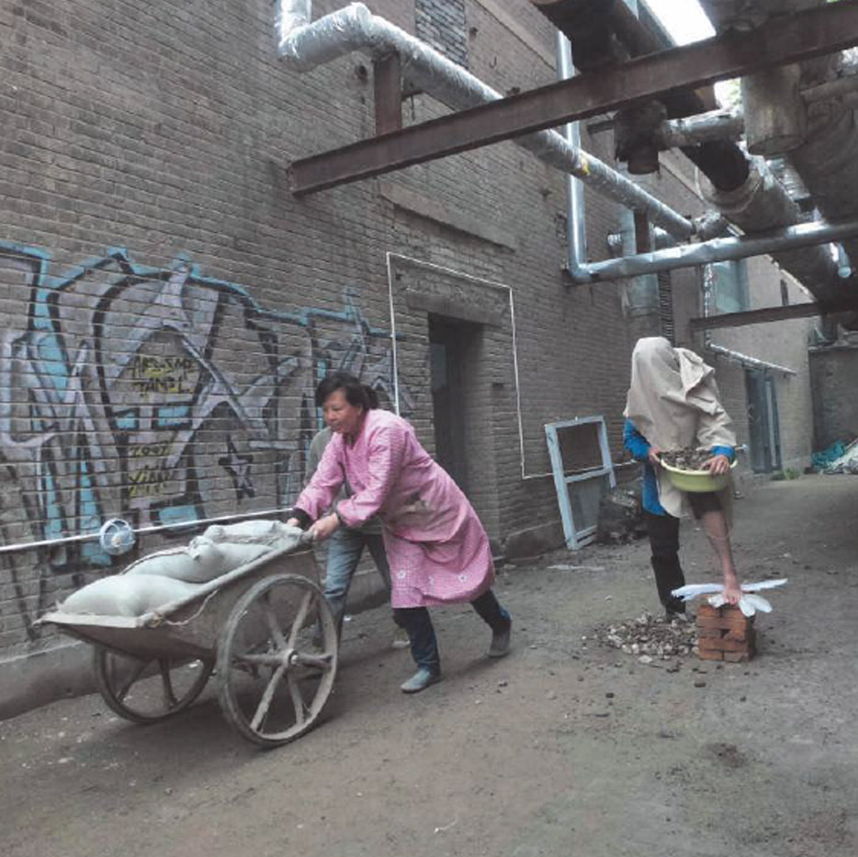
Chumpon Apisuk, I am not doing this for my country, 2014. Hong Kong. Photo: courtesy of the artist.
Many have been the artists and writers who have inspired my practice over the years, and each of them has influenced me or inspired me differently. To mention a few examples, I would speak first of Lee Wen, who inspires me for his poetic creativity; his works have moved me deeply and I feel that Chumpon Apisuk, I am not doing this for my country, 2014. Hong Kong. Photo: courtesy of the artist.
Web Sites
Art Service Association - ASA (Germany): www.asa.de
Asia Art Archive - ASA (Hong Kong): www.aaa.org.hk
APO Art Space (Philippines): www.facebook.com/APOArtSpace
Asiatopia International Performance Art Festival (Thailand): www.facebook.com/ ASIATOPIA-International-Performance-Art-Festival-229057933787655 / timeline /
Asiatopia - past editions: asiatopia.blogspot.com.co
Beyond Pressure (Mandalay / Burma): www.beyondpressure.org
Empower Foundation: www.empowerfoundation.org
Fettersfield (Singapore): fetterfield.blogspot.com.co
Future of Imagination (Singapore): www.foi.sg
Performance Klub (Yogyakarta, Indonesia): www.performanceklub.com
Tupada Action and Media Art - Tama (Philippines): http://tamatupada.multiply.com/
Zero Art Space (Mandalay / Burma): www.newzeroartspace.com.mm
Ultimate Akademie: www.ultimateakademie.de

1. I think what marked me about the School of the Museum of Fine Arts in Boston was how it should be a good educational system. Students were treated as young professional artists, we had a workspace for ourselves or we could create from our own study. There were workshops and teachers, but they were more like technicians who helped you to consolidate a project. We had advisers whom we could consult about the courses to take. There were meetings at which we discussed our work, which was very useful for building trust in the work itself and for gaining new ideas on how to improve it. There were also classes where students could meet with different people, from economic experts to janitors, truck drivers, union workers, etc.,
2. Apisuk refers to the massacre on the campus of Thammasat University and Sanam Luag in Bangkok, killing more than 100 students protesting the return of dictator-general Thanom Kittikachorn. [ N. de la T. ]
3. In 1983 I visited Beijing and met an old friend from Boston who studied Chinese literature at Peking University. She sneaked me into the residences of the university, where we attended a poetry recital in one of the student rooms. It was small and with its three cabins there was barely room to enter. It was very cold, but the room was filled with students. The poet stood in the center of the room and executed an action while reading in Chinese. I did not understand him. Everyone wore thick gray jackets with Communist caps, including myself (my friend had given them to me to camouflage me as one of the Chinese students). I found at that time a catalog of poetry reading in the cemetery, from which I later translated some poems to the Thai that were published inLok Nangsue [in Thai, World of the book ], in 1984, a very prestigious literary magazine of the time in Thailand.
4. That could be translated as "The society of the primary root" [ N. de la T ].
5. I performed an eight-hour performance titled Everything on a Labor Day, where I was inside a chicken cage a whole day, while works of art arrived via fax from different parts of the world. We received more than 100 faxes in eight days.
6. Initially, I received no institutional support other than that of friends, who contributed mainly to their creativity and work. I started the festival in 1998 because it was the right moment to get some political support. To be clear, the artists' community in Bangkok had been begging government support for art for many years before I did. In any case, it was at that time that we had enough people in the Bangkok administration, as well as the right governor (who liked art), so Asiatopia deserved a boost.Unfortunately, it did not last long enough.
7. For example: the phrase of the festival of 2002 was famous: "Center of art NO mall"; another year said: " Free Trade Agony") in response to the imposition of the World Trade Organization's Free Trade Agreement with Thailand in order to trade with the West. In 2014, the T-shirts said "Bla Bla Bla ..." in response to the state of Martial Law, and by the Thai Prime Minister, who was very talkative and always finished his speeches by saying "Do you understand?" In 2013, the Thais set up a large movement seeking agrarian and forestry policy reforms; the motto of then was: "The land under our feet / Belongs to the people". A few people collect our shirts as if they were political statements, and some artists have asked if the statements printed on the shirts were "the theme" of the festival. I do not think they were; were just our reaction to the situations we live.
8. The year 2015 was something particular. With the Thai artists who worked with me in Asiatopia since their preparation, we were able to perform together, the fourteen of us, a per-formance on the banks of the Nan River, in my hometown, on Valentine's Day (February 14). It was very special for me; without Asiatopia this would not have been possible.
9. There are one or two artists that we have decided to invite, according to their request to attend, by selecting their profiles by collective decision. We have meetings between our colleagues once or twice before we decide to invite particular artists.

