
THE ABSURD, THE IMPREVIST, THE EFFECTIVENESS OF THE ACTION
THE ABSURD, THE IMPREVIST, THE EFFECTIVENESS OF THE ACTION
Author:
Esther Ferrer
Edition:
ERRATA # 15: PERFORMANCE, ACTIONS AND ACTIVISM
DOSSIER
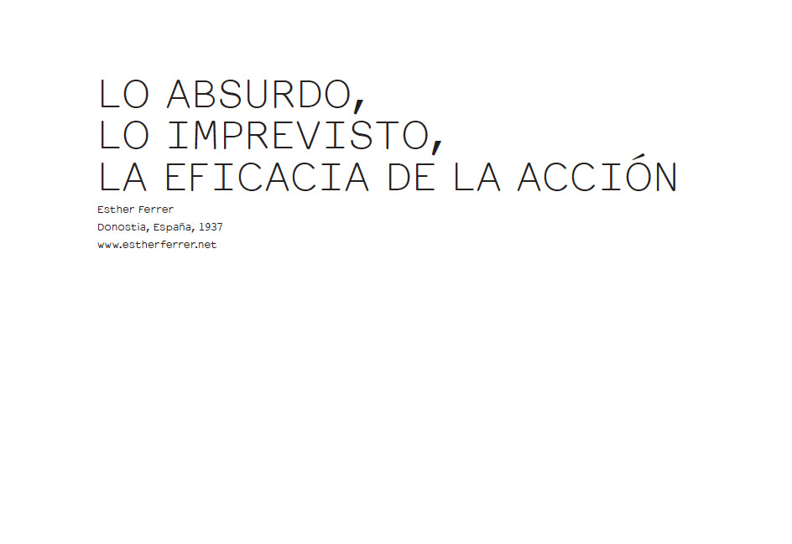
Errata # After decades of working in action and performance arts, how do you think the disruptive and confrontational nature of this creative format remains, in a context where it has been institutionalized, curated, historically and commercialized within the mainstream Of art? Does it survive today, or how has it mutated the transgressive and independent character that its precursors sought to give it, when it is incorporated as a new type of collectible or consumable object as a spectacle?
Esther Ferrer While the institution was not interested in the world of action, and it was the artists themselves who organized the meetings, festivals, etc., there was a time of great exaltation and true experimentation. There were no limits; in the artistic field everything was allowed. It was a different way of doing things, and this "shocked" the audience. I put these two words in quotation marks because I have never tried to provoke or shock anyone; the only thing I have always wanted to do is to do my work as sincerely and freely as possible. It would have struck or provoked, I did not consider it.
Little by little, the public accepted the world of action and became interested in this way of doing. When the institution "felt" that there was a public, it decided to take an interest in the world of action.
Things changed then: from being a nomadic art - as Jean Jacques Lebel says, "SDF", that is to say, without fixed address, because it was done everywhere, the street included -, the institution immediately "formatted" it. The institution is afraid of the street as it also has the possible accident, or the political message (in the best sense of the word, not the facade). You need to know what you are going to do, how long it will last, what spaces you are going to occupy and, what is worse, it is necessary to explain it to the public, because the institution believes that it is necessary to "educate" understand '. This means that everyone will understand the same in the same way, eliminating at a stroke all the interpretive wealth that a performance can generate. After the unique thought in politics,
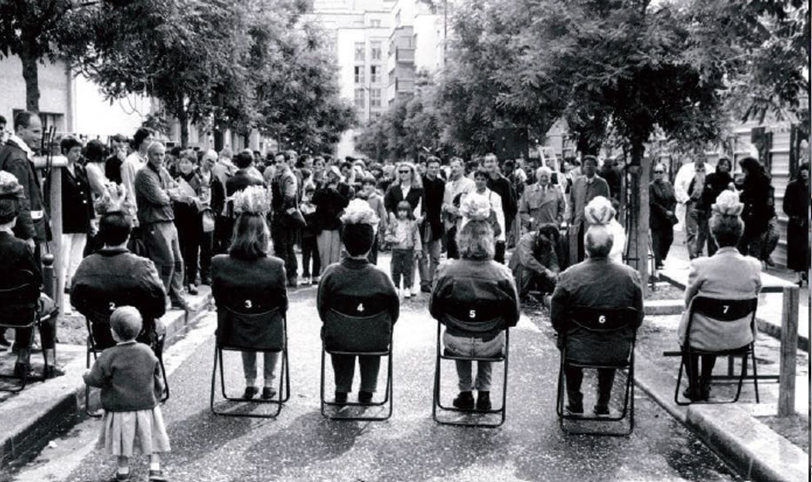
Esther Ferrer, Inauguration of Rue Marcel Duchamp, 1993. Paris XII Arrondissement. Photo: A. Szafran.
Then there is the phenomenon of fashion, of course, but that is a problem of artists.
# How do you perceive that the performance of the international art fairs is inserted today? How does it contribute or generate noise in the creation process or during the action, the presentation of the actions in that frame?
EF I refer to my previous answer. International fairs have gotten into the car because the performance and their "derivative products" have entered the market and sell well, and sometimes very well. When the world of action was understood as a "situation" that the artist proposed and developed as it unfolded, when there were neither photographers nor salable videos, the action was not interested in galleries, museums or institutions . Today there is a market for all this, and it is "exposed" and sold in the market that corresponds. Of course, in this case there is also a "type" of performances that interest and others do not.
I have never made a performance in this framework of international fairs. But I think if you agree to do it, you'll have to accept the rest as well. Personally I had to work only once with a terrible noise impossible to eliminate, and I have to say it was very painful, although I accepted it as one more circumstance. Anyway, if I had known before that there would be that noise, I would have thought of doing another action that needed another degree of concentration.
E # In today's trend towards performance focused on the LGBTI agenda or queer, post-consumer and other activism initiatives from the point of view of action, the balance has once again been turned towards a "committed" art with a "Message," a bit like feminism in the sixties and seventies, of which you were one of the protagonists. You have referred in the past to a tension between the discourse and the concept of performance: how do you see the conceptual solidity and formal decisions of the performers today, when the discourse is so preponderant?
EF Personally I do not think it is enough if a performance is inscribed in a queer , postporno, feminist or otherdynamics. It may be "politically correct," but "artistically null," which in my view is ineffective. I believe that in the case of a "committed" action it is better to be effective. The concept is the basis of action, the starting point, but then there is the "artistic" form.
And I put this word again in quotation marks, because I believe that the world of action has developed, among other things, new formal criteria that were previously not valid (they were marginal) but now are. As Restany wrote, "in art it is always the periphery that changes the center ", and there is no doubt that all these activist movements, in their artistic aspect, have renewed the artistic language and its discourse, by including in it subjects that were perfectly excluded (and when dealing with which were already) from a queer , postporno, etc. vision .
E # Thinking about the communication of the perfomer with the public and the capacity for real interaction, so sought today, you expressed in an interview with El País , about his action of throwing coins from a French franc to the spectators: "The work would have closed when, years later, the public threw me the same coins. But the euro came and the piece was unfinished. " With more than three decades of popularized performance, how do you see the ice that separates the actor from the viewer? ... Is it becoming more and more, becoming stronger, sometimes melting? In the end the spectators will throw the coins back, or it seems that we have to resign ourselves to a passive public, little less than indifferent?
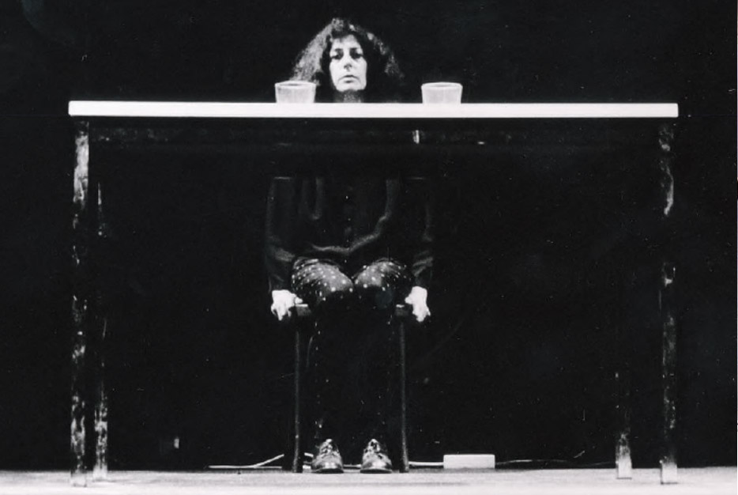
Esther Ferrer, To the rhythm of the tempo, 1983. Festival of Performances, Theater of the Bastille, Paris.
EF It is an action that I have never done again, but one day I think it is opportune to do it, of course I will, even if the first one is not finished and can not finish. I like to think this.
The public is currently passive for several reasons: the first, the television, the second, the performances in general are performed in an "artistic center" or are organized by him. Consequently, the whole world "understands" that it is a work of art and as such deserves "respect"; no one today is given the right to "answer" art, or anything. The third, they have become accustomed to seeing it, no longer surprises them. The fourth, more and more are performed in "theater situations", for example, with the illuminated performer and the public in the gloom; which means that the public accepts its role, behaves like a theatrical audience who knows they have to be passive and clap in the end. The fifth, the performance in the sixties tried to get as far away from "theatrical language" as possible; it was about making "truth", not about playing with "transposition". Nowadays he is getting closer to the theater; I have even seen performances where there are "characters", as in classical theater. The extremes come together, and more and more in the performance imposes "theatrical paraphernalia" with all that that entails. How can you make a street performance if you need lights, props, etc.? Also, if they are stolen, fatal problem! But when you do not need anything, or almost nothing, a glass, or a chair, or an ashtray, if they are stolen, nothing happens; that is everywhere. It should also be added that in the first case, so that they do not steal it, you have to put guards, private police or not, and thus we enter another terrain: everything must be under control, in this case, the police. The performance has become sedentarizado" with everything that this supposes for good or for bad.
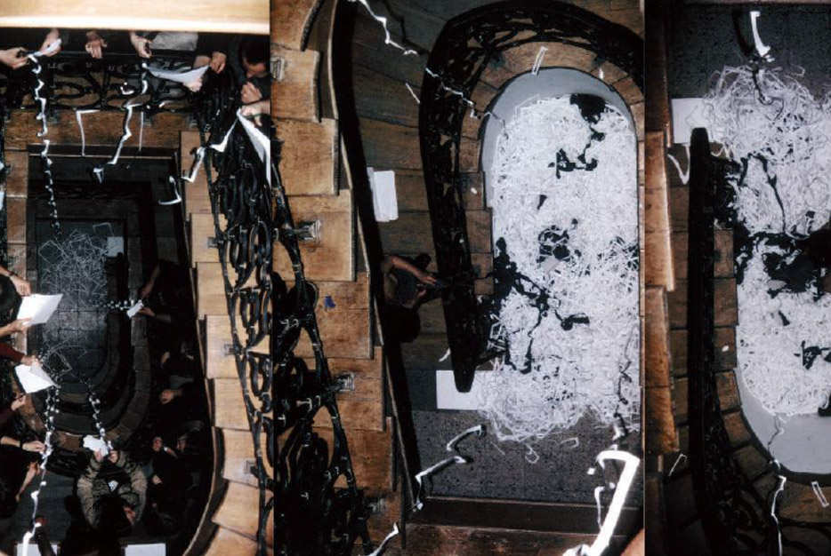
Esther Ferrer, Mallarmé reviewed or revised Malarmado - Tribute to John Cage, 1992. Georges Pompidou Cultural Center, Paris. Photo: PA Sonnolet.
E # And in this same direction, tell us a bit of ways in which the public appropriates the action or receives it ... In particular, in experimenting with the art of the absurd, at what point does the absurdity become more in the act comic, fun for those who look, blurring their power of criticism, their ability to move to reflection beyond the emotion that causes the gesture?
EF For the sake of the absurd, I can answer only for myself. I work a lot with the absurd, simply because this society seems absurd and sometimes I think, perhaps adding more absurd to the absurd will occur as a "vaccine" effect and I can understand something. Perhaps the public reacts in the same way. Anyway, I consider the adult public and able to interpret what they see using their freedom. I usually never think of the public when structuring an action; I do it only when the action is a reaction to a social fact (of any kind) and I want to protest because I need it. It's like a cry of protest. If I have a good idea to substantiate the action, my main concern is that those present understand the purpose of it. In these cases I sacrifice everything to efficiency, coherence
E # On the reactivation of his performance file in recent retrospective exhibitions, such as the one he had in Mexico, "Trans / actions" in 2007, or "The road is made by walking", in 2013 in Rennes, or how he personally felt this act of displaying the documents of practice, all this exercise of solidifying the ephemeral or "preserving" it hanging on the wall? To what extent do you consider that registration has become more important to the public than to witness the action?
EF For me the action is ephemeral, and what counts is the action the moment I do it, no matter what happens. It happens that now people or the institution makes videos, or photos; it did not happen before. Sometimes they give them to me, many do not. For me, photos, videos, etc., are only documentation, a very "castrated" documentation, because what is important of the action, is that tension, that communication or not, that occurs between the performer and the public, That is not seen in the photo. What happens is that we live in the age of documentation and often people prefer to watch the video of the action (is more comfortable) than the action itself, but in this also the artists have a great responsibility.
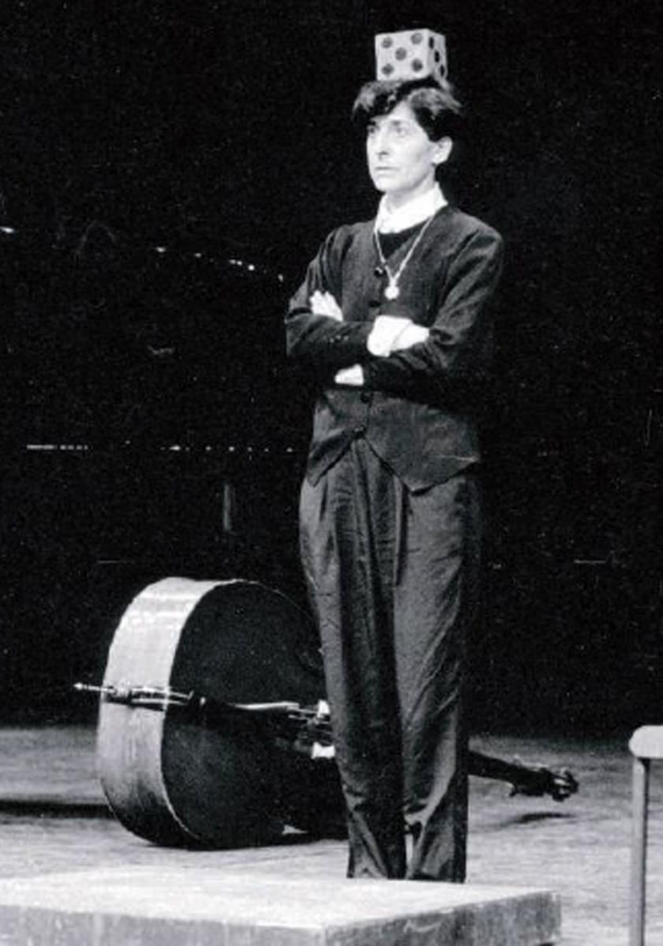
Esther Ferrer, Give time to time, 2000. Gallery Arsenal, Byalistok, Poland. Photo: Arsenal Gallery.
The "entertainment society" has evolved towards the society of the television spectacle. If this is the case, why not see it on television, and what if the spectacle, seen in these conditions (good or bad), is "dissected", deprived of its first vitality. All this fades into art; why go to see a performance if you can see the video, better and closer. A consequence of all this is also that many performances are made only to be recorded on video, and everything is aimed at getting a good image effect, whether public or not. Anyway, at the origin of the world of action, artists recorded them in their studio (the action only had this format), but I have the feeling that in these cases the concept of "spectacularity" was privileged;
E # Within his artistic practice has defined performance as a matter of space, presence and time. In front of the Mac / Val exhibition last year, you said that your only commitment, if any, is as a person and not as an artist: "I am a person who defends what he defends: a certain idea of ​​society, things that interest me in my daily life, and my everyday life comprises art. " In this sense, his work does not seek to "bring art to life", as is often understood the practice of performance. After so many years, does it still maintain that definition of the initial performance? Or do you think that with the evolution of this practice something has mutated or has registered some essential displacement?
EF I do not need to bring art to life, because arteforma has always been part of my life. These phrases so brought and carried rarely tell me something.
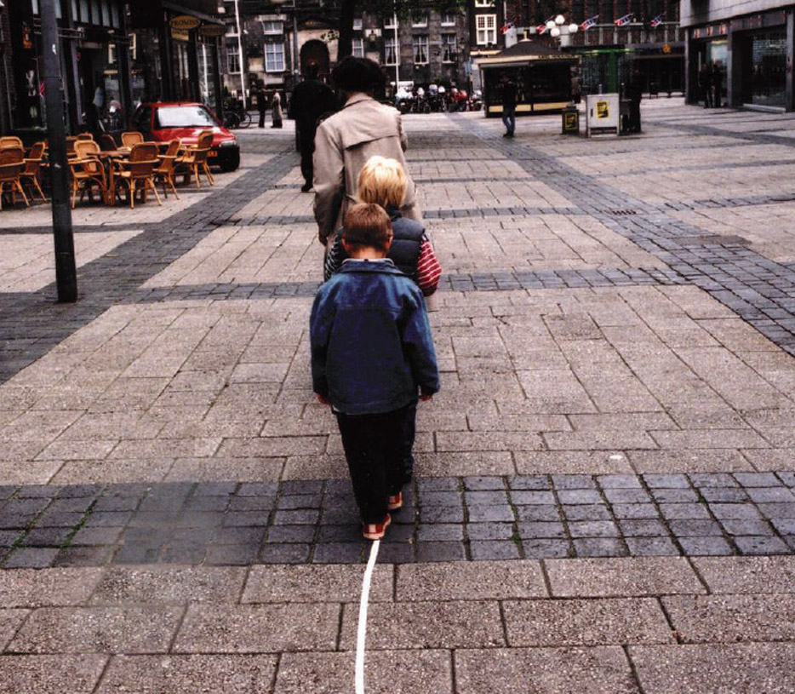
Esther Ferrer, Le chemin se fait en marchant, 2002. Festival Street Level - Hertogensbosch, The Netherlands. Photo: Allard Willense.
What I say sometimes is that if the performance is not "crossed" by life, it is nothing. What does this mean? For if we do not create a situation in which the "accident", that is, the unforeseen, is possible, we deprive the action of its fundamental element. I always say, "I know how I'm going to start an action, but I do not know how I'm going to finish it." Precisely, because I do not know what can happen, and in any case, I want to be open to any eventuality. Everything that happens, for better or worse, will be part of the action. As for the definition, I do believe that it is the art of time, space and presence, like many other forms of expression, only that in performance they are combined in one way, and in the installation, in another. Sometimes I compare it with water: its formula is always H2O,
E # Lately, among the many evidences of augede performance is its entry into the academic curricula of art schools. Do you think it is possible to "teach" performance? Do you think it is desirable that he enter into systematizing his genealogies, his practices, his history, etc., to become an academic discipline and field?
EF This is an interesting question. I have nothing against, but I always wonder what they teach for a whole year, what is the content of these courses. I suppose they analyze the different "types" of performances, etcetera. For which they have turned it into a "genre" more. A consequence of this is, of course, a certain uniformity in the result.
I personally defend the idea of ​​an "unclassifiable" form of expression, which accepts all definitions as valid. When I do a seminar, I do not teach performance at all; I never pass videos of anyone, especially, not mine, nor do I present catalogs, etc. Performance is not taught, but practiced, is the fundamental idea. What I simply intend is that at the end of the seminar the participants will know if it is a form of expression that goes to them or not, and if they choose it as their means of expression, that they themselves decide how to do it.
I start from the idea that performance is the most democratic art there is; you do not need anything to do it alone, feel like doing it. From there, if you need a technique, a discipline, a definition and a theory, then you create them yourself.
Oh, but this has many risks, they tell me sometimes. Among others, that put in the bag of performances anything, and that there are very bad performances. Well, so what, or is it that there are no bad movies, horrible pictures, unbearable sculptures and null poems, that we see and hear in museums? I insist: the fundamental question is the artist's own responsibility, how his creation lives, what other "interests" lead him to perform, and so on.

