
ACTIONS, PERFORMANCES AND ATTITUDES IN CUBAN CONTEMPORARY ART
Author:
Nelson Herrera Ysla
Edition:
ERRATA # 15: PERFORMANCE, ACTIONS AND ACTIVISM
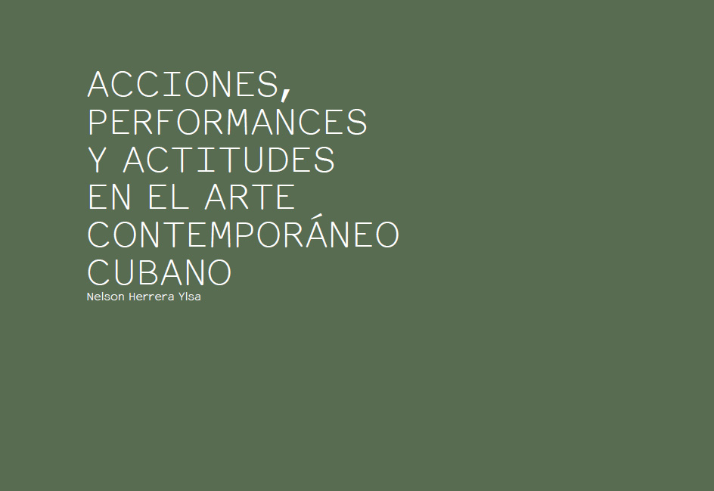

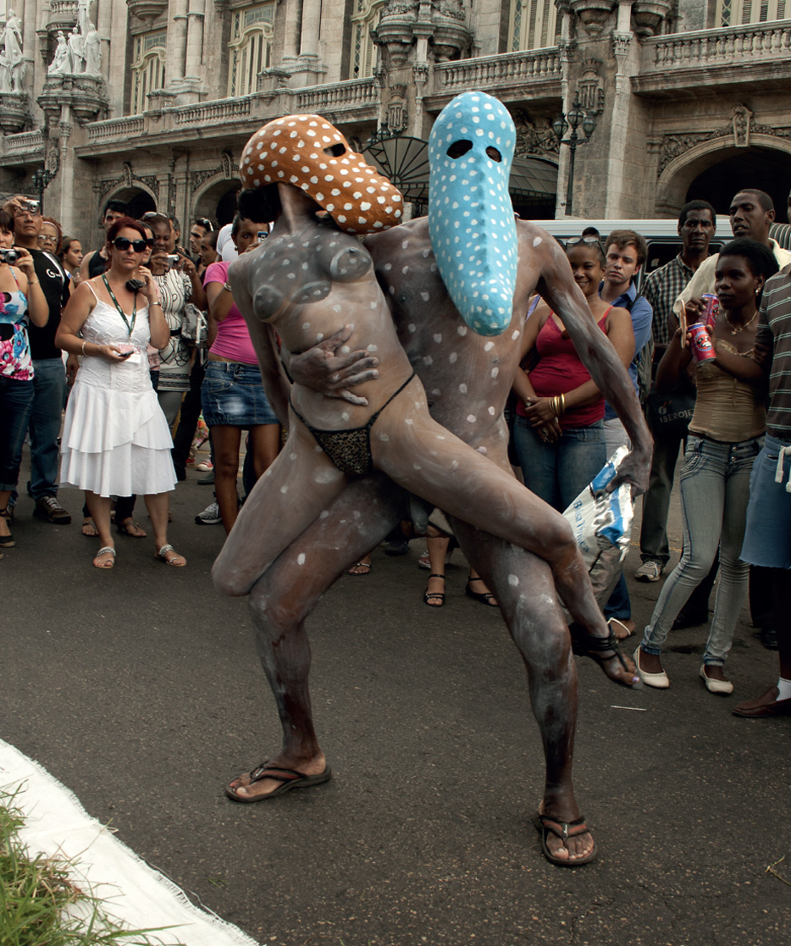
Manuel Mendive, Las cabezas, 2012. Street performances at the 11th Havana Biennial.
Photo: courtesy of the Havana Biennial.
The Cuban artistic scene has been strong for several decades, due, among other reasons, to its links with the cultural, social and political contexts in which it unfolds; and especially since the 1980s, when a group of young artists reformulated the codes, formats, supports, languages ​​and traditional actions of the aesthetic avant-gardes both in Cuba and in other parts of the world and emphasized in one new attitude towards the creation and the system of art as a whole.
A radical new attitude arose mainly from inside the classrooms of the Higher Institute of Art (ISA) in Havana, led by professors eager to change the status quo in art education and in the institutional system of art in general. This attitude influenced the relations that the artists maintained with galleries, museums and events, by modifying in a sensible way the content of the works, as well as their mechanisms of exhibition, promotion and circulation, bringing them closer to the most diverse segments of the public. For the first time, it can be affirmed, artists began to perform performances and interventions on a large scale in both closed and public institutional spaces, in streets and squares, in a way that had not happened before in Cuban art (with exceptions during the decade of 1960,
An important cause of such transformations is the fact that Cuban society experienced dramatic moments since 1980 due to the massive exodus of citizens to the United States in rafts and boats of all kinds; something that removed sensitivities, affections, feelings, ideology and politics in each citizen and family, highlighting serious cracks in the apparent homogeneity and unity of Cuban civil society. At the same time, over the course of the decade, we experienced the changes unleashed by policies known as Perestroika and Glasnost, which established the Soviet Union (then our "real" political ally and main supplier of equipment, oil and technologies), which would culminate with the dismantling of that state, then multinational, and bring it closer to a market economy that has put an end to the socialist and communist postulates assumed for more than seventy years. This, as we know, produced a colossal schism throughout the socialist camp of Europe and its effects were felt in those societies especially in the fields of culture and intellectuality, in their artists and expressions, to the point of forming a new economic map , moral and political. Those airs arrived also to Cuba, despite the enormous distance that separates us and that the context here was different (although at the same time similar in many respects). produced a colossal schism throughout the socialist camp of Europe and its effects were felt in those societies especially in the fields of culture and intellectuality, in their artists and expressions, to the point of forming a new economic, moral and political map. Those airs arrived also to Cuba, despite the enormous distance that separates us and that the context here was different (although at the same time similar in many respects). produced a colossal schism throughout the socialist camp of Europe and its effects were felt in those societies especially in the fields of culture and intellectuality, in their artists and expressions, to the point of forming a new economic, moral and political map. Those airs arrived also to Cuba, despite the enormous distance that separates us and that the context here was different (although at the same time similar in many respects).
The young Cuban creators, interested in changing the world (or specifically that world), took part of these influences in all aspects of their lives, while reevaluating the ideas of Joseph Beuys, of Viennese actionism, of art, of art, of art conceptual North American, of the Italian transvanguardia and other postmodern postulants in vogue. They were interested in the practices of Joseph Borofsky, Keith Haring, and Francesco Clemente - reading them into the Cuban context of that time, "nationalizing" many of them - and by the most advanced aesthetic thinking in Europe, which somewhat belatedly reached our shores.
Several factors contributed to the birth and rise of an artistic movement that revolutionized the main scenarios where it operated to publicize a new Cuban art in the Western Hemisphere. The most important works and actions were carried out in Havana, but there were also, to a lesser extent, other cities on the island. A transparent, bold and ambitious atmosphere was created in almost all the art system, especially in the institutions that supported, from the Ministry of Culture itself, such a movement. The first signs of performance that originated within this trend were those made by Leandro Soto in his native Cienfuegos, first in the street with cans of soda and beer, and then with ropes. Later, a group of young artists (Rogelio López Marín, Gustavo Pérez Monzón, Juan Francisco Elso and Leandro Soto) was summoned to fight and criticize the neutron bomb (that in those years appeared with force in the international scene like a sword of Damocles); and they did it in a park in Havana, painting flower maps on their walls, with epic gestures on top of statues nestled in the surroundings and with signatures of the participating public on the floor.
In the face of international confrontation, the Havana Biennial - whose first edition dates back to 1984 - served as an extraordinary platform to promote these changes that had been taking place in the Cuban art scene. The Biennial brought together artists and experts from many parts of the world interested in interacting with Cuban creators and their institutions, knowing that something "new" was happening in this small country: the huge showcase that the event meant enriched the debate and the artistic practices that then appeared in all areas. His contribution was ultimately decisive for the consolidation, maturity and promotion of such a movement, of specific artists and new attitudes.
The performances that began to proliferate in the decade took into account the diversity of the daily and general problems faced by the ordinary citizen in many aspects of his life. Some were located in the conventional spaces of galleries, museums and educational institutions, and the least in open squares of the city, walls or streets. In them the public did not intervene directly, it was not yet actively involved: it was the artists themselves who assumed the leading role, watched closely by passersby.
The group Puré (1986-1987), made up of five ISA students - Adriano Buergo, Ana Albertina Delgado, Ciro Quintana, Lázaro Saavedra and Ermy Taño - was one of the most active in this sense, as they attacked almost everything established : the national symbols, the prevailing ideology, the centralized economy; and they did so on the level of artistic teaching rather than the media, and irreverently, provocatively and tenaciously, making every exhibition or action a controversial, controversial event.
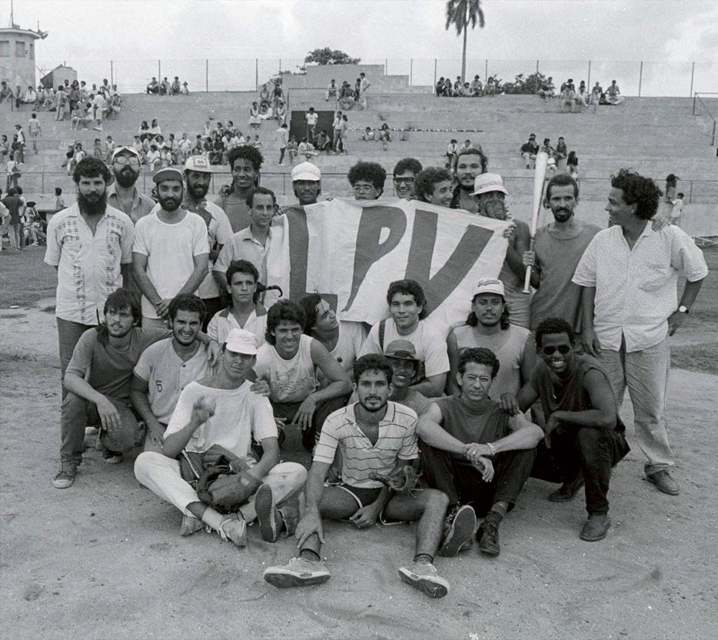
Ball game, September 24, 1989 (LPV: Ready to Beat). «In 1989, the peak of the censorship crisis, more or less all the artists came together to suspend their work. They declared, "If we can not produce art, we play ball". This act is still considered the highest point of the poetics and politics of the new Cuban art »Rachel Weiss. Photo: José Alberto Figueroa.
The group Arte Calle, which included nine young artists from various educational backgrounds (Aldo Menéndez López, Pedro Vizcaíno, Eric Gómez, Offil Hechavarría, Ernesto Leal, Ariel Serrano, Iván Álvarez, Leandro Martínez and Hugo Azcuy). interventionism in streets and walls of Havana. Arte Calle had actions in a frankly contested and dynamic attitude - many times quick to circumvent or avoid any censorship - for two years (1986-1988). They came to question, in a provocative and astonishing way, the inauguration in Havana of the great retrospective of Robert Rauschenberg, at the National Museum of Fine Arts (1988), considered one of the most outstanding in the national panorama.
To do this, some of them dressed in American Indians, dancing and making sounds around the American artist, who did not understand what was happening, perhaps excited by his gigantic project Roci ( Rauschenberg Overseas Cultural Interchange ), presented this time in the Cuban capital. The "Fazer" project, led by Abdel Hernández and also of short duration (1988-1991), managed to bring together eleven creators (at different stages of their existence and among those who were
a journalist, a musician and a designer) to carry out interdisciplinary actions; actions that allowed a new type of dialogue with the art institution from a socially functional artistic practice that integrated not only artists but professionals "doers". Interested in the links with certain social communities, this project required studies and specific investigations and more time of execution than the proposals of the previous groups, reason why they could only carry out few actions before dissolving.
It is in 1988 when Tania Bruguera, in the midst of turbulent times, made her first performance based on the work of Ana Mendieta (disappeared years before) entitled Body traces , as Mendieta had done; a performance that Brugueraretomaría several times until 1993, first as a student and then already graduated from the ISA. In 1994 she was invited to the 5th Havana Biennial, in which she made another long-term performance (more than six hours), Miedo , where she referred to the dramatic migrations by sea from the Cuban coasts and gave way, to a sustained trajectory in this artistic practice that has placed it at a certain level of recognition both in Cuba and in several countries of Europe and the United States.
His most well-known performance is likely to be Tatlin's whisper (2009) during the tenth Biennial of Havana, which consisted of activating an ornate stage in the manner of traditional Cuban political congresses, through a podium with a microphone so that anyone of the audience, concentrated in the courtyard of the Center of Contemporary Art Wifredo Lam, said there what he thought about any subject or subject of his interest, each for a minute.
In order to organize the short speech of each spontaneous participant, two young men in uniforms watched behind him for strict compliance with the established time limit, without the intervention of the artist.
The colophon of a decade as controversial as that of the eighties was undoubtedly an interesting performance in Cuban art, known as the Ballgame or The artists of plastic are engaged in baseball (1989), carried out by a series young creators on a sports ground in the luxurious neighborhood of El Vedado as a symbol of their farewell and collective disagreement with official institutions, before the turn taken by the Cuban society and politics of then. A real, if somewhat incredible, ball game between almost twenty artists ₁(and critics invited to participate) dressed with music in the stands, closed for the members of that intense movement one of the most controversial, emotional and vivifying periods of the Cuban scene of the second half of the century. Much fun, humor and winks to the audience made up that action that many do not remember anymore. The institutional exhibition, however, resulted in the collective exhibition "El esculturado" (The Sculpted Object) (1990) at the recently inaugurated Visual Arts Development Center in the heart of Old Havana and the opening night of René Francisco Rodríguez, William Carmona and Offill Hechavarría performed performances of simple invoice and purposes in the ground floor of the building, until Angel Delgado defecated on the most important Cuban official newspaper in the center of one of the rooms and in plain view of the public. A few days later, the exhibition was closed, and the Director of Plastic Arts of the Ministry of Culture was removed from office, which she later reached the vice minister, who had these cultural expressions under her area of ​​interest and work. In the national scene, both actions meant a decided change of direction in the artistic practices in the country, led to a rearticulation of the policies of promotion and development of the institutions and created the ideal climate for the exile of the majority of the main protagonists of the movement. A few days later, the exhibition was closed, and the Director of Plastic Arts of the Ministry of Culture was removed from office, which she later reached the vice minister, who had these cultural expressions under her area of ​​interest and work. In the national scene, both actions meant a decided change of direction in the artistic practices in the country, led to a rearticulation of the policies of promotion and development of the institutions and created the ideal climate for the exile of the majority of the main protagonists of the movement. A few days later, the exhibition was closed, and the Director of Plastic Arts of the Ministry of Culture was removed from office, which she later reached the vice minister, who had these cultural expressions under her area of ​​interest and work. In the national scene, both actions meant a decided change of direction in the artistic practices in the country, led to a rearticulation of the policies of promotion and development of the institutions and created the ideal climate for the exile of the majority of the main protagonists of the movement.
During the nineties the performance was concentrated, in the individual, in the work of Tania Bruguera and Manuel Mendive. Other young artists of those years, however, preferred to channel their proposals into different expressions, seeking transcendent aesthetic formalizations, placing greater emphasis on the craft and forms, especially in the fields decidedly on the international stage with their performances Daedalus or the Empire of the salvation (1995), What corresponds to me (1995), Tears of transit(1996), The weight of the fault (1997) and The body of the silence(1999), among others; which would then be reproduced by the artist in Cubay United States, England, Venezuela, Guatemala, Belgium and South Korea. However, it was Mendive who tilted the balance back to the collective and the community, performing performances with groups of actors, dancers and musicians, and using scripts that took into account the participation of animals, objects and part of the audience. Almost all of their actions took place in open spaces (squares, parks, streets), and some ended up in closed spaces such as galleries, museums, or art centers. Based on the deep knowledge of the popular traditions of African origin, especially the religious ones, he took the performance to the street, in search of the people and of an environment close to the spectacle and the exaltation of the body. Nobody remained indifferent to this "relationship" inscribed in the best Cuban traditions and that much owed also to the notion of carnival present in our Caribbean islands since colonial times.
Maldive, like no other, occupied Havana stages thanks to his participation in the Havana Biennials. In the second edition of the event (1986), he performed at the National Museum of Fine Arts what could be considered the first performance in contemporary Cuban art devised from beginning to end, using dancers dancing between bunches of bananas to the rhythm of Afro- invocation of gods and exaltation of mythologies. His visceral religiosity allowed him to integrate a sense of worship and festivity, of enjoyment and reflection, which he managed to maintain in the nineties and to continue at the beginning of the twenty-first century.
The great event that represented the Biennial of Havana undoubtedly put in contact with several Cuban artists with artistic practices made by guest creators of diverse backgrounds linked to performance, happening and actions. From the first editions to the last ones, artists and collectives from different parts of the world have contributed to the understanding of this phenomenon in Cuba. ₂Each of them contributed ideas about the territories through which the performance, actions and happenings have passed since the sixties, bringing to light the contaminations and loans between them. The Havana Biennial opened doors and windows to these theoretical and practical complexities without distinction or hierarchies, although some more than others occupied significant plans of attention in the public; among them, the consolidation in the Cuban scene of the idea that it is not necessary the presence of the body of the artist as an indispensable element for the performance of performances, since from that same body are derived actions that lead us by new and unknown ways towards that notion today so relieved of "art of action".
The untranslatability of the term "performance" sometimes creates logical misunderstandings in other languages, which however do not hinder its development and implementation in our Spanish or Portuguese speaking countries. It is now that the arts of action are reinstalled in some of the territories of Latin America and the Caribbean, I say "reinstall", since it is known that from pre-Hispanic times our great cultures and civilizations operate according to rituals as deep as their own origin. From contemporary codes and languages, several artists and groups have opted for performative attitudes according to participatory rather than contemplative discourses, a distinction that has in Regina José Galindo, the collective Quintapata, the group Bijarí, the group Opivivará, Sandra Monterroso, Humberto Vélez , The Tannery, Public Wives, Eduardo Pérez Karmadavis, Nelson González, Steve Bauras, Francisca Benítez, Tamara Cubas, César Cornejo, Manuel Santana, the collective Eighth Plastic, Lázaro Saavedra and Solid State to some of its main protagonists; each of which advances with multiple proposals by dissimilar routes, at times difficult to classify.
It was quite significant at the beginning of the 21st century that the Enema collective in Havana (Fabian Peña, Adriano Soca, Lino Fernández, Pavel Acosta, Edgar Echavarría, David Beltran, Alejandro Cordobés, Janler Méndez, Nadiezdha Inda, Zhenia Couso, Hanoi Pérez , Robert Quintana, James Bonachea and Lázaro Saavedra) within the Superior Institute of Art. Its denomination arose from the magazine of the same name founded by students of the second course, and the collective, in which the conduction of the artist and professor Lázaro Saavedra excelled, started from a critical attitude towards almost all the estates of the art institution. They especially questioned the artists seduced by a volatile art market that loomed on the Cuban scene from fleeting visits by collectors, gallerists and foreign dealers on the island. Various performances and actions where the individual dissolved within the collective creative space gave Enema relevance: each release of a new issue of the magazine was used to carry out its actions and performances; as was the case with invitations to participate in events such as the Biennial of Havana (7th and 8th, 2000 and 2003), "La huella múltiple" (2002) and "Romerías de Mayo" (the latter in city ​​of Holguin, to the east of the country, in 2001). Faced with the notable lack of material resources to bring his proposals to a successful conclusion, Enema members came to his body as a primordial and basic support: they performed street parades, for example; or, wearing dissimilar costumes, its members lay on the grass of the ISA sunbathing in order to burn their skin with a specific letter each allowing the final reading of a sentence when all stand. In other actions they remained hung upside down, suspended from a metal structure, or danced half-knots in short skirts to the beat of wooden flip-flops. Music, cigarettes, food dishes and little makeup were enough to carry out projects irreverent, aggressive, uncomfortable, able to disturb the viewers. The group questioned everything or almost everything from the academy and its weak teaching programs to the cultural policies emanating from official institutions.
The essential critical position of Enema influenced the formation of other artists and groups of the Cuban scene, although some had very own characteristics, such as DUPP (From A Pedagogical Pragmatics). This collective was led by the artist and professor René Francisco Rodríguez, and although founded also in the classrooms of ISA in 1997 (its original projection dates from 1989 with a similar name, it is worth saying), it leaned more towards what would later be known as 'Relational aesthetics'. DUPP was composed of students of several courses of the Faculty of Plastic Arts; together they held shares in Havana's commercial stores and in colonial buildings populated by low-income families, supported by their lively relationships with these immediate surroundings. The purpose of the actions was to improve or to transform these places occasionally, based on a mutual experience between subject and artistic object. As a ductile group in its structure, DUPP contributed to the formation of several of the contemporary Cuban artists recognized inside and outside the country (Wilfredo Prieto, Ivan Capote, Yoan Capote, Glenda Leon, Humberto Díaz, Grethel Rasúa, among others) this type of pedagogical practice as a platform for the improvement of artistic education programs, as did Enema.
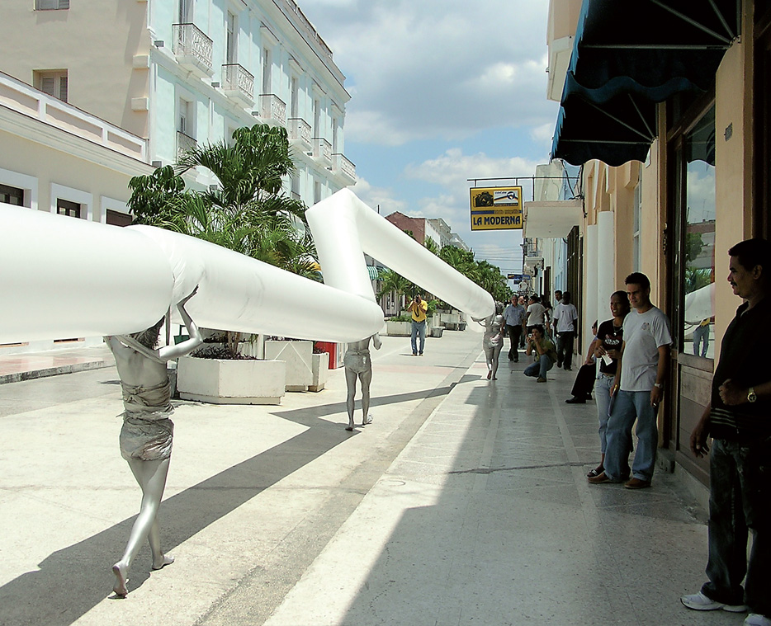
Among all, 2007. Collective action led by Lisvany García and Daymara Alonso in several streets of Cienfuegos, Cuba.
In those moments, the Department of Public Interventions (DIP), organized by the artist and professor Ruslán Torres with a diversity of students and of very short duration, also appeared in the ISA. a group that was directed to carry out actions in urban environments that culminated in its invitation to participate in the 8th Havana Biennial in 2003. The DIP had an organizing committee (Ruslán Torres, Fidel Álvarez, Analía Amaya, Douglas Argüelles, Abel Barreto, Humberto Díaz, Heidi García, Tatiana Mesa, María Victoria Portelles and Jorge Wellesley) and a group of collaborators. Collectively they took places and parks in various cities of the country to perform actions and performances, and in them soon excelled some of its members by a high degree of imagination and audacity, especially Humberto Díaz.
After these collective experiences was born in 2003, under the guidance of Bruguera, the Chair of Conduct Art in the same faculty of ISA; a pedagogical project that had the purpose of leading students towards a greater individual reflection on their role in culture and society, as free men and women who are or should become; "A space of discussion and generator of works with a social character where their condition of art was not the important thing", according to its manager. Through workshops given by experts from Cuba and other parts of the world, ₃ the young artists were working on an exhibition to be held at the end of each academic semester. In this way, they tested their ideas, corroborated or questioned the validity of what was learned, proposed new avenues of expression that resulted in performatic, installation, object, audiovisual, or simply in actions capable of involving different people each time a new attitude to the creative fact). The result of his sustained work was evidenced by the invitations to participate in the Gwanju Biennial in 2008 and in the 10th Biennial of Havana in 2009, this last time with daily presentations of his career in a gallery. The Chair lasted six years during which more than twenty exhibitions and presentations were held, most of them in Cuba. ₄The freedom to choose their own expressive means, their paths to follow, deepened in the students and in the Cuban scenario. This unique and singular pedagogical experience, which sought to recognize traditions in Cuban art and at the same time to be structured from the critical analysis, was thus linked to previous efforts with a very special tone and characteristics, without any ties of any kind, by focusing on the behavior of the individual in the midst of a specific social and political context.
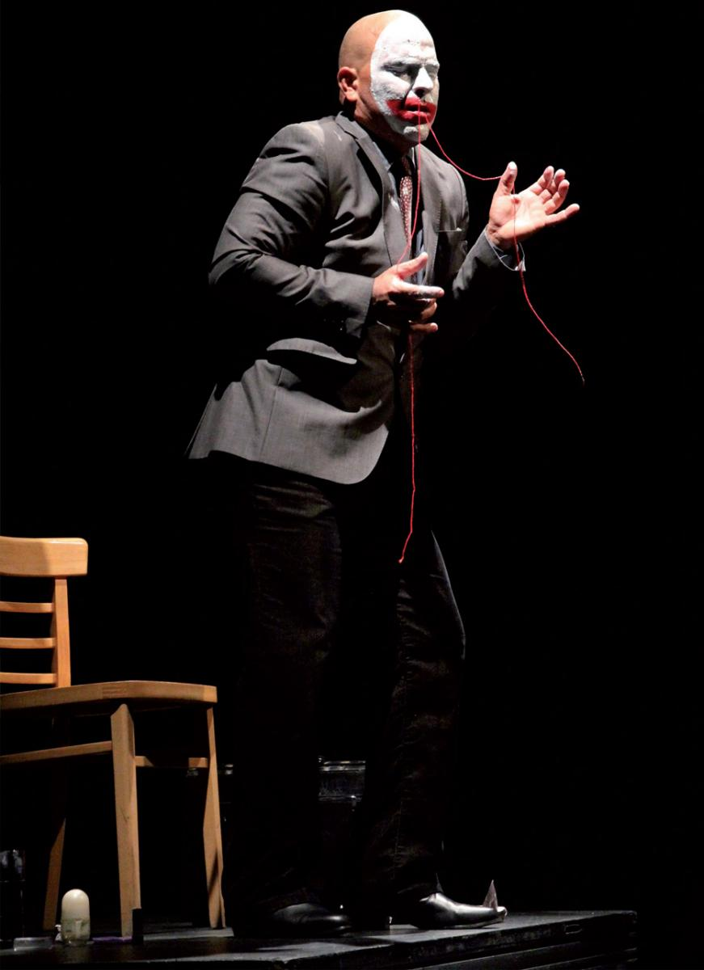
Mayim-B (José Miguel Díaz Pérez), Untitled. 2014. International Rencontre d'art performance de Québec. Photo: Francis O'Shaughnessy.
At the same time, the group 609, formed by Amarilys González, Yailin González, Anahis Martínez, Yanna Palomino and Aida Serrantes, also students of the ISA, came up in 2002 to reflect fundamentally on gender issues in a frank and contentious attitude. Although their best-known performance, Strip-piss (2001) took place at the ISA, they performed in various institutional spaces in Havana and other cities in Cuba, such as Cienfuegos, or Camagüey, where the action conceived as performance-protest was censored - when presented later in Matanzas, it was worth the prize of the festival. Short-lived, the group disbanded the following year.
In the city of Cienfuegos, in the south of the island, the Performance Days were held, organized by young artists, who for four days were attended by artists from all over the country. Only two editions of these days were achieved (2000 and 2001). Afterwards, Santiago Hermes proposes years later to investigate the African heritage in that city (founded by French in the eighteenth century) to highlight the role of slaves in the sugar production of the region and all their cultural legacy hitherto depredated , undervalued: his studies and research in this field have allowed him to sustain a more elaborate discourse as a performer, in which it includes actors, musicians and a wide participation of the public. Of this, Hermes has managed to awaken consciences about this legitimate legacy of Cuba, activating microhistorias and microses previously relegated to oblivion.
At the same time, in Santa Clara, another city towards the center of the island, the Vortex group was created, composed of several young people who intervened in public spaces with disguises of historical characters covered in reddish mud while they remained static for several minutes, then changed of positions, such as known living statues or mime statues, but rather seeking to generate visual impacts, break into the daily routine and the social environment, and interact with the people around them.
There are also other Performance Days in San Jose de las Lajas, east of Havana, guided by young artists who sought to enhance and deepen the expression, sometimes guided to the ecological by its relationship with the sea, as has happened several times . From another perspective, the painter Manuel López Oliva has since 2009 complicated the practice of performance in the country through the use of actresses and video projections in theatrical stages. Hence his known combinational performance (2009) and Mascaronte(2012, which also incorporates scaffolding, piano and dancers of the Rosario Cárdenas dance group), actions focused on deepening areas of its vast pictorial production and reformulating concepts of integration between various aesthetic disciplines. Also the artist Zayda del Rio, later in that decade, entered the field of per-formance, assisted by dancers in Havana theaters, in a sort of recreation of their imaginaries and artistic discourses. Osneldo García, a kinetic sculptor in essence, has developed a work with dancers parallel to his daily work, in an attempt to introduce the concept of performance in the sculptural from the end of the nineties: elastic fabrics framed in walls and large panels have served of ductile frames for the dancers to project their bodies out,
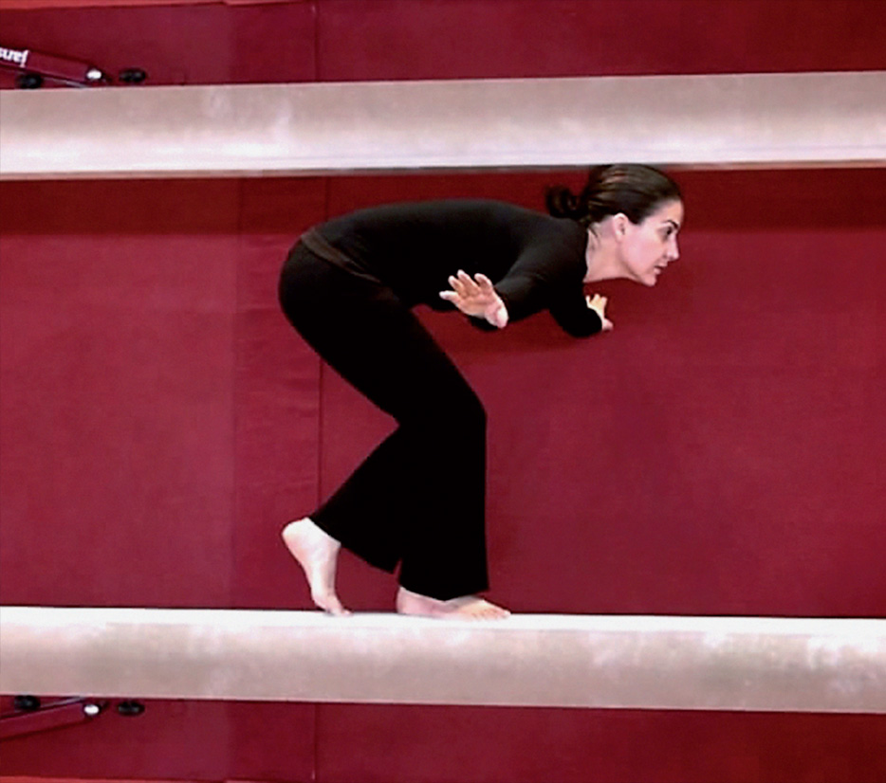
Marianela Orozco, Equilibrio, 2008-2010. Video-performance, 3'15 ''. National Gymnastics School, Havana. Photo: courtesy of the artist.
As we can see, artists recognized in the field of contemporary Cuban art (active since the sixties of the twentieth century) have been seduced by the poetic possibilities of performance and plastic action, even though none of the last three practice it in a systematic way . They handle the codes of perfor-mance art , as it has been understood in the West: a mixture of elements of theater, music and the visual arts, based on careful ideation and programming, and without the artist becoming an active part of it difference of happening, which is more sustained in the spontaneous, since Allan Kaprow coined the term in 1959. All these possibilities intersect, as I said above, and are related to what is known as relational aesthetics (to which Nicholas Bourriaud dedicated a small book years ago), since in general all start from "relations" ... either between disciplines, between creators, or between the spectator and the public; either manifest themselves in enclosed or open spaces. Hybridization is such that it is no longer easy to identify each of these expressions absolutely, even though they keep a central structure alive.
Now, it could be said that it is the young artists who carry these expressions forward in Cuba. While the group spirit is almost extinct in contemporary Cuban practices, the individual artist has become more aware of the role of his actions in front of the public and in the most diverse circumstances. Interested in these new modalities are Jeannette Chavez, Carlos Martiel, Susana Pilar Delahante, Grethel Rasúa, Dennys Izquierdo, Orestes Hernández, and several ISA students. And there are those who have concentrated mostly on these performance developments, such as the artists I present below.
José Miguel Díaz Pérez, Mayim-b , after completing his studies at the ISA, develops his work in the city of Pinar del Río, the westernmost of the Cuban provinces, since 2002. There he initially organized a performance workshop with pedagogical nature, until two years later decided to work only
the subject of the body and, especially, the concept of the flesh. Its fundamental language is its own body, but also that of the pig, whose parts it uses as grammatical elements of a certain symbolic discourse. In public parks and squares, he distributes to the public pieces of pork cooked by himself, and urges the spectator to reflect on the notion of the "sin of the flesh", so helped in the cultures of Judeo-Christian tradition (flesh attached to sex when it comes to the naked, and the negative image held by dogmatic believers), and based on the fact that the pig is seen as a cursed animal, unclean, disgusting, harmful to body and spirit. Mayim-b reverses that notion and locates it in its local economic, social or political context as necessary, practical, fundamental for human life in Cuba, as it is the most recognized (and perhaps the only) animal protein that Cubans have had for several years to sustain their precarious diet. Accompanied by wine as a drink, his performances last almost an hour before an audience that goes to observe and take part in an action that has both art and "utility." From 2010, his proposals have turned towards a more intense reflection between the carnal, the corporeal, the alimentary and the political. Sometimes accompanied by the national anthem of Cuba at the beginning of each performance, to end with the chords of one of the hymns of the working class of the twentieth century, "The International". The incorporation of soundtracks of different types is important in each performance and in some of them has used, even, fragments of speeches by Cuban revolutionary leaders from the second half of the twentieth century. In 2007 Mayim-b was invited for the first time to Québec as part of an exchange program between that city and Havana. In this and in Chicoutimi he makes two long-lasting performances following the same principles about meat.₅
Marianela Orozco had been released in 2003 with photographic documents of processes that included animals such as pigeons, ants and flies in order to reflect on the passage of time, physical limits and basic necessities for life. It is in 2004, in Kitchener, Canada, it takes a turn and decides to take advantage of certain structures of public services (telephone booths, restrooms, elevators) to produce a more participatory and interactive work that facilitates to the people the action, like for example shouting, thus contributing to the alleviation of individual tensions. In the same city, the following year, in an equally participatory action, he built in a park a modest wooden kiosk to sell land in small bags, just as if they were supermarket products. Between that year and 2008,Enchantment , in which it created the illusion of having fumigated Havana with perfume using a small plane, crossing its main neighborhoods. Additionally, he produced other public works in public parks in the city, as well as videos. In 2009 he performed his performance Way, in Montreal, consisting of walking in underwear in a public place of the city on a carpet of forty meters in length that later served to cover her body as a huge dress (finished the action, lay for a while on the floor wrapped in the big carpet). Between 2008 and 2013, his digital photographs document disturbing actions with his own body (hands, feet, pubis), which has been a key element in his career to create aesthetic discourses around punishment, desires and sin. In his impressions the body remains lying on the ground, subject to the action of mosses that completely cover it after a certain time; is submerged in the water until leaving only a part uncovered in the surface; or Dream Directed(in the Riap of 2014) is manipulated by a professional puppeteer who dominates his limbs and gives them movement with strings stretched from the ceiling, while the artist sleeps for hours in a bed. Orozco challenged the limits created by the man when developing a performance in which he lay down and was tied to a fixed point in the floor by means of a rope: from the floor he drew with his hand a circle until the distance that allowed the size of the rope. In a few minutes he defined his territory, its borders, its limits: once the circumference had ended, the per-formance, lasting only a few minutes, was over. In Victoriaville, she performed another action, this time drawing on the square floor around her, while the artist remained crouched in only one position. Each time one finished,
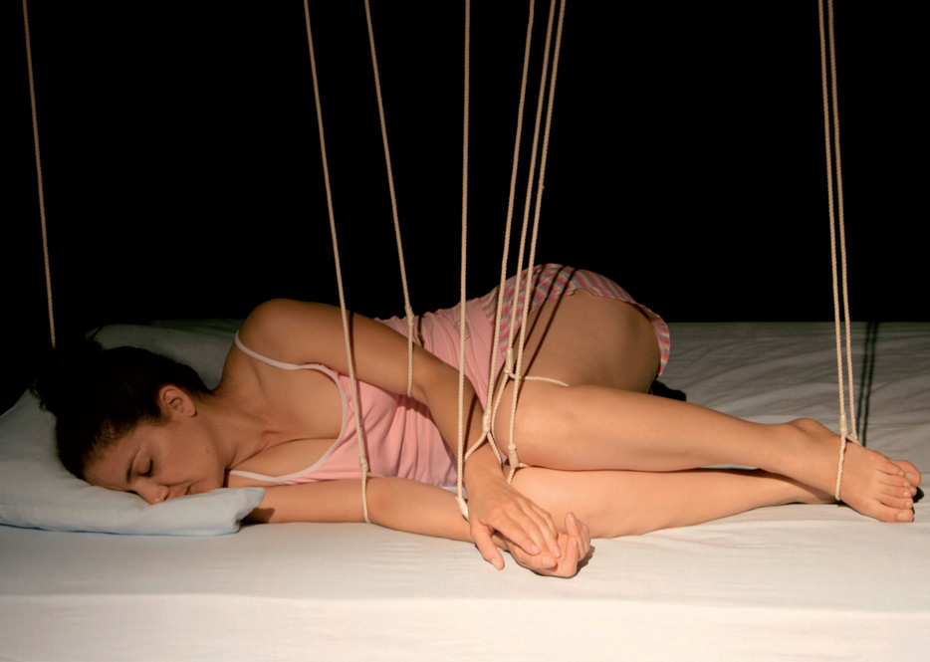
Marianela Orozco, Sueño directed, 2008. Video-performance, 6'26 ''; during the artist's dream, several puppeteers direct all the movements of her body. Photo: courtesy of the artist.
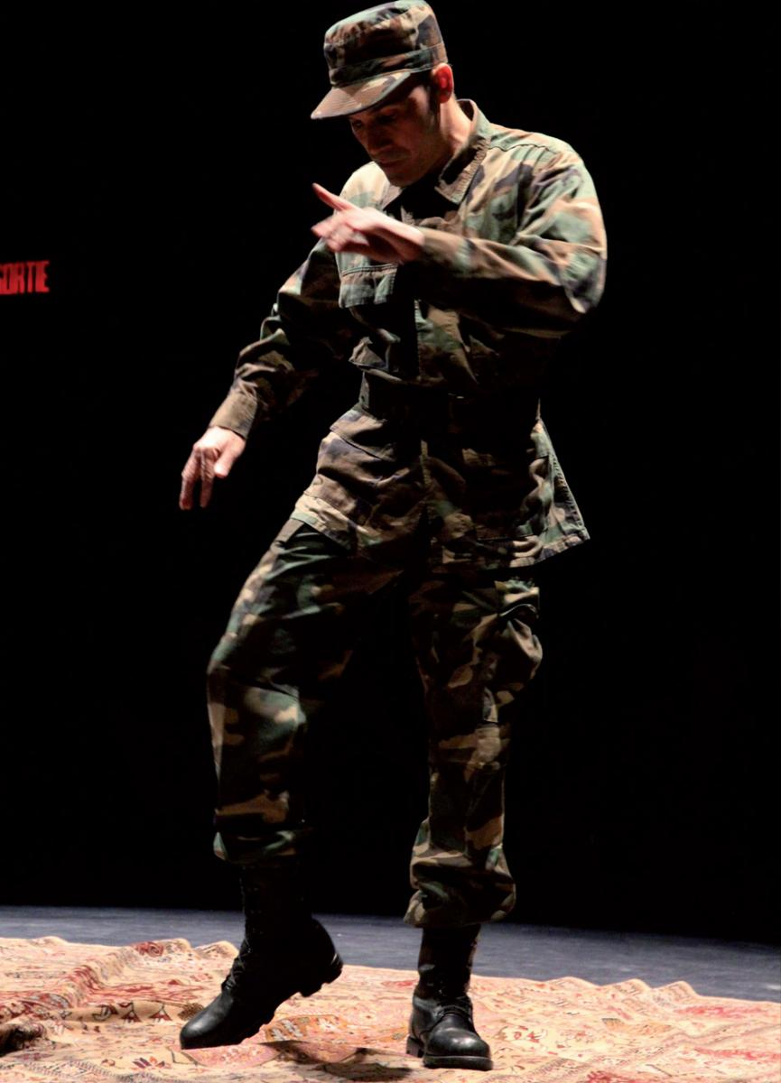
Adonis Flores, Dance on Persian carpet. 2014. Performance at the Rencontre International d'art Performance Festival of Québec. Photo: Emmanuelle Duret.
The artist Adonis Flores alternates, on the other hand, dramatic situations with other absurd, ironic or humoristic. Since 2005, and from his experiences as a soldier in the Cuban army temporarily based in Angola, Flores has built almost all his stories around the camouflage wardrobe to investigate human issues such as power, insecurity, violence, death or the fragility of life. Dressed in camouflaged military uniform, painted in turn with tiny flowers, he has walked in his actions in the streets of Nottingham, England, and of Havana, to provoke diverse reactions in the public. In Toronto and Montreal he also performed street performances walking with megaphones in his ears or doing daily rounds in military outfit, boots in feet and hands, and in a quadruped position. Many of his solo actions are registered as images of strong visual impact, for Flores is equally interested in every object of everyday life, whether it be a game of chess, a cardboard basket, a hammer, a grenade, and even human skulls. His most spectacular intervention in public space was made at the Havana Biennial of 2012, when he built the two letters of the wordfaith of the size of a four-story building with metallic scrap materials; the height of the word reached 16 meters above the street level and could be seen from far away, both on the promenade and the sea. At the Riap in 2014, in Quebec and Victoriaville, dressed again in military uniform, Flores performed a breakdanceon a Persian carpet in the center of a dark and illuminated space from its zenith. His steps and movements remembered that style of American dance that emerged in the streets of New York, this time on a symbolic and formal element originating in the Middle East. On another occasion, in the city of Alma (USA), he came to the center of the presentation room with a bucket of water and stripped off his shirt to clean the floor with it; he did the same with his pants until he finally managed to wipe everything around. Finally, he put back his shirt and pants moistened and left the space of performance.
Elizabeth Cerviño has ventured into various expressions linked to the natural environment and usually acts with clay, the earth element, as the basis of her own performances or installations. One of the latter consisted of creating figures (similar to men and women) to which small drops of water fell from the ceiling of the room. After a while these figures disappeared by the constant action of the water on the mud and only their remains remained on the floor. In his participation in the Riap of 2014, he used a good size limestone, carried from Cuba, dropping it again and again on the floor of the performance space. Every time he fell, he broke a piece, which he would reload with his hands and pull back against the floor. The action, several times repeated,
These artists are today the greatest exponents of the performance together with Tania Bruguera and Manuel Mendive in a country with little tradition in this field throughout the twentieth century, as Cuba is. Most of these creators point to social insertion actions, to establish certain links with sectors of society beyond purely individual reflections because the political context continues to influence much of the contemporary Cuban scene: it is not a question of expressing the consequences of political decisions in the interior of the human being, but of the external expressions of such decisions.
The little or no importance given to performance in artistic teaching, on the other hand, does not contribute to arouse the curiosity or enthusiasm of the students towards such manifestation. It is the artists themselves who are genuinely interested in probing their possibilities and therefore they come to diverse tools and means considered non conventional or traditional; something that is evident, for example, in La conga reversible devised by Los Carpinteros at the 2012 Havana Biennial, featuring musicians and popular dancers on Paseo del Prado (for thirty minutes each weekend) with intense and extensive participation of the public.
We are facing a new phenomenon of production of hybrid works, mestizas, which do not always imply actions of the artist in person but which involve different degrees of commitment in the cultural, the ethical, the social; as if he himself was the protagonist.
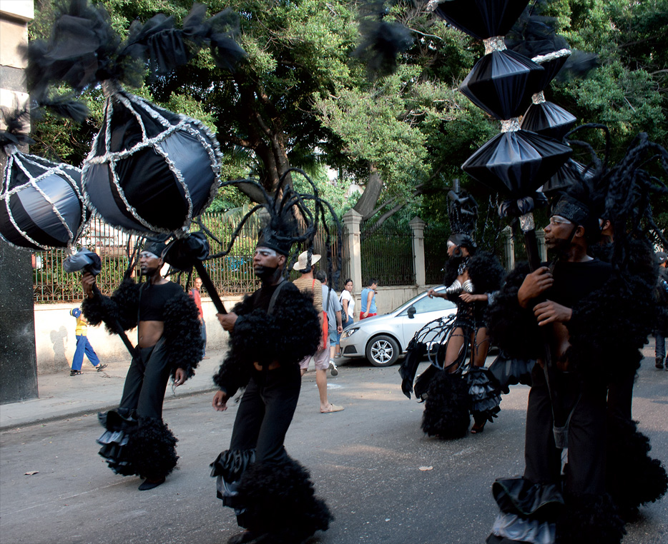
Los Carpinteros, La conga reversible, 2012. Paseo del Prado, Havana. 11th Havana Biennial, 2012, 30 '. Photo: courtesy of the Havana Biennial.
From a historical point of view, Cubans tend to express their opinions, feelings, desires, anxieties and ideas, through the open, casual word, accompanied by plural gestures that touch the pantomime or dance as a natural and spontaneous behavior, only formalized by an artistic conscience. But the Cuban on foot is not the same as the Cuban artist: this, usually, acts more reserved, cautious. It carries the weight of that long tradition of diverse oralities but knows that it requires more sophisticated instruments than spontaneity. Only the most open, daring or aggressive throw themselves on the path of being themselves the protagonists of their actions. The present artistic productions are permeated by those qualities inherited probably of the behavior of the African slaves, music and dance that identify us regionally and universally, and that are not learned in any institutional or official space in a clear, precise. Perhaps this is the reason for the rise of numerous theater festivals for children, youth and adults in recent years, including monologues, or the emergence of alternative spaces in the theatrical scene with its consequent dose of experimentation and provocation, and of the presence on the island of importantperformers from various parts of the world.
That is why here there is nothing written or fixed in this sense, but living processes where ideas and experiences, techniques and disciplines are merged, most of the time contaminated by multiple sources, and ready to assume and recreate everything that occurs in the world. Here there are no prejudices or pre-established codes, here there are no rules or rules, no laws a priori, no defined methodologies. Here, almost everything is subversion, risk, constant alteration. Actions, performances, attitudes, relationships, interactivity, happenings ? Aesthetics and ethics? Commitment and aesthetics? Contextual art? Better to say: all mixed up, as the poet Nicolás Guillén wrote in his day.
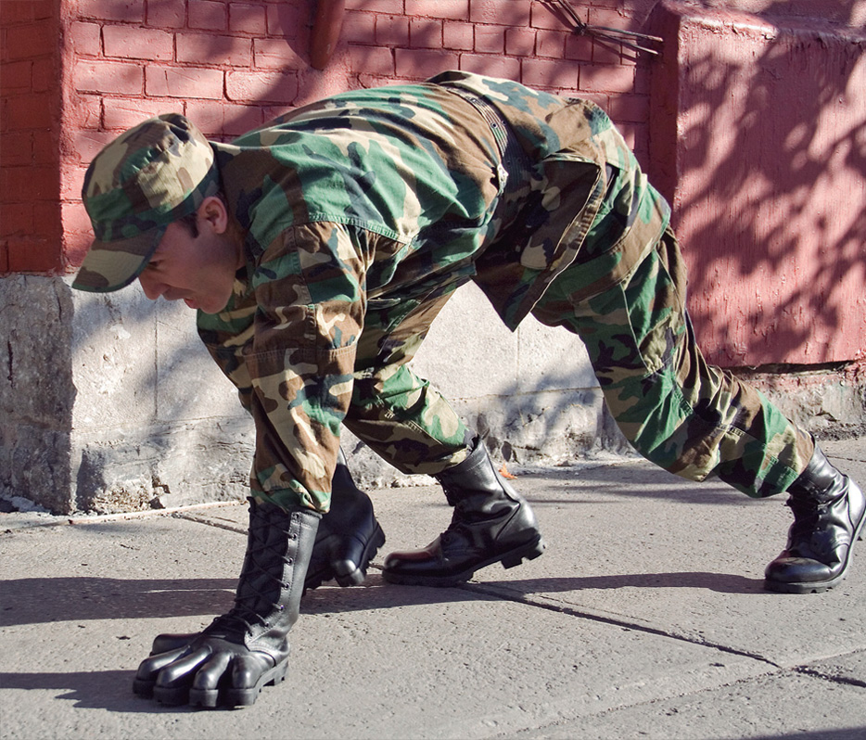
Adonis Flores, La Ronda, 2007-2009. Performance with leather gloves and natural rubber. Montreal
References
Block, Holly and Gerardo Mosquera. 2001. Art Cuba. The New Generation . New York:
Harry N. Abrams.
Camnitzer, Luis. 1994. New art from Cuba . Austin TX: University of Texas Press.
Espinosa, Magaly and Kevin Power (eds.). 2006. The new Cuban art: anthology of critical texts . Santa Monica CA: Perceval Press.
González, Margarita, José Veigas and Tania Parson. 2001. Let me tell you, compilation of critical texts . Havana: Cuban Art.
Herrera Ysla, Nelson. 2004. Eye with art . Havana: Cuban Letters.
Herrera Ysla, Nelson. 2014. Neither for nor against ... on the contrary .
Havana: Cuban Art.
Llanes, Lillian. 2013. Memories, Havana Biennials 1984-1999. Havana: Cuban Art. Reina Sofia Museum, 2014. «Playgrounds. Reinventing the Plaza ", curator of Manuel J. Borja-Villel, Tamara Diaz and Teresa Velázquez. April 30 to September 22. Brochure available at: < http://www.museoreinasofia.es/exposiciones/playgrounds>
Guy Pérez Cisneros Award. 2015. Compilation of award texts from 1999 to 2012 .
Havana: Cuban Art.
Santana, Andrés Isaac (ed.). 2008. We, the most unfaithful, critical narratives on Cuban art (1993-2005) . Palma de Mallorca: Cendeac.

1. Among them Flavio Garcandía, Rubén Torres Llorca, José M. Fors, Gustavo Pérez Monzón, Arturo Cuenca, Pedro Vizcaíno and Juan Francisco Elso; among the critics, the only ones were Gerardo Mosquera and Tonel (Antonio Eligio Fernández). The initiative started from themselves, determined to liquidate the period. The members were constantly seen and some could have given the idea, or two of them, but so far nobody has been awarded the authorship of the Game . In 2014 an exhibition was made at the Reina Sofía Museum about the playfulness in art, "Playgrounds. Reinventing the square ", where a small space was dedicated to that performance (see Museo Reina Sofia 2014).
2. To mention some of the most important: Maria Teresa Hincapié and the Grafito group (Colombia), César Martínez and Guillermo Gómez Peña (Mexico), the Yeguas del Apocalipsis (Chile), Juan Loyola (Venezuela), Rebeca Belmore and the group BGL (Canada), Peter Minshall (Trinidad and Tobago), Tunga Mourao and Cilindro Gallery (Brazil), Polibio Díaz (Dominican Republic), Algeria Bravo (Venezuela), María Magdalena Campos, Aimée García, Carlos Montes de Oca, Carlos Martiel and (Cuba), Amanda Heng (Singapore), Clemente Padín (Uruguay), Esther Ferrer (Spain), Humberto Vélez (Panama), Steve Cohen (South Africa), Hermann Nitsch (Austria) and Marina Abramovi (Serbia).
3. Antoni Muntadas, Adrián Paci, Christine van Assche, La Pocha Nostra, Humberto Vélez, Jacob Fabricius, Nicolas Bourriaud, Rirkrit Tiravanija, Santiago Olmos, Stan Douglas, Thomas Hirschhorn, Boris Groys, Orlando Hernández, Gerardo Mosquera, Alexander Arrechea, Elvia Rosa Castro, Magaly Espinosa, among dozens of other names.
4. In 2003, a total of four pedagogical experiences were in operation in this field. Those first years of the new century were substantial for all that had to do with the art of action. There has not been another such moment in the Cuban visual arts of the last thirty years, where such collective experience, group, in the pedagogical sense, was lived at the same time. With regard to Cuban literature on gender, however - except for Glenda León, who won the Cuban Literature Prize in 2001 with his text "The Performative Condition" - few artists I know who theorize or advance written or critical production on performance practice.
5. From 2011 to 2012 Mayim-b also ventured into the theatrical space to take advantage of the advantages of controlled lighting and a stage design designed for each occasion. The simplicity of his performance actions (a table, a chair, pork, bottle of wine) allows him to insist on the symbol of the pig in our society. At the last Rencontre inernational of arts performatives (Riap), 2014, held every two years in Quebec, Mayim-b made several per-formances with the aim of exorcising his family and personal demons sitting at a simple table with the help of pork and a bottle of wine. There, for several minutes, he began a monologue that recreated part of his family life in Cuba, his obsessions, anxieties, dreams, using musical fragments of the hymns mentioned.

