CONCEPTS, FORMS AND CONTEXTS: POLITICAL ACTIVISM AND PERFORMANCE
Author:
A preview of what LinkedIn members have to say about Álvaro Villalobos:
Edition:
ERRATA # 15: PERFORMANCE, ACTIONS AND ACTIVISM
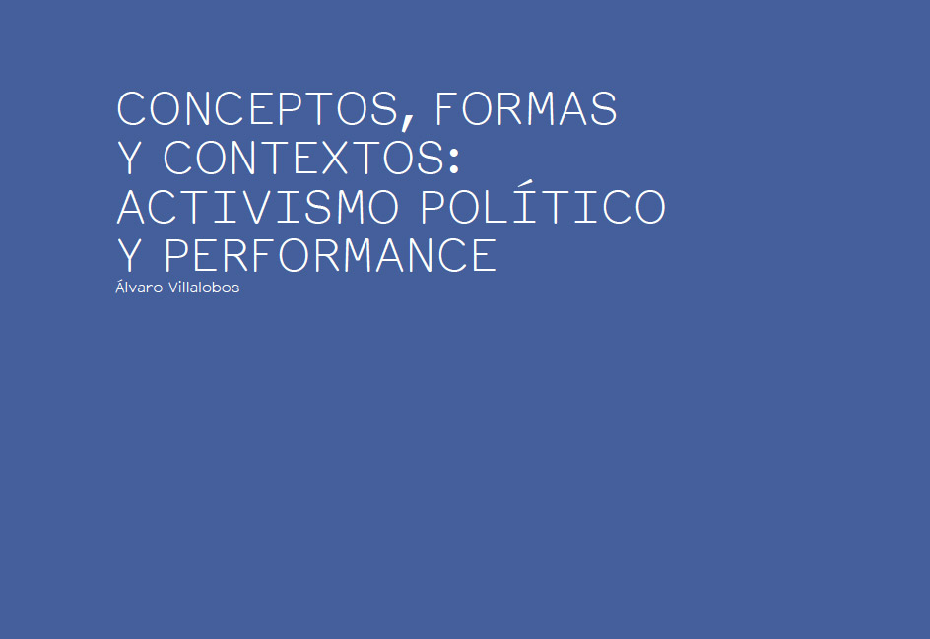
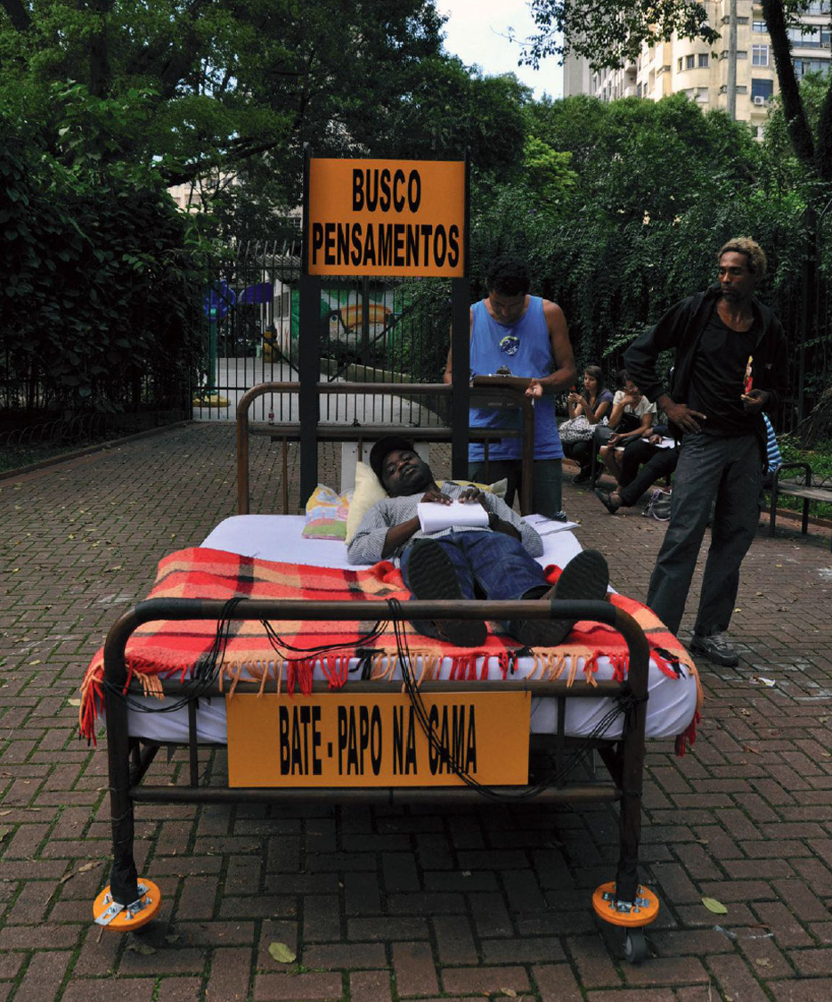
Álvaro Villalobos, Exploration. Chat in bed, 2013. Hemispheric Performance Meeting. Republic Square, Sao Paulo. Photo: file of the artist
Nomadic knowledge
Far from wanting to start or conclude with a precise definition of performance in this writing, let alone frame in a text the range of possibilities that exists to understand it, I intend, on this occasion, to follow the pattern outlined by the observation of some actions that are of my interest as an artist with experience in their practice. In order to generate my works, I move around vaguely recognizing the events that make up its history, always with the aim of establishing relationships between the conceptual, formal and contextual situations that give rise to it. I would like to refer to that series of relations below.
There are several publications with many terms that help define this practice; in addition, it has been quite long since the first performances appeared in catalogs, manifestoes, journalistic notes, interviews and testimonies. And yet, after many actions, declarations of principles, videos, sound and photographic records, festivals and exhibitions around the world, ideas about what can be understood as performance continue to change. The interpretations, exegesis and deliberations about its conformation are less and less necessary due to its continuous mutation. And even so, you have to think that it is a new old art, of modern conformation, and that the changes, fluctuations and novelties registered in its field of operation force our readings and interpretations to be in accordance with the dynamics of action and movement that have delimited it in different times. The same formal condition of the ephemeral art of action locates the performance in the environment of mobile, nomadic and traveler knowledge that forces the interested parties to compose and recompose their extensivecollage of possibilities, to create an enunciation that can be adapted to any circumstance. Performance is an agile and dynamic section of art that confronts the public, artists and institutions, motivating them to make active and laborious concepts and descriptions about the different ways it adopts. Its condition of instability obliges to modify the appraisals and to locate them as artistic thinking and to recognize the free and speculative character that nourishes it.
I will then model some ideas with the aim of understanding the development of specific situations of performance in the visual arts, emphasizing contents that emerge from social and political events such as gender violence or enforced disappearances allowed by governments; facts that are currently occurring in Mexico and concern us to many. But before I enter the subject fully, I accept the reiteration of my arguments, in most cases fragmentary, as a result of the constant friction between the methodologies I use for research, and ideally, can lead me to produce works and writings .
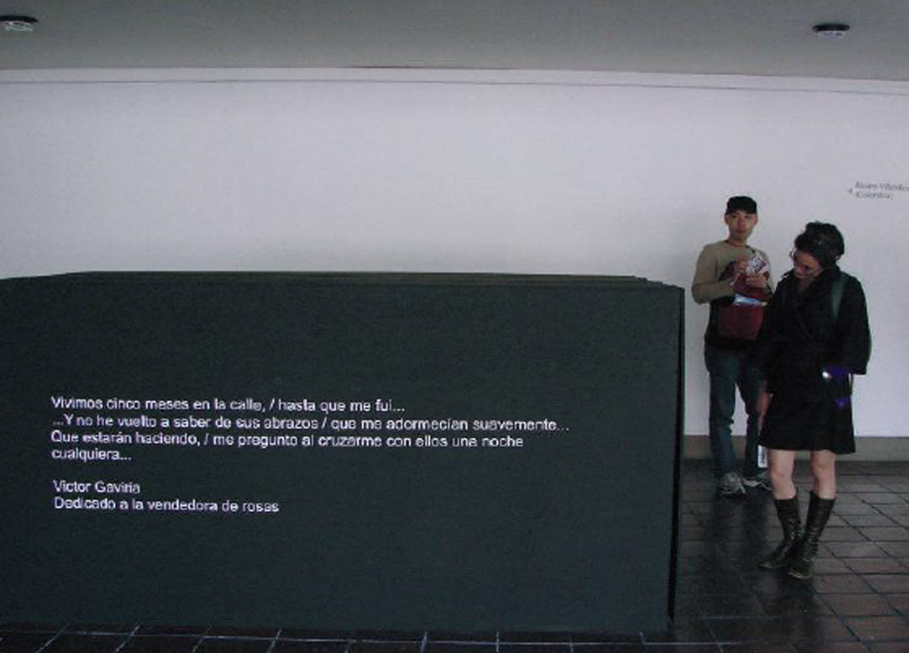
Álvaro Villalobos, Caja negra, 2009. Fasting of 40 continuous hours.
Hemispheric Performance Meeting 2009. Art Museum of the National University, Bogotá. Photo: file of the artist
These writings contrast with the formal dispositions of performances because they are apparently given as closed events corresponding to specific theories, while performative performance always occurs in untimely conceptual environments, prone to changes occurring during the presentation of the works, something that we see exemplified in recent works by Mexican artists Lorena Wolffer, prominent nationally and internationally for her artistic developments around gender violence in Mexico; ₁ and in Lavandera washes the flag (2014), by Edith López Ovalle, leader of the HIJOSMéxico collective and activist around the forced disappearances that this country has been suffering for several decades. ₂The same I will illustrate later with two personal works in which I worked on political problems of easy understanding for the public, independent of the acceptance or reprobation of the facts, as the indigence and the violent deaths of civilians, that later appear in mass graves.
The ideas presented below are based on the hybrid and syncretic character of the current sociocultural environment, also a product of the altermodernity that crosses contemporary thinking, in the sense of a mixture of traditions, dogmas, behaviors and philosophies. Something that today does not represent any novelty but that is worth noting because in this random way of living and thinking the character of the performance is modeled, nourished by different sources of knowledge in continuous movement. This mobile character of thought is necessary to work in the conjunction of postulates, texts and actions in which a researcher chooses useful devices to establish relationships with his object of study and with the contexts where the performance is developed,
Relativization
Relativization is assumed as a method to produce and understand performance, as a technique, and at best, as a poetic (in the sense of creating thoughts and variables) and not as a fixed stratification. As an example, it is worthwhile to say, although in academic circles and in circuits of legitimation this may be understood, that the exchange of position and roles between public and artists - that is, that the public can become a creator and the artist in receiving public - is the basis for generating new creative possibilities. As well as the concepts that sustain the works are changing and random because the sense of the flow of the communication can vary in the performance; that is, its fluctuating power serves both to change the direction of the concepts, as to create coresponsabilidad on them, altering, of course, the orders of the understanding. In this case, when the public is committed to the content of the work and feels part of it, it is responsible for the execution and criticism of the action, as we will see later.
Artisans, creators and recipients today are obliged to continue studying and researching constantly on the procedures of projection and artistic production; even small changes recorded at the reception influence much of the world's visions and the renovations in which the producers of this type of knowledge exercise. The audience of performance, eager to understand its characteristics and modes of presentation, must go hand in hand with the artist in his training as an observer, since it is an art based on experiential experiences not only of the artist but also, precisely, of the receiver; experiences generally mediated by imaginary shared in specific contexts, which generate mutual correspondences that help to understand this type of work of art,₃
Human too human
Direct and less representational languages ​​used by performance can basically be understood as a type of communication that is established by the difference between the symbol of a preconceived idea (or a previous situation that generates a certain image or icon), and the presentation of existence -in this case, understood as the present life and the direct experience of the recognizable, to the way in which vital factors involve immediacy, chance and indeterminacy flowing ceaselessly. The performance constitutes a continuous exploration of the symbolic universe of the subject whose results are elevated to artistic category.
It is said that creation in this art does not refer to a mimetic copy of the world but to a real way of seeing it and, therefore, a creation of it. "Signs that generate symbols in communication are not reduced but multiply" (Lehmann 2010). Since the human capacity to generate symbols in accordance with the experiences of the subject is increasing, the large amounts of information circulating freely around the various situations of life force the achievement of more spaces of thought that can be abstracted, and synthesized in ideas and works.
The performance emphasizes demarcations between theories of communication because, in terms of language, the denomination of this discipline comes from there; but, in the same sense, it must be recognized that performance creation does not refer to a fiction that occurs only in the mind, or to a simulation of reality, but to the presentational character of a situation involving another action and many reactions with which speech can be reduced or expanded. Santiago Tarancón, alluding to Grotowski in relation to the theater, called this process to create "according to a space referred to facts based on the simplicity in which human beings speak and move" (2006, 105).
An example of these determinations is the work of Lorraine Wolffer Look me in the eyes(2013), consisting of a series of actions developed in the Plaza de la Constitución Mexicana, the Manuel Gómez Morín Cultural Center in Queretaro and the Universidad Autónoma de Monterrey in Nuevo Leon. In it, Wolffer incorporated testimonies of women on gender violence to a gesture whose main objective was to convey the identities of the participants to the field of the visible and intelligible. As the artist called it, it was a collective experience of enunciation, formed through several stages through the direct voices of the participants, which provided the opportunity for street passers-by on the street to express themselves openly on the issues of women in the macho society. Their voices revealed lives, pleasures and sufferings. During the action, the participants talked equally with the public and with professional specialists on the issues that affected them. Finally, a series with photographs of the women and their testimonies was presented at the Ex-Teresa Arte Actual Museum, in facilities of the collective transportation system of the DF and at the Museum of Women in Costa Rica.₄ The project, in addition to achieving great relevance, evidenced the need to incorporate increasingly artistic creation processes into sectors of society that do not come from the artistic and cultural spheres.
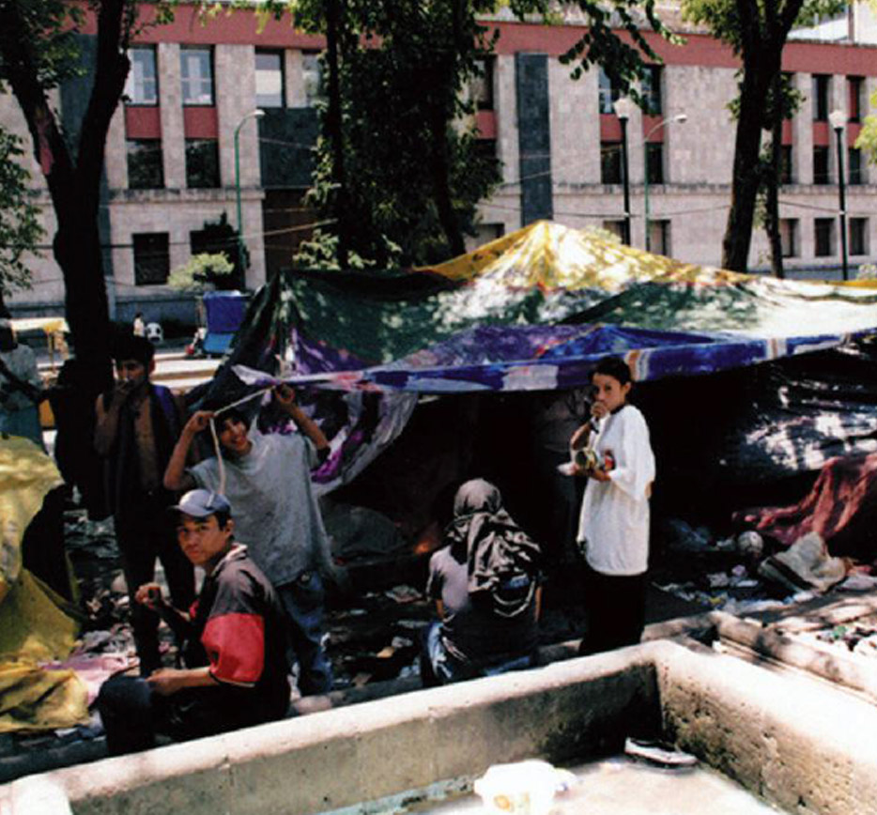
Álvaro Villalobos, The black box or the space of Ivan, 2004. Action with indigent children in the Alameda, Mexico City Photo: file of the artist.
The social body
From the intersections and contacts between authors and recipients must arise the parameters of understanding the work. In this type of art the order of representation is dissolving more and more, due, to a certain extent, to the infinite possibilities of living it. To illustrate this issue, we can also think about the debated performance of Tania Bruguera during the Encuentro of the Hemispheric Institute of Performance and Politics, held in 2009 at the National University of Colombia in Bogota, a case in which the work grew and was strengthened. was reduced), to the effect of the comments of a large number of people who expressed themselves by various means for and against. Some were offended by the fact that Bruguera included the distribution of cocaine among members of the public as part of the performance, as if they had put their finger in the wound; or perhaps because it alluded to the double standards of many subjects involved in this scourge. Others simply understood the correlation of the work with something very simple that social anthropology calls "working with the customs and customs of specific communities". The conceptual bases left the artist and moved towards external sensitivities of the place, characteristic that at least could be seen in the behaviors and reactions of the public.
At the level of communication, the performative is based on converting everyday experiences into a presentation that transforms their contents into meanings and signifiers at the same time; is nourished by connoting the experiences, pointing them out and emphasizing them so that others make them their own, personify them and live them. The performer's job in this case lies in the ability to direct the attention of the recipient, who must also strive in his understanding to match his own thoughts and actions. Formally, this is one of the main factors that typify performance: it is the ability of its manager to modulate the conceptual, formal and contextual elements that he has at his disposal, even to play with the unexpected of a situation,
For a long time performance was only a means to explore the body, to study its physical dimensions and its creative power, especially if we review the historical chapters of body art . ₆ The so-called body performance highlighted autobiographical intimacy, seen for example in the well-known English artist Tracey Emin (1963-), who also inspired Mexican artists such as Maria Eugenia Chelet (1948-), among other representatives of personal anthropometry ; 7line of work in which the creator expresses and communicates an infinity of feelings turned into "world" that generate reactions of acceptance or repudiation. Now the field of action of the performance is more extensive. Although it is not a novelty either, its active field has expanded to the exploration of other bodies, extending to the space of social conglomerates, to the social body .
Political situations
Some artists have put collective situations in their performances, in which broader and more complex sectors of society may be involved, with themes that transcend the psychological aspects of the author's personal plane. The list of creators who emphasize this topic is long, however, I can suggest a review of The Tijuana projection,of the Polish Krzysztof Wodiczko (1943-), which meant an important event within the program In Site 2000, of the Cultural Center of Tijuana. Through a complex performance reproduced in video, Wodiczko ventilated serious civil problems, when projecting on a public building the faces with the direct and direct voice of some workers of the maquiladoras of the border between Mexico and the United States giving testimony of violations to its fundamental rights by bosses and employers. These people denounced with their own voices (at the risk of losing their job, but not their dignity) that they had suffered constant abuses or sexual harassment by their employers. Knowing this, and reacting,
As a matter of course, reality carries with it concerns about the modes of behavior in which the collectivity is involved, and within these concerns is the political, understood as a methodical action inscribed in governmental models that strategically pose directing social structures through of one or another doctrine. To position itself critically, one of the most important steps recorded in the history of the performance was, precisely, the turning from the ritual to a political conception and social commitment. The artists who work the political must conceive the performance as a situation of eminently critical commitment to the political state of the social collective.
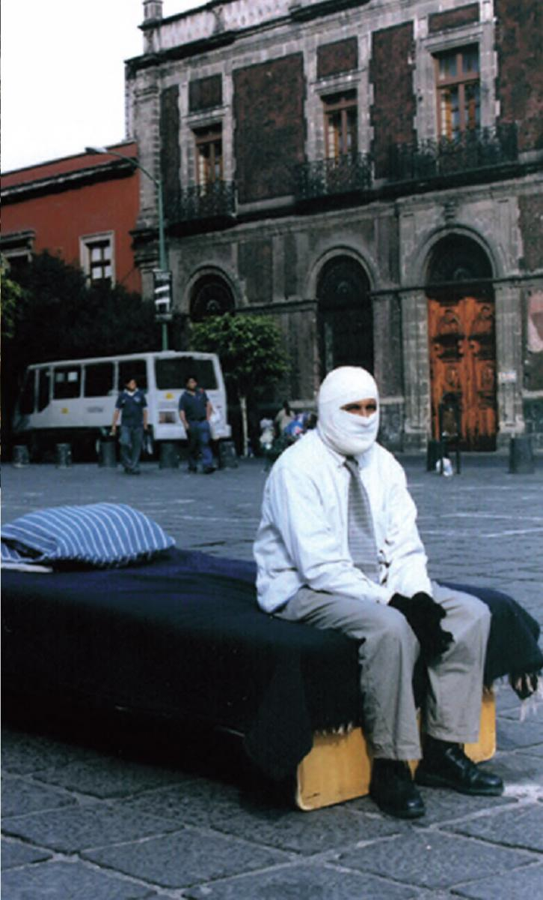
Álvaro Villalobos, While all eat, 2013. Performance in the Plaza de Santo Domingo, Mexico City. Photo: file of the artist
In general terms, the policy consists of managing governance issues, not only on a personal but also a public level, and on practices involving a variety of community factors affecting a population at different levels. In order to understand basic situations of the creative act in relation to the political, we must analyze the modes of thought that make up the personal and subjective symbolic universe, in order to compare them with the collective factors that constitute the basis of social relations. That is to say, it is necessary to see the sense in which the personal operates in function of the collective and vice versa. Maurice Merleau-Ponty (1993), in his theories on the phenomenology of the perception, relates the personal in function of the collective with the near phenomenal space,
The strength of custom
In a chapter of the book Syncretism and contemporary Latin American art, referring to the force of custom become law, I used the foundation of Pierre Bourdieu's sociological studies where habitus is a way of feeling, thinking and acting subject located in function of the social. Bourdieu presents a type of subject whose behavior tends naturally to transcend collective paradigms and to disorganize them. Here human subjective behavior is a function of the social, it is defined by its interaction with habits, which, in turn, depend on the dominant order of the symbolic in conjunction with the working relations of the world.
In this ideal argument of being able to object to social behavior, to criticize the laws and to generate proposals from the individual that impact on the collective, are based the performative proposals that we can call actions with social and political content; which, being purists, could be all and none at a time. Generally the desire to change the world is conceived as a natural condition of the individual, and changes that can effectively be achieved as symbolic events with great possibilities of locating in the order of culture.
Stories of performances such as that of Wodiczko, or of other Mexican artists such as Rosa Maria Robles (1963-), who works at a level less tied to the international art market, linking to his work the growing phenomenon of drug trafficking in Mexico in its destructive facet , gandalla and fratricide - show that one of the main concerns of the genre is to link political and social problems to the work of art. In formal terms, some works are devoted to the need to explore space with the body in a real way, and in that sense, blur the frontiers of art with life.
At the moment performance artists evoke the body as a search instrument considering time and space as fundamental complements in the concretion of the work, because it is precisely in the body, that feels the passage of time and penetrates the space, that life develops . The body alive in art has always been a matter of voluntary introspection, and not only in performance, since in dance and theater it is the pillar of any event.
That is why the marked interest in relating performance to other disciplines. Hans-Thies Lehmann (2002) called postdrastic theater to that based on explorations and experiments on the temporal and conceptual space of the events that constitute the life and work of the artists, in consonance with public sectors in which the knowledge works with ideals access to information.
In this ideal argument of being able to object to social behavior, to criticize the laws and to generate proposals from the individual that impact on the collective, are based the performative proposals that we can call actions with social and political content; which, being purists, could be all and none at a time. Generally the desire to change the world is conceived as a natural condition of the individual, and changes that can effectively be achieved as symbolic events with great possibilities of locating in the order of culture.
Stories of performances such as that of Wodiczko, or of other Mexican artists such as Rosa Maria Robles (1963-), who works at a level less tied to the international art market, linking to his work the growing phenomenon of drug trafficking in Mexico in its destructive facet , gandalla and fratricide - show that one of the main concerns of the genre is to link political and social problems to the work of art. In formal terms, some works are devoted to the need to explore space with the body in a real way, and in that sense, blur the frontiers of art with life.
At the moment performance artists evoke the body as a search instrument considering time and space as fundamental complements in the concretion of the work, because it is precisely in the body, that feels the passage of time and penetrates the space, that life develops . The body alive in art has always been a matter of voluntary introspection, and not only in performance, since in dance and theater it is the pillar of any event.
That is why the marked interest in relating performance to other disciplines. Hans-Thies Lehmann (2002) called postdrastic theater to that based on explorations and experiments on the temporal and conceptual space of the events that constitute the life and work of the artists, in consonance with public sectors in which the knowledge works with ideals access to information.
The political in its different versions and applications is the main subject of the post-dramatrical plays described by Lehmann. One of them, perhaps the simplest one, is that the practices of contemporary art, especially performances with political content, are based on the artist's need to alter the historical continuum ₈ , proposing new relations between the past and the present .
The ideas of artistic creation are confronted with the philosophy of historical experience and the thinking framed by facts and histories that have taken place in specific places, times and contexts that have managed collectively to mean a society. The works of art that refer to the political from the conceptual have to do with what Walter Benjamin called an interaction between the past and the present that emphatically considers the need for a change; are artistic approaches that coincide with the expectations of the public around the concerns for social change, derived from the administration of public rights, which also the viewers want.
Performative arts, activism and denunciation
Classical acting thinking was supported in dramatic ways based on representations forged from the playwright's text, a situation that until recently was the basis of criticism and provided a more or less stable functional support, ranging from the possibility of representing an elaborate text expressly for the scenic event. In post-dramatic developments, however, the text has ceased to be the hegemonic and structuring element of the work. Since then the staging is no longer conditioned and shares place with other elements of the work, placing these at the same level of importance. In the performative art, as in the postdrastic theater, no element subordinates or subordinates the other; but it does not idealize it either. The construction plans of the work must be transversal and longitudinal, never vertical, and can be ordered in different ways, without hierarchies or dependencies; should rather emphasize the relationships between the conceptual, technical or contextual elements that arise around the ideas that are sought to deal with the piece.
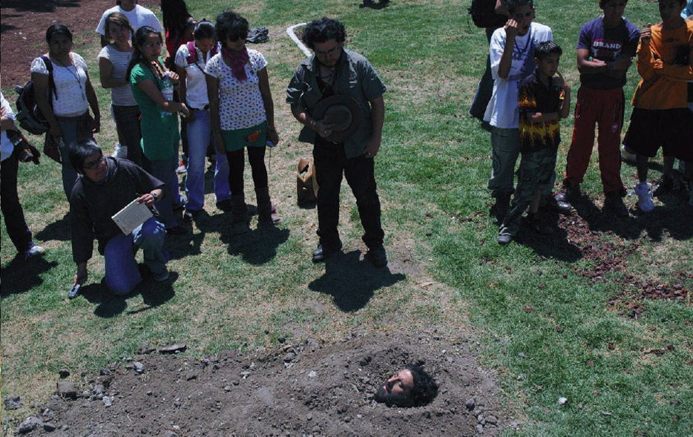
Álvaro Villalobos, Fosa, 2008. Performance, festival Hybrid. Faro Tláhuac, Mexico. F oto: file of the artist.
The classical way of acting depended on the script and the directional voices based on dramatic structures. Contemporary theater and dance, on the other hand, work in increasingly performative actions, divorced from modern forms employing traditional beauty schemes, stylized and forced to appear natural. Contemporary dance, like the postdrastic theater, presents a complex creative subject and a receiving public as non-unified models, moldable by the events they address in processes constituted by small dramatic and spontaneous moments. The dance, theater, literature, music and other arts that aspire to the performative now use human beings as total entities, in terms of the individual and the collective, recognized in the social, subjects who think of the compound ; who breathe, walk,
Within this framework of ideas, contemporary art increasingly emphasizes the need for presentational actions with political content. This emancipatory effect consists in that body and mind, as a single block, are immersed in the shared realities of the artist and society. The mechanisms of art, when operated directly, are useful to erase the fictional charge that exists in the conception of the other. Art is used here to personify the knowledge of himself and the other within the work, according to the collective. This is the sense of the postdrastic in the manner of Lehmann, who takes advantage of the old concepts of Antonin Artaud around the stage, which is not only conceived as an open space, but is the starting point of creation. In addition to taking place in any street, neighborhood, park,performa .
The postdrastic then becomes a place to reflect and act in collective all the circumstances of the work, disconnected from the dramatization of the scene.
This can be exemplified in the political activism of HIJOS
Mexico collective , in performances such as Lavandera lava la bandera (2008-2014), a series of artistic manifestations in which a large group of young people, led by Edith López Ovalle, called people to meet in front of the Supreme Court of Justice of the Nation, in the historic center of Mexico City.
The action was systematically fulfilled once a month, from 2008 to 2014, and consisted in collectively washing Mexican flags in containers with water of the color of the blood, while the artists harangued the unprepared public that circulated by the place, invited him to to join the actions of denunciation for the forced disappearances of civilians.
Although washing the flag as a symbolic act is a practice that other artistic groups or civilian population have done in different countries, it is worth emphasizing that on that occasion the citizens participated enthusiastically. In this sense, the work activated a cathartic mechanism based on the drama of a gesture around enforced and violent disappearances with different motives. ₉In this action one can see how the difference between dramatic representation and performativity is radical. In the performing arts, until recently, the space of representation of the work corresponded to the point of arrival of creation and in it developed a preexisting reality mimetically. Now we are modeling the realities of the social collective as a starting point, an attitude that involves a political stance of the same art, even when we never know where and how action ends.
Perceptual Levels
In the art of performance, at least three levels of perception must be differentiated, but they are never separated: first, the technical dimension of living art in its ephemeral condition; second, the presentational dimension that corresponds to the de facto space-time relationship; and, finally, the conceptual dimension that the work carries with it, that is, the subject matter to which it refers. In the conjugation of the three levels is that sort of art of action and movement that implies for the recipient an active order of immediate experience.
The first level is manifested as the production of knowledge in presence, in specific time and place, improvising and exploiting the reality of the moment in all its dimensions; this leads to the second level, understood as that condition that differentiates the presentational from the representational, ₁₀ and that links with the third, which implies the conceptual understanding of this experience. Then for performance the so-called act of presenceserves as a critical option, complex and difficult to expose and activate it to be. The experiences of artists and the public, as well as their immediate presence, are effects of practical awareness through which it is recognized to be there, patenting the terms that make this act of loyal knowledge possible at the instant in which one lives.
Currently many performers, including myself, experiment with overcoming the limits of art to reach the other disciplines. For this reason the question about the legitimacy of art is increasingly a philosophical and political - and, if one wants, linguistic and literary - question that objects to the ways of thinking it. I can here emphasize that the formal and conceptual ideals of my performances revolve around the political, at least as a possibility to critically point out the problems generated by the dominant modes of production that have become superb schemes of government.
In this regard, on May 23, 2008, at the Hybrid performance festival ,of Faro Tláhuac11 in Mexico City, I presented a piece based on the urban chronicles that emanate from the very place of the event. At various visits to the site, several people argued that official bodies had dumped debris with human remains from the earthquake that struck Mexico in 1985. Others told me that there were buried the missing people of the violent conflict with which the student movement was wanted to be dissolved of 1968, in a mournful time when the armed forces in the service of the Mexican government brutally assassinated many students and ran over thousands of them. By common sense, images of public knowledge are associated with the work of art in the same way that art draws elements of popular culture to introduce them into contemporary visual discourses.
Evoking the shadow of death that surrounded the place then, I decided to dig a grave in the land of the Tláhuac Lighthouse so that two policemen of the Federal District buried me at the beginning of the artistic journey. I dug the earth and they buried me and took me out four hours later. Enduring the weight of nature, receiving the land, being buried, buried, are symbolic acts used by different communities with various meanings, especially associated with death and oblivion. By means of action resources and body language, this piece used an ordinary matter of armed conflicts: that the sectors involved bury inert bodies in vacant lots, turning the field into a cemetery of mass graves where corpses are reduced to the last end, the transformation of matter.
Concepts and contexts
My work has consistently consisted, in works characterized by the political, with the ideal of operating as an organism of symbolic criticism of reality. For the work to join the thoughts that can be expressed in an iconic, verbal or written way with the actions of my own artistic practice I must be aware of involving various information from the systems of government, at least in a critical sense, along with take distance. Thus art can fulfill the function of directing the gaze to where people do not commonly.
In my practice it is important to understand from the conceptual and work performatively modulating the reality, harmonizing the contact with the spectator public to generate the work according to the resulting interactions in that space and time where the consciousness of the receivers is connected.
The third level referenced is one of the most important: the concepts that the work seeks to unveil. In this sense, it is not enough to develop the intention of the author or the infinite subjects that he can raise; it is about entering common fields of knowledge, with referents shared by different audiences. They have to be developed in specific contexts and with a strategic sense that makes them understandable; should preferably be based on social constructions that start from a grounded thinking environment in which both the creator and the public can take sides. The works that have political contents are not neutral activities, since they always connote a political position for or against specific situations derived from the chosen ideological environment. When it comes to politics,
Active entity: the value of the viewer
The art market, as a predominant institution in its material development, raises a dilemma that lies in the perspective of success as measured by the media impact; a fact exemplified by the abundance of trade shows such as Artbo, Fiac, Art Miami or Zona Maco, to name the closest to Mexico, where sales of performance records in video and photography formats proliferate. The works that, despite not achieving a great mercantile success, have shown society its weaknesses and strengths, then produce more lasting forms of understanding in the eyes of the researchers, as opposed to successful works in the commercial circuits that are only recognized by it. Even so, news about the popularity and commercial success of a work and its author predominate in the advertising media.
This is a central problem for performers, whose artistic production is not in principle commercial: the clearest example in Mexico is the work of Melquiades Herrera (1949-2003), who throughout his artistic career and up to the date of his death remained totally disconnected from the commercial scope of his work. Or also artists whose work is very much in force in intellectual and academic fields such as Víctor Muñoz (1948-), of an intermediate generation; or Roberto de la Torre (1967-), already consolidated in alternative circuits. The list of performers not positioned in the market of fairs, galleries and private retailers is immense, and as it does not predominate in them the harassment by the sales, or the trends of the taste of the clients,
It is clear the contrast of his production with works lacking a dynamic of integration between the public and the conceptual depth of the same, where it is not even possible to know if the public understands or is interested in the proposed concepts.
In fact, one of the variants of the performance in the current scene is based on a matter of vital importance: the place of the public. There arise diverse questions, such as what is, in essence, the site of the spectator? What is the value of the present body of the other ?, what is the value of the social body? In conclusion, one of the main issues of the current performance is the importance that the public that lives the work lives in the same place with the artists.
There was an era of Mexican festivals such as Performagia, of the Chopo Museum, or the International Festival of Ex-Teresa Arte Actual (the first of the years 2000 and the second born in the early nineties and lasting to the present day ), which laid the groundwork for the contemporary Mexican performance environment, where there was a boom of "posporno" presentations, actions by transgender or feminist artists, who work hard to reclaim gender violence issues in this macho culture. Here we can include many biographical and self-referential works such as those of the late Armando Sarignana (1954-2000), or of young generations like Jerry Transgerarda, of the collective Legs Open (1988),
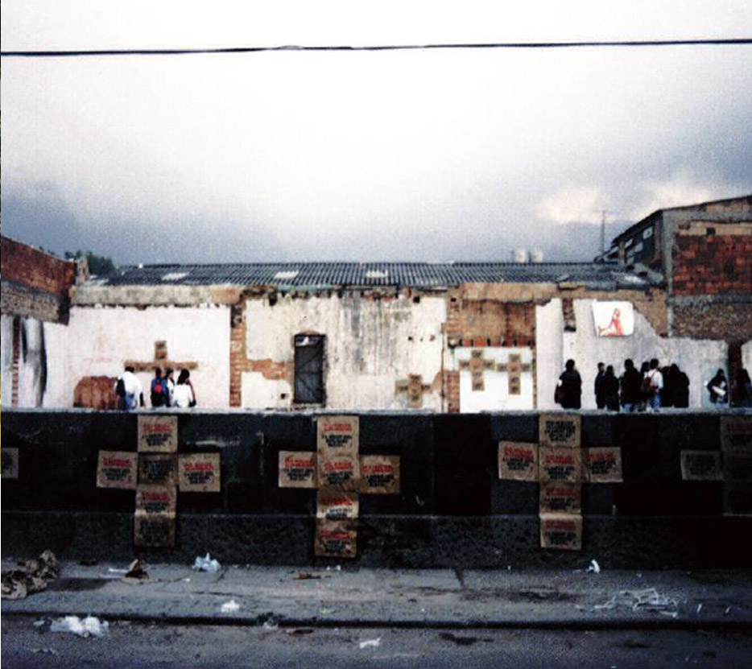
Álvaro Villalobos, La facción, 1993. Action with destitute people in the street of Cartridge in Bogotá. Photo: file of the artist.
It can be said that the artist's preoccupations with captivating the public with the concepts he handles are at present a force greater than his commercial motivations or personal goals. In today's performative art, much of the production of meaning must have the viewer, who takes the meaning of the work and orders it for himself, and recreates the action from his own perception. Now the unprepared public is involved in a type of actions that some sectors of the critic have called relational artbecause of its links with sectors of society that previously did not have access to it. In this way an artistic conception is created that we can also identify as the performative of the receiver, which consists in the participation in the work without cover or deceit, sharing the responsibility of its gestation with the artists during the execution. In the current performative art, the public should no longer be a passive entity, but someone who synchronizes with the work to generate a new mode of reception based on what was previously seen as an exclusive power of the artist (in self-referential performances this active category it did not belong to the spectators).
Creation consists here of a dialectical phenomenon, shared by other active agents, who take advantage of the direct presence and the immediate experience to create situations and experiences of cooperation in which the public and artists interact. In a play I made in 1993 on the old "carrer street" in Bogota (race 11 between 6th and 12th streets), a time when there were many people who had been killed, shot and shot in the streets, I met some indigent marijuana users and basuco. The motive, in addition to the deaths of fellow travelers, was to generate an action of denunciation, as it was said that the anonymous killers who were dedicated to kill those who found at dawn consuming drugs in the place and thus "clean the area "Were financed by merchants, politicians, and ex-militants of the time. The paupers who participated in this action were prepared to perform a reading of poems by megaphone in the wasteland where days ago had appeared the bodies of their comrades on a garbage dump. To the place arrived more unprepared people that passed by, and some invited. The assistants helped the destitute to stick some posters on the walls, in the shape of a cross, as a requiem for their murdered friends. In the posters printed in silkscreen, with black and red ink on paper The assistants helped the destitute to stick some posters on the walls, in the shape of a cross, as a requiem for their murdered friends. In the posters printed in silkscreen, with black and red ink on paper The assistants helped the destitute to stick some posters on the walls, in the shape of a cross, as a requiem for their murdered friends. In the posters printed in silkscreen, with black and red ink on paperkraft , read: "In the market for indolence death is too cheap."
The public generating circumstances
An important characteristic of the relationship between creators and recipients in today's performance is that by rotating the public's place (towards the execution of the work) to give him the floor, the responsibility for creation becomes shared; and the criticism that emerges from it is also shared and becomes a catalyst for ideas about the work, representing the thinking of both.
In contemporary thought the old is combined with the inherited of modern procedures - the mythical character of indigenous thought with processes of economic, political and social development - generating syncretic forms of perception and action. This particular mixture of moving and fluctuating reasoning is recognized in the current sociocultural environment and exploited within what Hardt and Negri call altermodernity, in the context of the decolonial. It serves to approach knowledge relationally, where all possible mixtures, the syncretic, the hybrid and the eclectic, become methodological virtues with useful propositive results, because in them they find the traditional with the novelties, with the indeterminacy,
Thus, we can also conclude that the behaviors treated in the performance must combine the intention of the artist with the information contained in the imaginary ₁₂ of the receiver. What the artist does in depth is to bring situations of reality to the surface of the work so that the receiver establishes relationships with them from his own understanding. The plane of reality and that of the work of art are parallel, although fully differentiable, and performative art takes advantage of the differences between the imagination, desires and desires contained in the receiver to compare them with the immediate events arising from the same performance, changing their position, combining them and conjugating them in different ways.
The imaginary, in the psychological sense, is all that survives in the memory and the imagination of the subject, derived from a previous experience of contact with the sensible world. It is pertinent to link the imagination to the process by which human beings manipulate the information that is within our knowledge. In the context of performance, the factor of differentiation between reality and the co-creation of the same by the receiver is indispensable for their understanding. That is, both must share basic information so that all the supports of the work described in the mentioned perceptive levels come into play.

References
Artaud, Antonin. 1978 . The teatre and his double. Enrique Alonso and Francisco Abelanda (trans.).
Barcelona: Edhasa.
Benjamin, Walter. 2001. "The author as producer", in: Theses on the philosophy of history .
Bolivar Echeverría (trans.). Mexico City: Contrahistorias. Bourdieu, Pierre. 1999.
The distinction, criteria and social basis of taste. Madrid: Taurus.
Deleuze, Gilles and Félix Guattari. 2012. "Nomadology treaty: the war machine", in:
Thousand Plateaus: capitalism and schizophrenia. José Vásquez Pérez and Umbelina Larraceleta (trans.). Valencia: Pre-Texts.
Derrida, Jacques. 1989. Writing and difference. Mauricio Peñalver (trans.).
Barcelona: Anthropos.
Domínguez Sánchez-Pinilla, Mario. 2000. "Imagination and the problem of the imaginary", in: Nomads. Critical journal of social and juridical sciences, n ° 2, July to December. Madrid: Complutense University of Madrid.
Foucault, Michael . 2002 [1968] . Words and Things: an archeology of the human sciences . Elsa Cecilia Frost (trans.). Buenos Aires: 21st Century.
Goldberg, Roselee. 1996 . Performance art: from futurism to the present.
Hugo Mariani (trans.). Barcelona: Destination.
Hardt, Michael and Toni Negri. 2011. Commonwealth. The project of a common revolution .
Oxford: Oxford University Press.
Pp. 1971. Writings . Mexico: 21st Century.
Pp. 2009. The Seminar. Book 16: From One to Another . Buenos Aires: Paidós.
Lehmann, Hans-Thies. 2002. Le théâtre postdramatique. Paris: Arche.
Merleau-Ponty, Maurice. 1993. Phenomenology of perception. Barcelona: Planet of Agostini.
Museum of Women. 2014. "Look me in the eye, for Lorena Wolffer," Costa Rica. Exhibition at the Centro Ex-teresa Arte Actual in Mexico DF Available at: <museodelasmujeres. co.cr/2014/04/mirame-a-los-ojos-por-lorena-wolffer/>, accessed on 22 July 2015.
Roca Jusmet, Luis. 2010. "The symbolic as the necessary order of language and law," in:
A Parte Rei: Revista de Filosofía, no. 70. Madrid: Society for Philosophical Studies.
Tarancón, Santiago. 2006. Theater Theories . Spain: Esperia.
[Links] 2011. Syncretism and contemporary Latin American art. Performances by Tania Bruguera, Carlos Zerpa and Rósemberg Sandoval. Toluca: Autonomous University of the State of Mexico.

1. Lorena Wolffer (1971-) is an artist and cultural activist with important works on political problems such as aberrant machismo and gender violence, exemplified in the so-called Juárez death case, which involved murders, rapes, forced disappearances and attacks against the fundamental rights of the civilian population, mainly of the female sex.
2.Edith López Ovalle (1983-), visual artist with important history of political militancy and activism that demands the presentation of the disappeared in the conflictive cases in which the Mexican government has been directly responsible, such as the well-known student genocide in 1968 in the Plaza de Tlatelolco (which led to the exile of his mother in Cuba), and as the violent disappearance of more than 43 students of the Normal School of Ayotzinapa in the state of Guerrero in 2014
3. The interaction between the intention of the author of the work and the recipient of the work has been sufficiently developed by Hans-Thies Lehmann in his book on postdrastic theater (2002), in which he points out how the performative has influenced the other arts (literature, theater, music, to name a few) helping them to represent less and seek a more direct presentation.
4. The photographic shots exhibited in the work were realized by Guillermina Navarro. Other generalities of the project can be consulted on the Museum of Women's website (2014).
5. In my opinion, without thinking about the conceptual magnitude of the piece and reducing it to the material, perhaps the deplorable was not in the use of the narcotic but in the poor quality of it, their advisers failed because, to say of many, in Colombia produces the best type of that narcotic.
6. Extensive is the list of references to the subject from its first systematizations; for example, from the book Performance: Live Art, 1909 to the Present (Goldberg 1979), to the compilation of critical essays, documents, manifests, interviews and photographs by Tracey Warr and Amelia Jones at the beginning of the present century for the publisher Phaidon with the title: The Artist's Body. In both texts the body is presented as the main motive of artistic creation.
7. Between December 2012 and February 2013 María Eugenia Chellet presented an autobiographical retrospective at the Museo Ex-Teresa Arte Actual, which included recordings of performances in videos, photographs and object art called "Bonita hasta la muerte"; a journey of more than twenty years of artistic work on personal motivational experiences.
8. More extensive considerations on this concept can be found in Luis Antonio Cifuentes's article "Artistic Dialectic as a Historical Dialectic" (2003).
9. Dramatism that is no more crude than the Mexican reality: statistics indicate that at the end of the presidential term of President Felipe Calderón Hinojosa, in 2012, violent deaths from the frontal war against drug trafficking throughout the republic amounted to more of thirty thousand.
10. Derrida proposes (1989) that for philosophy there is no absolute presence as such, and therefore, the subject can never leave the field of representation: once he begins to think is represented and is appealing to images and signs of the past. For thought, according to this author, the presence is only a momentary illusion in the time that activates the imaginary of who owns it. The difficulty is that in expressing ourselves we always use language, and language always starts from images conceived by the intellect in the past tense.
11. Located in the park of the same name, a wasteland regenerated by the local government, where now the Faro Tláhuac cultural center, under the Ministry of Government of the City, in one of the most depressed areas of Mexico at the economic levels and social.
12. To expand the subject of the imaginary, see Domínguez Sánchez-Pinilla (2000)

