BEYOND THE INSTANT. PERFORMANCE: A PRACTICE FROM THE MARGIN
Author:
Mildred Durán Gamba
Edition:
ERRATA # 15: PERFORMANCE, ACTIONS AND ACTIVISM
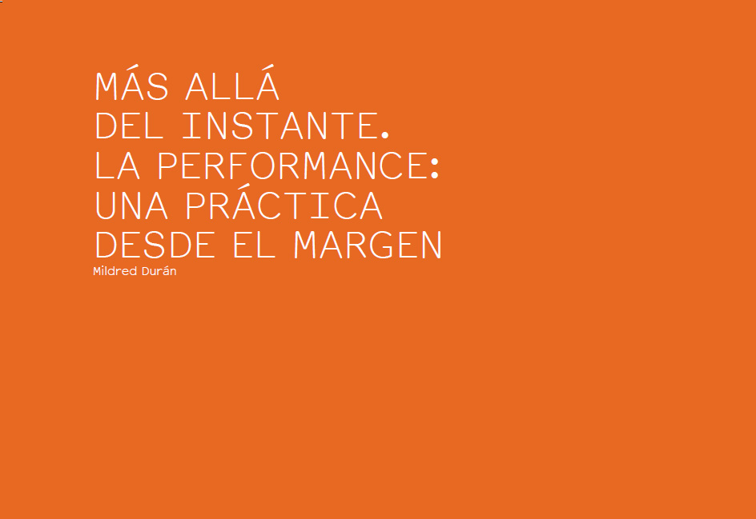
Persuaded that art would eventually dissolve into the real, Helio Oiticica sought above all to insert art into life, this being the essential principle that should guide all artistic practice. In the 1960s, the Brazilian artist adhered to the way opened by the avant-gardes of the beginning of the 20th century, which would be amplified in the late fifties and sixties, thanks to figures such as Allan Kaprow and his proposals for experimental practices that abolished the boundaries between art, the artistic object and the spectator.
Performance, marginal discipline, is one of the most complex and radical artistic practices in the history of art. She continues the path initiated through the processes of dematerialization of the artistic object, in which the artists sought to separate themselves from all kinds of free aesthetics thanks to the gesture of a specific body, in a precise and ephemeral instant. It is in reality that the artists of the per-formance strip away any useless narration of the work, purify the sign and transpose the semantic and temporal codes, favoring a gesture, an act, a presence. In this way, the essential qualities of the performative fabric that the specialist of action art, performer and theoretical Canadian, Richard Martel, describe as the intimate, the private and the public. For him "to make art becomes the alternative to produce art; then it is a matter of behavior and attitude. " The art of performance is, above all, "a disturbing activity" (Martel 1998, the translation is mine).
In the best known sense, the body of the artist is used in a specific context as material of work and creation. The performative attitude is possible thanks to the participation of the public or the use of objects, but it is not reduced to an action centered and exclusive of the body of the artist. The contextual question is determinant in these practices. In fact, an articulation between the context and the different spaces that welcome the action is essential in the symbolic construction of bodies, and thus constitutes one of the indisputable elements for performance artists. In the seventies and eighties in Latin America, the repressive and dictatorial sociopolitical context in most countries of the region gives rise to one of the most fruitful moments of the performative expression in which the body of the artist is conjugated in a politicized social body. The artist, as the Peruvian Fernando Bedoya points out, becomes a "conscientious objector" (2011).
Tehching Hsieh, an artist of Taiwanese origin based in the United States, is interested in philosophy and the meaning of life, his notion of performance work can be summarized through the idea of wasting time . For the Guatemalan Regina José Galindo, on the other hand, the experience of the moment is focused through performance, in which different tempos can circulate. In another context, Nyan Lin Htet, of Burmese origin, understands performance as a form of direct and conflictual communication between him as an artist - agent provocateur- and the public, which has the purpose of opening new avenues of reflection. For Felipe Ehrenberg, in Mexico, the performance creates a proposition of a philosophical order in which artists are defined as neologists . These propositions, which have as support the body, gesture, footprint or ephemeral, seek to become an ambiguous and uncertain terrain, a perpetual contradiction, an interstice of improbable encounters that allow new symbolic constructions or short circuits with the real. For Guillermo Gómez-Peña, also Mexican, his performative work is a forceful critical and political weapon that he claims as radical acts . Adolfo Cifuentes, in Colombia, conceives the body as a semiotic element that allows us to approximate the imaginary and the representation; for him, the body is essentially time making itself visible.
I mention these different conceptions of performative activity, without pretension to make a geographical sweep, but to account for the wide range of possibilities that cross it and the difficulty to establish a homogenous and universal definition. Each performer of the performance apprehends his own notion of the performative act, through his practice and his interests, reflections and sociocultural experiences. In Colombia, the unusual experiences in Barranquilla of two groups, El Sindicato (Efraín Arrieta, Alberto del Castillo, Ramiro Gómez, Carlos Restrepo and Aníbal Tobón) and Group 44 (Delfina Bernal, Álvaro Herazo, Eduardo Hernández, Fernando Cepeda and Víctor Sánchez), as well as the work of Jonier Marín in different contexts; all of which privilege conceptual and performative strategies within their artistic practice. Also worthy of note are the proposals of other pioneers of this discipline: María Evelia Marmolejo, Luis Alfonso Suárez, María Teresa Hincapié, Rósemberg Sandoval, Dioscorides Pérez, and later Adolfo Cifuentes or Constanza Camelo, among others.
Thanks to the invitation of Adolfo, in turn one of the first theorists of performative practices in Colombia, we have configured for the magazine Errata# a rich dialogue in which we discuss paradigms, confusions, the evolution of performative language in different contexts, among other topics. In this issue, devoted to these hybrid practices and constantly evolving, we decided to confront different questions and theories about this discipline and its potentialities. We do not intend to make a taxonomy of the practices of the per-formance, nor of its evolution in the history of contemporary art. Our interest is to understand the processes that influence the preponderant role that these practices have exerted in the contemporary art, through significant cases, because in them it is possible to elucidate the intentions of some neologists, which elevate the body as a destabilizing and critical presence and power in different contexts.
Different questions frame the preparation of this edition of Errata # on Performance, actions, activism. We delimit the analysis to follow by three main axes, starting from reflections that arise (1) from the very practice of the discipline from the different processes of creation, (2) from its spatiotemporal and contextual particularities, and (3) artistic, research or theoretical. In the background, in particular, in my research on the subject, the question of reception
and exposition of the ephemeral instant to understand the relation with the spectator, but also the interest and the role that different institutional actors play there. In this sense, the analysis of how today permeates the current curatorial and museographic practices based on their own evolution as a language is fundamental. In this same direction, we include in this dialogue the question about the reactivation and retention of the ephemeral work from its acquisition and conservation; issues that are essential to the issue of archiving and historicizing these ephemeral practices, and which aim to raise awareness of the art institution, the market and the collection of this type of immaterial work.
The main objective in this edition of Errata # is, then, to deepen these questions and confront them with different contextual and spatiotemporal reflections by performers who come from different cultural, economic and political realities. Thus, in this issue we find figures who are traditionally very relevant and also very critical critics of this discipline.
Considered as a contradictory, transgressive and disturbing expression, largely due to its unpredictable and immediate nature, the performance becomes a privileged mechanism for artists seeking to influence the social sphere; it is not gratuitous that a political, militant and activist dimension is for some performers the very essence of their artistic ethics and responsibility in the socio-economic and political context in which they live. Recalling that for Adorno the very essence of art is freedom, Chumpon Apisuk in Thailand conceives art as the freedom of nonsense, as "a kind of emancipation where one is aware of the freedom of body and spirit without any limit with the society "(2014).
In my contribution to the configuration of this reflection, it was logical for me to invite artists who theorized about their own creative exercise and who had more than thirty years of artistic practice, discursive and theoretical, prominent figures that would have marked the history of performance of the 20th century and today. I proposed to present different conceptions of artists and theorists from various regions: Richard Martel, from Quebec, questions the practice, limits and challenges of this discipline in a historical and universal way, noting the importance of the periphery, the margins for the consolidation of new channels of circulation and dialogue of these immaterial productions.
In this global panorama, the art critic, curator and poet Nelson Herrera Ysla brings a perception focused on particular practices, and its evolution in the last decades, in the Cuban context; explores its impact on the pedagogical field and the influence it has exerted on the new generations of artists. Chumpon Apisuk Finally, he approaches the Thai and Southeast Asian context from a conception that links art and politics, and reflecting from an independent management trajectory and evidently contestatory actions carried out in that region of the world.
The text of Richard Martel, "Art action and performance: peripheries without center!", Is the product of that tireless work that develops since the eighties.
His role is indisputable with the artists of the Le Lieu collective in Quebec, both in the diffusion, in theorization and in criticism: first, through the creation of the Le lieu Current Art Center, the Inter and the Inter art actuel magazine; and also with the establishment of the Rencontre Internationale d'artperformance de Québec (RIAP), one of the first performance festivals. All this began at the beginning of the 1980s and placed it as one of the fundamental pioneers in the opening and consolidation of this South-South dialogue, between artists of a marginal discipline at the beginning, typical of the geopolitical periphery ( ignored in the cartography of contemporary Western art). In his text, Martel approaches different aspects of the practice of art action or performance, analyzes its historical positioning, decentering as practice and as a place of aesthetic experience and style. It also reflects on the question of the dematerialization of the object of art and what it implies both in practice and in the notion of the periphery through different artistic, political and institutional prisms. It also addresses this thorny issue of the definition of performance, which clarifies our preference for the termaction art ; and, finally, closes its analysis with a reflection on the direct reception of these practices by the public, taking into account the role of the new communication tools of cybernetics social networks.
In a historical tour, Nelson Herrera Ysla traces a map of Cuban art and its evolution, starting with the founding generations, especially in the 1980s, made up of groups such as Puré, Calle Arte, Volumen I or the project "Hacer" , and the influence they exerted on artists like Tania Bruguera, to address the current generation that privileges, among other languages, performative discipline. Nelson also performs an analysis of the group of artists that he himself selected to participate in the Riap 2014 in Quebec: Mayim-b, Adonis Flores, Marianela Orozco and Elizabeth Cerviño. In his text he also studies the unprecedented case of experimental Cuban pedagogical processes that start from the initiative of artistic figures of the island and that are concreten in different proposals: From A Pedagogical Pragmatics (DUPP), Enema, the DIP and the Chair of Conduct Art. To amplify the field of analysis, Nelson also evokes in this tour the role of performance artists and their participation in the Havana Biennial throughout different editions, and their relation with the actions carried out in the urban fabric and with the population, which constitute one of the specificities that the Biennial has promoted since its creation as a field of experimentation.
Chumpon Apisuk, a pioneer of this discipline in his region and globally, proposes a tour through the evolution of his own artistic practice and management of performance encounters, which has been inextricably linked to the development of the history of performance in Thailand . Chumpon is the first artist to open the way in the eighties to performing art. Through different times related to his learning and artistic training process, both in Bangkok and Boston, his step as a reporter and activist in New York, and his return to Asia first to China and then to Thailand, his text reveals his beginnings and interest in the discipline of the ephemeral instant and its undisputed will for a political and activist art.Concrete House in Bangkok, an alternative artistic space where it develops awareness work on the AIDS population, and from where it defends the rights of prostitutes. Chumpon also addresses the question of interest in performance practices, especially in Southeast Asia, highlighting his decisive encounters with other performance figures in the region (notably Lee Wen of Singapore and Seiji Shimoda of Japan). He thus conveys the dynamism of the field in that region of the world, giving an account of the process of creation, development and consolidation of one of the most important performance festivals currently: Asiatopia, which he created in 1998 in Bangkok.
In "Rethinking aesthetics", a dialogue of members of the Erratta National Committee with Jacques Rancière, published in the issue devoted to Ethics and Aesthetics , the French philosopher stresses the importance of the study that contemporary performance can exert in construction of forms in space, and organization conducive to exchange and discussion. In fact, for Rancière these are more important than the existence of a new art or a new artistic paradigm. In his criticism of Nicolas Bourriaud's relational aesthetics, Rancière clarifies this tendency to interpret and affiliate performance with this notion of relational art, recalling that the art of performance, face-to-face art, has been combined with other arts throughout the 20th century .
This porosity, that faculty of contamination of performance by and towards other arts, is part of its very nature, where different types of expression and temporality are conjugated. In order to approach this question that goes beyond the analysis centered on artistic practices, I considered it pertinent to extend the field of approximation, reflecting on the complex thematic of the different processes that surround it: from diffusion, exhibition, acquisition to conservation of intangible works by professionals of the art of the most varied artistic institutions. I decided to incorporate another context with a great inheritance and awareness of the role of performance in the history of contemporary art, summoning the experience of three figures from the current French art scene working from different places. They accepted to be part of the conversation Alexandra Baudelot, co-director of Les Laboratoires d'Aubervilliers, a space located in the Paris suburbs dedicated to the promotion and support of multidisciplinary experimental proposals, which gives a central focus to research, processes and performative theories ; Mehdi Brit, young curator and performance art critic, director of the "In Process" program, per-formances cycle held during the International Fair of Contemporary Art (Fiac) in Paris and performance programming in different spaces the Louis Vuitton Foundation, El Silencio, etc.); and Sébastien Faucon, responsible for the contemporary collections of the National Center of Plastic Arts (CNAP) of the Ministry of Culture and curator of different projects that question the traditional format of art exhibitions and curatorial practices. For this purpose, Faucon proposes samples designed for a public performer, ie in total osmosis with the expository device. Sébastien's role is also essential for understanding the evolution, interest and difficulties of acquiring, preserving and building collections with ephemeral and performative works; processes that in France, unlike the Colombian context, have a tradition and occupy a central place in both state institutions and private collections.
This issue of Errata # seeks to provide the necessary tools to delve into this series of concerns and enrich the debate and analysis about this practice and its artists who persist in betting on the strength of ephemeral gesture and presence; to think that unlikely and staunch dialogue with the real of this discipline of the moment that seeks to dilute, defer or activate through time.

References
Alcázar, Josefina. 2001. «A look at performance in Mexico», in: With the body ahead. 47882 minutes of performance , National Institute of Fine Arts.Mexico: Ex-Teresa Arte Actual.
Apisuk, Chumpon. 2014. «Interview with Mildred Durán», November. Bangkok: unpublished document.
Bedoya Fernando. 2003. «Interview with Mildred Durán», October. Havana: unpublished document.
Brett, Guy. 1995. Fait sur le corps: the paragon of Helio Oiticica . Paris: Cahiers du Musée national d'art moderne.
Cifuentes, Adolfo. 2004. "Body and Weapon", conference for the Master's Degree in Art History from the National University. Bogotá: unpublished document.
Galindo, Regina José, 2011. Correspondence with Mildred Durán in November and December.
Unpublished document.
Gómez Peña, Guillermo. 2000. Dangerous Border Crossers . London: Routledge.
Heathfield, Adrien and Tehching Hsieh. 2009. Out of Now , The Lifeworks of Tehching Hsieh .
Cambridge Mass .: Live Art Development Agency - MIT Press.
Kelley, Jeff (ed.). 1996. L'art et la vie confondus Allan Kaprow , Jacques Donguy (trans.).
Paris: Center Georges Pompidou.
Martel, Richard. 1998. L'art en actes. Performance. Installation. Manœuvre. Average Arts.
Québec: Le Lieu center in art actuel.

