ART ACTION AND PERFORMANCE: PERIPHERIES WITHOUT A CENTER!
Author:
Richard Martel
Edition:
ERRATA # 15: PERFORMANCE, ACTIONS AND ACTIVISM
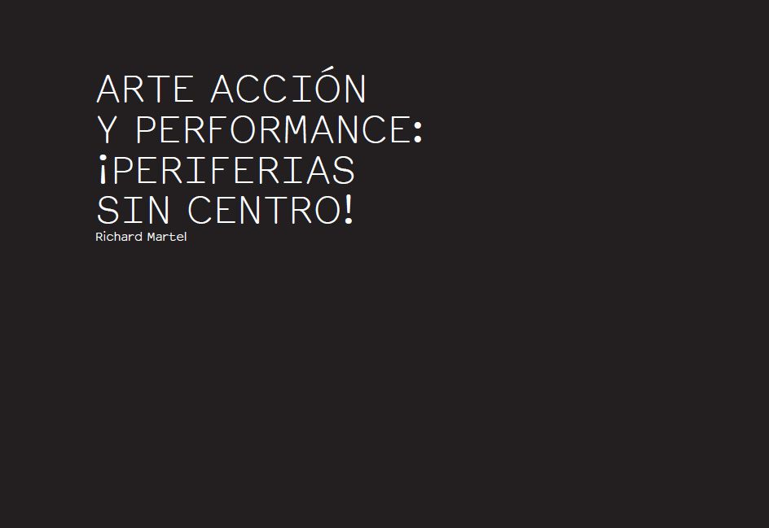
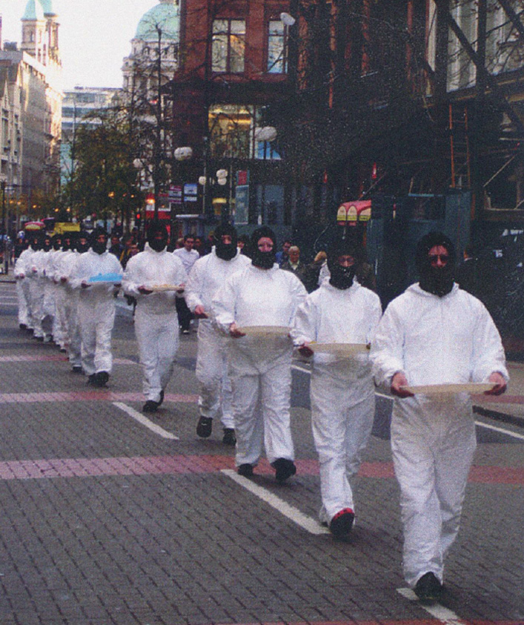
Richard Martel, Déambulation Exchange Places, 2006.
Beyond, Belfast, Northern Ireland.
Prolegomena
Writing about the practices of living art, that is, about performance and art action, in 2015, is a task, especially if you seek to circumscribe the trends here and elsewhere, knowing that this type of discipline is in continuous renovation. It is almost impossible to generalize a delimitation that is just and tends toward universalism. Artists are plentiful, their productions, multiple, and festivals are performed a little everywhere. In the era of globalization there is a cultural invasion by artists of all categories; however, it is the artists of the art of action that interest us here.
First of all, a difference of terminology should be established. I advocate using the term "action art" instead of "performance," a word that is used for all sorts of occasions: one speaks of the performance of a bank, a car, and even a particular sport. ₁ We must make a delimitation through language, and it is vital to carry it out in a committed way, in a kind of detachment from conventional structures.
The action art has a historicity and a future that artists contribute to "feed" with their gestures and positions continuously, and is in the process of mutation. In art there is a great reciprocal contamination and the forms are in permanent transformation. Generations follow and preoccupations diverge and conform to the social fabric and are related both to human relations and to institutions, whether these are more or less 'official' or 'alternative'. At all times the artists act framed in the historical consciousness of their time and always have proposed renovations.
Positioning in history
Emergence of the individual: when we go back to the fifties, a concern for the positioning of matter and the person, and for what constitutes its unfolding in history, is consolidated. In architecture, for example, in the framework of brutalism we speak of materialization: the material must "appear", show its textures and what constitutes it. In music also the sound is proposed as matter and this will be denominated "concrete music", denomination that is very pertinent. In literature, with the "new novel", attention is again directed more to the author than to his historical context; a kind of introspection is set up. Is this an influence of human rights that, as we know, date back to 1948? In painting the materiality and the various components of the "pictorial" are studied as if it had been declared:
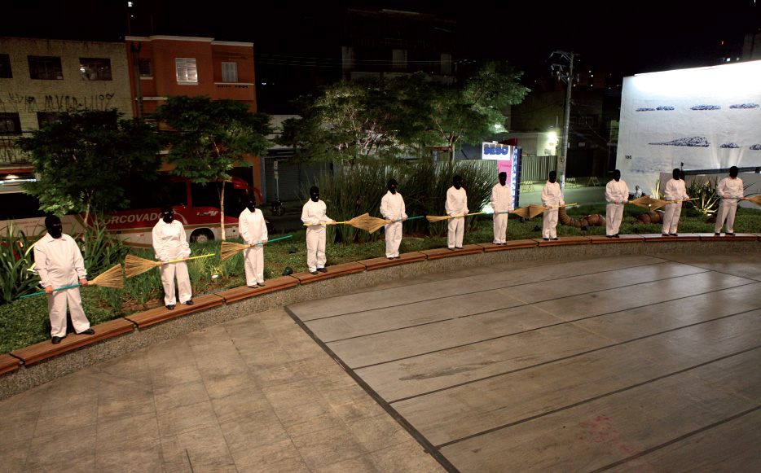
Richard Martel, Déambulation integration-action, 2011. SESC Pinheiros, São Paulo. Photo: Patrick Altman.
In addition, the arrival of new technologies, tools and machines allows to use new parameters and is installed at that moment a kind of "work in laboratory"; the artist is more like a "philosopher engineer" than a "decorator" or a "cultural entertainer." Consideration should also be given to the research of the human sciences in artistic processes, which leads to a panoply of analysis and, consequently, to questions. The art and its multiple supports undergo a destabilization both in its content and in the forms that lodge it. This involves taking position and interrogating both categories and systems. From this analytical character, the artistic proposals are agitated and alternatives emerge in the diversified field of culture to a very large extent.
Something else must be taken into account, and it is the fact that the artists of the sixties obtained mostly titles from specialized schools or universities; and this involved at least a theoretical approach, which in turn facilitated the analysis and an implication in a "research" that involved entering into diverse methodologies and contexts. Here, the forms and categories are pulverized and will lead to military then by new strategies that will eventually pop the disciplines. That is why this concept of the "dematerialization of the work of art" comes. Thus arise a multitude of aesthetic attempts, such as the practices of "living art" such as action art and performance.
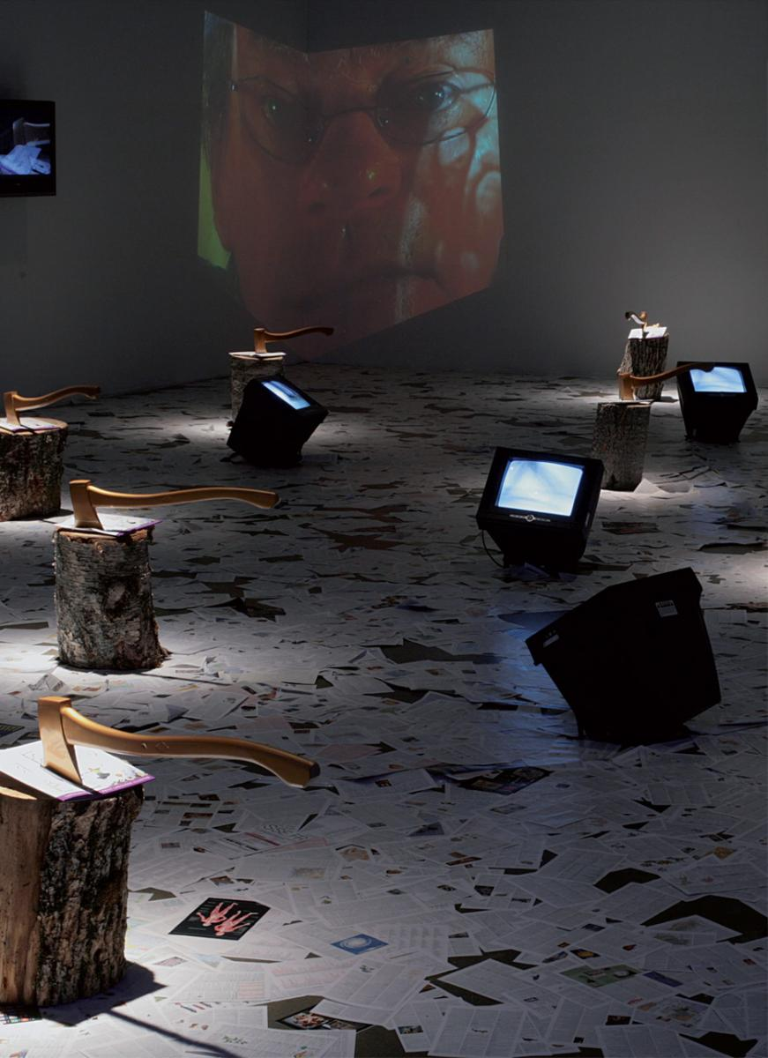
Richard Martel, La Conquête OEil de poisson, 2008. Video installation, Québec. Photo: Ivan Binet.
There is also contamination of some disciplines by others, of music passing through poetry or the plastic arts. In the artists of Fluxus, for example, this is absolutely evident. The 1960s witnessed the emergence of new media such as tape recorder, video and various mechanisms and instruments with which artists "experiment". This gives rise to a series of new practices that will speak of "artistic proposal" much more than of "work of art". It is, in some way, a transformation both formal and conceptual. The famous debate of the twentieth century, in the context of the avant-gardes, between poetry and the plastic arts, gave rise to the emergence of many positions among its protagonists and still continues to do so! But this also allows us to adopt a position.
Obviously, we can understand that this "attitude" is not new; its precursor might be found in Greek cynics, for example. At all stages of human history artists and intellectuals have subjected institutions of power to criticism, and this has led them to some research work. This same type of attitude implies taking into account the physical and psychological reality of the artist / sender. We are aware that the main axis of involvement is much more in the person than in his work.
The positioning in art action is justified in the social, technical or aesthetic changes characteristic of the great transformations, mainly that of the sixties. This stylistic outburst is evident in "decentralization", that is, in detaching itself from the center towards the periphery or peripheries. There is a structural homology: the peripheries are political, institutional or disciplinary. It is here that performative practices are justified both in their materialization and in their diffusion.
But there are books and stories about the development of these "disciplines", which consolidates these alternatives and their deployment in the socius ₂ . In most cases, this implies a responsibility of the artists themselves, rather than an institutional implication. We are talking then of a kind of 'self-management', of a sort of 'counterculture'!
Make art more than produce it
A postulate: all questioning of the formal plane calls for a recoding-or recoding-action -of its place in the architecture of the system that manufactures or distributes it. To dematerialize art is a diametrically opposed, dynamic approach in the hierarchy of presentation and demonstration systems.
The actuality of the process thus acquires an important dimension and can prevail over the product. We jump from producing to doing: to "recontextualize" the process of delimitation of artistic energy and its distribution. Has the conceptual apparatus also contributed to transforming the aspect of artistic fact? Proposals can claim halogen status in the cacophony of artistic projects!
This makes us reflect, since an act in process is nourished by a certain activity that is being programmed or installed, as if it were a solution to the interior of the excessive gear of the globalized culture. Now more than ever we need to renew our imaginary, both personal and collective, transform the codes, and, within art, the very nature of the medium: everything pursues an existential search. This is part of an active and reflexive positioning in order to renew these structures of behavior and language.
Make art, not produce it : we suggest to propose an artistic activity that wants to replace the work as an end. It is convenient to find new mechanisms and choose a different option in peripheral systems, where the imaginary finds a terrain to experiment and achieve concretion. Likewise, we must reshape, make a proposal that is affirmed as a situation against the order constituted and fixed by the institutional fabric. Acting means that we do not stick to the limitation and that we investigate, in a constant adjustment of the efforts to determine a future not conditioned but open to the peripheries as indeterminate and volatile disciplines.
Center and periphery
Between the center and the periphery there are substances and morphologies that perform a dance in the chaos of relational interactivities. Programming is then infected and reformulates the mechanisms that compose it. A reorganization accompanies the distribution of actions in the context in which it is presented; a context that must then be updated by means of unconventional acts that incite a position and propose a model based on the determinisms that are sought, perhaps, to pulverize or destroy.
The direct action, the objective intensity, the energy used are an offering in the cultural immensity, which is politically conditioned, that is, metaphysically. Social mechanics is a flattening machine. In its gear, sediments of deregulation are deposited which can be activated in areas of poetic plasticity. Transforming mentalities is more rewarding than putting works in a museum! It is a transit of the ornamentation to the questioning, a detachment of the conventional fabrics, a potential pulverization of that act from its own questioning; as a mirror that updates its presence more or less functional, but, moreover, more or less destabilizing. It is necessary to reaffirm the artistic position as a relation of osmosis in the institutional tentacles, reconfiguring the styles of practices and providing opportunities for drive delirium; contaminate reality with imagery to reaffirm our methods of thinking. Since thought is subject to social order, our opinions are relative and our perceptions are cultural differences equally subject to fluctuations of all kinds. Thus, the artist is not free, because he is molded by the territory of his action and is prisoner of the staging of the order of his lived experience. This is why network relationships are decisive because they provide the opportunity to check alienating situations, and because they also allow confronting motivations and perspectives, even if they are paradoxically organized in the universe of creation: here the act is a proposal in the mechanism of exchange.
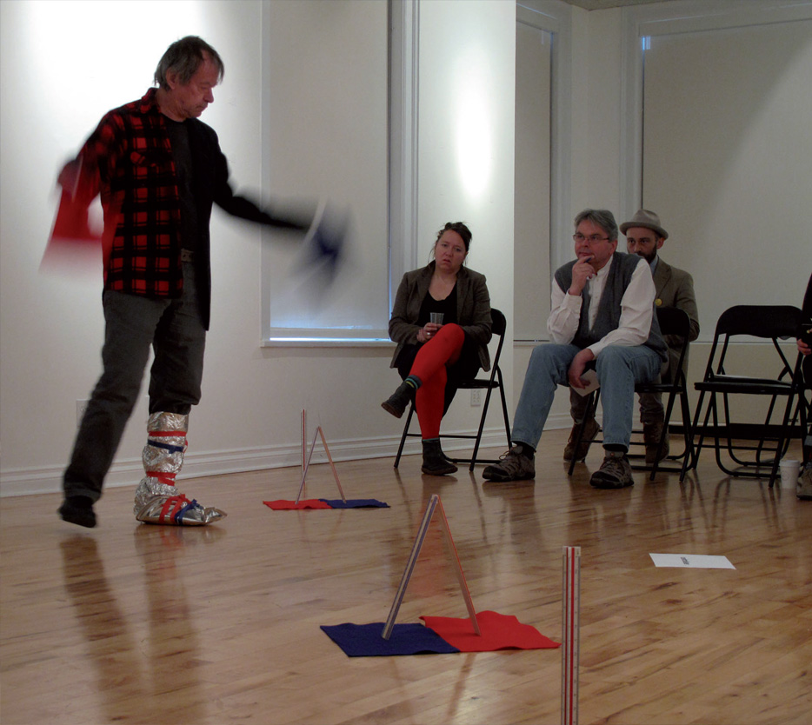
Richard Martel, Construction / Déconstruction, Maisons des artistes visuels francophones, 2014. Winnipeg, Canada. Photo: file of the artist.
The event must be conceived: to organize meetings, to activate thought, to imply praxis, to break with habits, to pose behavior, to intervene in updating conventions, to do what is possible between uncontrollable potentiality, to affect more or less fictitious devices, to manifest a metaphysics of the strange. We must achieve this correspondence and allow delirium (here, also, more or less constructed), to infiltrate and destabilize, to find new dispositions to slide the imaginary in the components of the real. Against the hegemony of directed thought, either politically or religiously, it is necessary to resume solidarity in relationships on a human scale because we are rational animals endowed with sensible and intellectual systems. In fact, it is necessary to define contact areas through dialogue and "closeness", to affirm communication, especially in this epoch of virtual mechanisms; to undertake the ritual in festive revolt against all kinds of contaminants, to recognize allies beyond the differences.
It is necessary to reposition the human at the center of the discourse, to determine relations in spite of oppositions, to confirm loyalties and networks, to allow both ideas and practices to be shaped. We must seek tolerance in the midst of hierarchies to create areas where sharing takes place rather in dialogue; practice ludic activism and denounce the lies instituted by abstract mechanics of language as a reflexive level. Finally, let us propose to understand and legitimize critical and polysemic positions, and militate for equality, being faithful, however, to our differential logics.
Thus, it is essential to consider the peripheries in the political, institutional and disciplinary axes. As a system proposal, relativism lies within the hierarchy: a desire to propagate an active angle of attack, decentralized, but aimed at obtaining legitimacy for the periphery.
Political, Institutional, Disciplinary Peripheries
A political periphery demands action that propagates outside the great dominant centers and a geography of network colleagues, related in reciprocity.
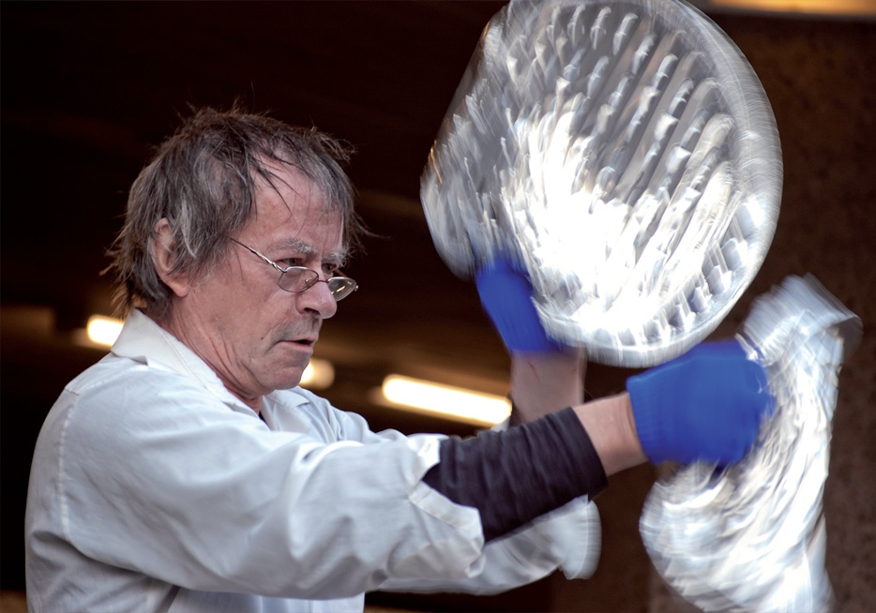
Richard Martel, The creation of man as ready-made, 2011. Paersche, Cologne. Photo: Thomas Danielowski.
Against the preponderance of the great artistic capitals, such as New York, Paris and London, the so-called intermediate citiesmust get in touch on the artistic level, propose peripheral links that enter into communication and network solidarity. To consider the peripheral zones as a relational and political system is to promote cultural construction without the need for quantity to prevail over quality. It is also to produce their own culture as an option and solution to supremacy, especially in this age of cannibal globalization of destructive monetization.
An institutional periphery proposes to modulate the gear so that the distinction understands the operational organizational. In this distributive act occurs a destabilization of the so-called reigning model. Spaces and architecture are never neutral data, they give form and materiality to the device that sets them in motion. We must return to the human scale through practices that juxtapose the festive through plural, polyphonic dialogue, in the sense that the symphonic aspect prepares the structure of the statement. The museum institution loses the monopoly of aesthetic discourse as soon as the scale is relativized. Let us return potentially to the tribe, to a "group" position, to establish bridges, to produce self-management, to hold people accountable through participation that we call "project". By organizing a microorganic model, we dynamize its management mode by making the creative moment in solidarity. The museum institution imposes models in function that demands its architectural space: adjust to its measure to submit the aesthetic system to the conditions of its presentation; a limited and orchestrated technical assembly, which leads to compliance with a formal delimitation. In the "eternal network" being "responsible" is the effect of belonging to an original mode of management that an active solidarity fabric. The more or less alternative centers, always on a human scale, are lighthouses and stills where art is catalyzed into acts, often in a festive, non-competitive atmosphere. It is a kind of dynamic mobility that involves communication and exchange, a process of contagion of creative energy through a "transformer" in the distributing machine, and it is also a safety valve against the preponderance of the dominant static model that founds and tries to delimit aspects of the product. What an imposing system!
A disciplinary periphery is affirmed through the renewal of forms and materials. Again, betting on the application of the human scale involves a reformulation of aesthetic grammar and points to an off-center utopia: art action as the possibility of inserting a blade of grass into the machinery, to affirm a gesture or a situation propitiated in the moment and from the context that is promoted. Here too, against the hegemony of the genres, interdisciplinarity means renaming the systems of expression. Equally, against the commodification, the periphery proposes a praxis, a process that is fulfilled giving shape to the situation beyond impositions and habits. In any case, we have observed that the new generations of artists handle different "disciplines" and that there is a determined search for changes in both method and themes, both in forms and mechanisms, impacting on the push and agency of artistic orientation. Against the absolutism of the dominant archetype model, the artistic effort seeks to detach itself from the (conventional) system of the interior and modify it, producing proposals that are notworks , but events turned into acts of creation: to do more than to produce! A disciplinary periphery justifies a panoply of moments and bets of resistance in the midst of the instituted magma: to destabilize by means of an imaginary, sharpen reflection and act in unconventional circumstances.
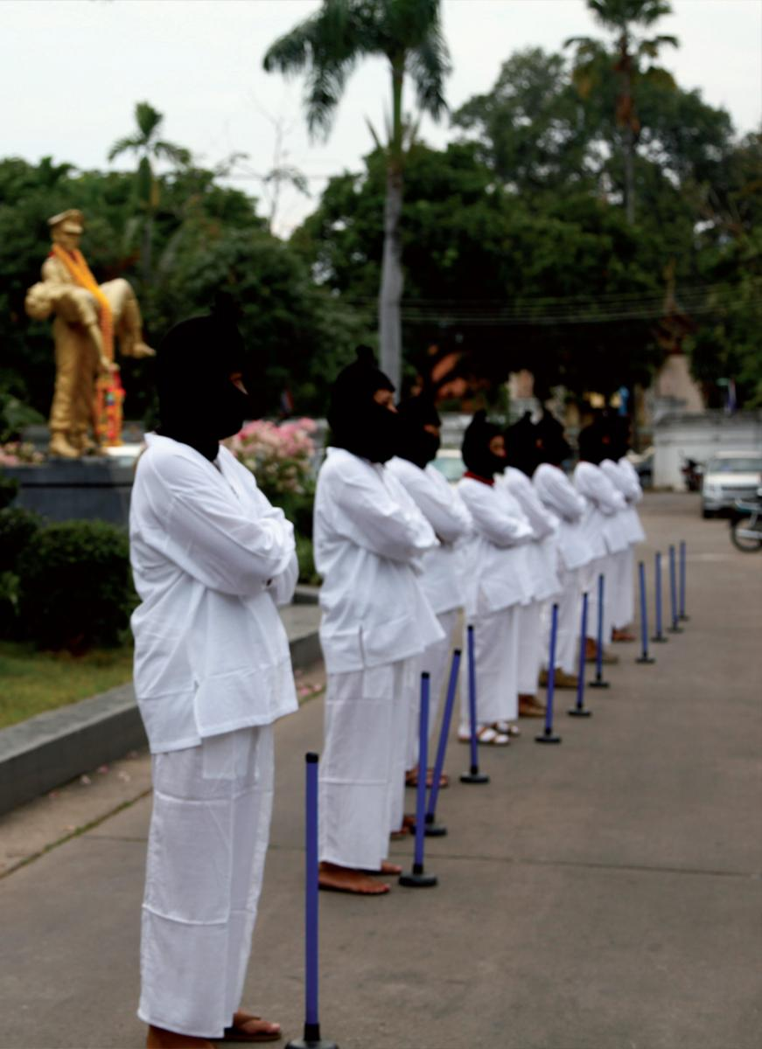
Richard Martel, Déambulation in thaïlandais sol, 2011. Festival Asiatopia, Chiangmai, Thaïlande. Photo: Patchara Thaïsup.
A definition of performance
Here I propose a "possible" definition of performance or art action:
Performance consists of updating a variable content in its expression against a potential audience; is both an attitude that aims to liberalize habits, norms, conditioning and, at the same time, to destabilize the codes of representation, of knowledge, of consciousness, to reformulate them. Performance is a placing of materials within a context, a removal of "conventional" relationships and a transformation of stylistic categories.
The performance disseminates the cultural experience and seeks to establish possible places in the hegemony of the more or less institutionalized forms, according to the genres and the affirmative or critical needs. There are performances resulting from practices such as visual arts, poetry, music, theater ... and others point to criteria that draw methodologies beyond conditioning and conventions, trying to give their positioning a functional originality. There are as many types of performance as performance artists. The cultural characteristics of an ethnic group or of a geographical space-time are criteria that influence its presentation. The same performance will be perceived differently from one geographical region to another. The performance is articulated, most of the times, depending on the context where it occurs. There are performances in which the body is fully present, others where the "objetual", media or technological equipment becomes paramount in the proposal. Sometimes the stage device composes the essence of the activity, in others the research work involves theoretical questioning, while at times there is an interaction between artist and audience.
At the level of official recognition of this type of artistic practice, historically the performance results from the dematerializing practices of the sixties. However, performative actions find their historical basis in the protagonists of the vanguard of the beginning of the last century: Futurism, Dadaism, Surrealism ...
The hybridization that the artists of the eighties promoted against the specialization and the trade confirms the artistic versatility, be it multidisciplinary or interdisciplinary, characteristic of the performance as an attitude that aspires to liberalize the established objective criteria. Ultimately, there will be Expressionist and other "ritualistic" performances; however, modes of presentation are instances that teach us how artistic-poetic activity is performed in a given context. The responsibility of the author reveals his commitment and the validity of his affirmative and symbolic potential.
The social organization, the religious context, the technological evolution, the standard of living and other cultural features are the axes on which the performer performs. The level of its response is given by a sociocritical analysis of the philosophical presuppositions that the artist puts in question; the freedom of the performer is correlative to his commitment to art. (Martel 1996) ₃
The meeting, the public, social networks
The action art is today a recognized discipline and even imparted in the universities practically to world-wide level. One issue that remains important is that of public presence. We note, in fact, that in the new generations the motivation is more than anything at the level of "individual expression", which, in the end, does not necessarily require the presence of a public? Particularly with social networks, which artists have in mind, it is possible to speak of a "performativity" that considers its audience in the dissemination of the activity in the networks without the presence of an "updating" of an audience. However, let us remember the case of Rudolf Schwarzkogler, the Viennese action artist who recorded in 192 photos an action without public, made exclusively for the photo! A paradox!
For example, the Semefo group in Mexico claims the direct influence of the action, as these photos of the performance of the Viennese artist do not leave anyone indifferent. Imagine: an artist in his room performs any action, captured in a photo or video, and "injects" on Youtube almost immediately after ... Do you lack public? Will you know if this has an impact? And another realization: someone sings a song on the corner of a street; also this is captured and uploaded to Youtube ; but does it really communicate? Is this also clearly effective?
The question arises: does this need to document and verify the number of 'followers' are the result of the demands of the public authorities which 'support' and 'subsidize'? Is there a certain control here? This question deserves to be formulated!
With the encounter, the exchange, the contact, the action art physically points to an osmosis, whereas the acts "in private" and disseminated in a mediatic way, perhaps constitute a certain diffusion, but without "infusion" and perhaps without so much impact? The relationship is here virtual, not direct. How should we understand that the goal of "diffusion" prevails over production and even the Orient?
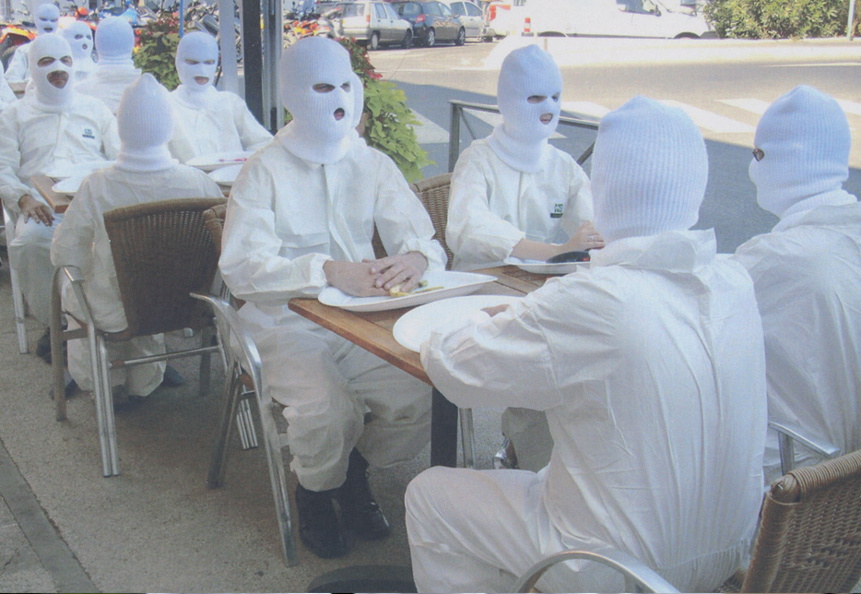
Richard Martel, Déambulation, 2008. Festival Infraction, Sète, France. Photo: Valentin Torrens.
However, action art artists know to what extent the presence of an audience remains important. Often this directly influences the protagonist: doing an action against twenty, eighty or two hundred people has an impact on their development itself; even more, on certain occasions it can even "condition" the activity, a fact which must be taken into account!
The means of 'communication' are not recipients, but rather dissemination opportunities, and a proposal has to take into account both physical and psychological contextual conditions and the presence of an audience. Let us not forget that the relationship with the public comes to fill a void, namely: it opposes the solitude of the workshop; a situation where the artist works isolated, and is on the day of the inauguration (and often only then) to the art fans. It is difficult to know the degree of reception in that case. And this is an additional explanation of why artists have come to present live the "artistic act"!
In short, then, performance is an art of presence. And we must understand what this means: that this presence occurs within a relational praxis, and thus, the presence of the public becomes an accomplice component in action art. In the last century, theater was "surpassed" by cinema and then cinema by television, and television now by social networks. However, theater continues to exist, as does film and television.
Going back to the sixties, we have the impression that at the time it was mainly an impulse directed to the outside, towards a public that had to "provoke". On the other hand, the often "solitary" actions in the execution of recent artists find their "audience" in the mechanisms of diffusion; particularly in social networks. Micropolicy rather than "great stories"!
The relation of the emitter-artist to the public is somewhat transformed! At the organizational level the partnership is possible and even necessary; the "formation of networks" is a matter of affinities, and at the time the concept of natural network as that which exists first physically between people, as opposed to the "artificial" network of various types of connection due to communication mechanisms.
With Le Lieu, center in art actuel we have organized eighteen meetings on the subject of the action art and the performance and, in these last editions, the selection was made by geographical zones. We have shown cultural criteria specific to each region. There is a great difference of expression between the Brazilian, Cuban or Spanish artists ... but this is not something that one discerns in a night with performers of different countries. The fact of selecting by "region" would seem like a test to extract the motivations of action from their cultural baggage; and this we have seen in festivals we have programmed in recent years in which the selection have made contacts or organizers of the respective regions.
In this way, the so-called "festivals" are privileged moments to dynamize the discipline; are occasions of encounter and exchange where a kind of "camaraderie", a tribe in the anthropological sense, takes place. Festivals are occasions to highlight transformations or "conformities," and favor confrontation as well as relationship. This very concept of 'relationship', with relational aesthetics as confirmed in 1990 and 2000, shows that the dimension of sharing is as important to the 'sender' as it is to the 'receiver'. Even if it seems that these ideas are from the fifties, paradoxically they are still so current!
We unanimously recognize the pertinence of organizing meetings and other performative occasions, and in any case there are those who question whether it is still important to do them. From the moment in which the new generations seem to favor their "performative enunciation", through the insemination of media devices, the question of the "recipients", in the sense of assimilation and projection itself, is outlined!
In the community of use, through social media, an interactivity is still possible: there are links that confirm such presence!
The action art is in process, in permanent redefinition, we will not be able to say how it will be in the future. However, if the performative act uses processes, elements of the spectacular, it is advisable not to fall into the "spectacle" (as discussed by Debord and the Situationists). Let us try to continue these trajectories by fusing, uniting or disjoining the implication of the person, since it is not necessarily the institution that produces and, as Robert Filliou pointed out: "Art must return to the people to which it belongs!"

1. A word that in English most commonly refers to the level of "performance" or "performance" of something [N. of the Trad.].
2 . Socius understood as described by Giddings, in his "Principles of Sociology": the individual who is not only an animal and a conscious spirit, but also a companion, an apprentice, a teacher, a collaborator. No of Erratum.]
3. This text, published for the first time in 1996 in the number 66 of the magazine Inter, art actuel , has been abundantly quoted. We highlight some cases: in 2003, in the reissue of L'acte pour l'art by Arnaud Labelle Rojoux as "The best recent definition of performance in the French language, the most synthetic"; recently, Eric Mangion, uses it in the catalog of the exhibition «À la vie délibérée !, 1951-2011»; in the book Interviewer the performance of Mehdi Brit and Sandrine Meats (2014); and Mobilemagazine , album / international , which publishes the entire text and proposes an English version. [ N. of MD ]

