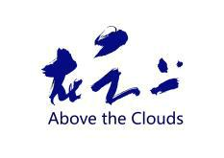

“Above the Clouds” International Live Performance Art Festival

2023“Above the Clouds - International Live Performance Art Festival”

He Libin Performance Art Workshop, No. 2007, Building 1, Southwest Yi, No. 8 Longrun Road, Kunming, China

Kong Art Hspace, Section C of the Jinding 1919 Art District, No. 15, North Jindingshan Road, Kunming, China

Tel.: 0086-13987660923
E-mail: 863511927@qq.com

Dear Chantawipa Apisuk:

“Above the Clouds - International Live Performance Art Festival”, as an international art exchange program, is dedicated to the development of performance art in China and the establishment of an open platform for international art exchanges. The Art Festival was successfully launched in 2009, and has been successfully held for six years. Over 100 artists from China and overseas have participated in its various activities. “Above the Clouds - International Live Performance Art Festival” has become one of the most important platforms for academic exchange for live performance art in China’s contemporary art circle.

- In view of your academic influence and important contribution to live performance art, the executive committee of the Art Festival would like to extend our warmest invitation to you to participate in the Ten “Above the

Clouds - International Live Performance Art Festival” to be held in Kunming China from August 16 to August 23, 2023, and to present your works on the spot. We believe this is an excellent opportunity for outstanding artists from around the world to share and exchange ideas with each other. Your participation will make the Art Festival more fruitful and successful.

As the organizer of the festival, we will provide it for you free of charge

Eating, housing and transportation of art in China during the festival. And subsidize 2000 RMB for international travel.

Looking forward to your coming!

With My Sincere Regards!
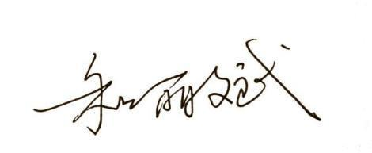

Curator of the 2023 "Above the Clouds -

International Live Performance Art
Festival"

He Libin

July 26, 2023

