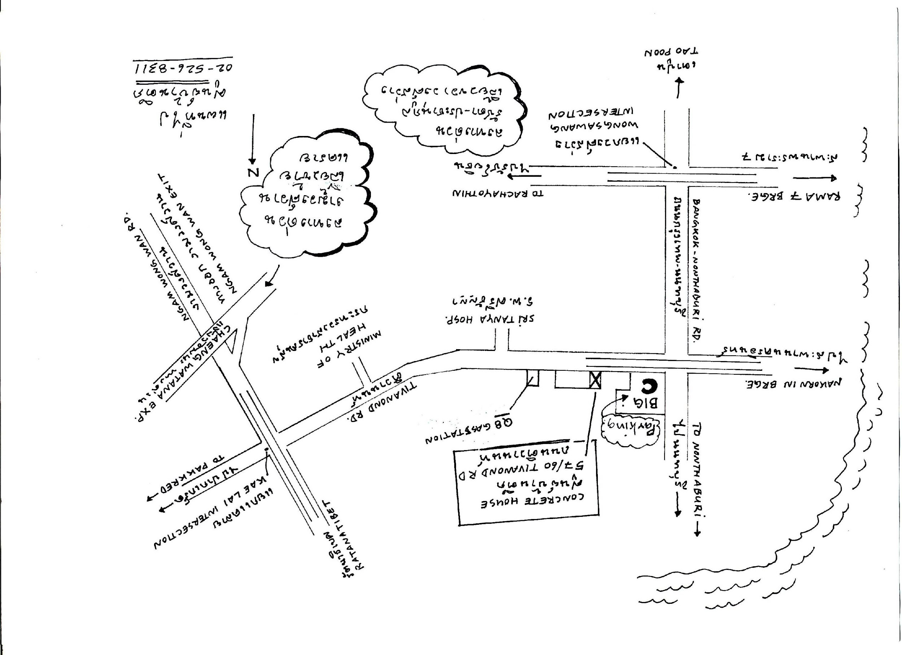

CONCRETE HOUSE

CORDIALY INVITE YOU AND YOUR COMPANY TO

THE OPENNING OF “SAMAI DIALOGUE”

A MONTHLY CULTURAL DISCOURSE/MULTI-DISCIPLINARY PROGRAM

THURSDAY 6 FEBRUARY 2003
6 – 10 PM

AT CONCRETE HOUSE, NONTHABURI
(PLEASE SEE MAP ON OPPOSITE SIDE)

DIALOGUE WITH SURACHAI JANTIMATORN (NGA CARAVAN)

TRIO PERFORMANCE BY PAISAN PLIENBANGCHANG, MANA POOPICHIT, SOMPONG TAWEE; ACTION POETRY BY NOPPAWAN SIRIVEJKUL

FOR MORE INFORMATION TEL: 02-526-8311

