RE: Performance Workshop at Asiatopia 14/2012, Bangkok

Dear

I thank you for your interest in joining the workshops we organize this year during the festival in Bangkok during 14 – 18 November 2012, at Bangkok Art & Culture Centre.

Asiatopia Performance Art Festival has been held annually in Thailand since 1998, organized collectively by a group of performance artists in Thailand. Each year we organize workshop for people who are interested in knowing and trying performance art. Again this year we are very honoured to have Monika Gunther & Ruedi Schill, and Morgan O’Hara who will perform at our festival, and also give workshops for 2 days, on 14-15 November.

Normally during the time of the performance event, we wish workshop participants will stay throughout, and hoping we will find time to do a brief performance session with the public.

However, as a non-profit organizations with limited resources, we cannot support participants from overseas. I am hoping you can find supporting funds for your travel, and personal expenses from your home country.

Please do not hesitate to ask any questions about our festival or any help from us.
I am looking forward to meet with you in November 2011.

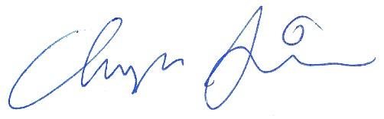Yours sincerely

Chumpon Apisuk
Curator / Founder

