Contemporary Korean Performance Art
“The 13th ASIATOPIA; International Performance Art Festival, Thailand”
Participant

Organized by SORO Performance Art Centre
Supported by Arts Coucil Korea
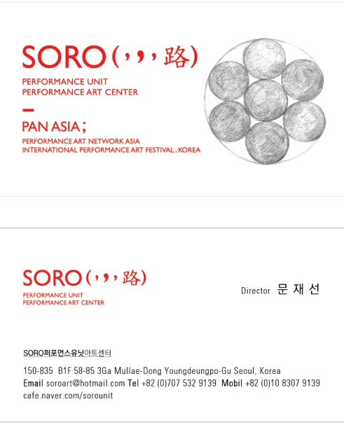

Organizing Body – SORO Performance Art Centre

■ Producing_Contemporary Performances/SORO Performance Unit
■ Archiving_Asian Performance Art, Live Art/SORO Performance Art Centre
■ Networking_Creative International Exchanges/PAN ASIA

SORO is committed to increase the profile of performance/live arts in Korea and Korean arts abroad by producing performances, supporting practitioners, organizing tours, and building international networks. SORO has created interdisciplinary performances, and has presented its works at the Korean national and European countries.
SORO invested on building up international networks of performance artists, organizations and institutions. SORO founded an annual performance art festival 'PAN ASIA' (Performance Art Network Asia) in 2008. It has become a hub for the cultural and creative exchange amongst Asian performance artists.
SORO has established close relationships with performance arts organizations in Asia such as NIPAF(Japan), Up-On Live Art Space(China), MIPAF(Macau), ASIATOPIA(Thailand), New Zero(Myanmar), PERFORBURNCE(Indonesia), TAMA(Philippine) and DADAO Live Art Festival(China). Artists from those countries have been participating in PAN ASIA to share their works and ideas for the last 3 years. SORO is now trying to outreach beyond Asia. Since spring 2010 they have had active interchanges with Live Art Development Agency in London.

Contemporary
Korean Performance Art

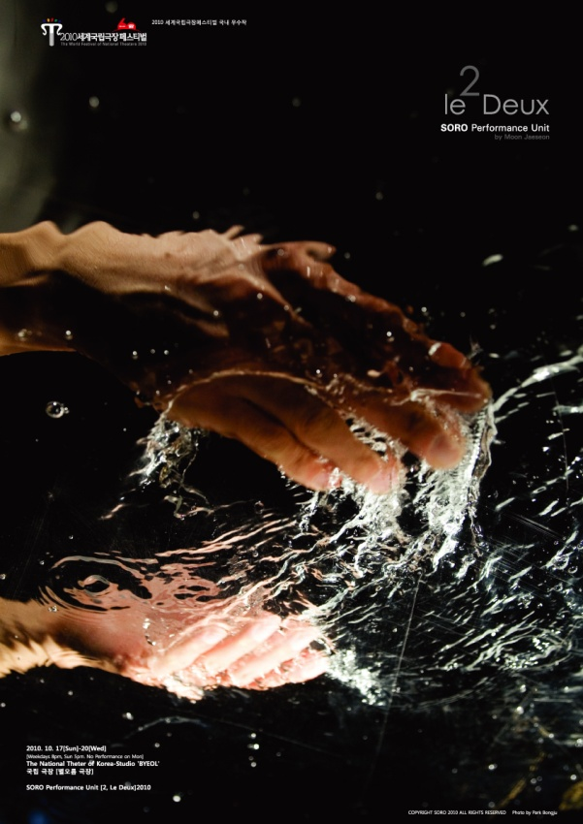
Poster_SORO’s ‘2(Le Deux)’
The World Festival of National Theaters 2010
(National theater of Korea_Byoloreum)

List of the International Exchange / Network Programmes
2006
● Korea – Japan Performance Exchange Project RAFT Theatre, Tokyo, Japan
● Seoul – Kyoto Exchange Urbanguild, Kyoto, Japan / Co-Organization
2007
● Performance Art at Woodford Folk Festival, Queensland, Australia
● Gosford Art Flux Forum ‘Click Here’_[Streeming], Kibble Park,
Gosford, Australia / Participant
2008
● The First PAN ASIA, Yogiga Gallery, Seoul, Korea / Organizer
● Inward Gazes;Introduction of Performance Art in Asia,
Macau Museum of Art, Macau / Participant
● PAMS(Performing Arts Market in Seoul) Choice, _Overseas Expansion
of Korean Multidisciplinary Arts, Myongdong Arts Center, Seoul, Korea
2009
● The 2nd PAN ASIA, Zeroone Degine Cneter, Seoul, Korea / Organization
● NIPAF; Nippon International Performance Art Festival Proto Theater,
Tokyo / Bank Art Studio NYK, Yokohama, Japan / Participant
● [2(Le Deux)]_ International Tour Grant by Korea Foundation, Mix’Art Myrys,
Toulouse, France / Production
2010
● The 3rd PAN ASIA, Seoul Art Space_Mullae, Seoul, Korea / Organization
● MIPAF ; Macau International Performance Art Festival,
Ox Warehouse, Macau / Participant
● Crazy Wisdom Tour for PAN ASIA, Incheon Art Platform,
Gwangju Museum of Art, Korea / Organization
● The Future of Performance Art in Asia [Action Script], Sympsium,
Hong Kong Arts Center / Observer, Commentator
2011
● The 5th MIPAF / Body Methapor_Asian Contemporary Art Exhibition
Ox Warehouse, Macau / Participant

Future Projects

● The 4th PAN ASIA, Seoul Art Space_Mullae, Seoul, Gwangju Museum of Art, Korea / Organization
● The 13th ASIATOPIA; International Performance Art Festival in Thailand
/ Participant, Co-Organization

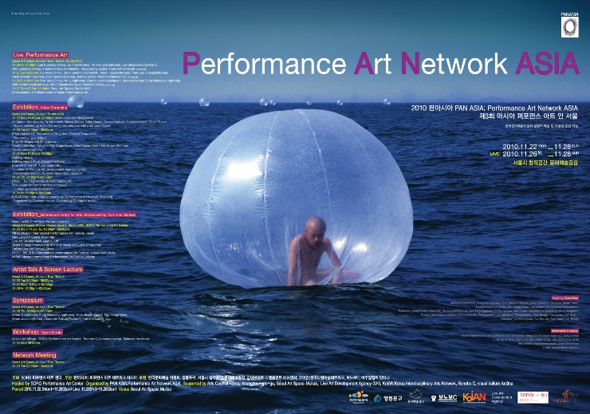
Poster_The 3rd PAN ASIA
;Performance Art Network Asia 2010, Seoul, Korea

“Contemporary Korean Performance Art”
The Origin of Life, Vehicle for Evolution
Korean Performance Art at ASIATOPIA2011

As SORO is in the course of establishing a close relationship with ASIATOPIA in Thailand, SORO’d like to seize an opportunity to collaborate with the ASIATOPIA in Bangkok, Chiangmai, Korat, proposing an event of Thailand Korean performance art Exchange Thailand’s representative live and experiment Featival.

SORO has selected works of 4 performance artists, Jaeseon Moon, Neungkyung Sung, Solmoon, and Moohye under a title ‘Contemporary Performance Art’. Their practices share a root of Korean sentimentality but also cover immensely diverse backgrounds and approaches to their practices. In this selection you’ll witness performances whose concerns range from the political gestures to sensory languages, from Korean traditional art form to Asian aesthetics, and from spirituality of nature to materiality of things.

SORO hopes that this project will sow a seed for more ambitious projects such as a Korean performance Arts event, which could mediate the turbulent modern history of Korea involving generations of artists since 1970’s, or exchange between the PAN ASIA and ASIATOPIA involving the network of Asian practitioners and organizations

Selected Works/Korea
The Pacato by Jaeseon Moon Stone Remains in the Wind by Moohye
Conversation by Solmoon(2009) Do you have something that is no art? by Neung Kyung Sung
Jaeseon Moon

Lives and Works in Seoul Korea

Jaeseon Moon is a performance artist, and the founder and director of the performance arts organization SORO.

He majored in Visual Arts, and worked as an actor, a scenographer in various theatre and dance productions. The credits include the productions by the Theater ETAT, Theater Company Ggipan, and Korea Performance Art Sprit (KOPAS). He also created solo performance pieces, ‘Adagios’ (1999), 'The Vibration and Unforming Circle'(2000), 'Dust'(2002), 'The Old Vibration'(2005) in which he translated autobiographical and socio-political issues into the corporeal visual languages. Since he founded SORO Performance Unit in 2004, he has contributed to raise the profile of Korean performance arts in and out of the country by organizing festival PAN ASIA in Seoul.
Moon employs sensory languages in his performances. He has been experimenting with various methodologies to bring immanent sensations into presence. He approaches the inner human through gazing into the physical body. Moon strives to recompose the inner and outer movements of body to create a new dynamics of materiality, visuals, and soundscapes in his performances. His has been influenced by various disciplines such as bioscience, arts therapy, contemporary dance, visual arts, and sound arts and has collaborated with artists and professionals in the practice in creating performances 'Le Deux'(2007) and 'Pacato'(2009).

The Pacato
Work in development(2000~2011)

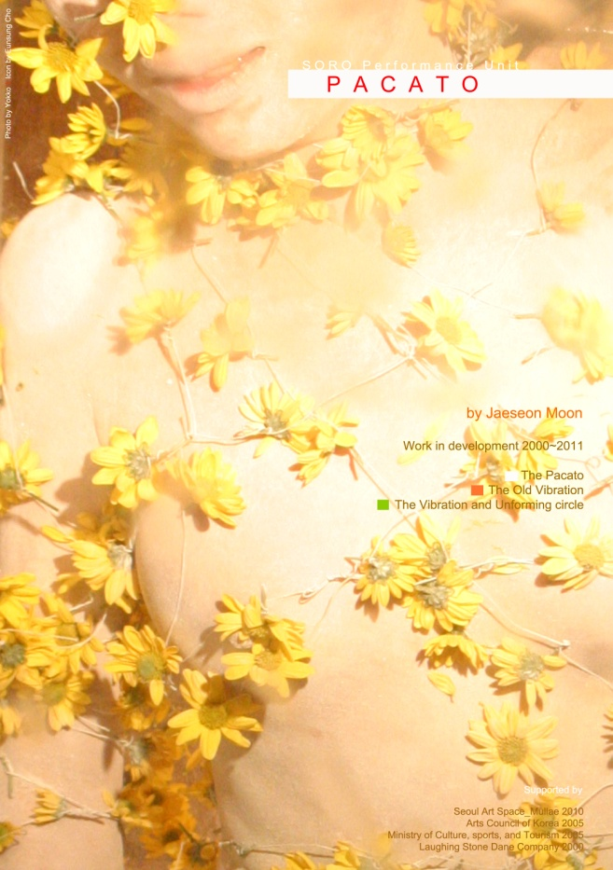
The Pacato_2)The Old Vibration
Mokin Gallery, Seoul Korea, 2005

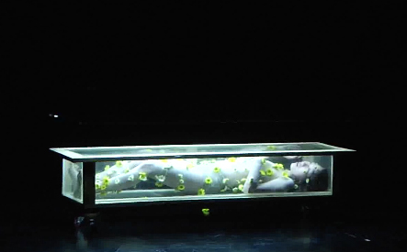
The Pacato,_3)The Vibration of Tacit.
Seoul Art Space_Mullae, Box Theatre, Seoul, Korea, 2010

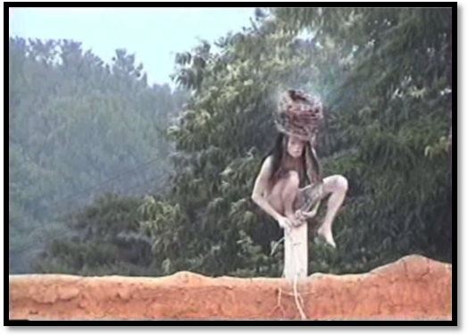
The Pacato_1)The Vibration and Unforming Circle,
Laughing Stone Oudoor Theatre. Anseong, Korea, 2000
T
his is a long artistic process that promotes love for humanity by visiting the places of sad memorials of human kind.
“The Pacato” expresses sadness resonating in history, the weeping of inerasable past. It is a silent prayer for peace of humankind, and restoration of human will for better future.

At the time of terrorism and the wars in the Middle East and Africa, the performance consoles the souls perished in the past wars to express the human wishes for human. There is heartrending DMZ(Demilitarized Zone) set between north and south Koreas after Korean War. Although World War 2 ended long ago, there are still many victims of the atomic bomb in Hiroshma, Nagasaki, Krakow and even in Korea, and the world is not exempt from its responsibility.

As a pilgrimage to the places of violence, ‘the Pacato’ was performed and documented at Taepung Oversation Platform, which is situated near Imjin River flowing across the border of two Koreas. In Hiroshima, I recorded my performance at some places of the memory of victims of the atomic bomb, such as Hiroshima Peace Memorial and Genbaku dome. I visited Auschwitz State Museum in Poland, and made a visual documentary of performances about the Wall of Death, and monuments for the victims.

This performance expresses nomadism that seeks for the continuous vibration from past to present of mankind. Through performance, installation, and sound, the artist attempts to show a process, in which arts pursue active and positive aspects in the society

 http://www.youtube.com/watch?v=Qfs1danJPSM
Solmoon

Lives and Works in Seoul Korea
Solmoon is a performance artist, choreographer, and writer. He inherited Bong-san-tal-chum, a traditional Korean mask performance form originally from North Korea. He is a teaching staff of Kim Yoo-kyung style Bong-san-tal-chum preservation society. He incorporates the traditional forms in his own creative practices to find their legitimacy within the current social, political and cultural frame.
In 2005 he embarked on a one-year-long project 'Black Peace Box'. He participated in anti-war protests as a performance artist with a box and paper puppets, 'Peace Doll'. He collected materials and photographs from the demonstrations and stored in the Black Peace Box as a black box stores memories a journey. He buried the Black Peace Box with his puppets in a trench built during the Korean War.
'Nostalgia', an ongoing project since 2008, is based on the story of 'Dae-chu-ri', an agricultural village disappeared due to the expansion of American army base in the west-coast of South Korea. He has performed with a stone, which was the last piece of nature survived from the land now rendered with tarmac. He also curated an exhibition 'A Road to Dae-chu-ri' in 2007 exhibited the archive of the people and nature that lived and fought against the force of authorities.
Along side with solo performance works he has taken dramaturgic roles in wide range of performances. He worked on 'the shadow of flowers' by On and Off Contemporary Dance Company and with SORO for 'Le Deux'. He is currently working with Kang Sung-gook, a performer with the cerebral palsy, in telling a story of his wish for his own baby 'Oh! Baby'.
Conversation

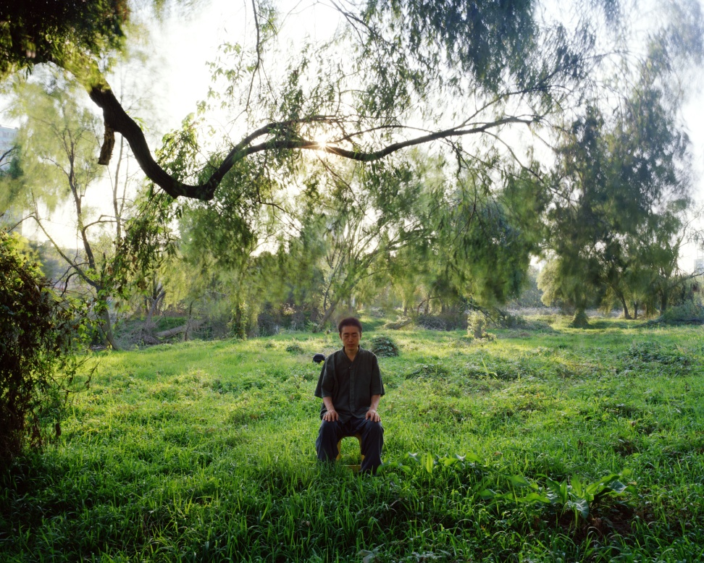
Solmoon, Photo by Pyunhyun Ye
Conversation, Near the Han River, Seoul, Korea, 2010

http://www.youtube.com/watch?v=BXU7VIW0t54

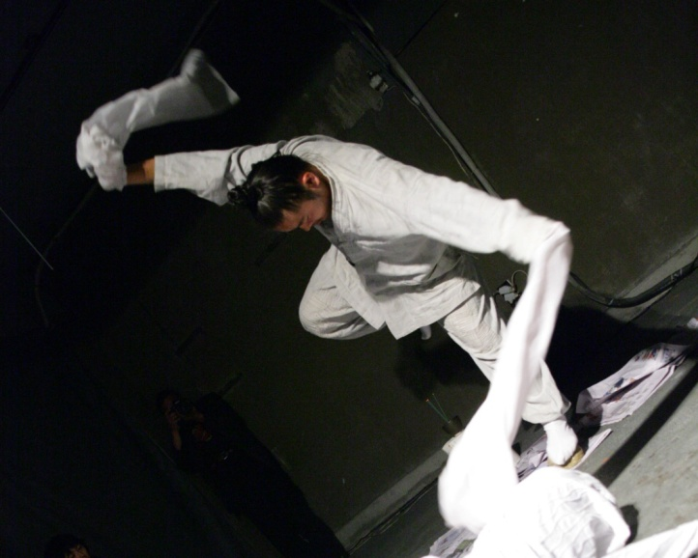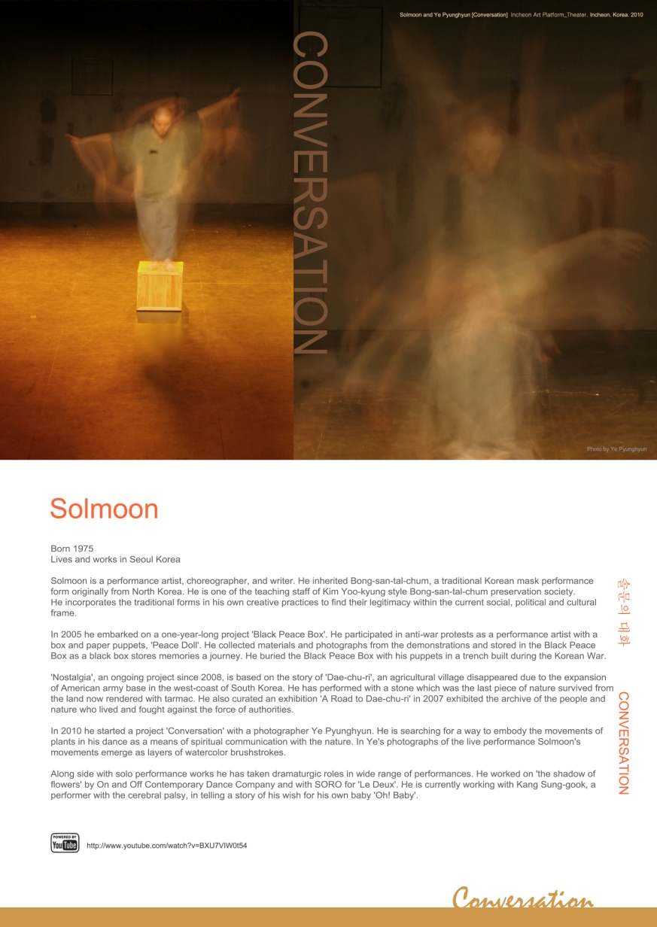
Solmoon and Pyunghyun Ye, The Conversation,
Incheon Art Platform_Theater, Incheon, Korea, 2010

S
olmoon has practiced Bong-san-tal-chum for the past 20 years. Even though he is dedicated to the traditional mask performance, he has been exploring methodologies for creating variations of its form and style. In his performance ‘Conversation’, Solmoon employs methods of meditation on nature to embody the movements of plants: his body is a seed, which transports life of plants from nature to theatre.

Solmoon, Nostalgia, Yogiga Gallery, 2008

Neung Kyung Sung

Lives and Works in Seoul Korea

The artistic career of Neung Kyung SUNG can be divided into two phases, namely conceptual art of the 70-80s and the postmodern performance since the 90s. As his art changed from comceptual works revolving around minimalistic events and semiotic photo installations to trans-genre performance, he established a new style based on his own sensibility, which can be defined as postmodern hybride or pastiche. SUNG’s hybrid performance is one of maximized excess; excess of actions and events, excess of props, excess of speech and text. In particular, the reading of prepared text, chanting of spells, forcing of audience participation, and other excessive chattering make his performance noisy, unfocused, tedious, gossipy, and in some instances brings to mind the mess and disorder of the market place or country theatre. Another effect of excess is boredom. It is an endless series of unrelated one-scene event and repetition of identical actions. For an audience familiar with interesting and exciting theatre, this is a new experience of boredom and puzzlement.
Excess and boredom are not the only aesthetical foundation of ‘SUNG’s performance but also the keywords in postmodern performance of the 1900s. Neverthless, he does not never miss the link with the modernist paradigm. This is, although the pastiche and bricollage style falls under postmodernism, his work shares the utopian ideal of modern avangard in terms of politics.

Do you have something that is no art?

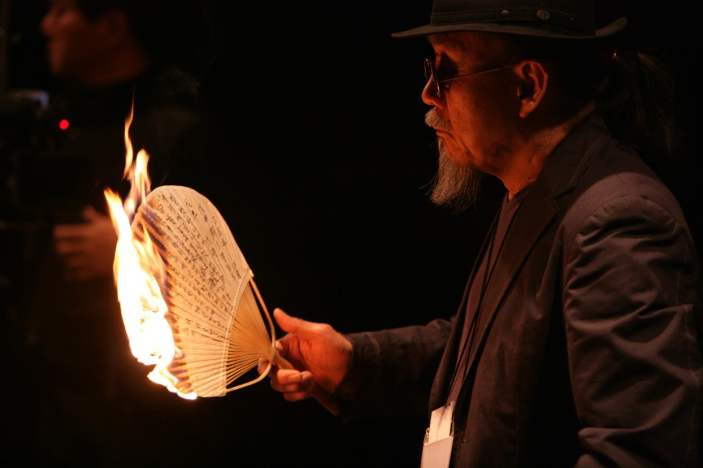

Korean Performance Art 40Years, 40Artists
Velvet Bnana Theatre, Seoul, Korea 2007

www.youtube.com/watch?v=LfASfFMJo8c

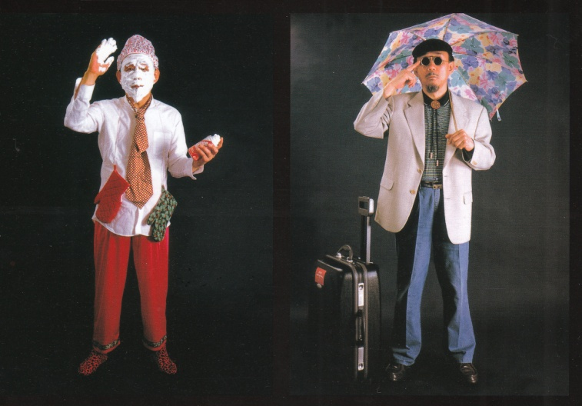
Neung Kyung Sung, Photo by Kangwoo Lee.
The Art(ist) and Cultural Landscape of the Body,
University Gallery, Seoul, Korea 2001,

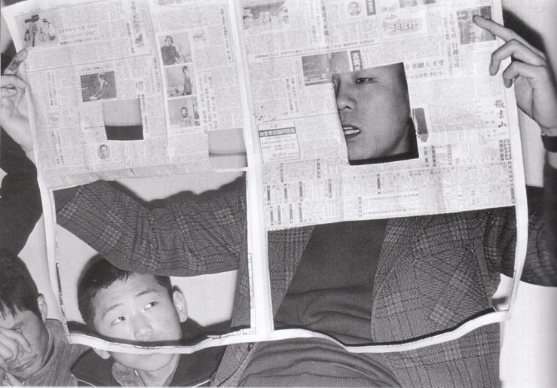
Neung Kyung Sung, ST; Space and Time, Newspaper 1th June 1974
National Museum of Contemporary Art, Deoksugung, 1974.
H
His dual identity of maintaining modern avangard resolve in postmodern performance is likely related to the sentiment of the 70-80s period to which he belonged. In this period dominated by monochrome painting, he had freed herself from the orbit of modernism in terms of genre as evidenced by his works with photography, installations, and events. However, in terms of aesthetics, form, and politics, these works were still conceptually linked to modernism. In sum his performance sits on the boundary of modernism and postmodernism with compound dual identity. Hong-hee Kim/Director_Gyonggi Museum of Modern Art

I’m at the end of my rope.
SCRATCH! SCRATCH!
Stop putting me on!
SCRATCH! SCRATCH!
I’m all mixed up.
SCRATCH! SCRATCH!
I got ripped off.
SCRATCH! SCRATCH!
Keep your chin up!
SCRATCH! SCRATCH!
I was humiliated.
SCRATCH! SCRATCH!
It’s killing me.
SCRATCH! SCRATCH!
I’m a little short on dough.
SCRATCH! SCRATCH!
Make some sxtra money on the side.
SCRATCH! SCRATCH!
Moohye

Lives and Works in Seoul Korea

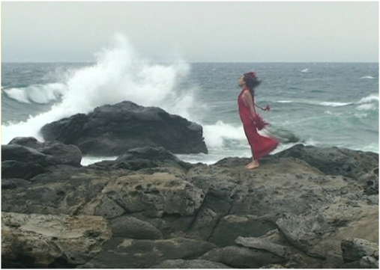Moohye studied French Literature and Art Management. Having previously worked as an organizer in the field of interdisciplinary art, She has been working as a performance artist since 2007.
Her main interest is the original form of the world. Which is still valid in the present time. She works by listening to all of the elements of the environment and attempting to perceive a boundary of inhalation and exhalation, even through each grain of sand, each flow of wind.
Moohye is trying to experience life from the start of human history, and the movement and form of all animals and plants: beauty, shock, and fear at the same time. She is trying to deconstruct a system of vocabulary to widen the area of human thought and actions by looking at mysterious phenomena of nature that cannot be limitated or controlled.

ON LINE www.moohye.com

Stone Remains in the Wind

Moohye, Stone Remains in the wind, Gapa Island, Jeju, Korea 2009
,

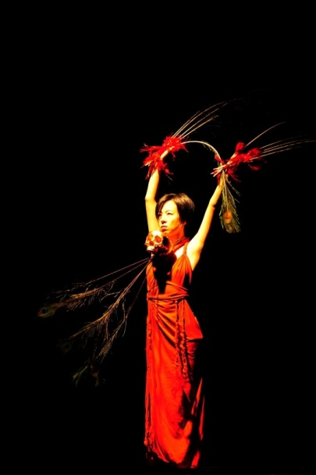

Moohye, Stone Remains in the Wind, Post Theatre, Seoul, Korea, 2010

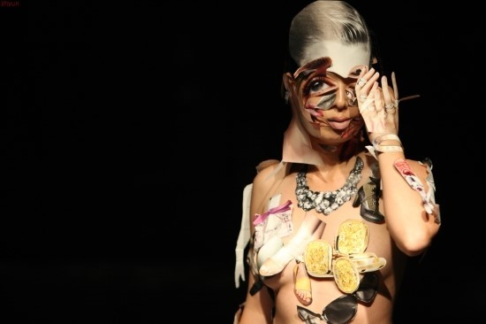

Moohye, Korean Performance Art Day in KEAF, B-boy Theatre, Seoul, Korea, 2011

M O R E

PAN ASIA
http://www.panasia2011.blogspot.com
Progammes http://www.blogmoon.co.kr/files/attach/images/296/790/68ad6469cfd8c706103dad2c101f88bf.jpg

SORO
Korea Arts Management Service http://pams.or.kr/AE/OP/PB2/main.asp?cate=1&sub_num=7
The World Festival of National Theaters http://www.ntok.go.kr/wfnt2010/eng/program/29_detail.jsp

Address 58-85 Mullae –dong 3ga Youngdeungpo-gu Seoul Korea / Tel +82-70-7532-9139/ +82-10-8307-9139
In Charge Jaewoo Kim(Seoul, Korea), Email soroart@hotmail.com / Jaeseon Moon(Seoul, Korea), Email soroart@hotmail.com

