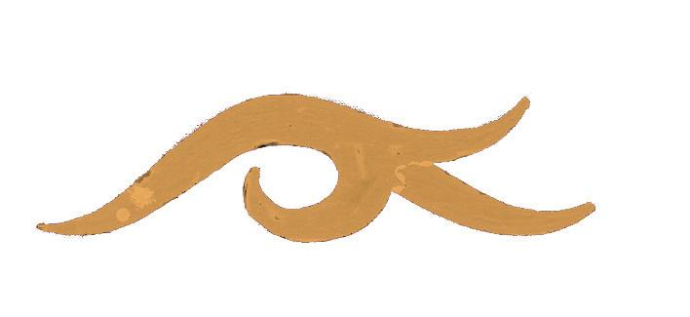

สำนักงาน
ศิลปวัฒนธรรม
ร่วมสมัย

ASIATOPIA 6/2004
International Performance Art Festival, Thailand
18 - 28 November 2004, Bangkok - Chiangmai

You’re Cordially Invited to the

OPENING RECEPTION
18 Nov 2004, 6:30 PM

Bangkok Program:
Artists Seminar: 18 Nov, 10 am – 5 pm
Performances:
19-20 Nov: Patumwan Intersection Art Center Site
21 Nov: Concrete House, Nonthaburi

Chiangmai Program:
25 – 27 Nov: At Chiangmai University Art Center

Organized by Concrete House, EMPOWER Foundation,
57/60 Tivanond Road, Nonthaburi 11000, Thailand
T: +66-2-526-8311, F: +66-2-526-3294;
concretehouse@empowerfoundation.org
