1 October 2004

Dear Khairuddin Hori,

On behalf of Asiatopia 6/2004, I am delighted to invite you to participate in our performance art festival focuses on Asia initiatives. The festival will be held in Bangkok and Chiangmai during 18-28 November.

Asiatopia has started since 1998, and has been the only international performance art event in Thailand. Asiatopia 2004, is supported by the Office of Contemporary Art & Culture, Rockefeller Foundation for all core cost. However, Austrain artists also supported by Austrian Government, Adinar Bar-On from Israel is supported by the Jerusalem Center for The Visual Arts. From Asia we have Iwan Wijono from Indonesia, Mideo Cruz from the Philippines, Zhu Ming from China, and also yourself from Singapore.

From Thailand we are very proud to have a group of pioneer sound composition group (since 70s) – Bangladesh band, most of the band members now are leading popular musicians and artists today. Vasan Sittiket, a political activist famous painter, critical artist, who has been creating a new form of shadow puppet. His shadow puppet performing about current politic of Thailand. And M.L. Suksin Kasemsun, a multi-disciplinary artist.

In Bangkok, beside Concrete House which will be used for artists seminar on 18 Nov, and a final performance day 21 November.

On 19-20 November, we will be use the site for future Bangkok Contemporary Art Center, and the event will be opened with Bangkok Governor. We are very honoured to be able to hold performance event at this future site of the Bangkok Contemporary Art Center.

The event in Chiangmai - 800 km away to the north, will be held at Chiangmai University Art Center from 25-28 November. Any of international artists who would like to join the program in Chiangmai are all welcome. However, since the funding in Chiangmai is very limited, they only can offer free accommodation and meals. We will drive all artists up together in a 2 vans along the highway, as you all can see some part of the country side, and the trip takes about 10 hours.

I would like to suggest you all bringing some copies of your works in prints as well as in video or CDs. Some will be used at our seminar, some we can keep in order to use in our performance workshops and show at Concrete House events in the future.

I am looking forward to working with you.

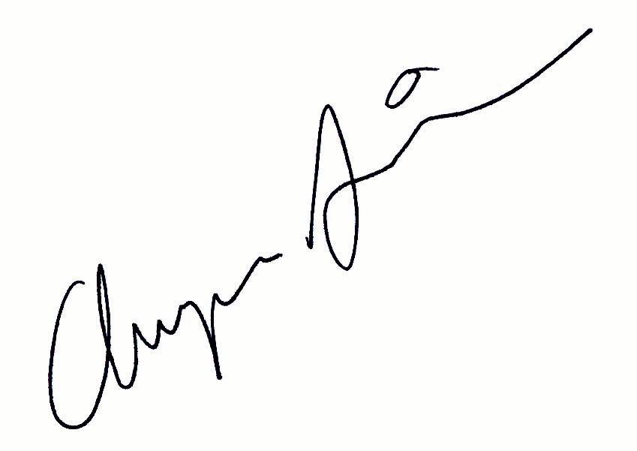
Very Truly,

Chumpon Apisuk
Artistic Director

