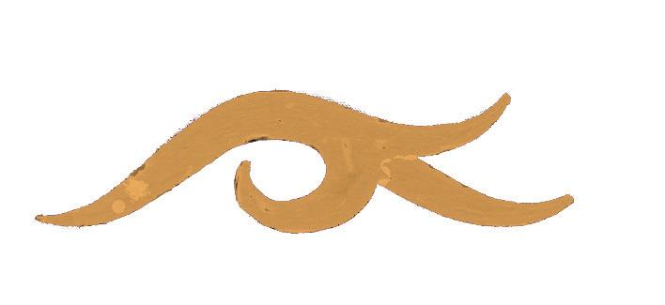


สำนักงาน
ศิลปวัฒนธรรม
ร่วมสมัย

ASIATOPIA 6/2004

International Performance Art Festival, Thailand
18 - 28 November 2004, Bangkok - Chiangmai

Karl Bruckschwaiger (Austria)
Gertrude Moser-Wagner (Austria)
Valerian Maly & Klara Schilliger (Austria)
Sabine Marte (Austria)
Rolf Hinterecker (Austria)
Julie Andree T. & Dominic Gagnon (Canada)
Adina Baron (Israel)
Zhu Ming (China)
Iwan Wijono (Indonesia)
Mideo M. Cruz (Philippines)

Khairuddin Hori (Singapore)

Thailand:
Bangladesh Band
Vasan Sittiket
The Beauty Suit Group
Chakkrit Chimnok
Mongkol Plienbangchang
Paisan Plienbangchang

ML. Saksin Kasemsun

Concrete House, EMPOWER Foundation,
In cooperation with Art & Culture Foundation of Bangkok
concretehouse@empowerfoundation.org







