
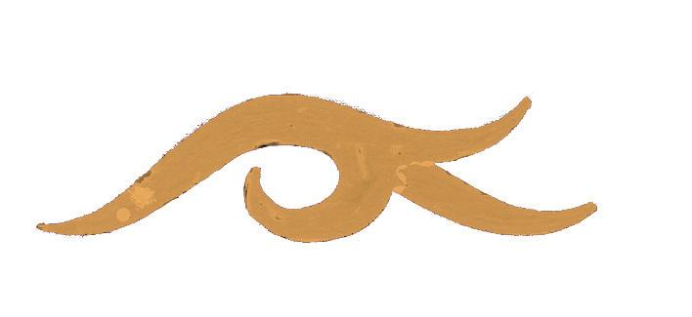
สำนักงาน
ศิลปวัฒนธรรม
ร่วมสมัย

ASIATOPIA 6/2004

Program

18 Nov. 2004 10.00 am – 05.00 pm
Concrete House, Tivanond Rd., ( near Big C Tivanond)

10.00 am Welcome by organizer
ASIATOPIA slide show
10.30 am Performance Art in Indonesia: Iwan Wijono
12.00 - 01.00 pm Lunch Break
01.00 pm Performance Art in Philippines: New World Disorder: Mideo Cruz
03.00 pm Introduction to artists works with video
“Performance and Science” Austrian Artists :
Karl Bruckschwaiger
05.00 pm Break / Setup for the party
06.30 pm Reception

19 Nov. 2004 04.00 pm – 09.00 pm
Bangkok Art Center Site, Patumwan Intersection

04.00 pm Iwan Wijono: Intervention
Gertrude Moser-Wagner: Intervention
Karl Bruckschwaiger
06.30 pm Bangladesh Band” on stage in the park
08.00 pm Vasan sittiket: contemporary Shadow Play, Act 1

20 Nov. 2004 06.00 pm – 09.00 pm
Bangkok Art Center Site, Patumwan Intersection

06.00 pm Miedeo Cruz
06.40 pm Valerian Maly & Klara Schillger
07.20 pm Adina Bar-On
Julie Andree T. & Dominic Gagnon
08.00 pm Vasan sittiket: contemporary Shadow Play, Act 2, 3

21 Nov. 2004 03.00 pm – 08.00 pm
Concrete House, Tivanond Rd., ( near Big C Tivanond)

04.30 pm Adina Bar-On
05.30 pm Khairuddin Hori
06.00 pm Rolf Hinterecker
07.00 pm Sabine Marte

