Report:
ASIATOPIA 5/2003

Artists:
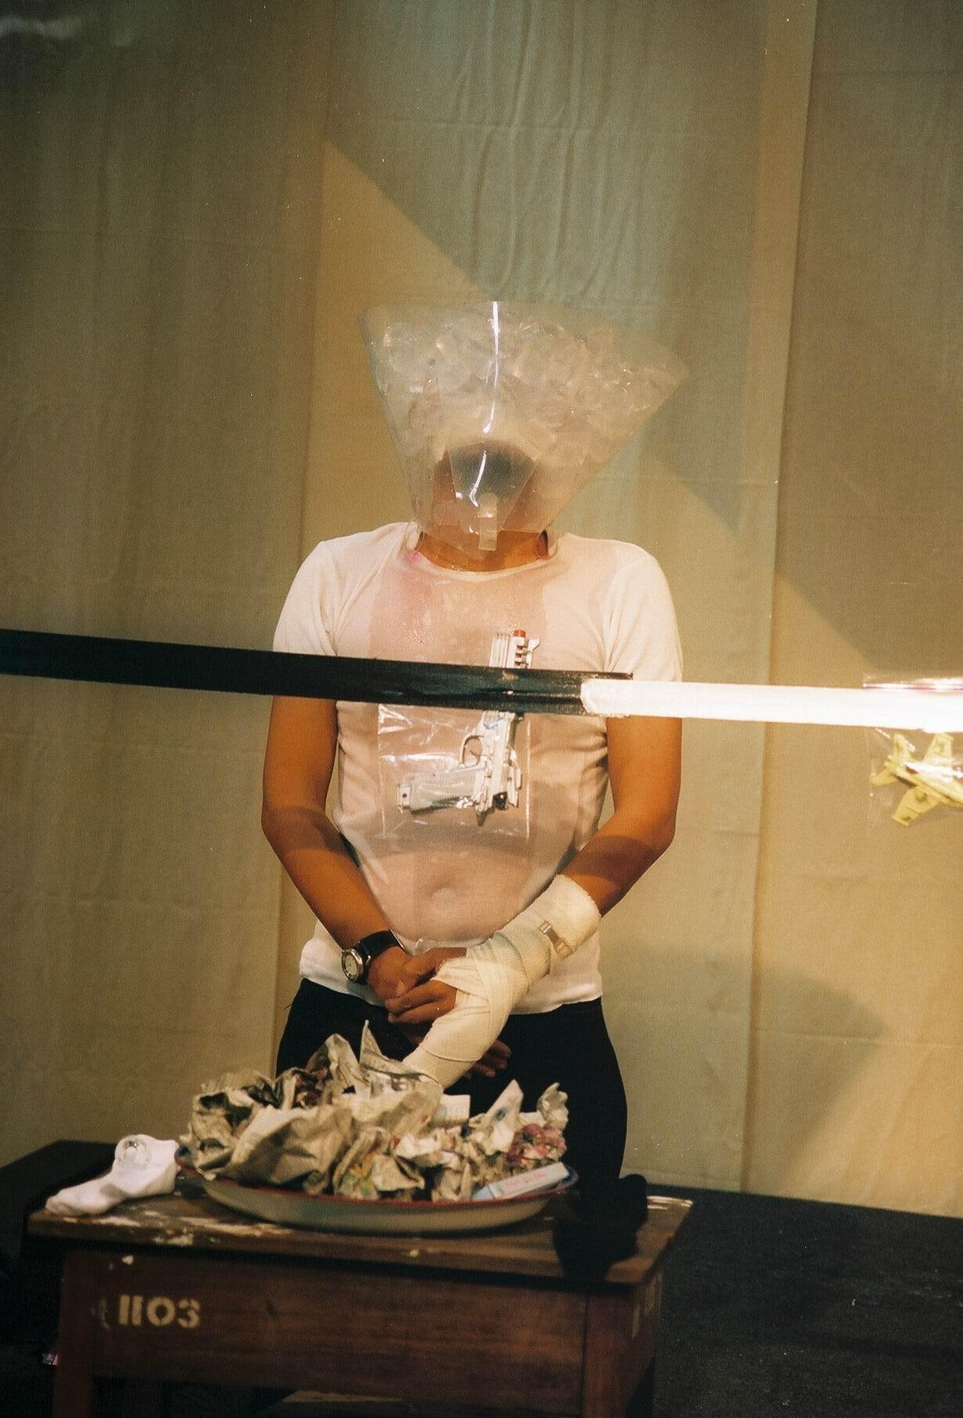
Amanda Coogan Ireland
Apanchalin Israngkul Na Ayudhaya Bangkok
Denis Romanovski Belarus
Esther Ferrer France/Spain Fairy Von Lilienfeld Germany
He Chengyiu China
Jan Swidzinski Poland
Jittima Polsawake Bangkok
Mideo Cruz Philippines
Mink Nopparat Bangkok
Mongkol Plienbangchang Bangkok
Nongo Ono Japan
Parawee Poopetch Chiangmai
Pdungsak Kotchasamrong Chiangmai
Richard Martel Canada
Sompong Tawee Bangkok
Thammasak Meesuk Bangkok
Viktur Petrov Belarus
W. Christiawan Indonesia
Xuan Tihn Do Vietnam

Padungsak Kotchasumrong, Chiangmai
Bangkok Venues: Concrete House and Alliance Francaise
Chiangmai Venue: Chiangmai University’s Art Center

Asiatopia Working Committee
Chumpon Apisuk, Director
Nopawan Sirivejkul, Manager
Paisan Plienbangchang, Technical
Padungsak Kotchasumrong, Chiangmai coordinator
Chantawipa Apisuk, Administrator
Sunee Pungpaisan, Assistant
Thanom Chapakdee/Josef Ng: Researchers

Technical Assistants:
Panboon Sirivejakul
Kawin Traisaj
Norapon Pimwan
Suthipol Hiranchatchawan

Chawin Thawanpinyo : Photographer
MCAD: Video recording

Overview
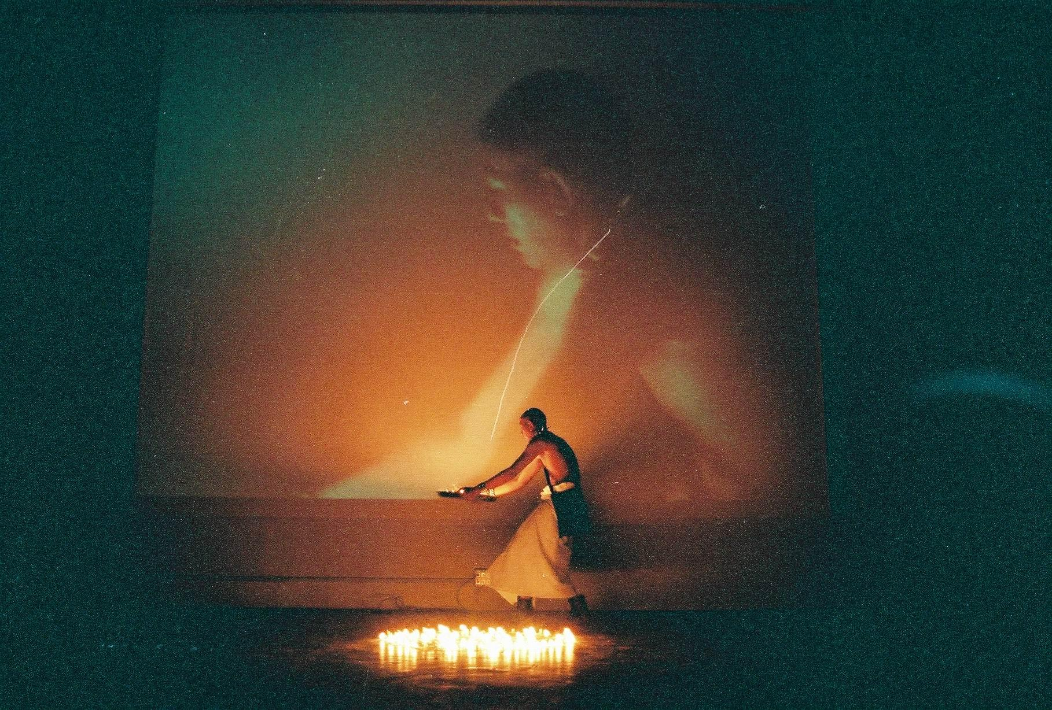

W. Christiawan,
Indonesia

Asiatopia has reached to it 5 anniversary this year. It has brought altogether 145 international performance artists from 20 countries, which mainly comes from Asia, such as; Indonesia, The Philippines, Malaysia, Singapore, Vietnam, China, Korea, Japan, Bangladesh and Thailand. The festival first three years, were solely supported by Office of Social Welfare, Bangkok Metropolitan, with partly from Thai Tourism Authority in 2000. Since last time, 2002 and this time 2003, Asiatopia has been supported by the Rockefeller Foundation, S.E. Asia Regional Office and the Office of Contemporary Art and Culture, Ministry of Culture.

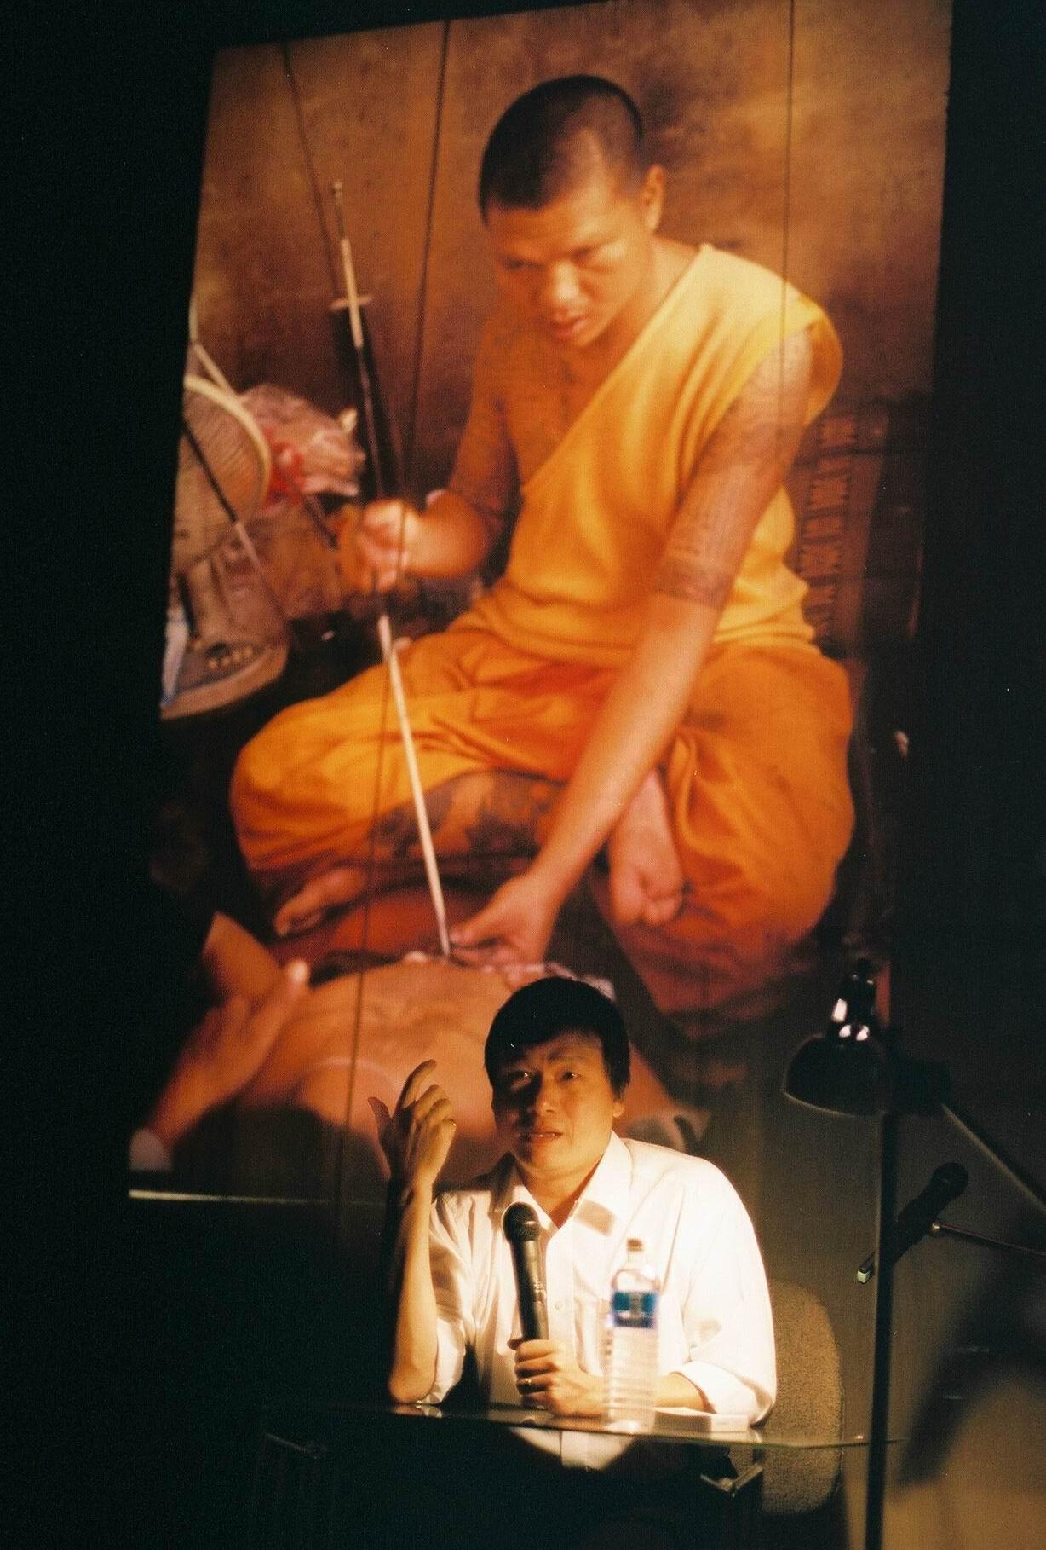
We also have been working in cooperation with the Art and Culture Foundation of Bangkok, Chiangmai University’s Art Center, Silapakorn University’s Art Gallery, Alliance Francaise and Goethe Institute.

The support from the Rockefeller Foundation, regarded as a rescue, it came in at the time that Asiatopia was running out of its resources. The Bangkok Metropolitan’s Governor at the time (in 2000), was not supportive to the art. He dislikes the idea of the city to build an art center, and has stopped the project which was developed by the previous governor in cooperation with artist’s community networks.

However, the situation of contemporary art in Thailand, since 2002 has come to the new phrase, when the new Ministry of Culture was found. The Office of Contemporary Art and Culture became the first state office to deal with the growing community of post modernism culture and trends. Asiatopia is one of the art projects this year, received recognition from the central government.

Dr. Apinand Poshyananda, ‘performativeity’
Ideology
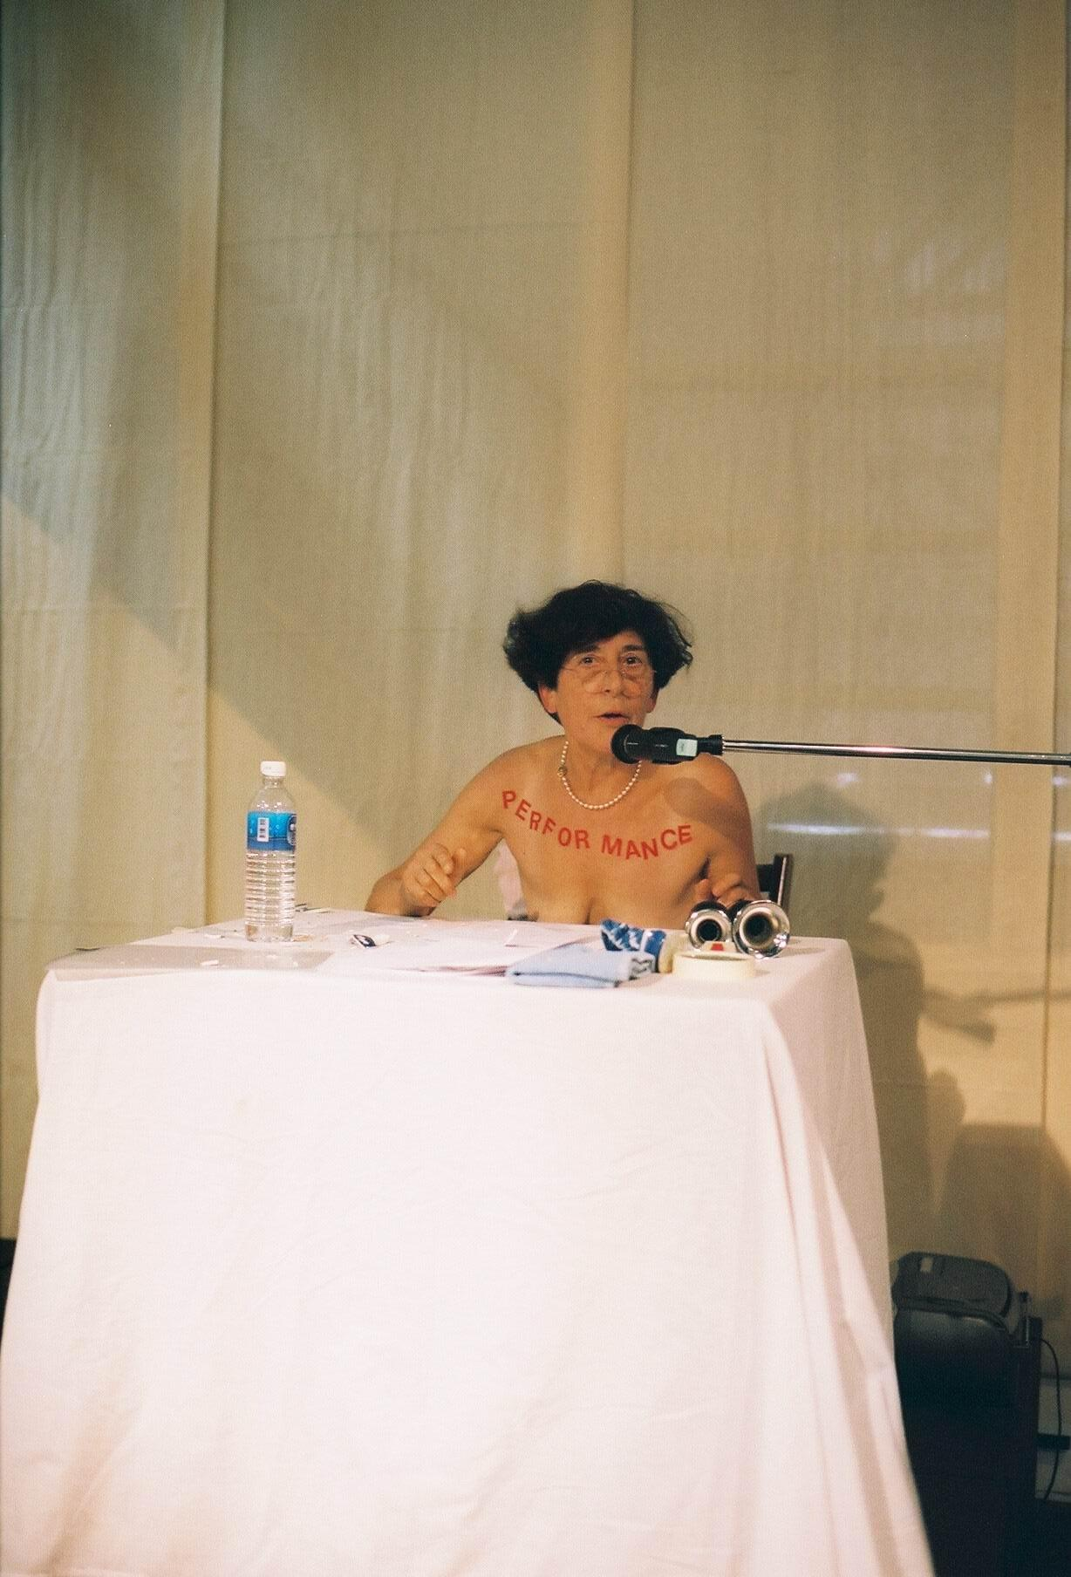
Asiatopia 2003, we have invited 23 artists, which 16 came from S.E. Asia including 1 from China. And among 6 artists from Europe and Canada, there were three distinguished performance artists and theorists.

Jan Swidzinski, a respected artist of the Eastern block, who published his theoretical book call “Contextual Art” in 1975. To celebrate his 80th birthday, he came to Asiatopia to perform his deep sorrow to Bali incident.

Jan Swidzinski gave his lecture at the artist’s seminar on 13 November, about ‘Contextual Art’. He said, in summery; all art works are representation of the artists associated social groups ideology or stand point. He emphasis that to be able to recognize our own social group, will allow us to re-examine context in our arts and how it reflects our stand point. He call this re-examination is to recognize that we’re all making Art of Mind, which speaks to its own social group communities and individuals, thus developing a mutual ‘context’. Esther Ferrer, France

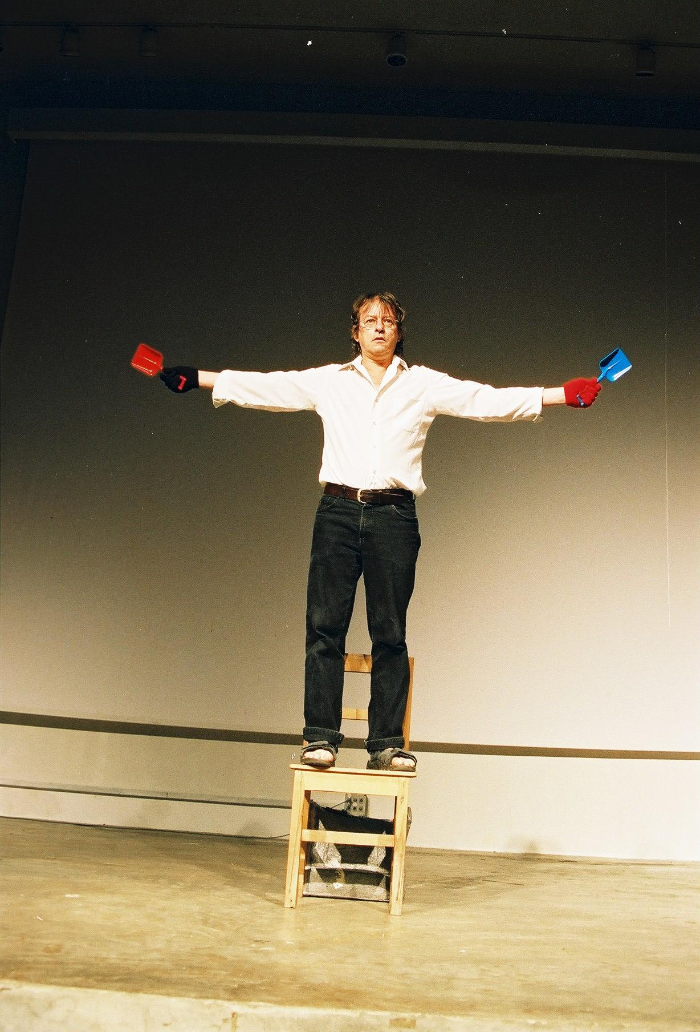
Esther Ferrer, one of the members of the avant-garde artists group in Spain ‘ZAJ’ in the late 50s to early 60s. The group is one of the important members of anti Franco movement. She later moved to Paris and worked in association with John Cage and his Fluxus artists based in New York City. At her talk about women’s art, at Asiatopia seminar, Ferrer argued, “What are the real women thought – women thinking? How can we find them? We do not really know what women are thinking, because we have grown up in this world that makes us all believe that all the thought are of men.”

“How can we tell whether or not women have painted the cave paintings, since there is no one has ever proof that those painting made by men.”

She said what she has seen 3 kinds of art works which claimed to be ‘women’s art’, one is the art that accept women are victim of men, two the art that stigmatize the first kind of art and three the art which denounce men. All these arts were made by women who are living with their men husbands and lovers, or in order to manifest lesbian.
She argued, whether or not is important to find out, at this time, Richard Martel, Quebec
what is women’s art, what is women thinking and thought.
She said it is probably more important to think about women can bare a child without having any relationship with men. With an advantage that women have child baring organ, which is a system in itself. This idea, however, made women even more independent, and also can bring change to the relationship.
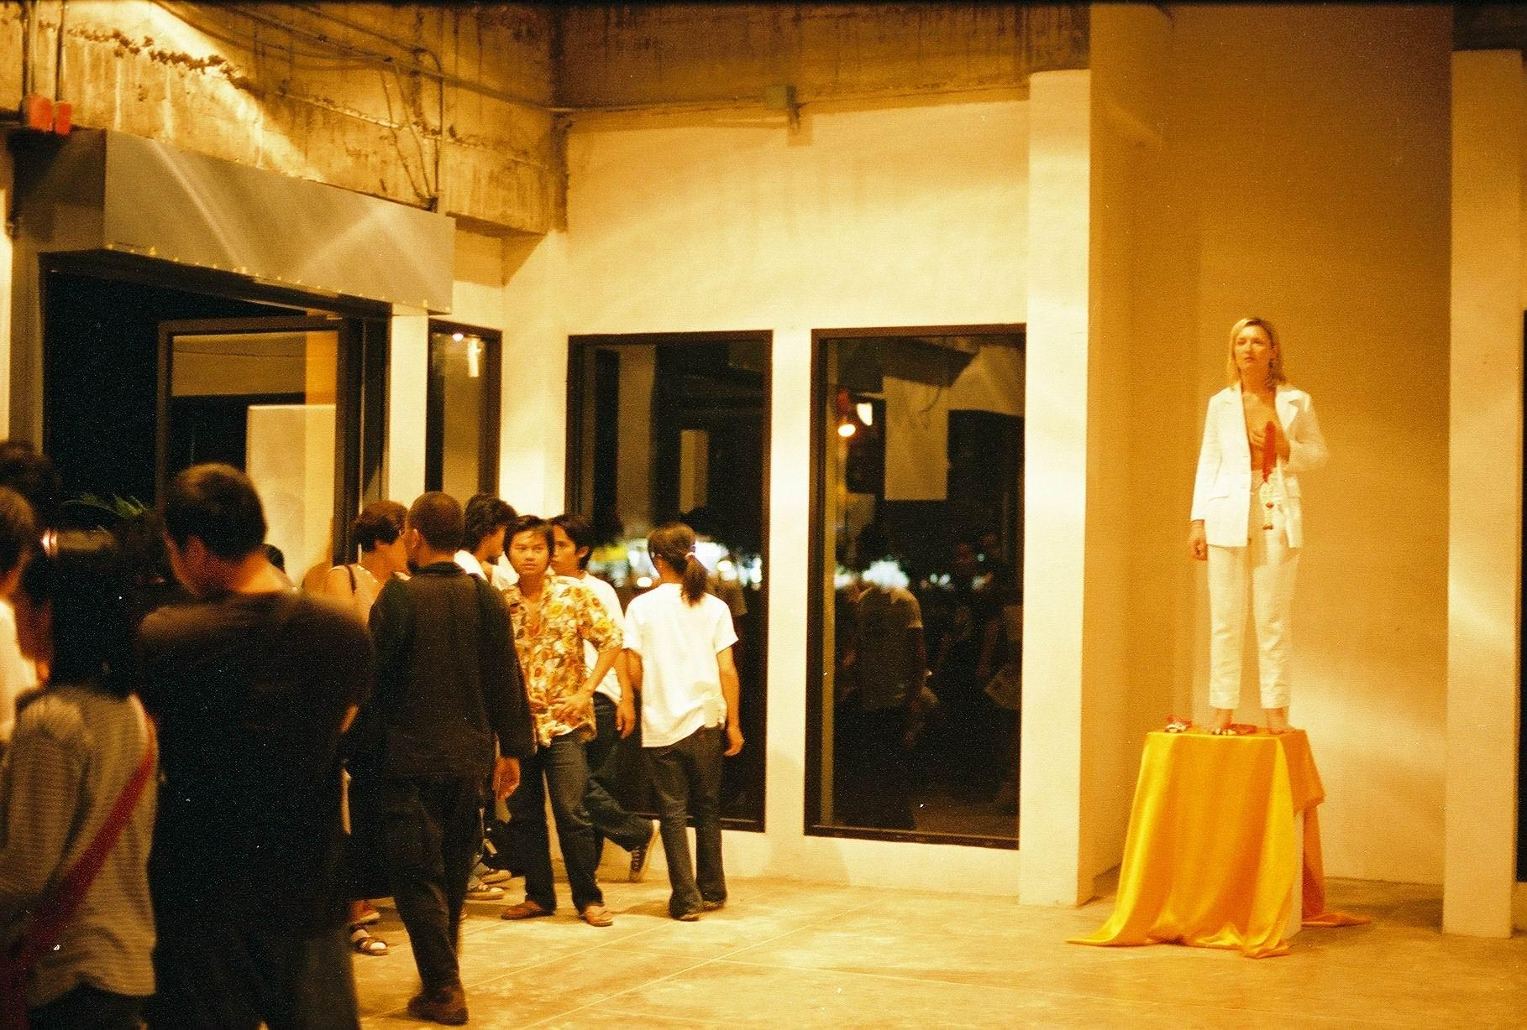
Because when women do not want men anymore, she will be able to develop the way she sees and thinks differently from men.

Richard Martel runs his art center Le Lieu, which also published ‘Inter magazine’ and organize artists meeting in Quebec City since 1979. As a performance artists and organizer, Martel travels extensively in many part of the world, including Latin America, Europe, Africa and the Amanda Coogan, Ireland Far East.

Martel, expressed his interest in S.E. Asia, when he was invited to Japan and Korea, where he met artists from S.E Asia. He observed that performance art in S.E. Asia especially in the Philippines, Indonesia, and Thailand. (Myanmar, where the situation is not pleasant, artists must organize them in secret location to avoid policing by the authority. In Vietnam, where art is allowed to develop with an open atmosphere, performance art in Vietnam is slowly taking shape. Though, in Singapore artists also fought for their freedom of expression, but the political circumstances in Singapore are not as the same as many countries in the region.) Most artists in those countries were taken part in political rally or event combine political activism to their art.

He said he does not question whether art should be politic, or art is politic, but he questions that how art can achieve to the others goals? Is it possible? Then, what makes art different?

Questions and opinion from artists from other region at Asiatopia is very important to Asian artists. It is not because we never ask questions, but we believe that visitor’s questions are always reflecting what we are, and how we do.
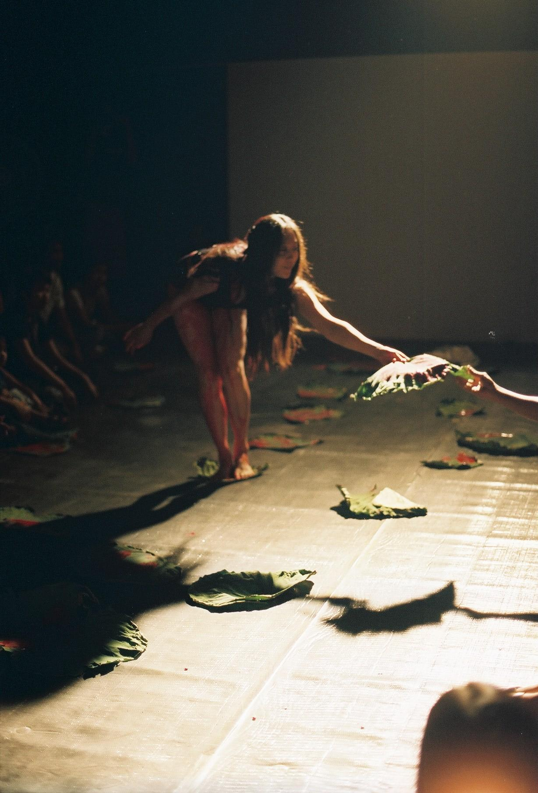
Networking
One of the most relevant speakers of our seminar is an artist from China, He Chengyao. She said in China, contemporary art form like performance, has not been recognized as an art. At one performance event, 2 artists were arrested and jailed for 2 months after police raided the gallery. However, as the group is still strong and supportive to each individual works, performance artists in Beijing manage to perform in public location without announcement.

However, since many Chinese contemporary artists from China has made names overseas, and many have lived in exile in many western countries. Today, the authority has begun to open its door to some level of avant-garde Chinese art. In most recent national exhibition, several contemporary performers were invited to exhibit their art objects and installations.

He Chengyao, China
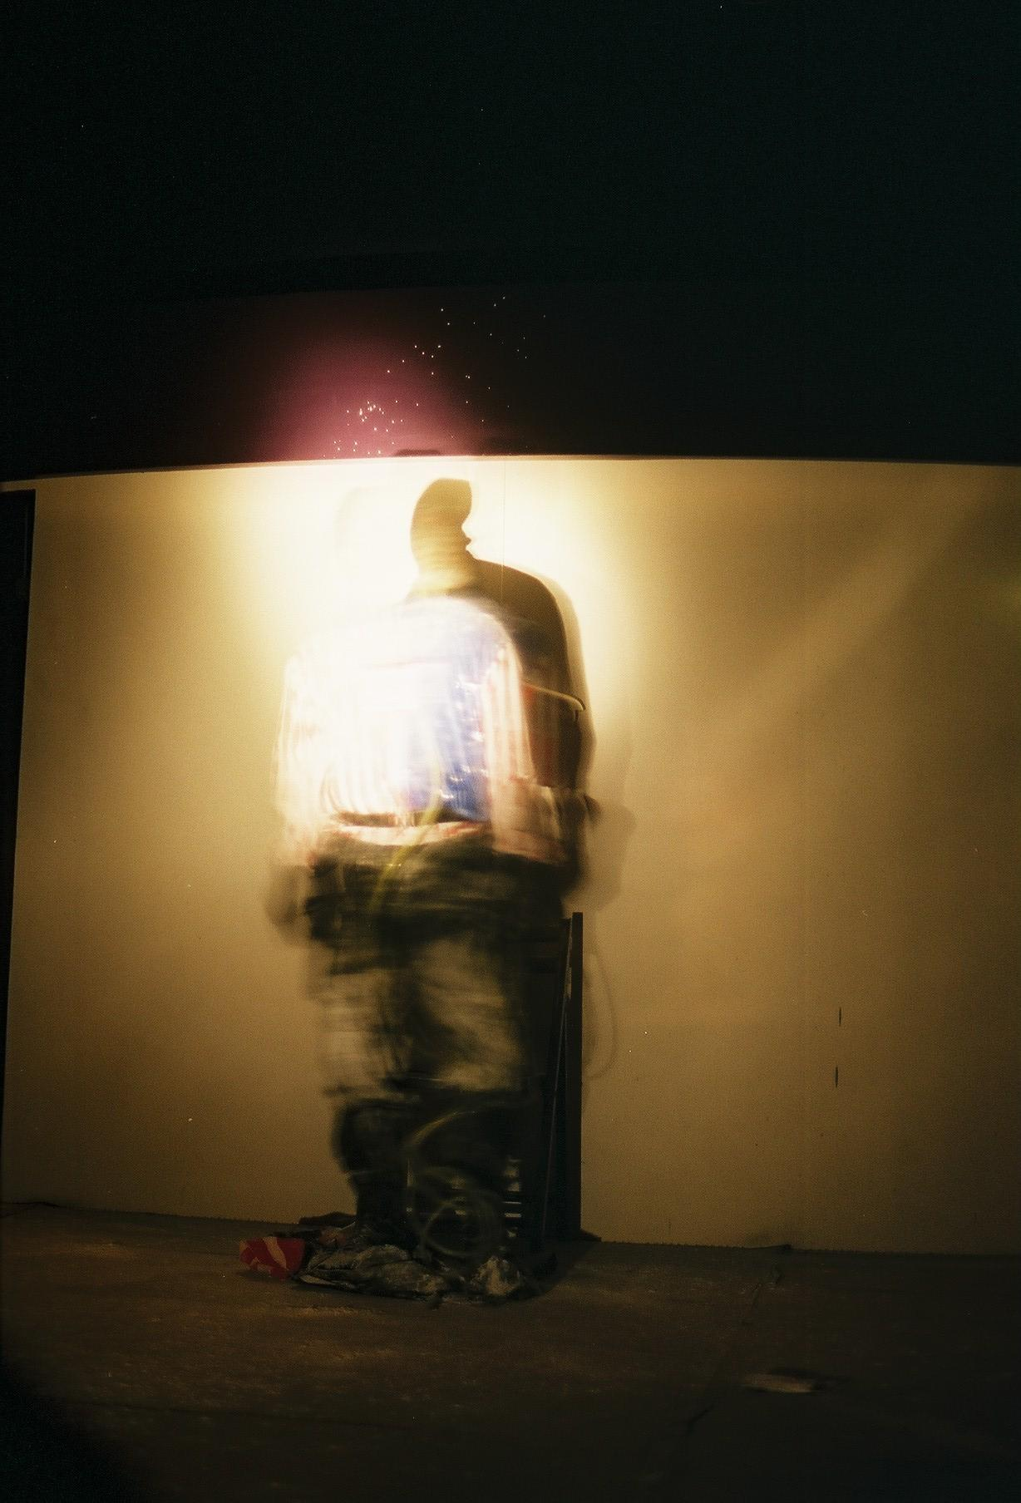
He Chengyao, at the end concluded that when domestic art market does not open for new art, or too slow to open, Chinese artists produce their work for international market to earn a living from foreign currency, in China.

From Indonesia, W. Christiawan gave samples of activities in Bundung where he lives and works. Christiawan organized a series of event which he called “Action Poetry”, a performance event based on sound, music and poetry. The event combined with group action on street to express their statement of protest against US domination and Indonesia democratic system.

He also talked about how artists in Indonesia in three major cities; Bundung, Yogjakarta, and Suwa networking with each other, and how Jakarta movement become weaker to almost none. Economic situation and expensive living in Jakarta combine with chaotic situation in the capital, which is not suitable to organize performance event to even any kind of art.

Mideo Cruz, The Philippines

During the time between performances event, Mideo Cruz, Christiawan, and members of Asiatopia will sit down together, discussed about network strategies.
Cruz invited members of Asiatopia and Bundung to come to his international Tupada – an impromptu performance event in the name of cock fight, organized in the small park in Manila. Christiawan also mention about his organization which plan to organize an international event in early 2004. However, the idea of bringing artists from one country to visit other countries, is a simple form which can take place.

Audience Grows
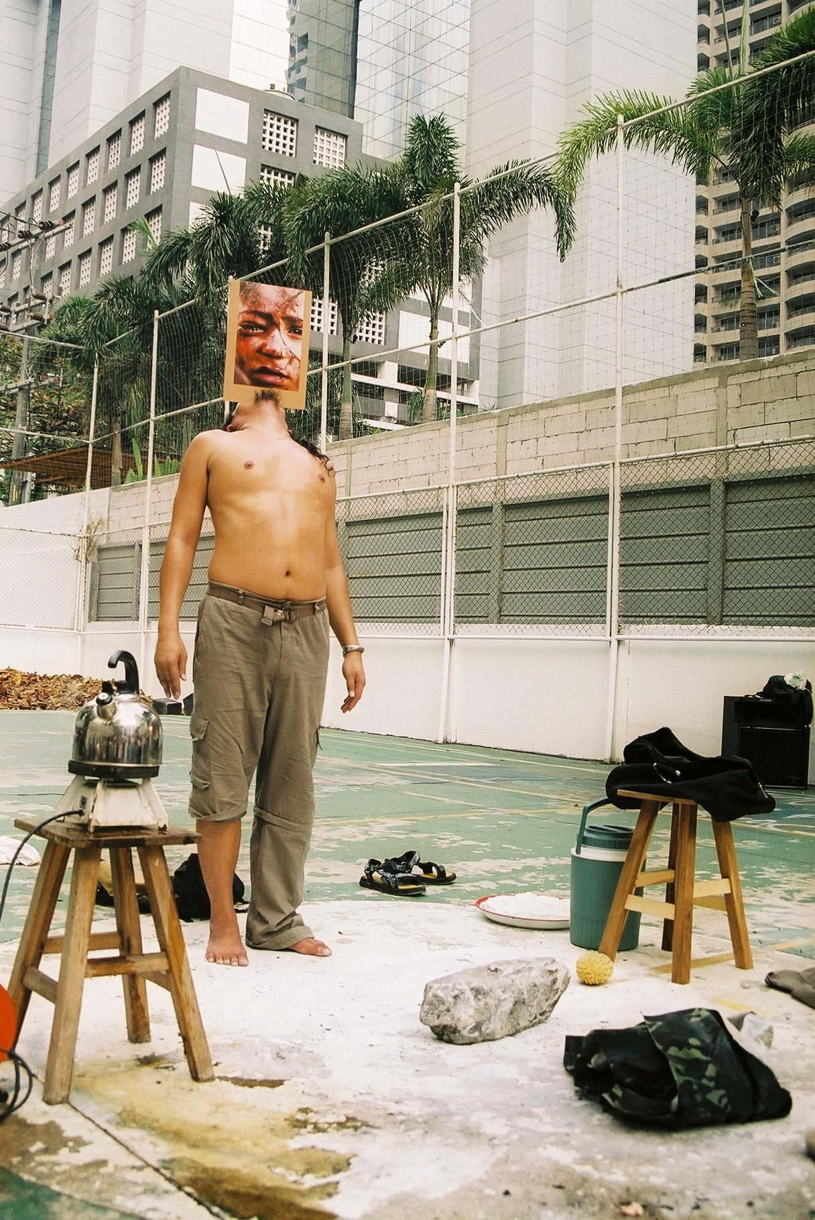
One of the events at Asiatopia Festival which can bring many young artists, especially students and regular audience, who need to understand the art form and how to understand them.

Despite changing venue from Suan Satichaiprakarn Park on Pra Athit Road, to Alliance Francaise and Concrete House. Expecting to lost some audience at the park, but it turn out that many people made through the public from Banglumpoo on the western side of Bangkok to Sathorn Road in the southern part of the city. Concrete House located in Nonthaburi, a suburban town north of Bangkok, where about 130 people turn up for the opening, seminar and a performance evening.

In Chiangmai, where art lovers community is very warm and enthusiastic. The number of people turn up each year, has been constantly increased. Artists talk is one of the popular programs, as people can discuss directly with artists and prepare their mind for performance which would be followed.
Mongkol Plienbangchang, Thailand
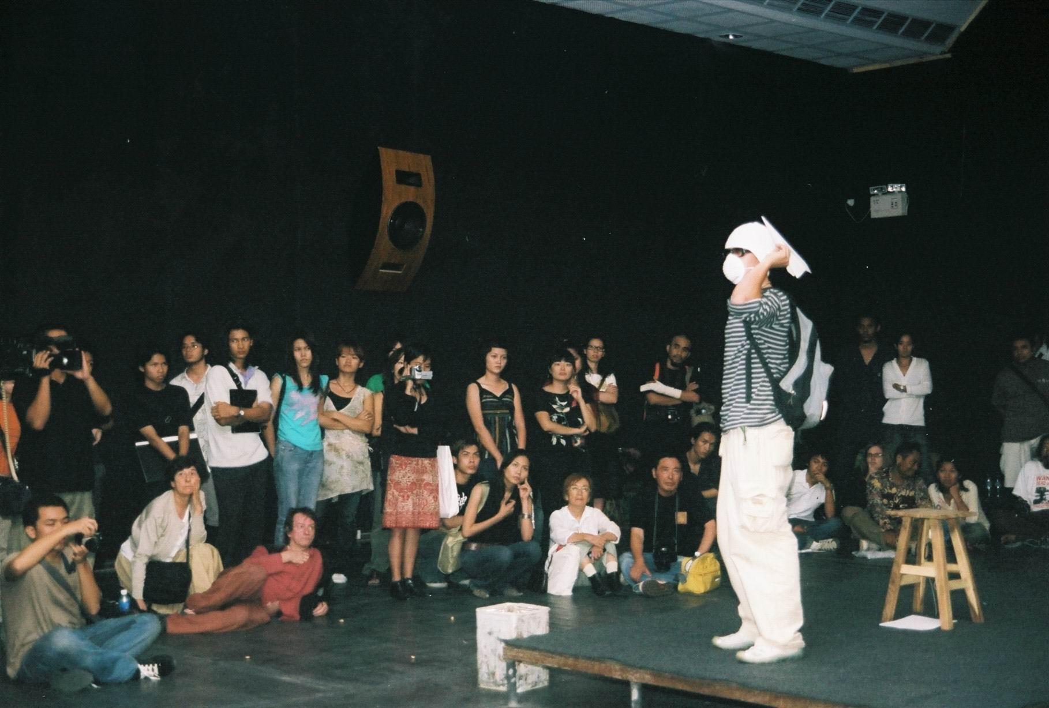
For the press, we see increasing feature about performance art, and interview with selective artists. This year with Esther Ferrer, who is considering senior feminist artist in Paris. Her talk about women’s art has been published in 3 women magazines, and 4 young artists has come directly to her and asked to be her students.

“Come to see me in Paris” she said to them.
Parawee Poopetch, Thailand

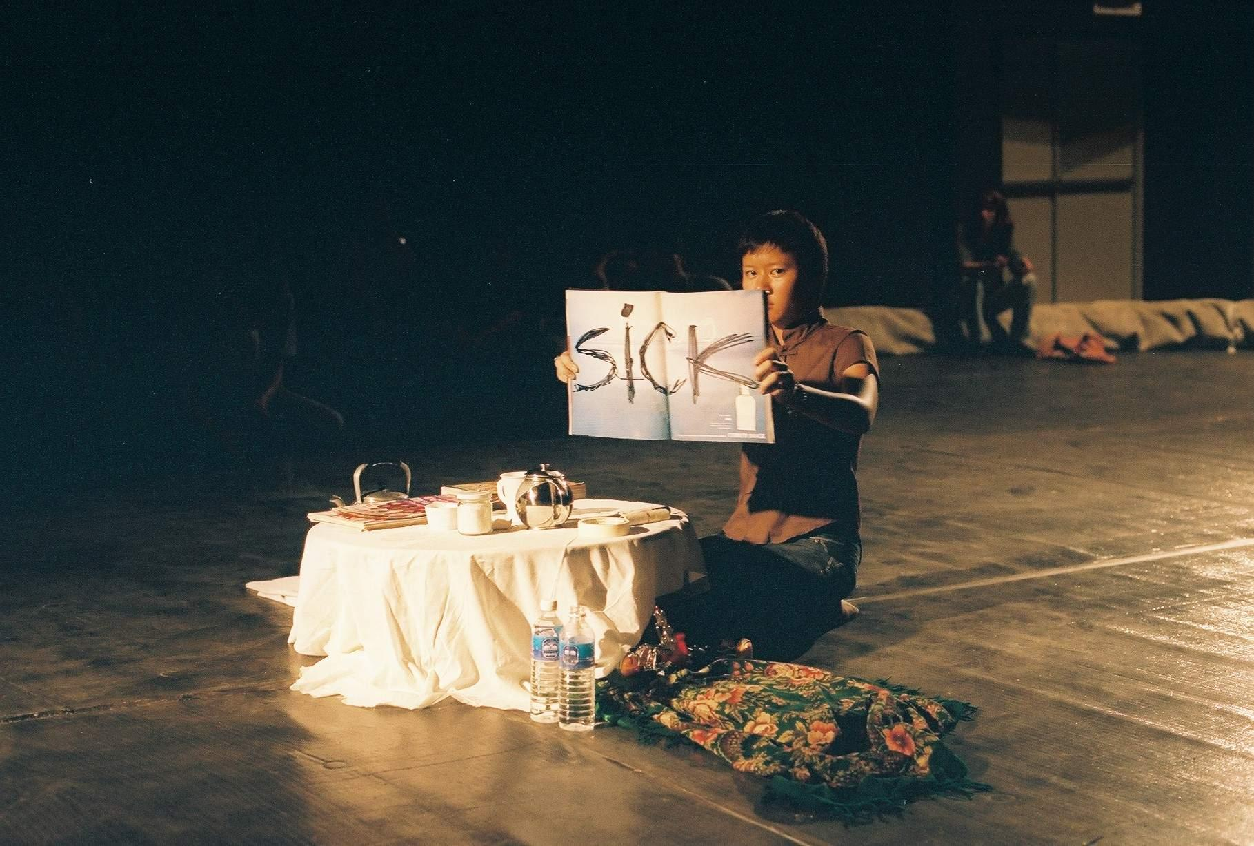
Apanchaleen Israngkula Na Ayudhya, Thailand

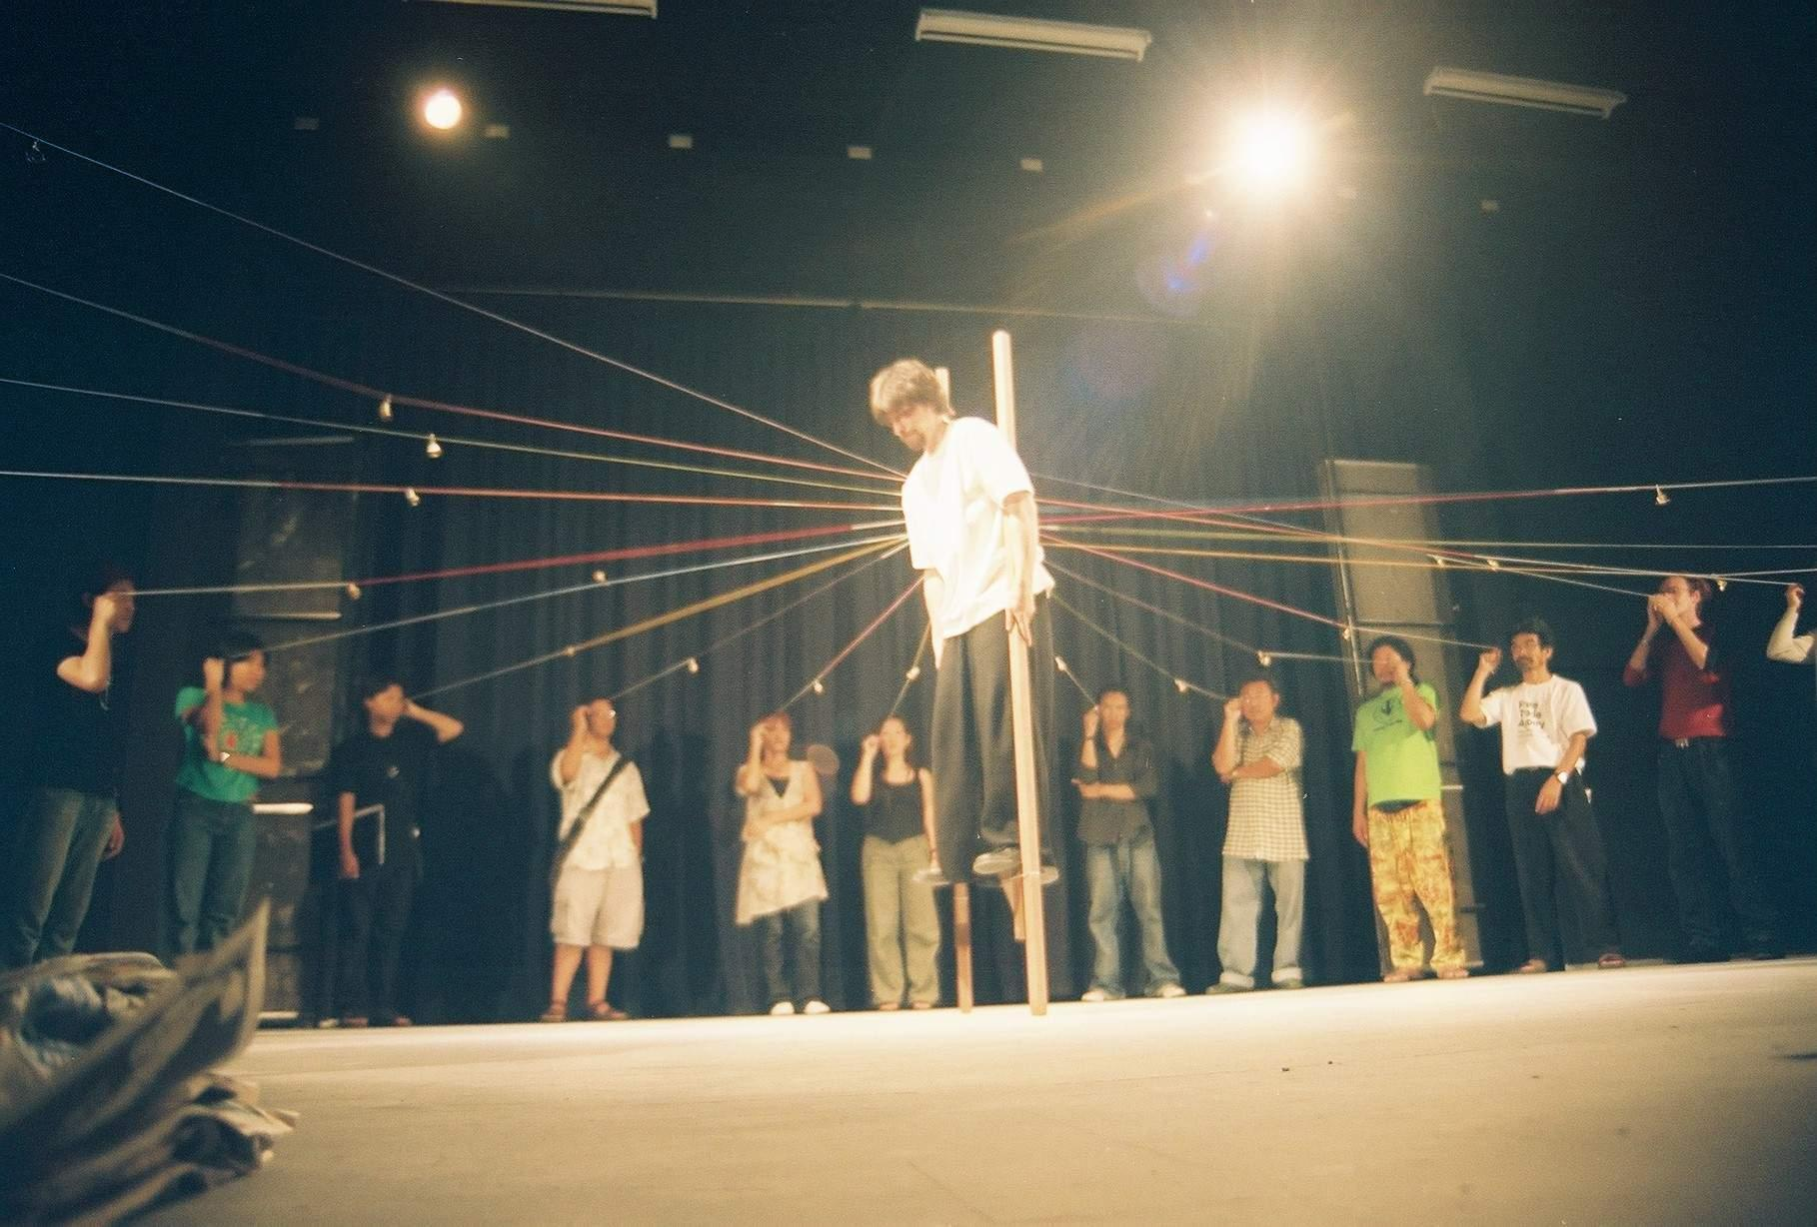
Denis Romanovski, Belarus
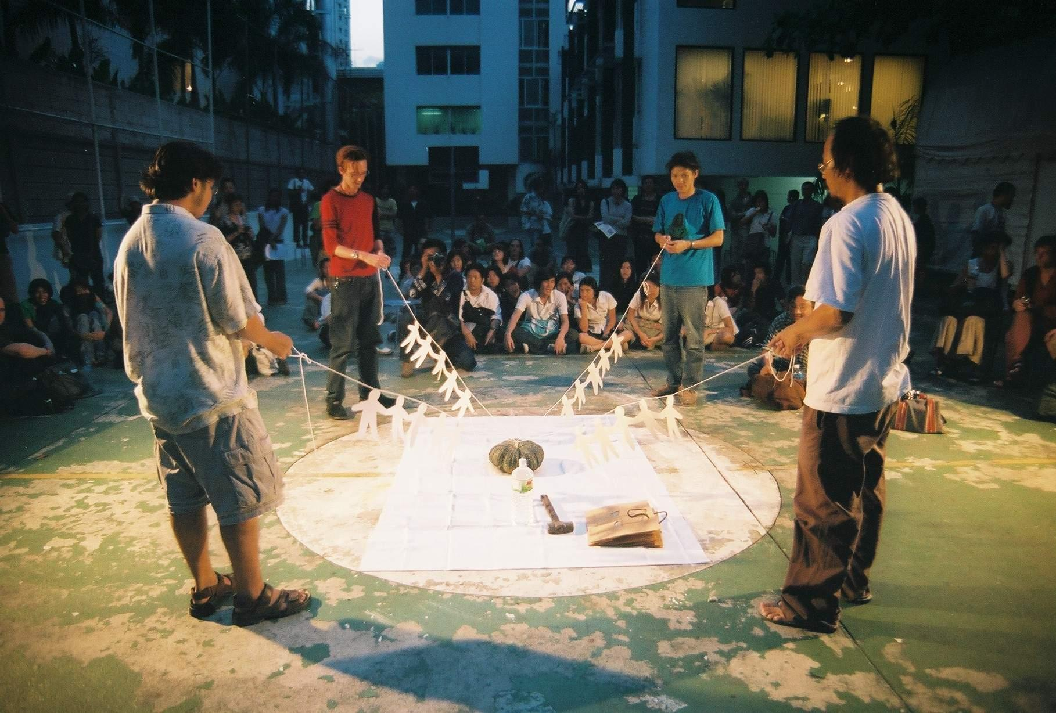

Do Xuan Tinh, Vietnam
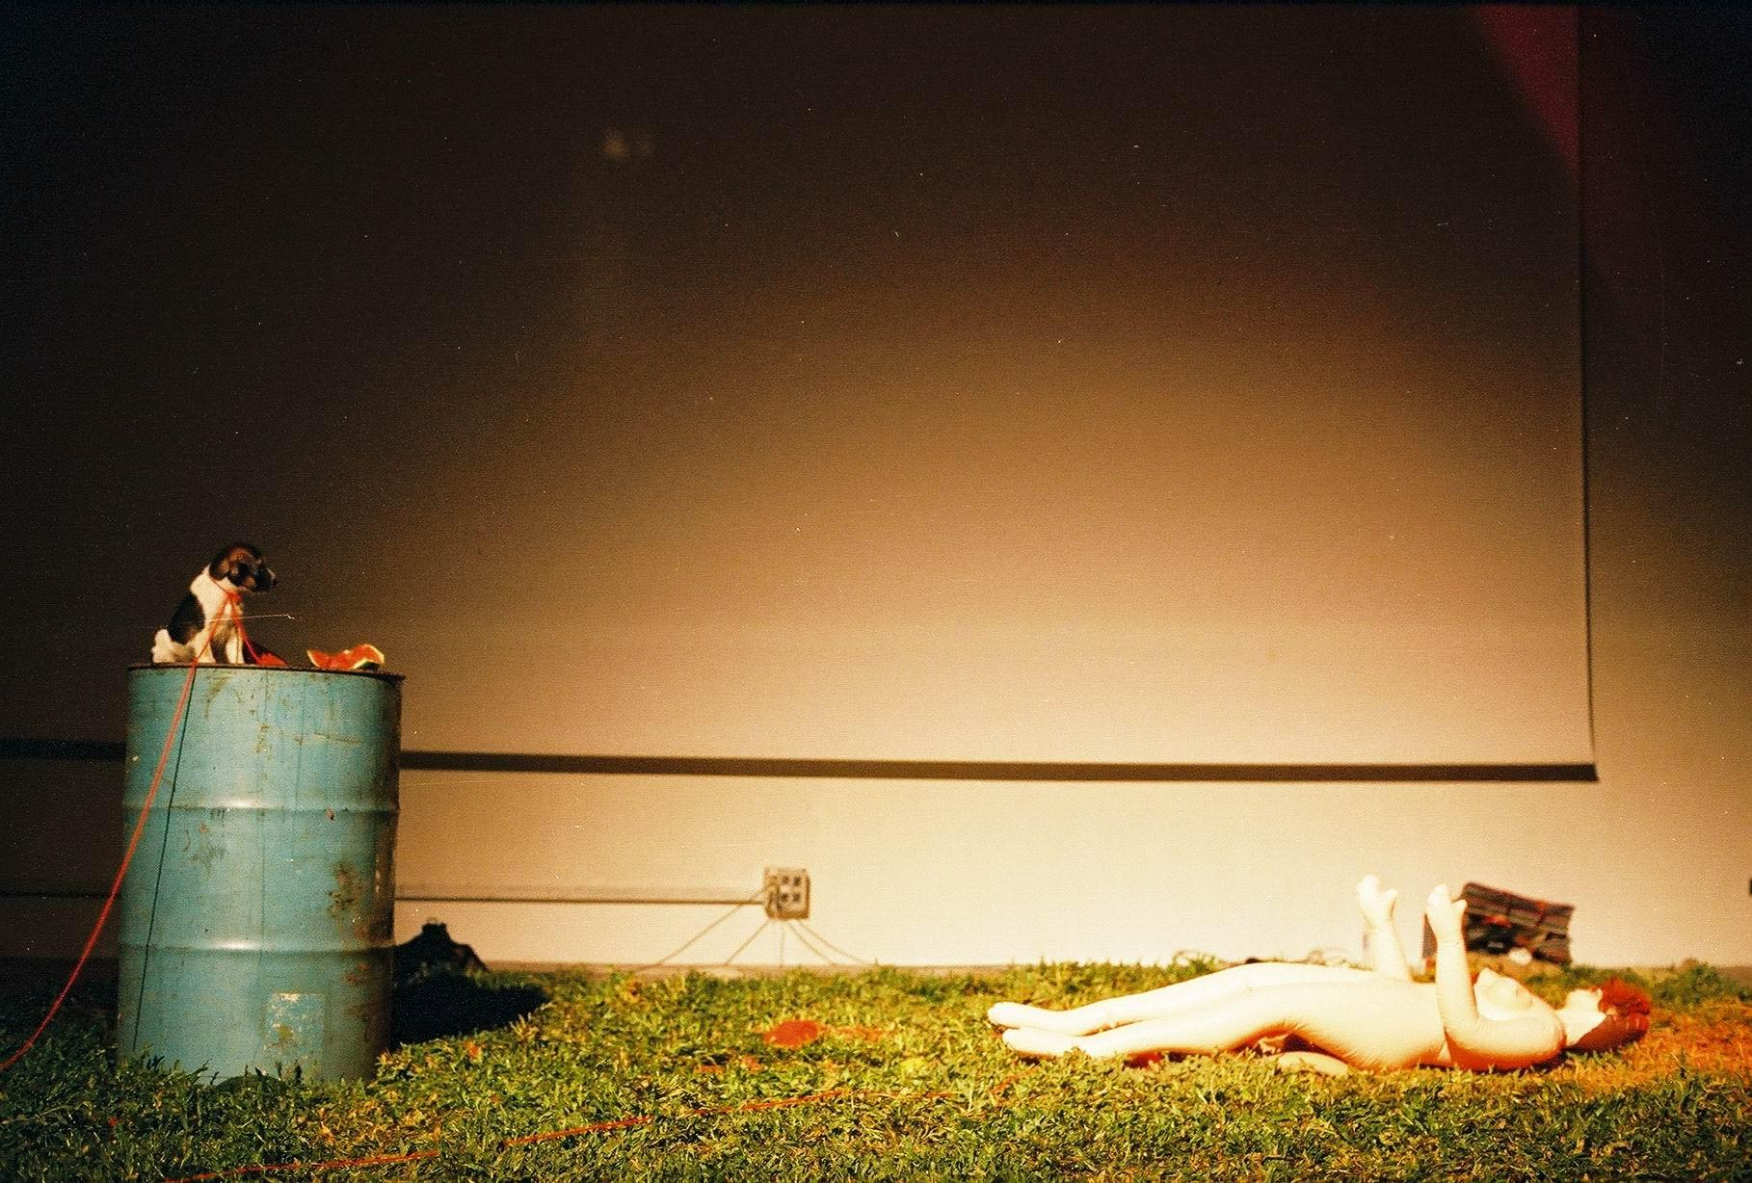
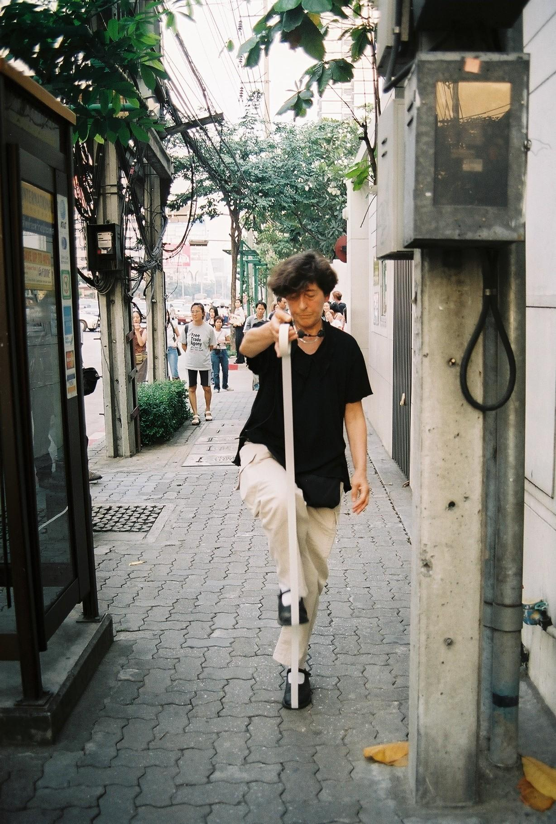
Jakkrit, Chiangmai/ Thailand
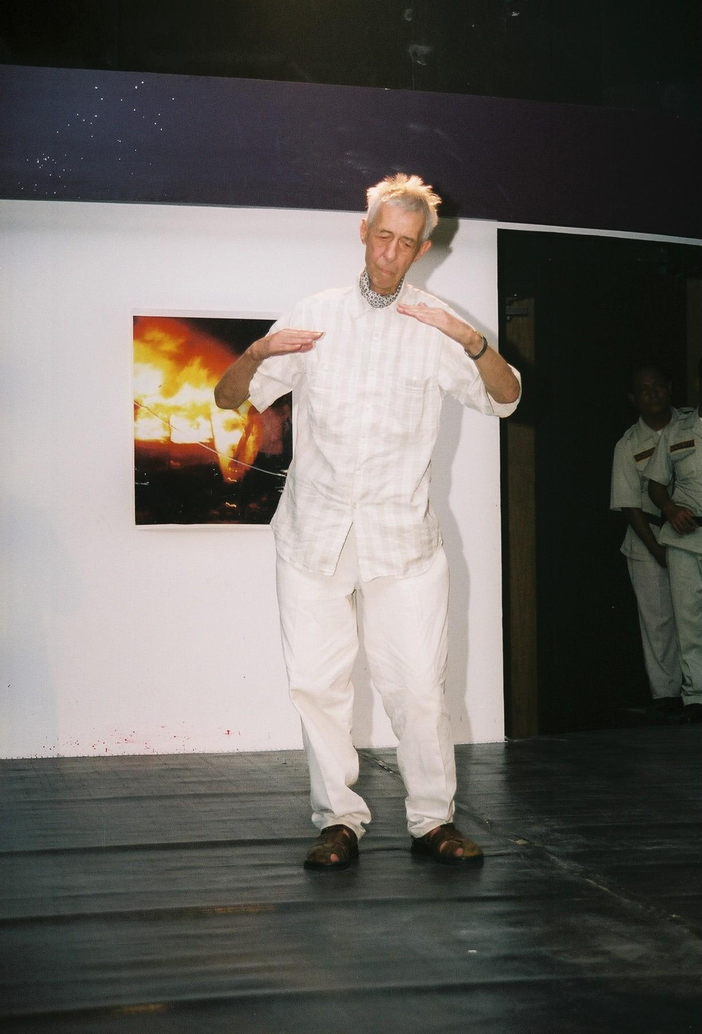

Esther Ferrer, France

Jan Swidzinski, Poland

Opening Speech of Deputy Prime Minister

Mr. Jaturon Chaisaeng

At 5th International Performance Art Festival ‘Asiatopia’, Thailand
at Concrete House an art and community center of EMPOWER Foundation

13 November 2003

Distinguished guests, artists and friends,
It is my privilege to be here among international artists and friends on this special occasion. May I use this opportunity to welcome you to Thailand, and I hope that you all have a happy stay in our country. I also would like to congratulate the organizers of Asiatopia Performance Art Festival, for successfully organizing this unique event
for the 5th time.

Not only performance art that is new in Thailand, the word ‘contemporary art’ itself is not familiar to most Thais. Our modern art history is still very young, the word Art itself which translated into Thai as Silapa, was invented not very long ago. In Thai when we say making things with Silapa, it normally means to make thing delicately, and pretty. To be creative in art is a very sophisticated concept, for us to say making things beautiful seems more relevant. I mention this in order to bring to the point I want to say that the art festival like this one is not something that we are use to either. Although Bangkok has been seen as a very active city for contemporary art in the past few years. However, for the government sector our ministerial responses to the contemporary arts have just begun.

But we realize that things are changing, that we need more art events like this to make us all understand and access to the new concepts. We One thing about Thailand is that we are always open to new things, especially in the present time when the world is connected, so that cultural exchange is necessary, as culture and art is important to make our connection more human.

Today we are living in democratic society, and art is a milestones for our freedom. Because to be creative we need freedom, and democratic society is a society where freedom of expression is respected. I also would like to congratulate supporters of this festival, includes the Office of Contemporary Art and Culture, The Rockefeller Foundation, Alliance Francaise, Goethe Institute, including private companies that
Give their helping hands to this festival. I hope you will continue to support this festival and also many other festivals to come in the future.

I thank you all again for allowing me to speak to you, and I am eager to learn more about your works and your ideas, which will help motivate our young art movement to be more active and interactive with the international art movement.

May you have successful performance, thank you very much.

