Asiatopia 5/2003
5th International Performance Art Festival, Thailand
10-23 November 2003

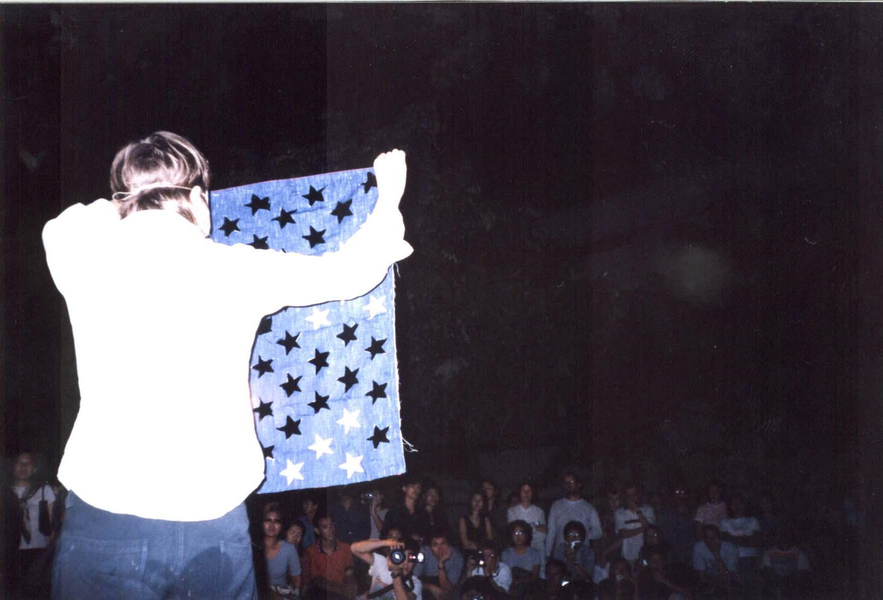
Julie Andre T. from Quebec at Santichaiprakarn Park, Bangkok,
22 November 2002, Asiatopia 4/2002

Organized by:

Concrete House

Supported by:

Office of Contemporary Art And Culture, Ministry of Culture,
The Rockefeller Foundation, Bangkok Regional Office

In Cooperation with:
Alliance Francaise, Bangkok,
Goethe Institute, Bangkok,
Air France,
Sofitel Silom Bangkok,
Center to Promote Arts and Culture, Chiangmai University,

Beer Chang

And

Huen Kalasin Restaurant

ASIATOPIA 5/2003
Bangkok & Chiangmai
10-23 November 2003

PROGRAM

Bangkok 10-16 November 2003
Venues:
Alliance Francaise, 29 Sathorn Tai Road, Bangkok 10120
Goethe Institute, 18/1 Soi 1, Sathorn Tai Road, Bangkok 10120
Concrete House, 57/60 Tivanond Road, Nonthaburi 11000

Chiangmai 17-23 November 2003
Venue:
Chiangmai University Art Center

Schedule:
10 Nov. Artists Arrive Bangkok
11 Nov See venues:
Meeting at Concrete House
Alliance Francaise: Venue (auditorium and other area)
Evening: Visit Womanifesto Festival
12 Nov Preparation day artists meeting at Concrete House
13 Nov Artists Symposium: Concrete House
opening ceremony by Director of Office of Contemporary Art and Culture: Concrete House
14 Nov 16:00-20:00: Alliance Francaise
15 Nov 14:00-21:00: Goethe Institute and area around
16 Nov 15:00-21:00: Concrete House

17 Nov Travel to Chiangmai
18 Nov Artists meeting at the venue
19 Nov Artist Symposium / evening reception
20 Nov. 1st Performance Night
21 Nov Artists Talk and Second Performance Night
22 Nov Artists Talk and Third performance Night
23 Nov Performance evening / Party

Artists:
Europe & America:
1. Waldermar Tartarzuk Poland
- Przemyslaw Kwiek Poland
- Jan Swidzinski Poland
- Viktur Petrov Belarus
- Fairy Von Lilienfeld Germany
- Esther Ferrer France/Spain
- Richard Martel Canada
- Amanda Coogan Northern Ireland

Asia:
9. Hiromi Shirai Japan
10. Nongo Ono Japan
11. He Chengyiu China
12. Xuan Tihn Do Vietnam
13. Phyu Mon Myanmar
14. Nyien Chan Su Myanmar
15. Christiawan Indonesia
16. Madeo Cruz Philippines
17. Tang Da Wu Singapore
18. Amanda Heng Singapore

Thailand
19. Parawee Poopetch Chiangmai
20. Padungsak Kotchasumrong Chiangmai
21. Sompong Tawee Bangkok
22. Jittima Polsawake Bangkok
23. Monkol Plienbangchang Bangkok
24. Mink Nopparat Bangkok
25. Thammasak Meesuk Bangkok

26. Apanchalin Israngkul Na Ayudhaya Bangkok

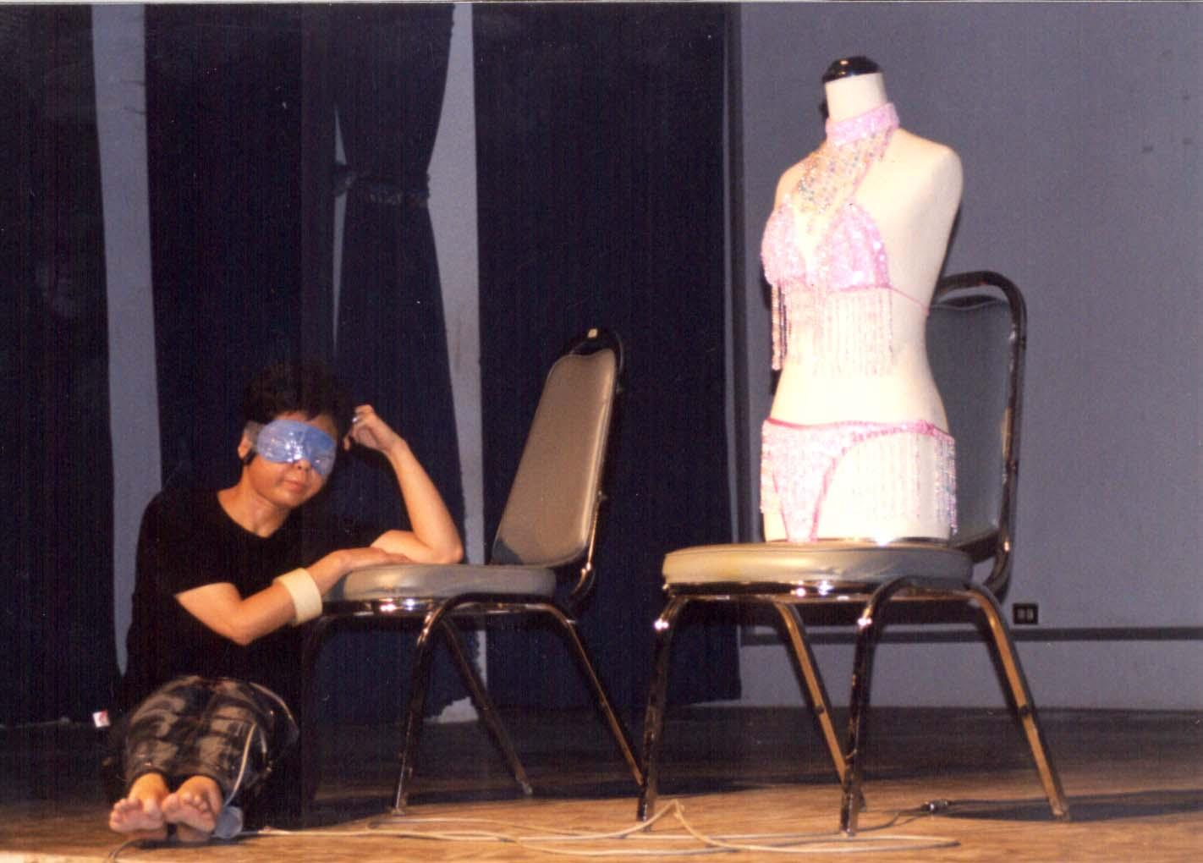

Asiatopia 5/2003
5th International Performance Art Festival, Thailand

Organizing Committee:
Chumpon Apisuk Director
Noppawan Sirivechakul Manager/Media
Paisan Plienbangchang Technical
Pdungsak Kotchasumrong Co-ordinator (Chiangmai)
Thanom Chapakdee Production
Chantawipa Apisuk Administration
Chantorn Chaung-Arun Assistants

Contact Address:
Concrete House
EMPOWER Foundation
57/60 Tivanond Road
Nonthaburi 11000
Thailand

Tel: +66-2526-8311
Fax: +66-2526-3294
e-mail: asiatopia@empowerfoundation.org

Introduction

In 2002, 4th Asiatopia was able to organized with the support of Rockefeller Foundation. The support encouraged local artists to feel confidence in our movement and inspired the local initiatives festival that has been discussed widely in Bangkok and Chiangmai. This also allow us to continue our initiatives in creating cultural environment in Bangkok, as well as introducing the live art form to Thai art community.

In Asiatopia 2002 Report, wrote the conclusion:

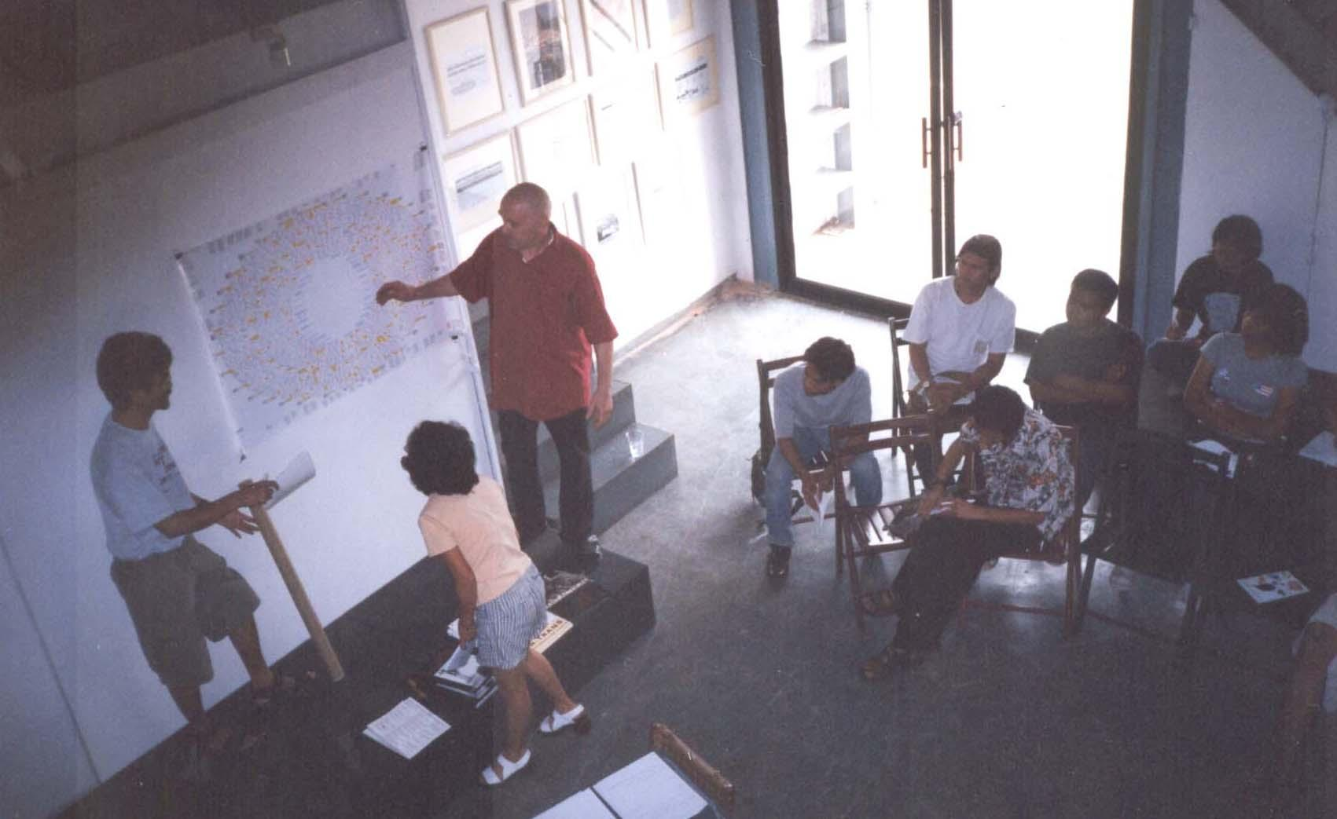
… One of the activities Asiatopia tries to develop is to provide lectures and workshops by
participants artists to art schools around Thailand. The activities not
only allow students to gain more experiences directly with practitioners from different cultures and backgrounds, the direct contact creates opportunity for art students to be involved and open themselves to outside school activities. Asiatopia is an out-of classroom workshop for art students.

… Asiatopia, on the other hand, is not only a platform for international performance showcase, but that the role of art festival is also to strengthen the art community, provide chances for theoretical development, open discussion to contextualize the arts. The art festival is a form of artist conference.

… We have noticed a stronger community for performance art in Thailand,
especially in Chiangmai, where art center has become a main community center of local art and intellectual community.

… The lacking of art center in Bangkok makes cultural activities work around alternative spaces, and public parks and streets became main entertainment and cultural activities venue for its people. The public spaces as such, however, is unable to help strengthen community spirit, but only provides temporary
entertainment event..

In a report back to artists after the festival 2002, the director of Asiatopia wrote “The strong presence of Asian artists helped creates a community feeling, a common people and neighbourhood friends. As I gathered some reflections from people who came to our festival, they are happy to see artists from Vietnam and Myanmar, as well as artists from Philippines, a beautiful Indonesian artist and a joyous artists group from Singapore. Some people remember Kaori Haba who was in Bangkok and Chiangmai two years ago. A few people asked me if there would be artists from Laos, Cambodia next time. This small things are very meaningful to us all, because we could feel that there are people following our effort, and there is a sense of community growing inside.”

We are very proud to be able to presented Black Market International (BMI), a respected group of performance artists and art teachers who has been inspiration in the active movement in
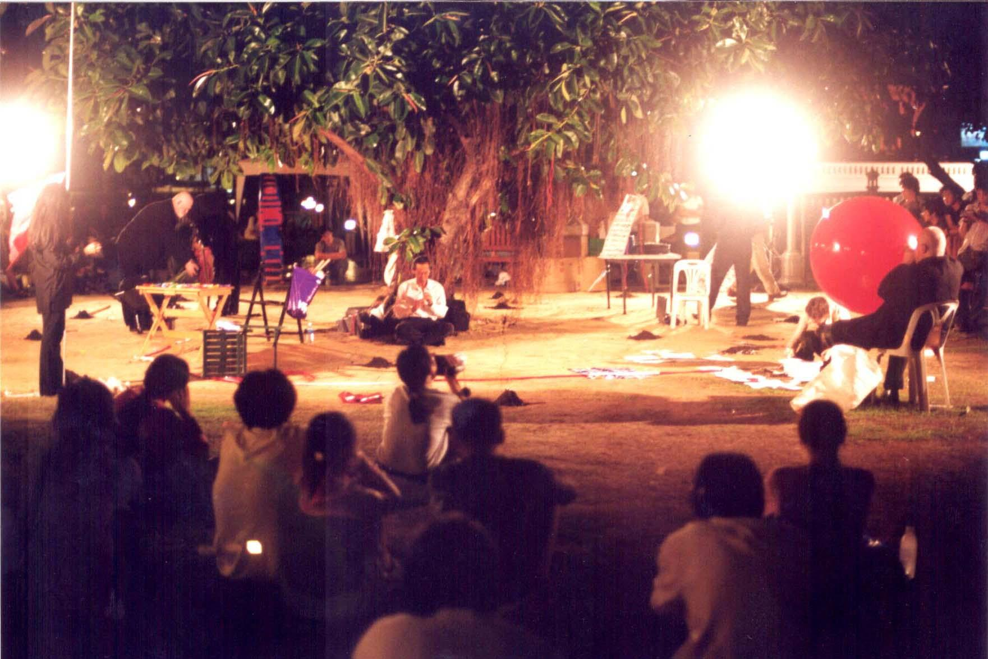
Black Market International at Asiatopia 2002

Europe, to Asiatopia 2002. There were also leaders of performance art movement from Philippines, Vietnam and Myanmar, and a famous performance group in Thailand ‘Ukabat’. The exchange has brought us the clearer perspective of Asia, and creating a stronger network among Asian performance art movement.

We hope that Rockefeller Foundation will continue to support our effort to bring Asian artists together and also in exchange with artists from Europe and America. At this 5th anniversary of Asiatopia, we are bringing artists who created their works in the 70s in Eastern Europe and remain there in this time of changes. The idea of performance art in the 70s (Jan Swidzinski, Krszystof Zerebski, Esther Ferrer, etc. for instance) which is a foundation of performance art today. We are happy to be able to have a cooperation with artists from those generation who are still active to let us learn the first hand experiences. For many of them this is the first time to visit Asia and the first meeting with Asian artists.

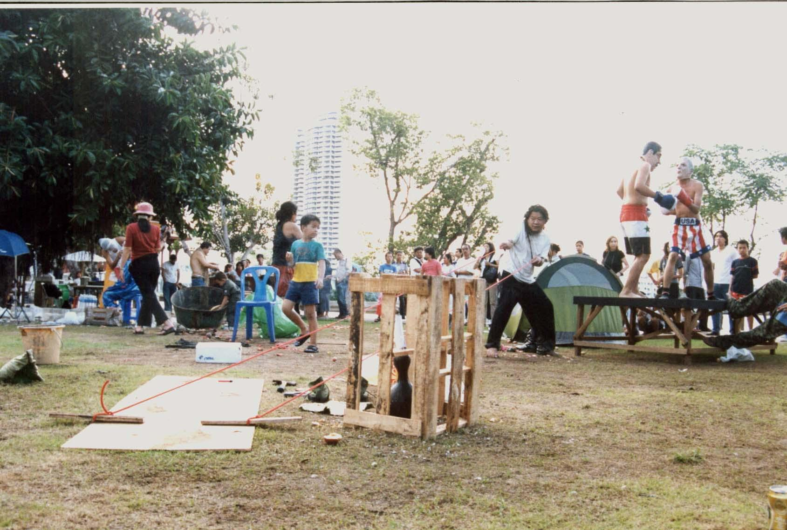

Ukabat Group, a famous performance group from Thailand, Asiatopia 2002

Inspiration
Last year, 2002, a new Ministry of Culture was established with 2 active departments. They are the National Cultural Commission, which was handling all aspect of heritage culture, traditional value and practices and the Art Department, primarily takes care of historical sites, archeological research and historical museums around the country. The Office of Contemporary Art and Culture was starting to take shape. The fruit of tireless efforts of many individuals and the arts community in Thailand, has led to official establishment of the office of contemporary art, with the first director, Dr. Apinand Poshyananda, an international curator who has helped placing Thailand’s contemporary art in the global map, being nominated by the arts’ community.

This year, 2003 at 5th International Performance Art Festival in Thailand-Asiatopia 5/2003, the Office of Contemporary Art and Culture agreed to partially fund the festival, and we are now trying to establish a long term relationship with each other. This is a good beginning for the future of contemporary art in Thailand. In addition, the development of this relationship, has become an inspiration to make the festival better by improving the organization and re-affirming it’s local community.

Asiatopia appreciates the support from international artists & colleagues, friends and organizations, who have fully engaged in bringing the festival up to this point and kept it going.

Moreover, looking out to the broader Asia, active movement of performance art spreads their paradigm everywhere, from Indonesia to Philippines, Vietnam, China, Hong Kong, Korea, Taiwan, and especially in Japan. Despite this, on the southern peninsular Singapore, is known as a troubled state for performance art. However, many artists and institution, the art community in Singapore has been an active movement of performance art in Asia and the international community.

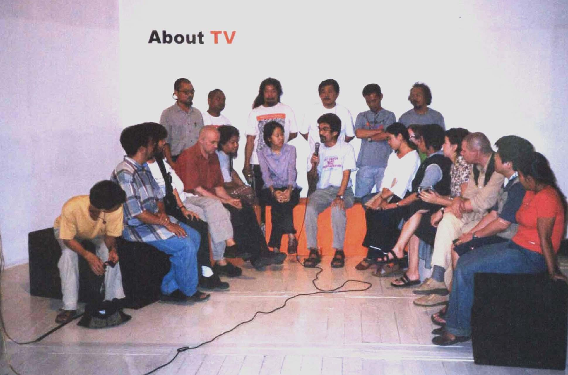
Live interview on Super Channel Web-TV Program /2002________________

In March 2003, an exchange initiated by Singaporean performance artists group – Artists Village, began in Yogyakarta. This inter-country-regional exchange, of Artists Village, supported by Singapore Art Council, allowed artists to have
direct contact and interact
in a cross cultural
perspective and environment. In an opening exhibition of the new Contemporary Art Museum in Hanoi in November 2002, Houng Ly a notorious performance artist from Ho Chi Minh City, staged her first performance inside the state museum.

Tupada, a bi-weekly gathering of performance art in the public park in Manila, is run by a few individuals performance artists, without money involved. In May 2003, PIPAF 3/2003 organized by Yuan Mor’O Ocampo, invited international artists from all Asia and other regions of the globe. PIPAF is becoming a strong festival in Asia. This year there will be 5 artists from Thailand participating.

Despite political difficulty in Indonesia, ‘The Poet of Body’, organized a journey festival from Bandung to Yogyakarta, in October-November last year.

NIPAF (Nippon International Performance Art Festival) which are one of the most inspiring movement that has helped bring artists from Asia into international community, and has been going strong for 10 years now. In May 2003 NIPAF10/2003 has organized performance art tour in several provinces and cities in China.

These few samples of activities initiated in Asia by performance artists in the region, has played a significant role in creating a supportive environment for art and culture in the whole region, not only in the social setting of each country. The inspiration has aired throughout the region. Asiatopia is proud to be part of this active movement.

Venues:
In the past 4 Asiatopia festivals, we’ve organized our festival in public places, which has created limitations for our performers. Although the festival is still open to the public, the institutional premises with both outdoor and indoor spaces would allow artists to have more freedom to create their works. Moreover, the specific venues would eventually limit viewers to self-selected audiences, clearly, helping us define our community.

The sites will be challenges to organizers and local artists, who are more familiar with performaning in public places with respect to public culture. However, artists from overseas who are familiar with specific spaces, will not have much difficulty. So in this respect, it will help us to develop sites, as well as developing sites specific works. For those who prefer a theatrical setting, the audience will have a chance to experience a full stage production of performance art, which distinctive from live-performing art.

The Experimenting goes on…
Grass Roots:
We gained experience from Asiatopia 2002, in Chiangmai, when the festival coincided with a local community festival organized by network for traditional liquour, to campaign for legalized traditional brew. The local community event allowed artists to experience and directly interact with Thai people and their issues of concern. This interaction helped link community workers and cultural workers of Asiatopia, and we hope this linkage can lead us to merge local community festivals and Asiatopia together.

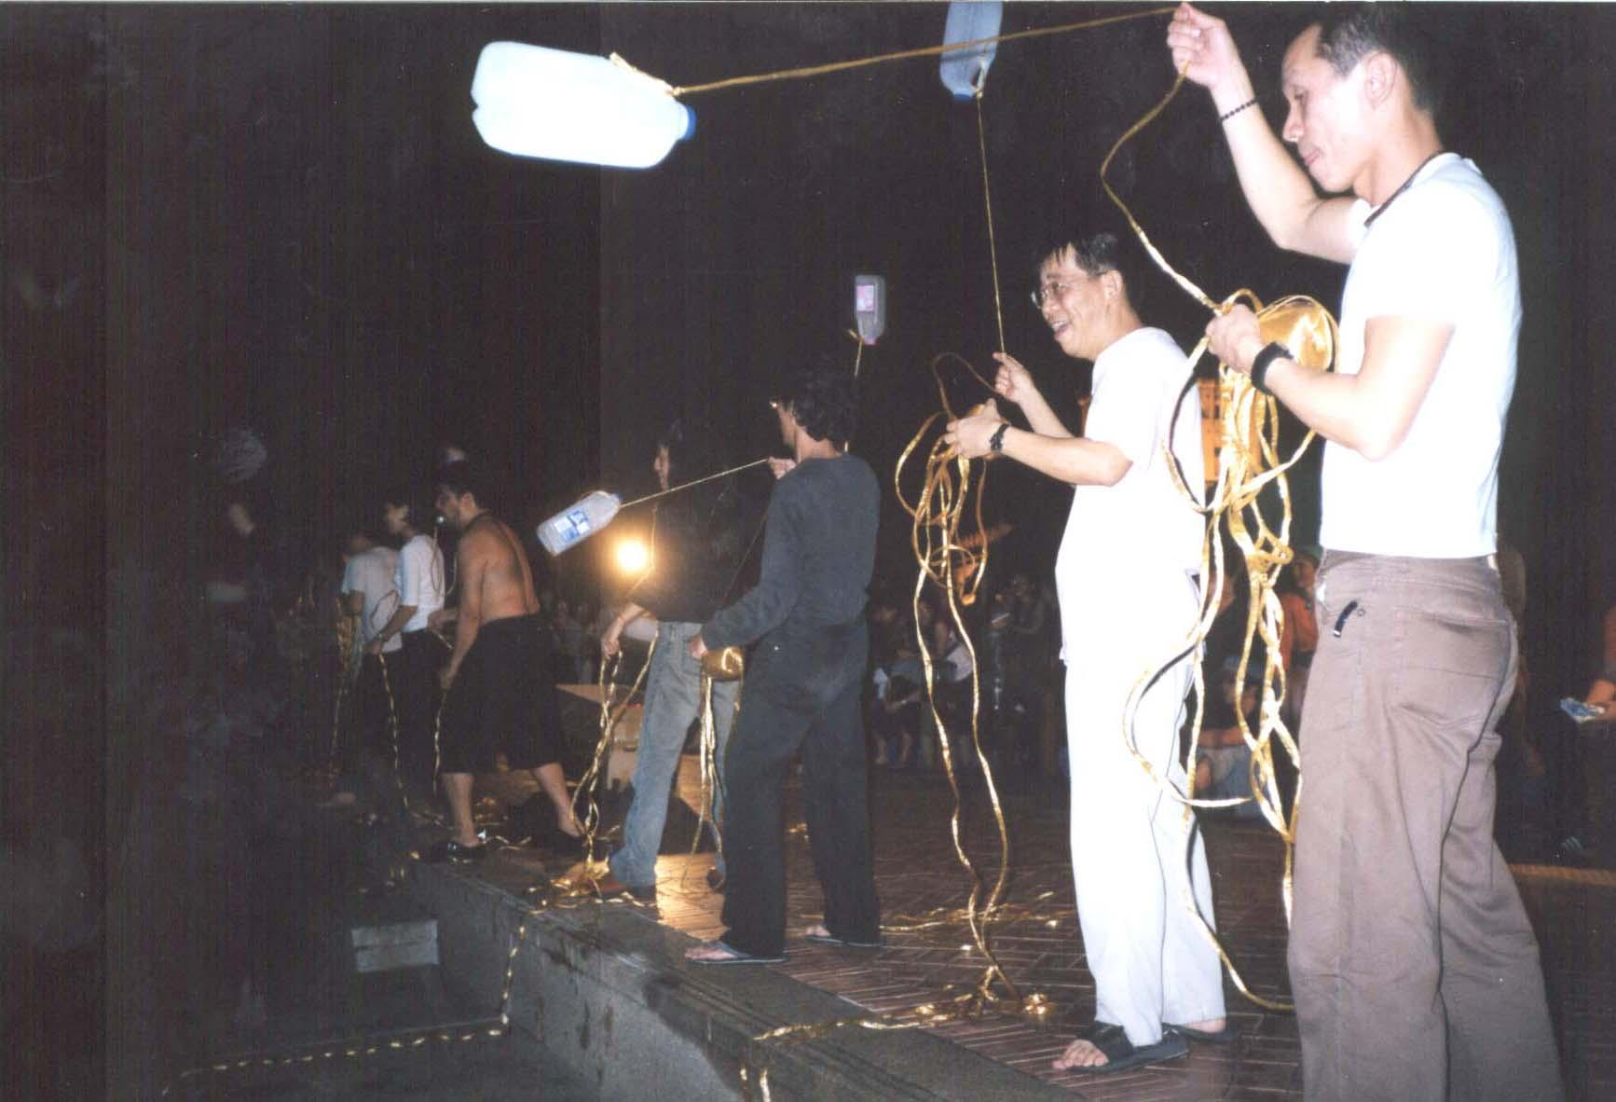
Yuan Mor’O Ocampo from the Philippines turned audience to performers, Asiatopia 2002

2003 Situation
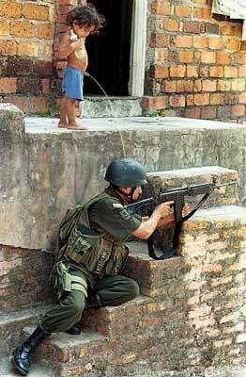
The terror of war, threatens the world and us all. We define the world with our actions, define our humanity with performance art, and we hope to make peace the substance of our humanity. Is there any year, since we began Asiatopia (since 1998), that there is no war crime in any countries in the world?

In March, we’ve heard about a terrible virus, spreading in China, Vietnam, Hong Kong, Taiwan, Singapore and beyond – SARS. At the end of March, a WHO medical doctor who identify the deadly new type of Corona virus, fell ill in Thailand after his investigation trip in China and Vietnam and later died in a hospital in Bangkok,. The deadly virus has become the greatest thread in the region. It caused cancellation of the Rolling Stones concert in the region, and Thailand's a gate to tourism business in the region has lost to 70% cancellation.

And SARS respiratory virus killed nearly a hundred people in a few months, and infected thousands. The disease was simply like normal flu, that then became deadly, and medical science is reluctant to admit that they are unable to find a cure. Asians, again become unwanted travelers and citizens. Strict measures were implemented and travelers from 5 Asian countries mention above are counted as a major threat. With reports that the virus is also spreading in Canada since the earlier stages, and with a few cases also found in Australia, still the tourists from these western countries are barely mentioned, and remained free to travel. We hope the virus will be eventually under control, by the time of Asiatopia.

Thailand, where we hold Asiatopia meeting, has been confronted with a war waged against it’s own citizens by allowing the assassination of at least 11 persons a day (reported over 1,200 people were shot dead during the first 90 days of government declared War Against Drugs, while the police are unable to arrest anyone). Police are authorized to go into bars and pubs checking everyone’s urine, as if a urine check for drugs is a national security policy…

In the depth of our skin, thousands of people were forced to leave their home, for the beauty of the Angel City. People are prevented from rallying in front of government house, because our Prime Minister won’t be confronted. 135 species of local fish in a river in our northeastern region are in danger of disappearing, as their lives and reproduction system has been stopped, after the hydro-power dam has been built to block off it’s mouth which is connected to the Maekong River. Hundreds of villagers in the south were beaten up by the police, when they rallied to petition the Prime Minister to re-route a natural-gas pipe line away from their rich and clean sea water. Etc…

In Asia, our neighboring country Cambodia went ‘mad’, when local press speculated that a Thai super TV-star had claimed Ankor Wat was once part of Thailand. The angry mass of young Cambodian’s rampaged through the Thai royal embassy and all Thai businesses, which disrupted their diplomatic relationships. However, slowly, the government on both sides repaired the wound, and hopefully the people from both countries can enjoy their normal relationship again, soon.

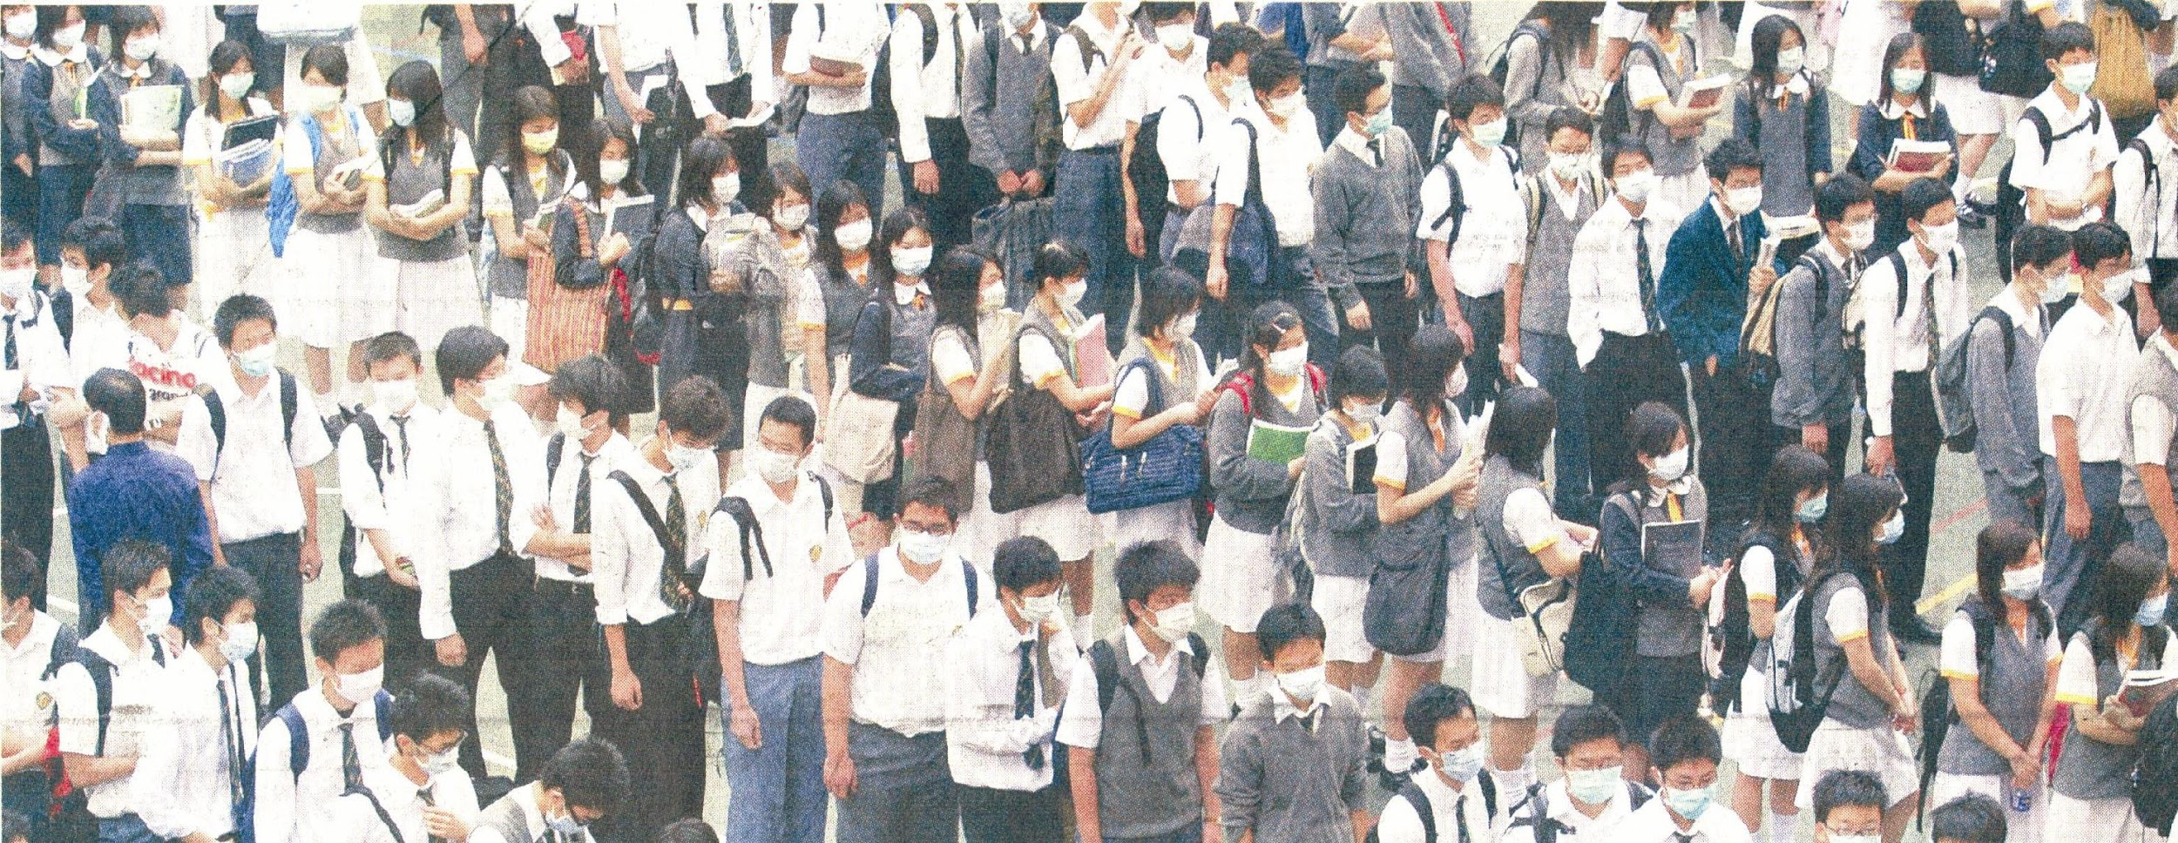

On Thailand’s western front, the war on drugs, caused tightening up of the border line. While the publishing by a human rights group of ‘Licence to Rape’, a critical investigation of Myanmar soldiers raping ethnic women in several villages near the Thai border, became a major issue for a while. However, the American-British war against Irag put this and other human issues under the carpet for the time being.

The terrorists’ bomb explosion in Bali, killed a couple of hundreds people – Balinese, Indonesian, Australian and other oversea tourists in seconds and stired up another time of unrest in Indonesia, and ‘the restless region’. While the political conflict between Manila government and Muslim south in the Philippines is still unresolved, war breaks again in Aceh, and East Timor remains world poorest nation, etc, etc…

These are some of the global threats and issues, all happen in Asia, in the year 2003. And these very facts make the idea of ‘Asiatopia’ still relevant.

