ASIATOPIA 4/2002
International Performance Art Festival, Thailand

Bangkok 18-25 November 2002
Chiangmai 26-30 November 2002

As if it's our dream,
Asiatopia 4/2002, has awakened,
to encounter reality,
to challenge factual reality.

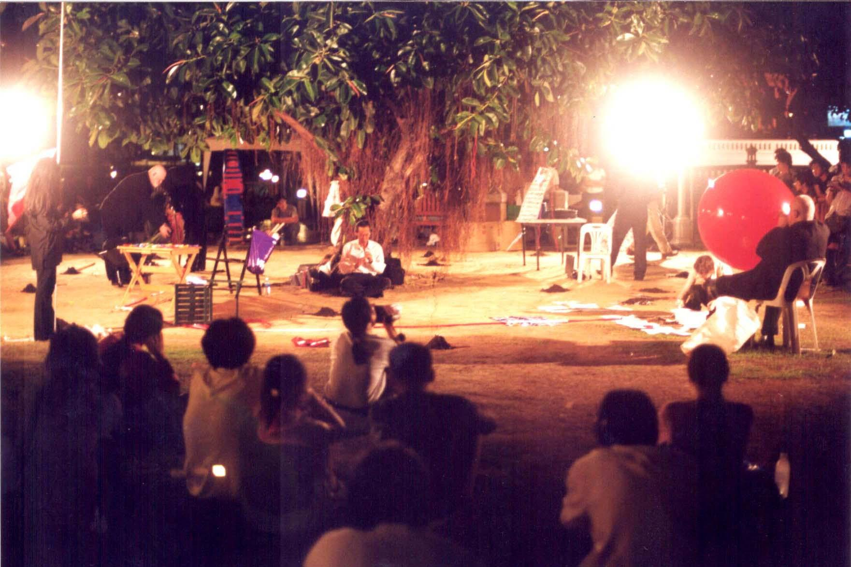
Black Market International, 21 November 2002, Asiatopia 4/2002, Bangkok

The reality that should has been laid long before it actually happened, in 2002, in Bangkok. The reality which international arts & cultural exchange has been able to continue, for the 4th time in Thailand, with a spirits of solidarity among international arts community. Most artists from far away countries in Europe and as far as Mexico and Japan, found their own funds to come and joined the 10 days long artists meeting. While 7 regional artists gained support from international doners (Rockefeller Foundation) and friends to make the exchange a strong presentation of the local and regional communities.

The reality which Thai public is intervened and directly interacted with critical art form that should not be compromised or disguised as any entertainment. The reality of public, which artists have to observe and respect rules of limitations, while negotiate strategies to maintain their artistic statements and expressions.
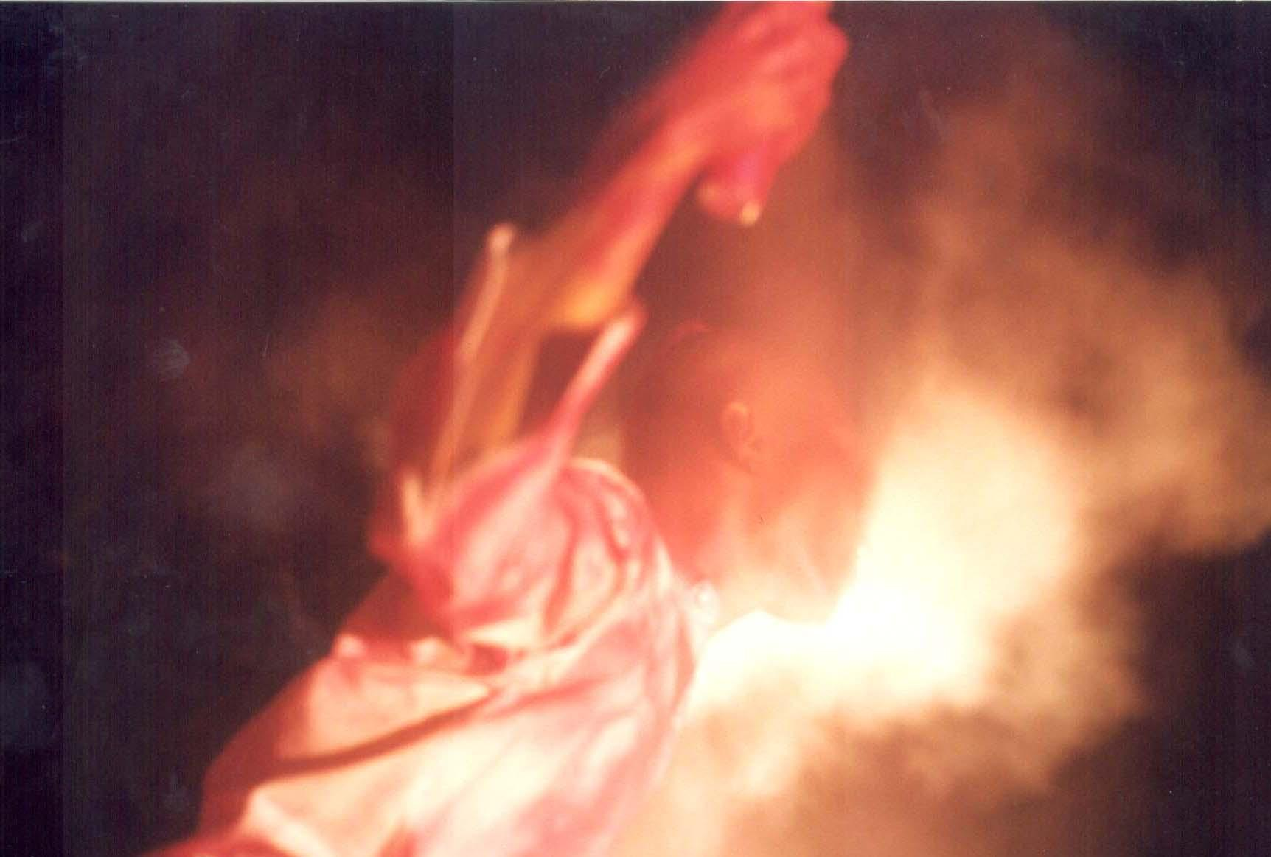
The encounter becomes a challenge to both artists and organizer, by introducing living performative images of body expression, interacted with real public activities. Without changing or intention to render community lives and activities of the park, 44 artists from 14 countries were able to perform their art actions in the situation and atmosphere of normal community lives.
Montri Toemsombat, Thailand, Asiatopia 4/2002
23 November 2002, Bangkok

Actions of each individual artists are circled by enthusiastic crowds, and the crowds moves along as artists perform and move from place to places. Many asked for explanation of the acts, while some interacted with queries more and more. Times moved on, actions continuously changes, more exchange of words describing actions whispered from mouths to ears.

As reported by the artistic director to participated artists and organizing team:
“Black Market performance, despite being interrupted by stormy rain and disrupted crowd, I felt the site has been developed and situation has got on the way. Despite the situation that could develop further and people followed well. But what I’ve followed gave me a delightful moment to see the magic of performance art. Some of us later compare the BMI performance as a priest meeting in church, and some did not agree but said it was like farmers work collectively in the rice field. I agree with both comments. And I’d like to thank the wonderful moment.”

“The strong presence of Asian artists helped creates a community feeling, a common people and neighbourhood friends. As I gathered some reflections from people who came to our festival, they are happy to see artists from Vietnam and Myanmar, as well as artists from Philippines, a beautiful Indonesian artist and a joyous artists group from Singapore. Some people remember Kaori Haba who was in Bangkok and Chiangmai two years ago. A few people asked me if there would be artists from Laos, Cambodia next time. This small things are very meaningful to us all, because we could feel that there are people following our effort, and there is a sense of community growing inside.”
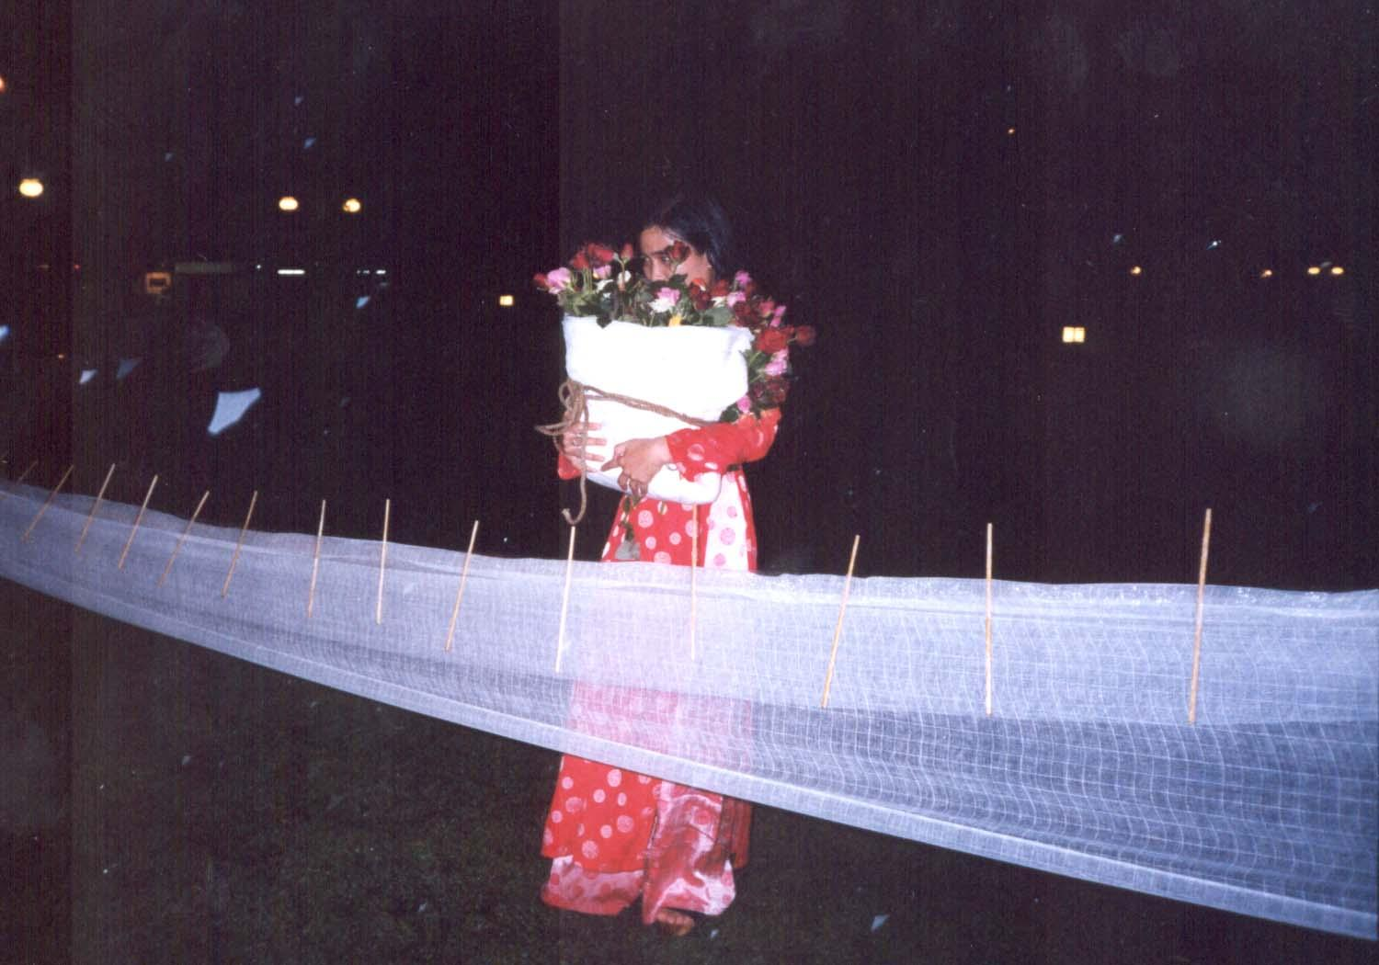
On the first evening of the festival, an unexpected off-season storm rained the park into a drenched pool within minutes. While performances were carried out, many enthusiastic audiences stood in the pouring rain, observing the performers continue their actions.
Houng Ly, Vietnam, Asiatopia 4/2002,
22 November 2002, Bangkok At the end of one performance, a couple of audiences escorted performers to the organizer's tent under their umbrellas. The audience became supporters to performers; solidarity spirit was high and encouraging for both organizer and performers.

Alastaire MacLennan, a participant artist of Asiatopia 4/2002, praised the festival as real challenging and one truly public art event. Arai Shin-Ichi, from Japan, thanked the interacting atmosphere of the festival, as it has inspired him a new performance, which tells of his long hidden life story. Elvira Santamaria from Mexico found the festival encouraging and promised to try to organize cultural exchange between S.E. Asian artists and Mexico. ETC…
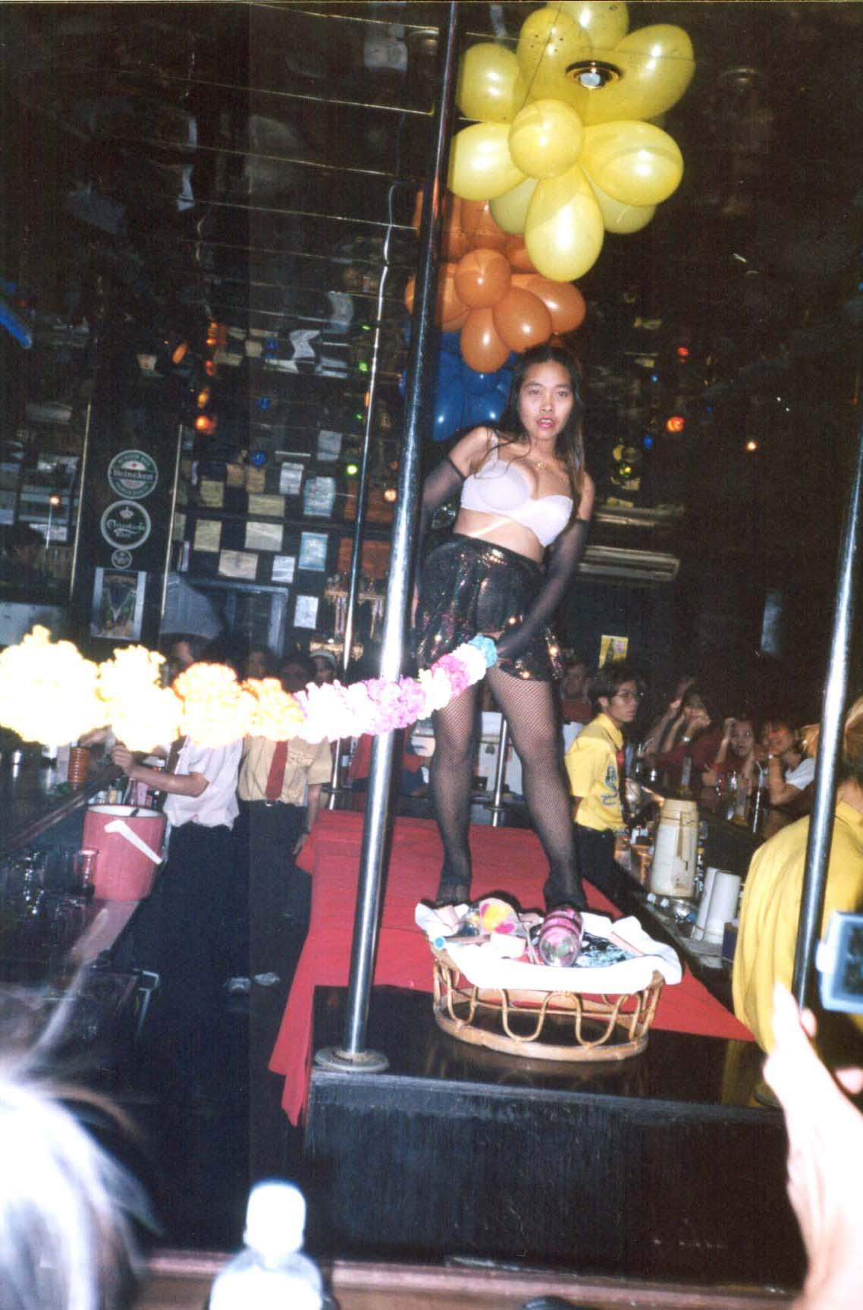
For local performance art community, 6 strong young artists were invited. All of them did their first public performance in the festival. Especially we manage to invite Siriporn Sriphen a sex worker self-trained erotic performer to join the festival. Siriporn is a sex worker in Bangkok and has worked with sex workers rights organization EMPOWER Foundation for many years. The inclusion of sex worker performance into the festival is to show an art form which has been developed in other cultural sector of our society.

However, disappointingly, only a few local artists have opportunity to share luxurious time together with international participants after each evening events. This missed-opportunity of private exchanges among individual artists from the local participants is due mainly to
Siriporn Sripen, Thailand, Asiatopia 4/2002,
24 November 2002, Bangkok

their limited time; not language as most will use as an excuse. The organizers hope that in the future we will be able to accommodate more local Thai artists for they can stay and share their whole time together with international artists.

Highlights of performances:

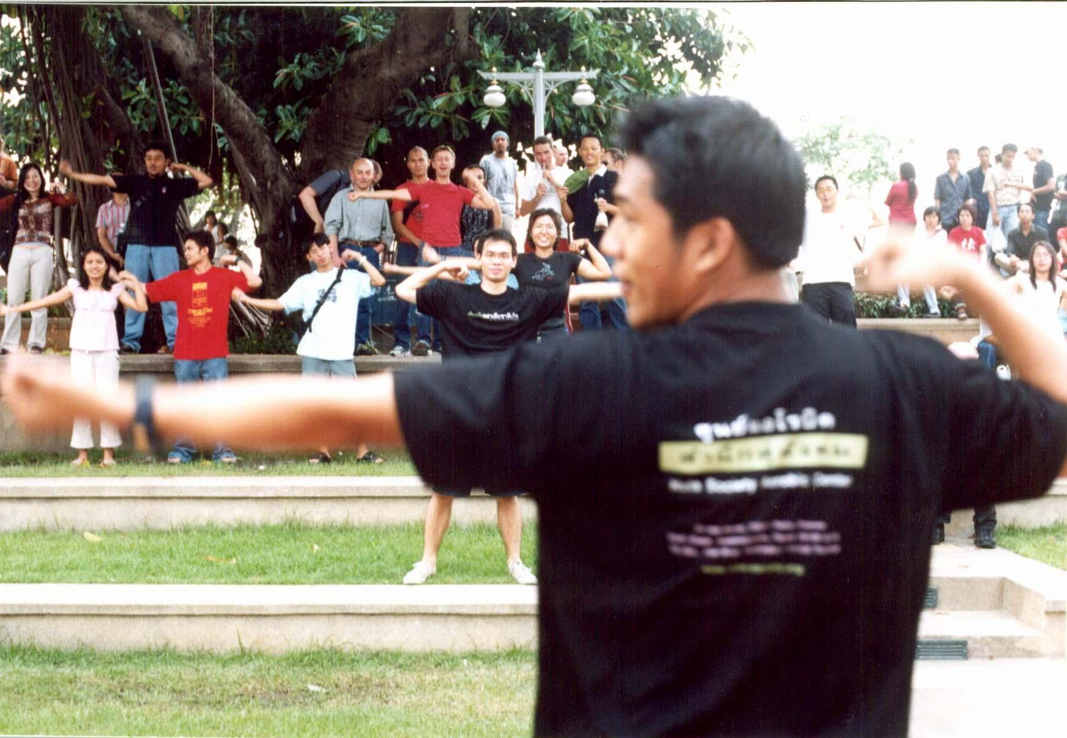Nut Society, Thailand, Asiatopia 4/2002, 24 November 2002, Bangkok

Nut Society, based in Thailand, is a group with aims and direction to re-create cultural norm of social gathering by adding moral jargons into each of their activities. They work as a group; create their intervention strategies as a group. Their presentation is closer to social intervention than an art group.

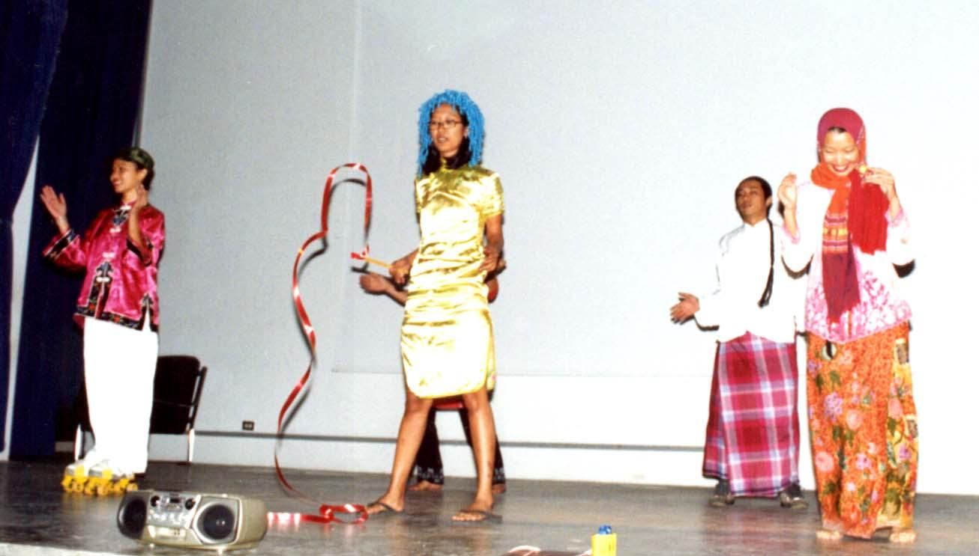
Artists Village, Singapore, Asiatopia 4/2002, 30 November 2002, Chiangmai

Singapore Artists Village is well organized with structure and programs. They created exchange program in galleries and art spaces around the region. They work with media technologies mixed with performative actions, sounds as well as installation.
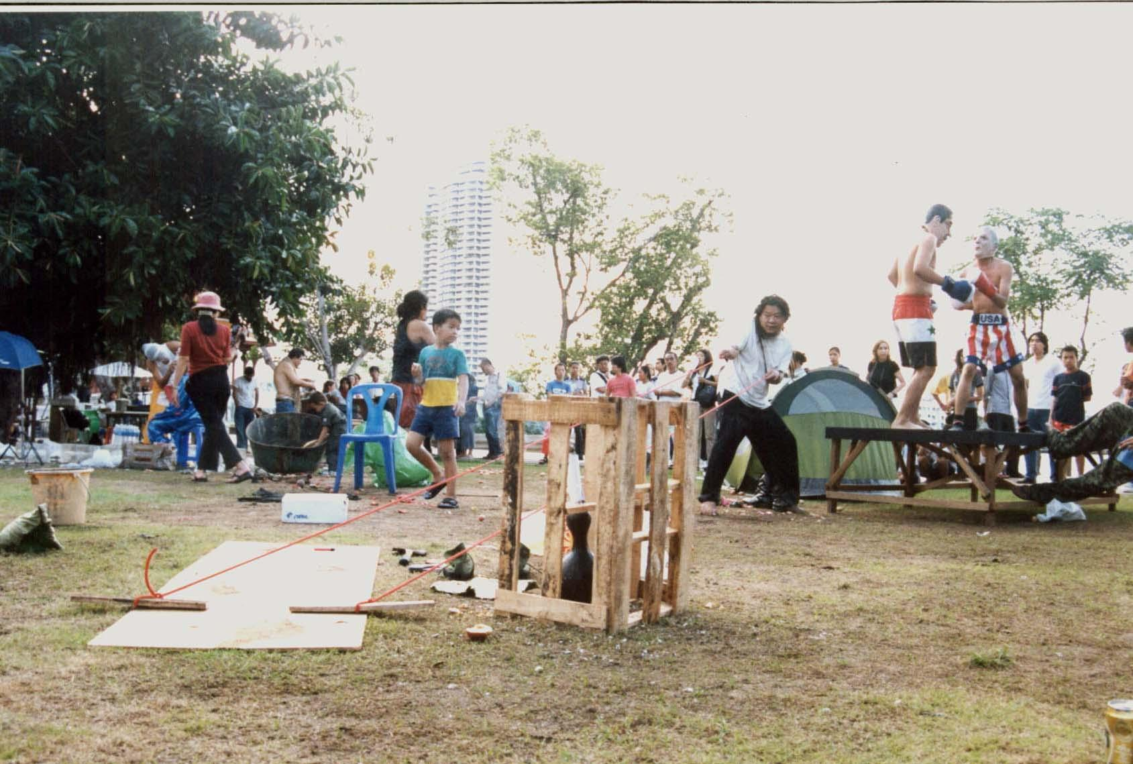
U-Kabat Group, Thailand, Asiatopia 4/2002, 22 November 2002, Bangkok

U-kabat, an artists group based in Bangkok and Black Market International based in Europe, have similar function, which based on individual artists and do not have group structure. The groups emerge as they perform together each time. However, they are both different in their social and cultural background.
Black Market International, mainly emphasis in interacting and harmonizing in their meeting, as they develop the performance site and situation together.
The U-kabat, is violently mixing their individual political actions together in the confinement of time and space.
Their differences are similar to the differences between priests and shamans, a churches of subdued sacred activities and a chaotic of weekend markets in Bangkok city.

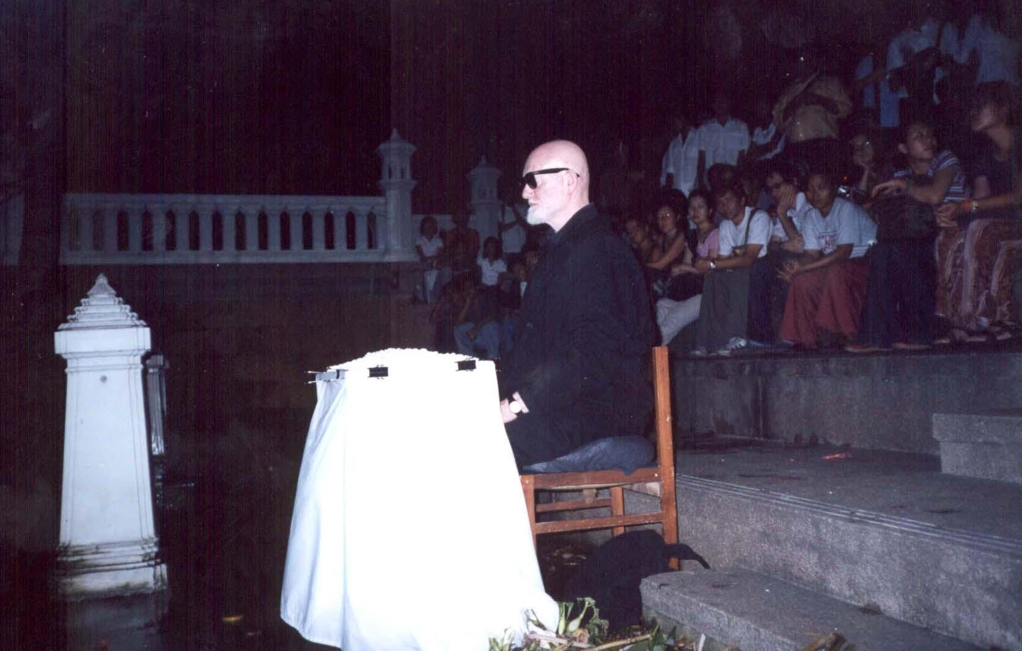
Alastiar MacLennan, a senior lecturer in fine arts of University of Ulster, who define his own work as ‘ACTUATION’, a member of Black Market International, presented his own duration performance in dedication to people who have lost their lives and family and those effected by the civil war, in the world and in particular in his home country, Ireland.
He sat on a chair behind the table laid the top with small stones, in front of the last Lumpoo tree of the district, in normal park lid lighting and with little additional lights from 2 regular torch lights projected slightly near him. With little action once in a long while, he slowly put little ashes on the top of the pebbles atop the table.

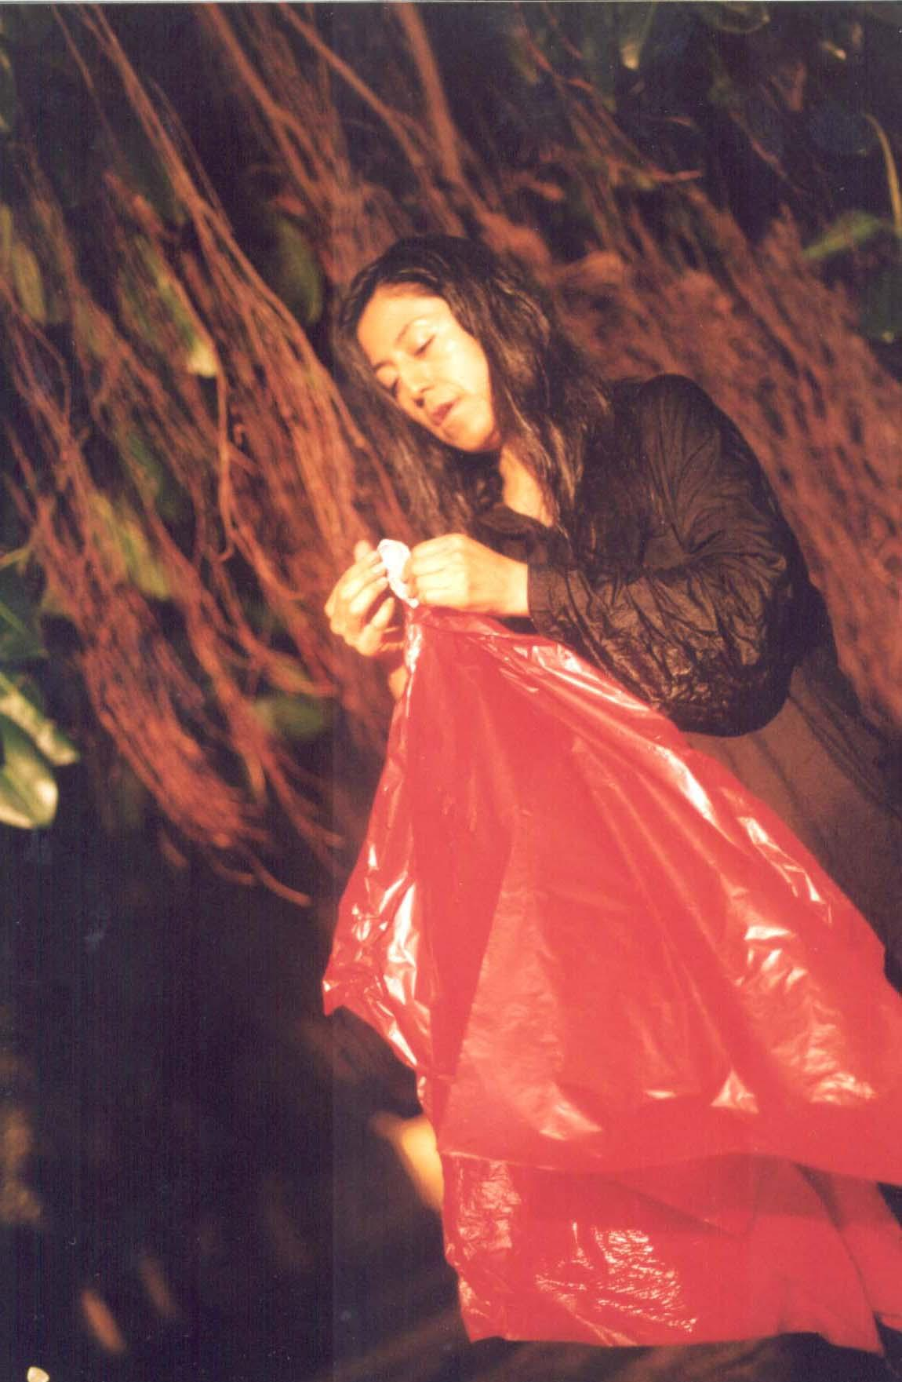
Elvira Santamaria from Mexico, tried to run backward with high speed, until she fell many times. Then recited a poetic phrasing in Spanish while folding a red Baht 100 bank note to only the image of a king on the bank note. The image of the king then attached to a red triangular shape paper before sending it to float down the river of the king. When asked what she was recited, she said, this is only to be said in Spanish and you will understand this when you are in Mexico.
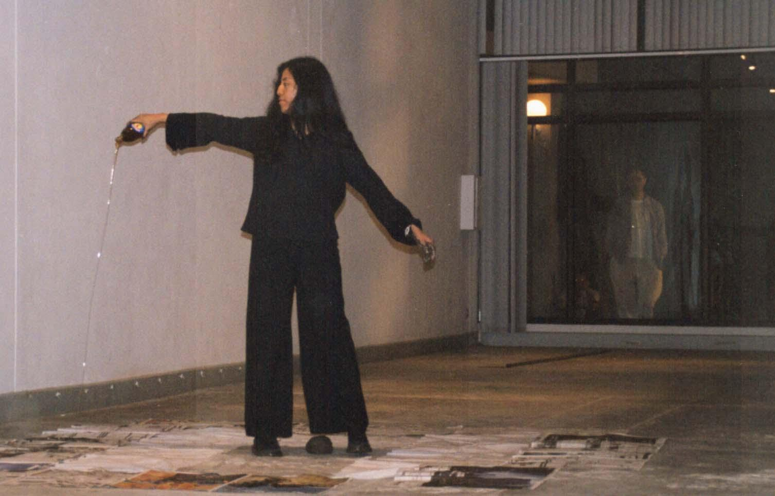
Elvira Santamaria, also perform in Chiangmai, with honey, mud ball, newspaper and long metal tube. She let the medal tube fall to the concrete floor a few times which created loud medal sound. In the middle of the space, she laid newspaper on the floor, where she poured honey and put mud ball in the center of the paper matted floor.

Houng Ly (see picture on 2nd page) from Vietnam, dressed in a traditional bright red colour gown of a Vietnamese bride, handed out roses to the audience, before commanding assistants to bundle her with white thin clothes, which is used for dead body. Then roses from the audience are re-attached to her white bundle body as if an act of memory to the death.
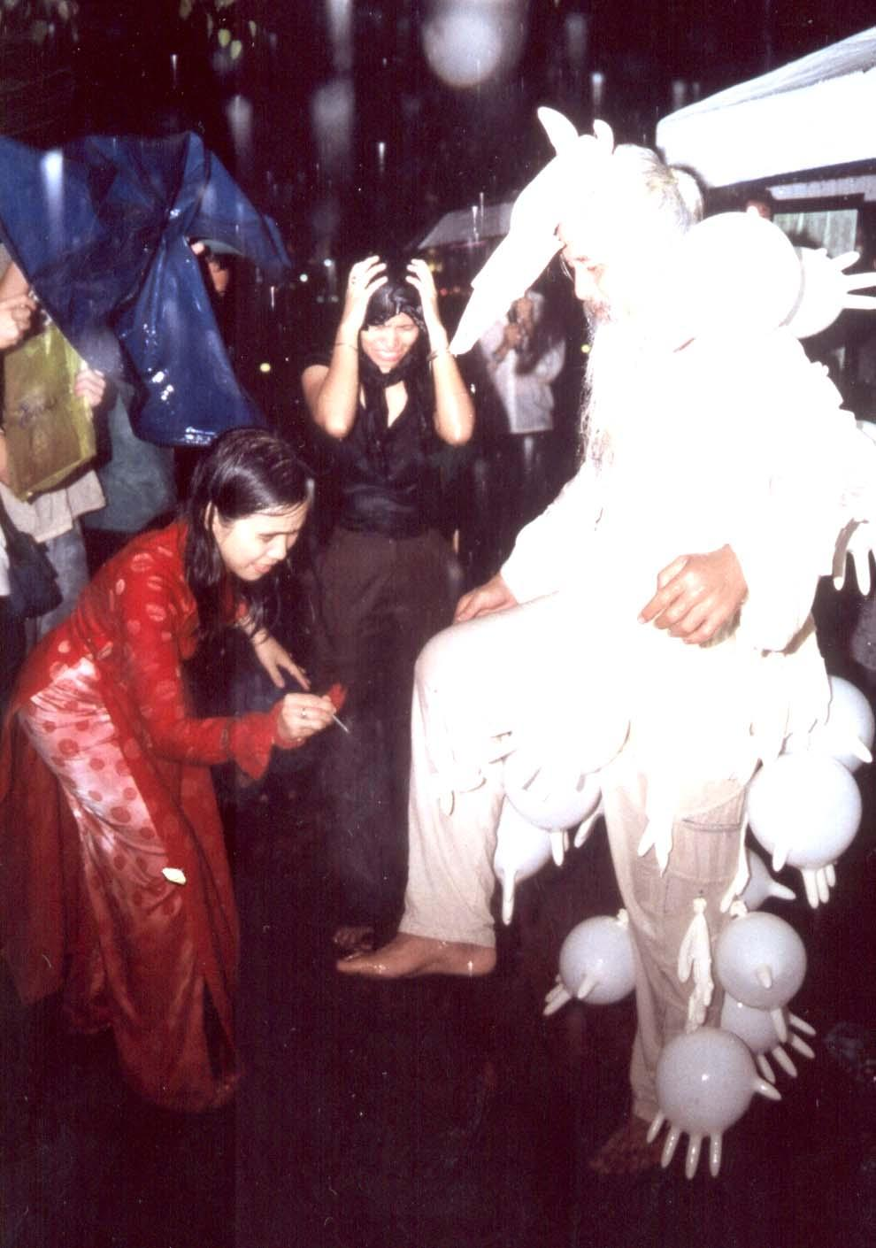
Surapol Panyawacheera from Thailand, his performance was cut short as stormy rain which began during Houng Ly performance getting heavier to resist. He has done his statement by asking the audience to help led go fingers-shape (cow breast alike) ballons which attached to his body.

Arai Shin-Ichi (Picture next page) from Japan, cover his near naked body with Japanese goods brand names, walked down the street to the park. He then began to tell a story of his experience as a Japanese Government volunteer in Tanzania, which is an action of neo-colonization. He ended his act by stuffing his mouth with each page of Japanese heroic nationalism comic book, and painted Japanese red sun flag by his ass.
“Despite some people reported to the police, as he/she afraid Arai performance in the park could break the law and interfere our social Taboo, but I told the police that a Japanese artists expresses his criticism to Japanese politic and products, like we did to our politic and bad businesses. The policeman was satisfied with my answer and he left.” (Chumpon Apisuk report back to artists, 10/12/02)
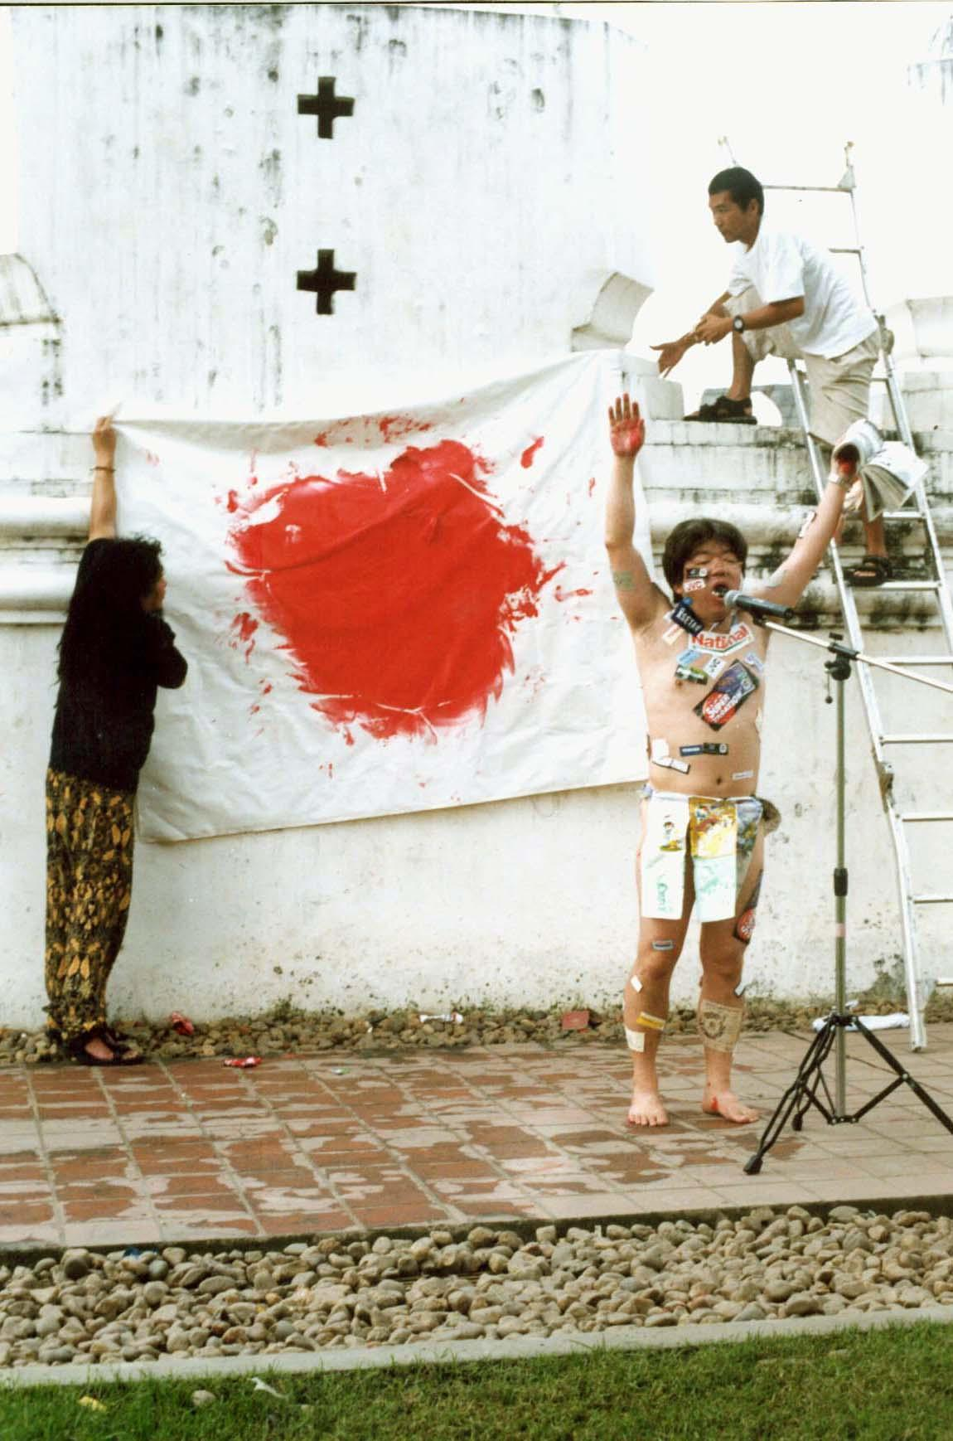
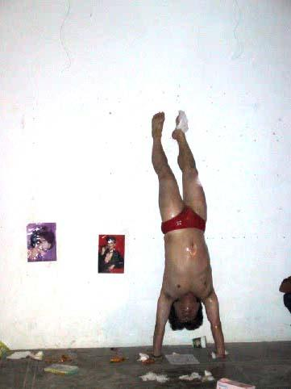

In Arai performance in Chiangmai, he informed the audience about the piece he was about to perform was inspired by his experience in Bangkok, by EMPOWER members / performer Siriporn Sripen, and especially when she did in Patpong bar, he visited with other artists. The performance was a true story of himself and his girl friend in Tanzania, who has continue her work as sex worker after he left. He ran himself to the wall of the art center, several times, to broke 2 eggs and a banana he put in his underpants.

Lilanne Zumkemi from Switzerland (picture page 8), stood on the TV monitor, in her hands holding a heart shape crushed ice. In the TV screen a man read morning news non-stop, until the ice in her hands were all melt down.

Lee Wen from Singapore (picture page 8), the only Asian artist in Black Market International. He bagan his performance by shouting in Thai ‘Haam Tum/ห้ามทำ or Not Allow’ on a chair, in front of him a small table with white cloth, where he laid down several chewing gum, and began to give the chewing gum to audiences while put some in his mouth. He took his shoe and began to stamp it to his heart, chanting ‘Haam Tum’ again and again, while his mouthful of chewing gum.

Aung Myint from Myanmar (picture page 10), a respected senior artist from Yangoon performed his prayer for peace, in the world and in his country.

Aye Koh, a young talented artists from Myanmar (picture page 10), hiding his true face inside white mask, symbolically attacked people with a toy army gun then at the end handed out flowers to the audience.
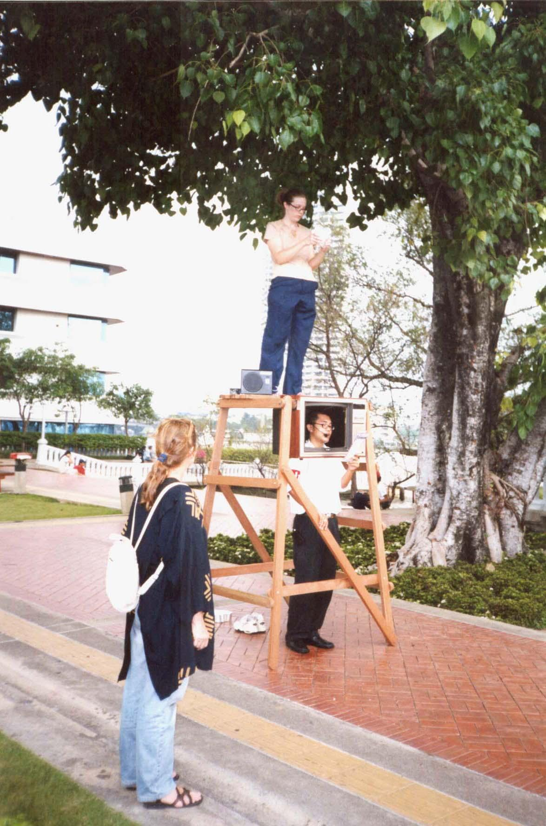

Lilianne Zumkemi, Switzerland
Asiatopia 4/2002
23 November 2002
Bangkok

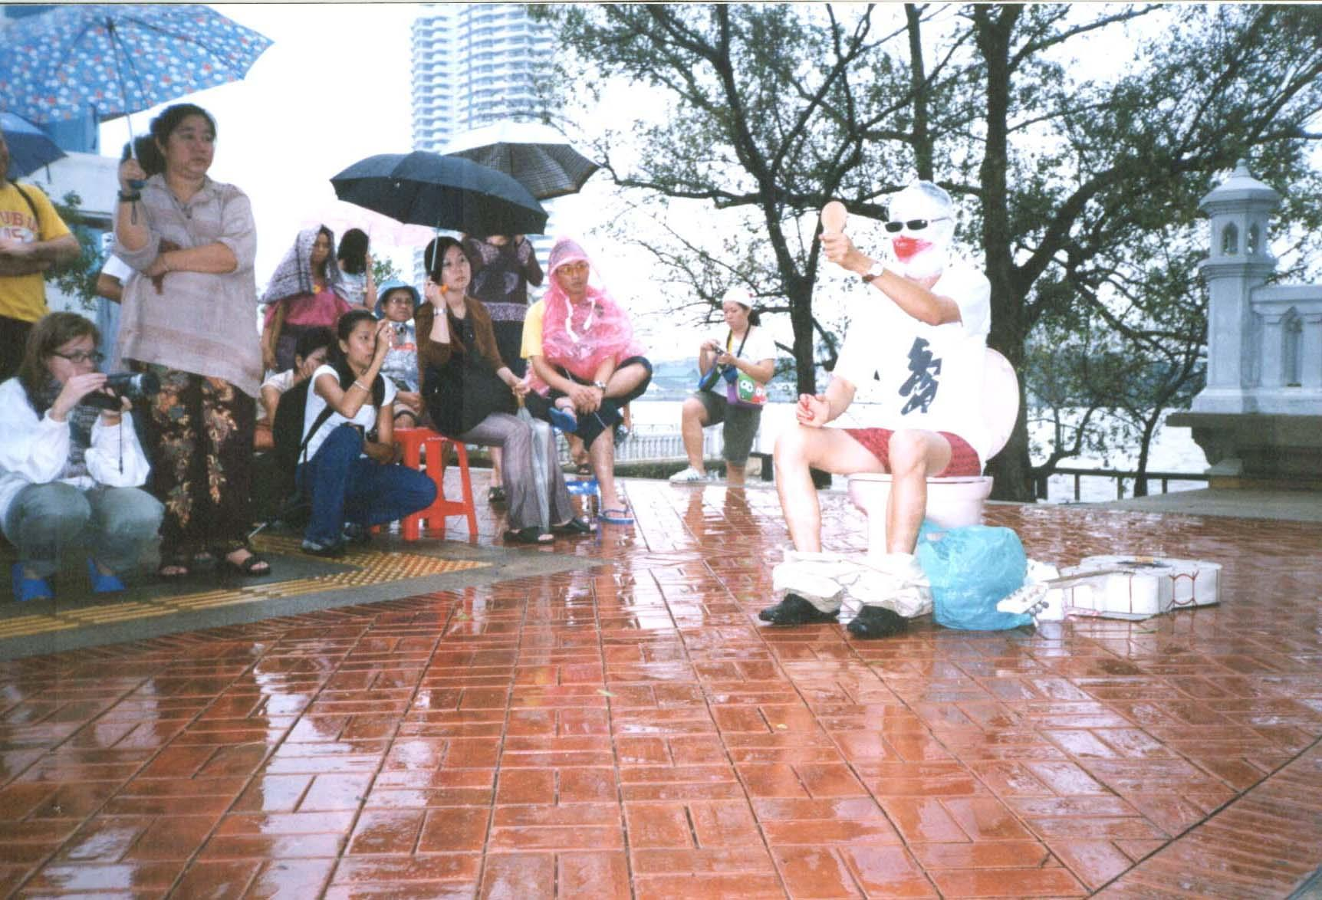

Bui Cong Khanh, Vietnam,

Asiatopia 4/2002, 24 November 2002, Bangkok

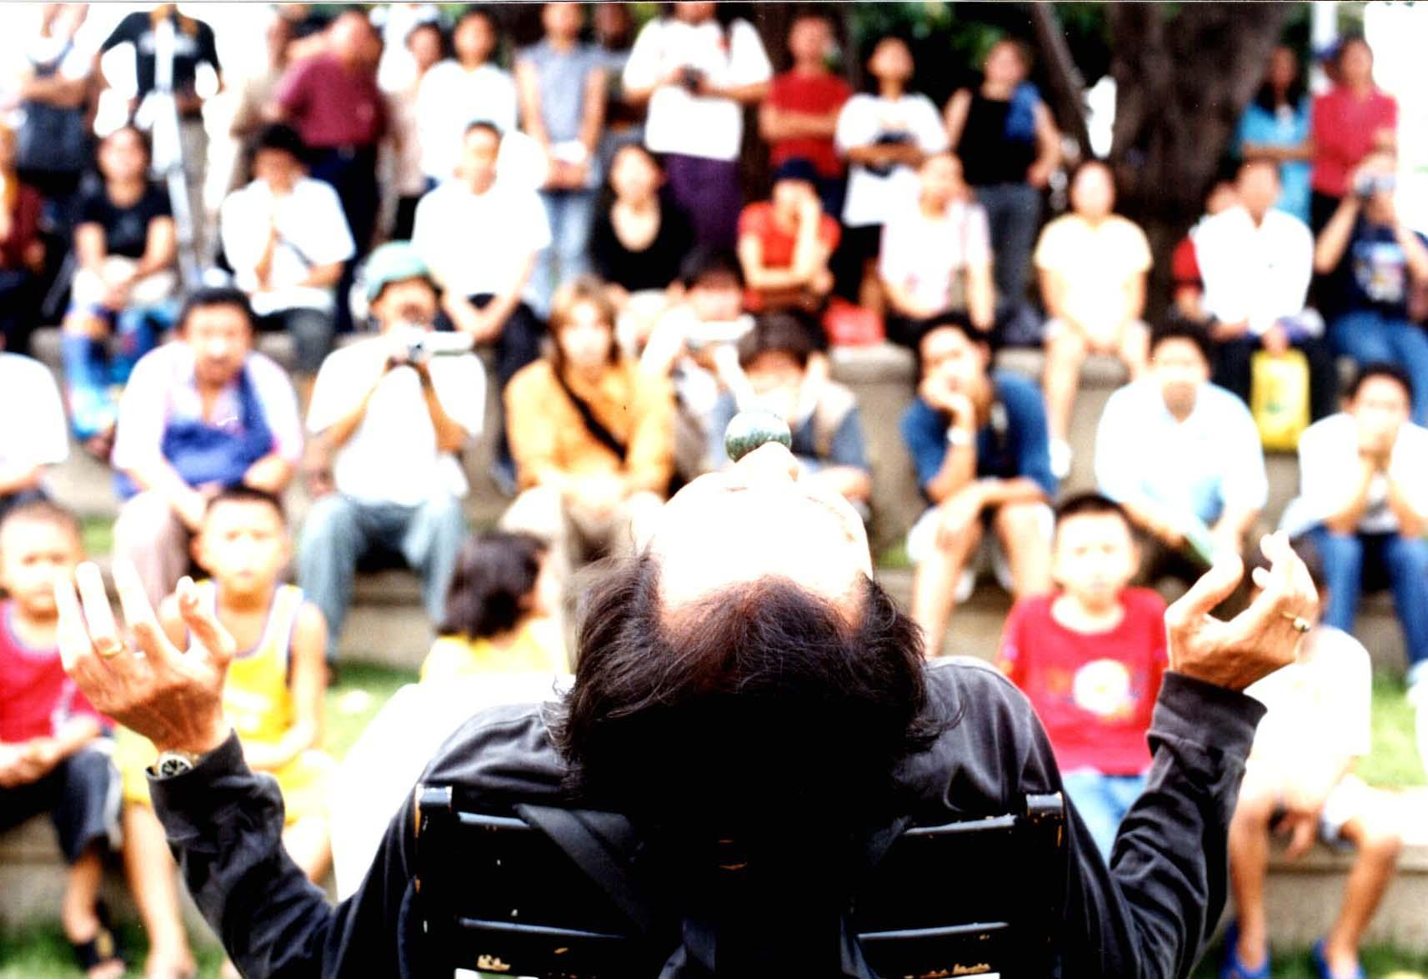
Lee Wen, Singapore, Asiatopia 4/2002, 23 November 2002, Bangkok

Bui Cong Khanh a young artist from Vietnam (picture page 9), masked himself with
a big smile mask. He sang beautiful Vietnamese folk song for the audience before led a role of partcipated audience in his alike children's train walk, to see an out of order toilet.

M.L. Saksin Kasemsun from Thailand (picture page 11), began his 4 hours performance from side walk across the street from the park, proceeding to his stupa form cages. Big cage on the bottom is for himself and a life size pig sculpture, and the two smaller cages stack on top are cages of 2 chicken and a python on the smallest top cage. Outside his cage sat a set of chest board and a Thai traditional painting. Inside the cage the performer play 50s Thai pop music, while he read moral teaching text, written by various monks.

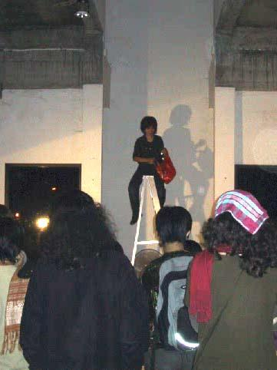
Kaori Haba from Japan (see other picture page 11), perform a very sensitive piece dealing with different sides of women. She began with images of migrant Thai women in her home town performed traditional dances. While she began to shave hairs on one side of her body, while covering the other side of her with black cloth. The shaved hair were then cover her face, before she began to paint her finger and toe nails on the shaved side. She took off her wrist watch and gold necklace, tied the watch on one end of the neck lace then slowly drop them into a glass of water infront of her. This intensely slow, quiet performance, all happened on one side of her body, while the other side covered in black cloth of all time.

She did another performance in Chiangmai, with a similar subject matter, but this time she blind folded herself and try to select women out of the unseen audients by touching each of their hands. She then climbed up the ladder which placed a fan beneath it, she tried to drop the women sign paper on the spot below, when the fan keep blowing it away. As a woman does she really feel that there is no choice of place for her.

Mimi Fadmi from Indonesia (picture page 12), took a contemporary life of the young fashionable office women workers. She walked in fashion show style,with disco rhythm songs blasted in the background. In Her hand a huge shopping bag, written names of big fashion designer brand names. She put the bag in the middle of the glass lawn, and step inside, pulled out water jar and soaped sponge, she began to wash herself in working suit, until the bag also washed away, and her whole body were covered with foamed. The dancing song ended then she walked away.

Montri Toemsombat from Thailand (picture page 2), continued his new series with barb-wires. He set his performance site in the center walk way of the park, floored with bright red carpet. He dresses himself in white, began by putting a mouthful piece of barb wire into his mouth and began to spray dye his whole body into red.

Risto Heikineimo, a poet and playwrite from Finland(see picture next page), make up his face like mask, dress in a loosely black rope. Accompanied by one man inside the black blanket, who curled himself like a rock seat. The performer sat on him, reading a poetry from a black fan. At the end of the poetry, he put a barb-wire crown on his head.

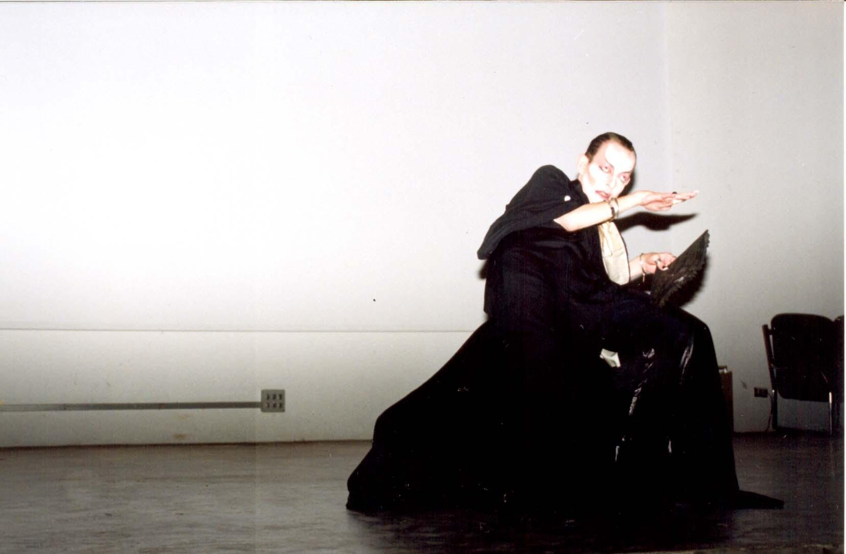

Risto Heikineimo, Finland,
Asiatopia 4/2002
29 November 2002
Chiangmai

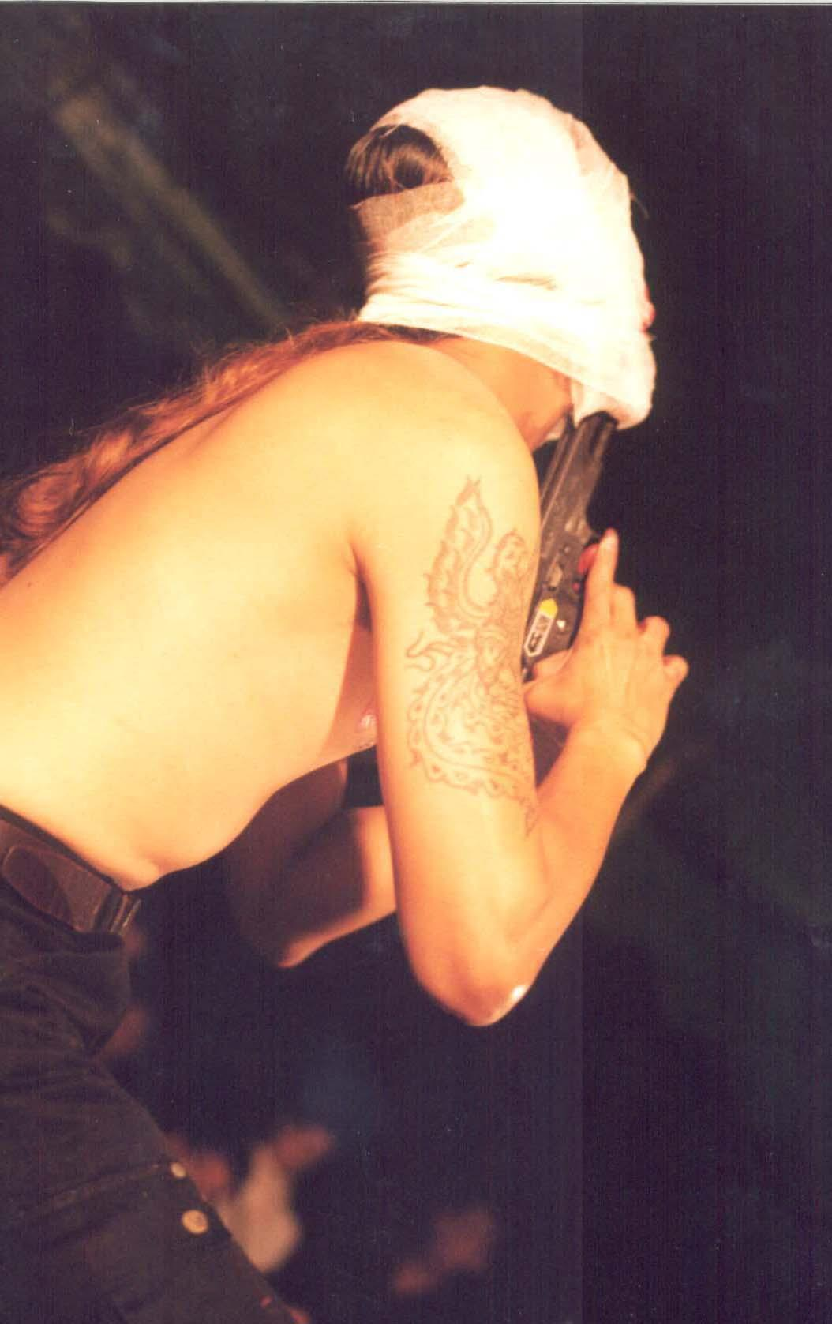

Aye Koh, Myanmar,
Asiatopia 4/2002,
23 November 2002,
Bangkok

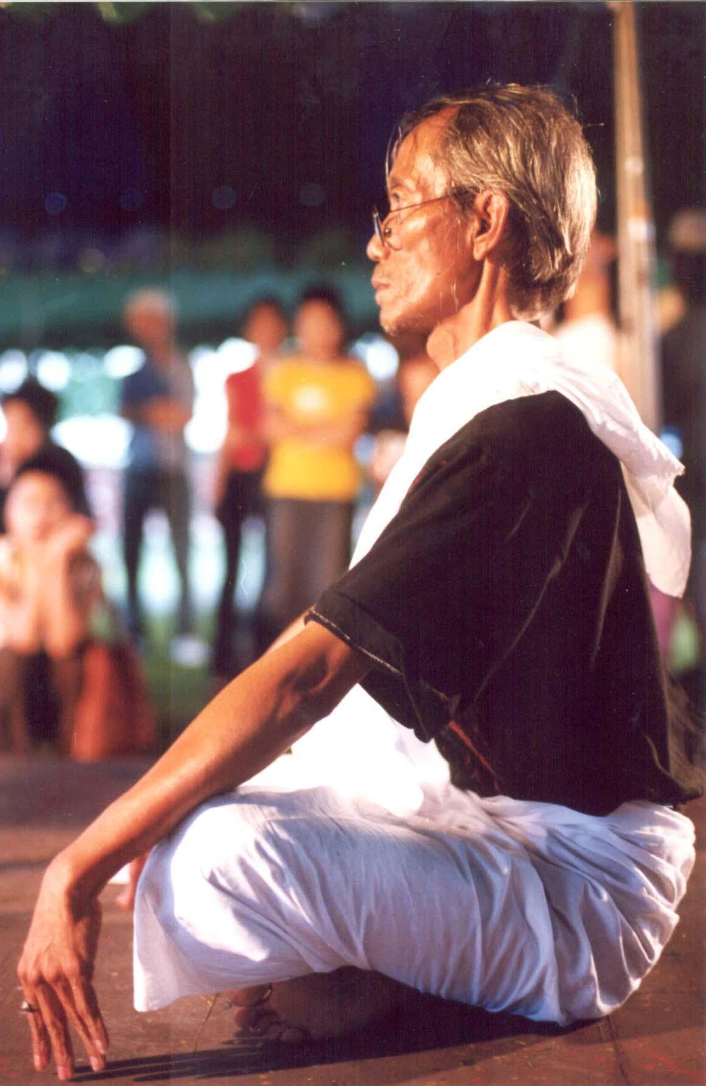

Aung Myint, Myanmar,
Asiatopia 4/2002,
23 November 2002, Bangkok

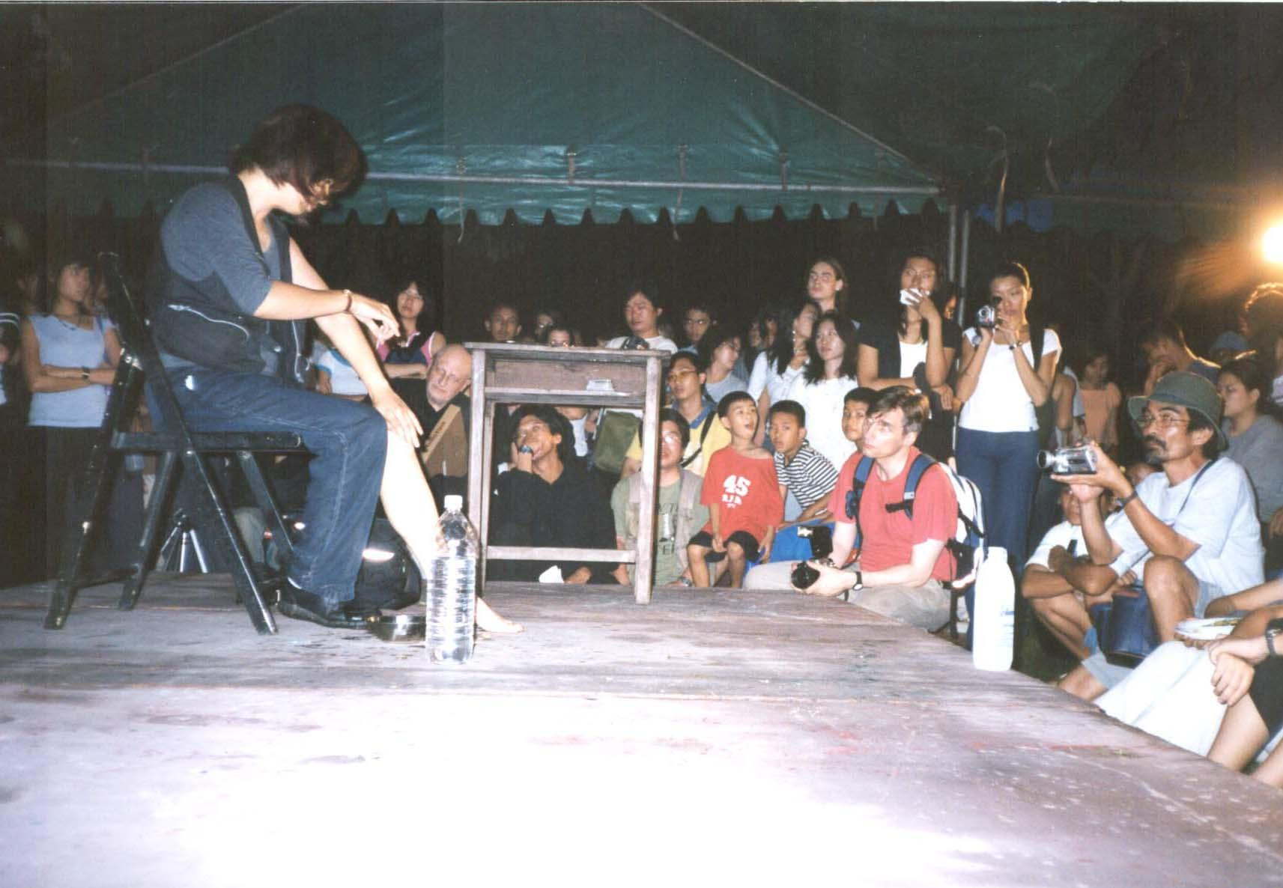

Kaori Haba, Japan, Asiatopia 4/2002, 23 November 2002, Bangkok,

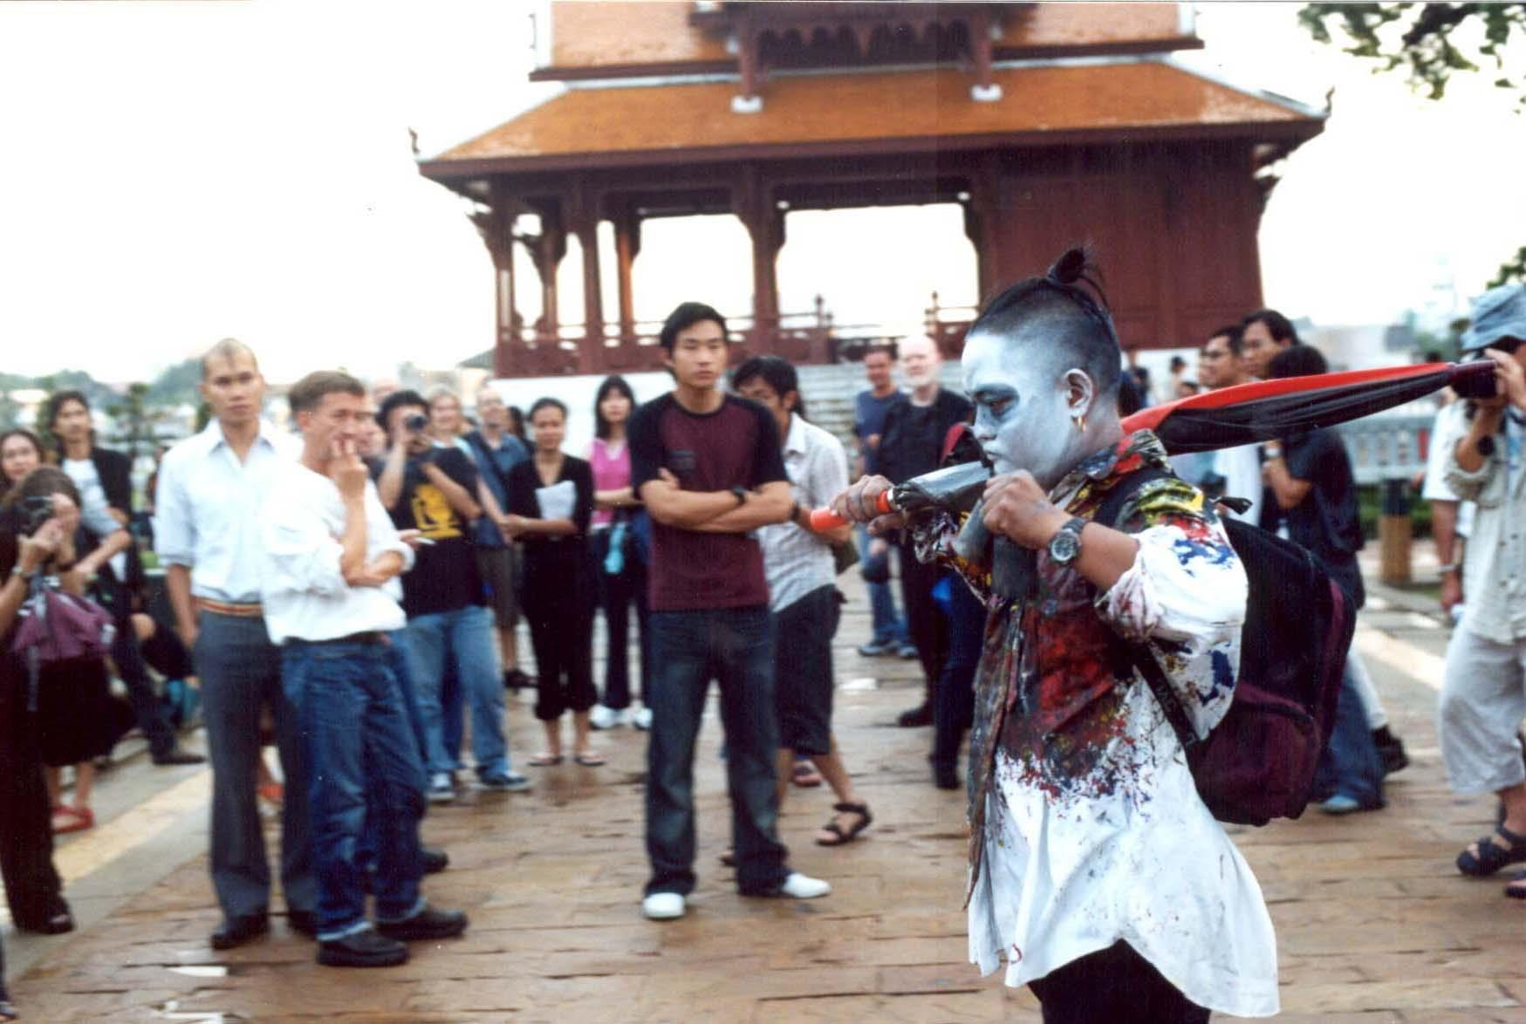

M.L. Saksin Kasemsun, Thailand, Asiatopia 4/2002, 23 November 2002, Bangkok

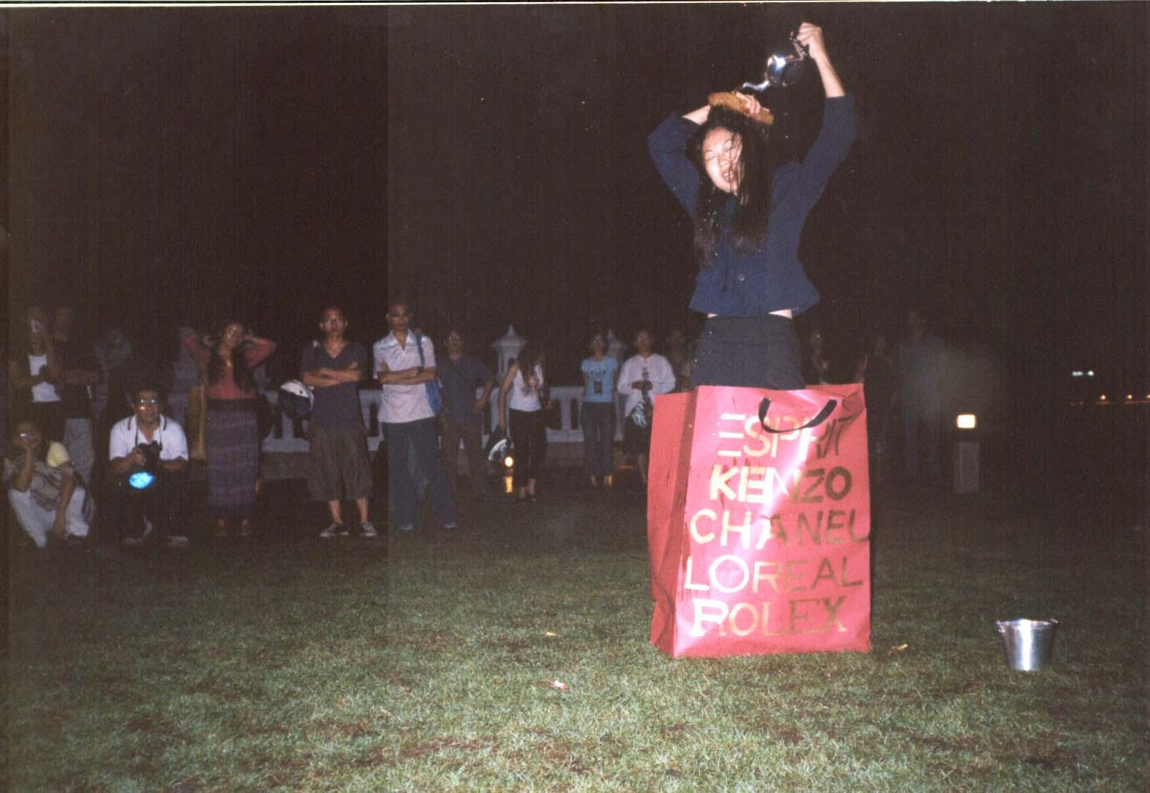
Mimi Fadmi, Indonesia, Asiatopia 4/2002, 23 November 2002, Bangkok,

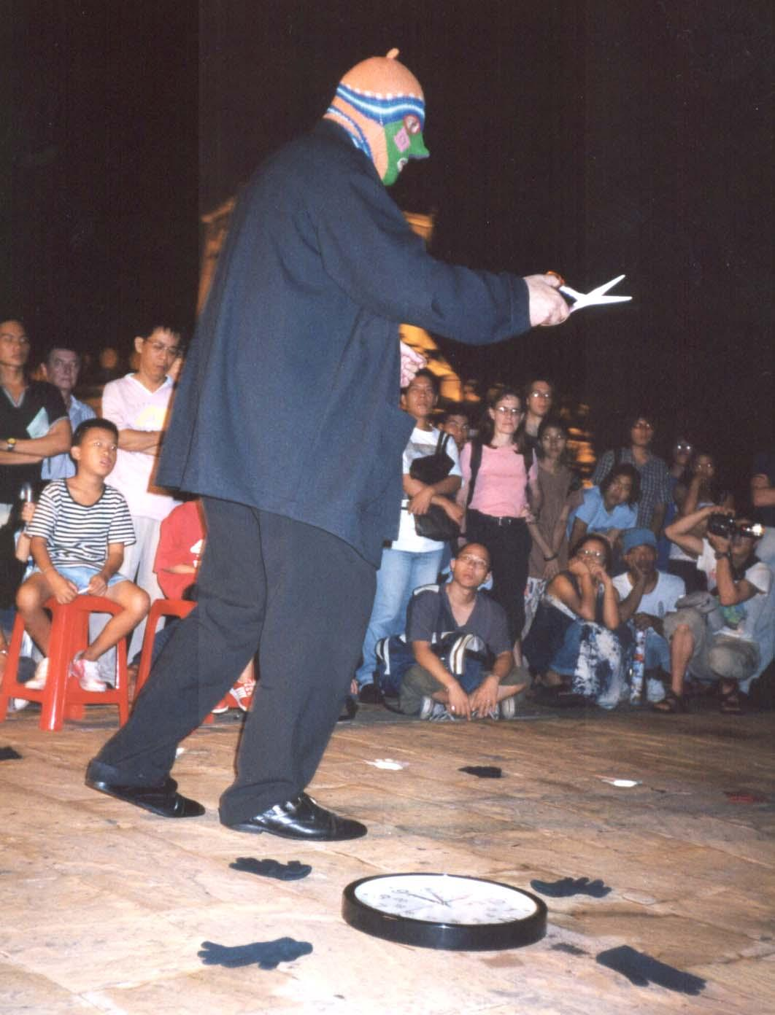

Norbert Klassen, Switzerland,
Asiatopia 4/2002,
23 November 2002,
Bangkok

Norbert Klassen, a senior artist from Switzerland, who symbolically perform with time machine and gloves which pointed in different direction, while the time was tickling on. He put on multi coloured masked hat with pointed nose, while use scissors cutting in the air in circle. At the end the time machine was smashed to the ground.

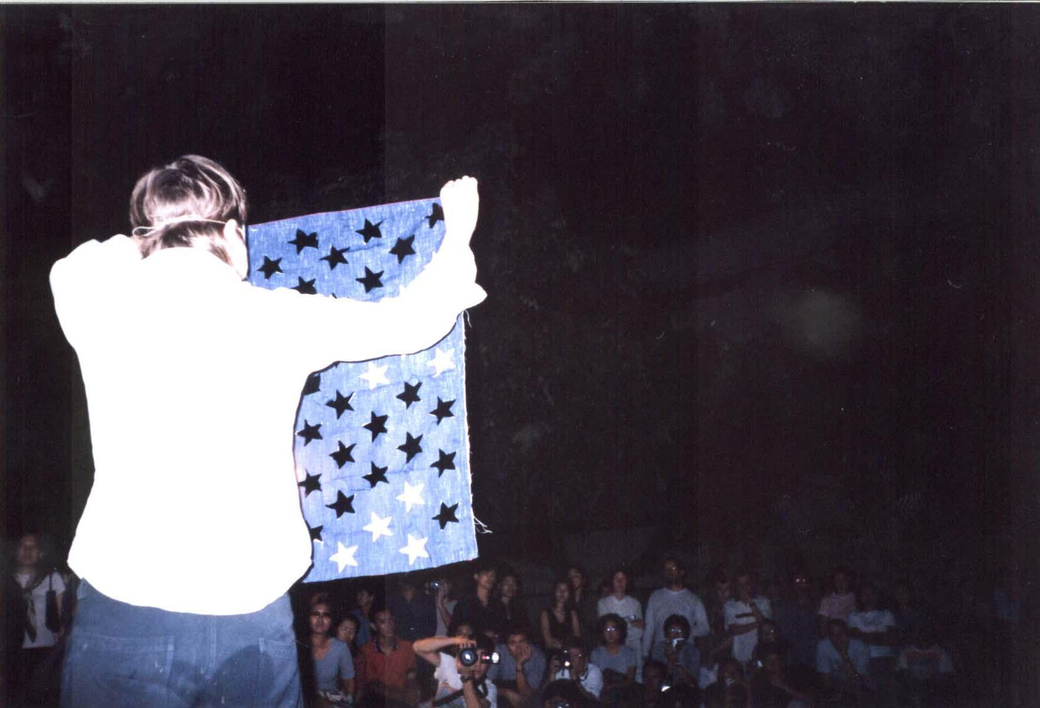

Julie Andre T. from Quebec, Canada, perform a hot international political piece of dye an American flag into black while painted red colour with her feet on one big sheet. The process of dyeing each cut out stripe of American flag including each star that has been cut out before. She then jumped up high and curled herself let fall to smashed the balck flag 2-3 times, before slowly go down to a preparing float on the river. She rolled the float into the bush nearby the shore, violin in hand, then she played an untuned violin from the hidden shade inside the bush.

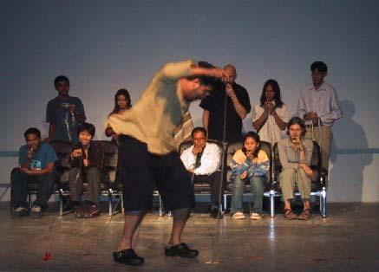

Yuan Mor’O Ocampo, Philippines,
Asiatopia 4/2002, Chiangmai
29 November 2002

Yuan Mor’O Ocampo from Philippines, has successfully get many audience to participate in his bucket throwing game, without any goal of contestant. The throwing buckets game was accompanied with the sound of clog-shoes stamping repeatedly of all time. The loud clog stamping, however, build-up momentum and tensity of the action.

In Chiangmai, Mor’O did similar action but with different materials, he used bird whistle attached to a long plastic lines, where he stamped at the far end of the line, the audience whistling. The performance create variety of sounds along side with clog stamping sound. Here at the end he showed inside sole of his clog, labeled a word ‘Capitalism’.

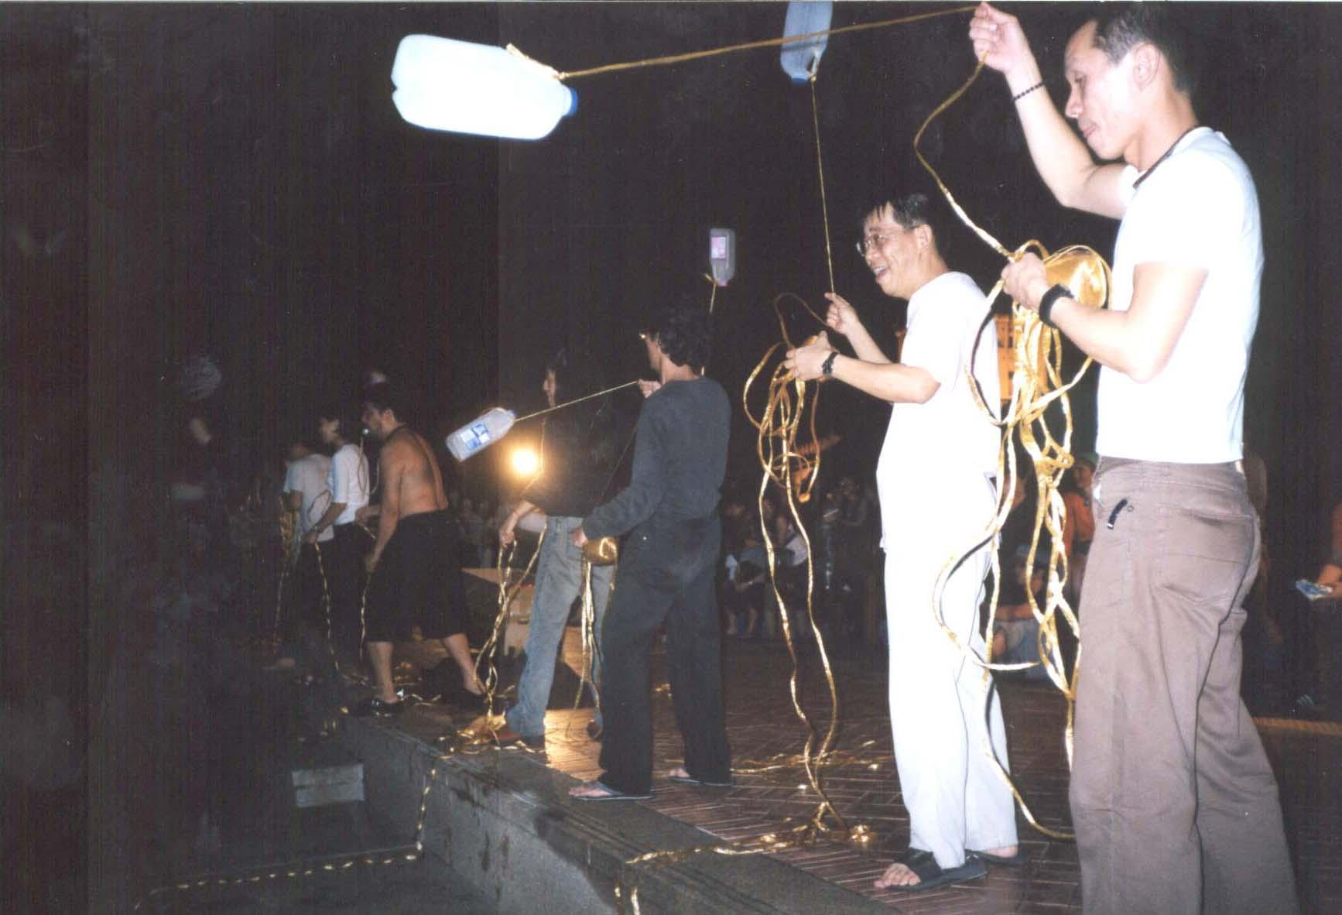
Yuan Mor’O Ocampo, Philippines, Asiatopia 4/2002, 23 November 2002, Bangkok

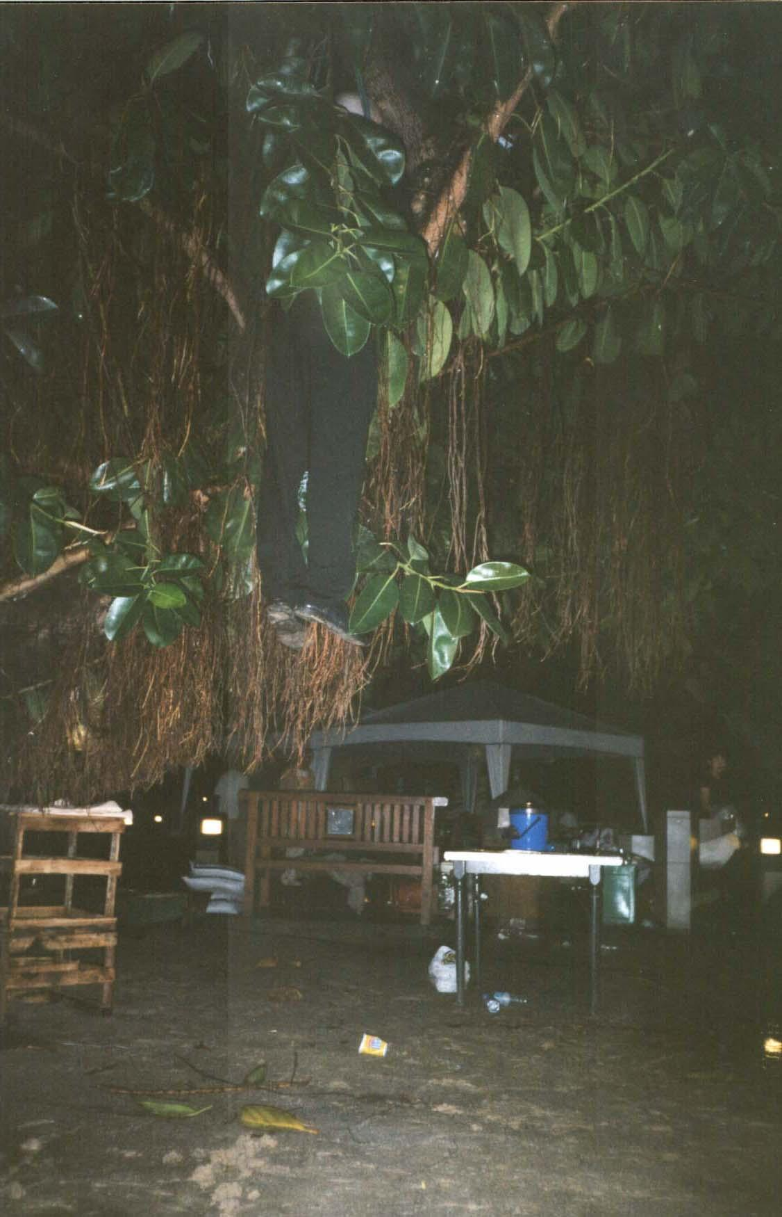
Roi Vaara, from Finland, a member of Black Market International, tried to hang his body on to a tree, only let people see his feet dangling from thick leaves. His first tried failed as the tree branch could not hold his weight, and break. He succeeded in his second tried. However, the broken branch stir an unease felling among park attendants.

“A day after Roi accidently broke a tree branch, a park officer came to see the broken branch, and said he would report to his boss, but he said there was nothing to worry, the branch must be trimed once in a while by his office anyway. I told him that I was worried about the falling artist whose can suffer from broken bones or something. He said he was happy too that no one got hurt. He also mention the branch was big and strong, but suspected that the rain might have soften the wood, and that cause the accident. He left, and I have not heard any news from the Bangkok Park Office.”(Report back to artists / Chumpon Apisuk / 10/12/02)
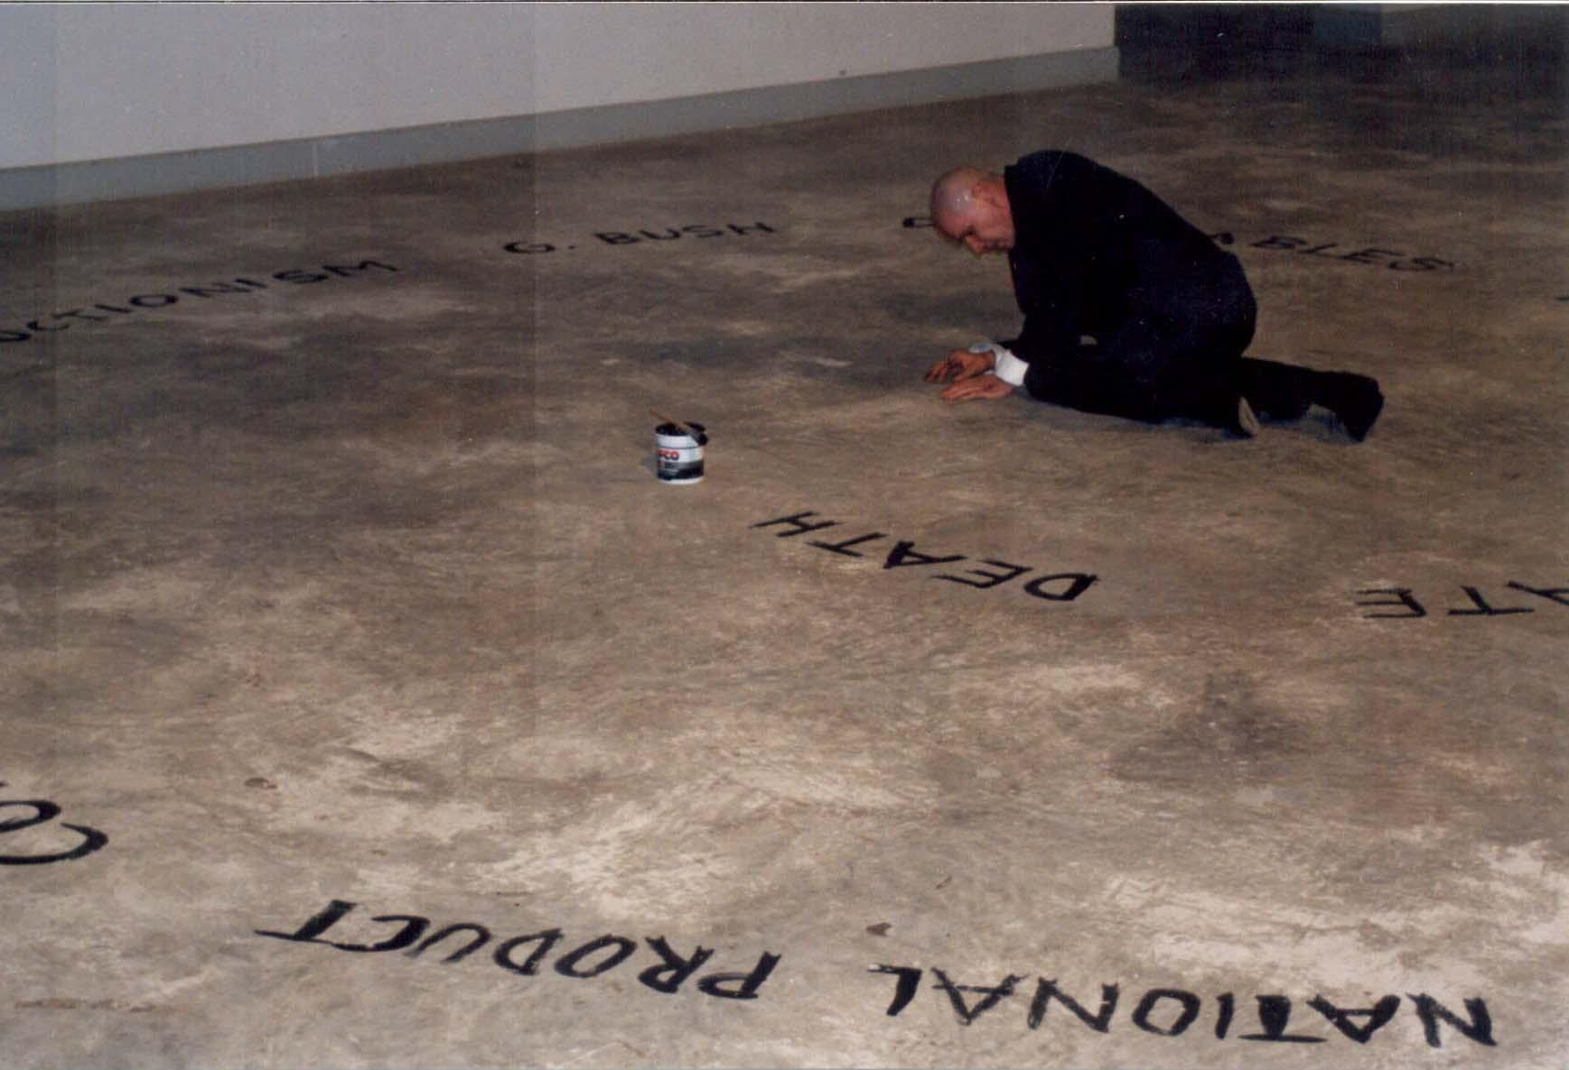

Roi second performance in Chiangmai, was conducted in the gallery space of the art center, where he painted words of negative ideas in circular, then spinned himself until he fell to the floor. His last action was to cross off the written negative words and replace them with another words with positive ideas.

Tomoko Takahashi, from Japan (see picture next page) questions about if there is an identity, and if there is one, why she found some Thai woman that look very much like her. She took the true story of herself, when she was an exchange student from Japan some years ago. There was a picture of her, wore the same dress she did for this performance, and another woman dress in Thai traditional costume, both have similar look in their face. She ended her performance by asking the audience take out brand name from t-shirts she wore over each other, as to make them look the same and become an identical objects.
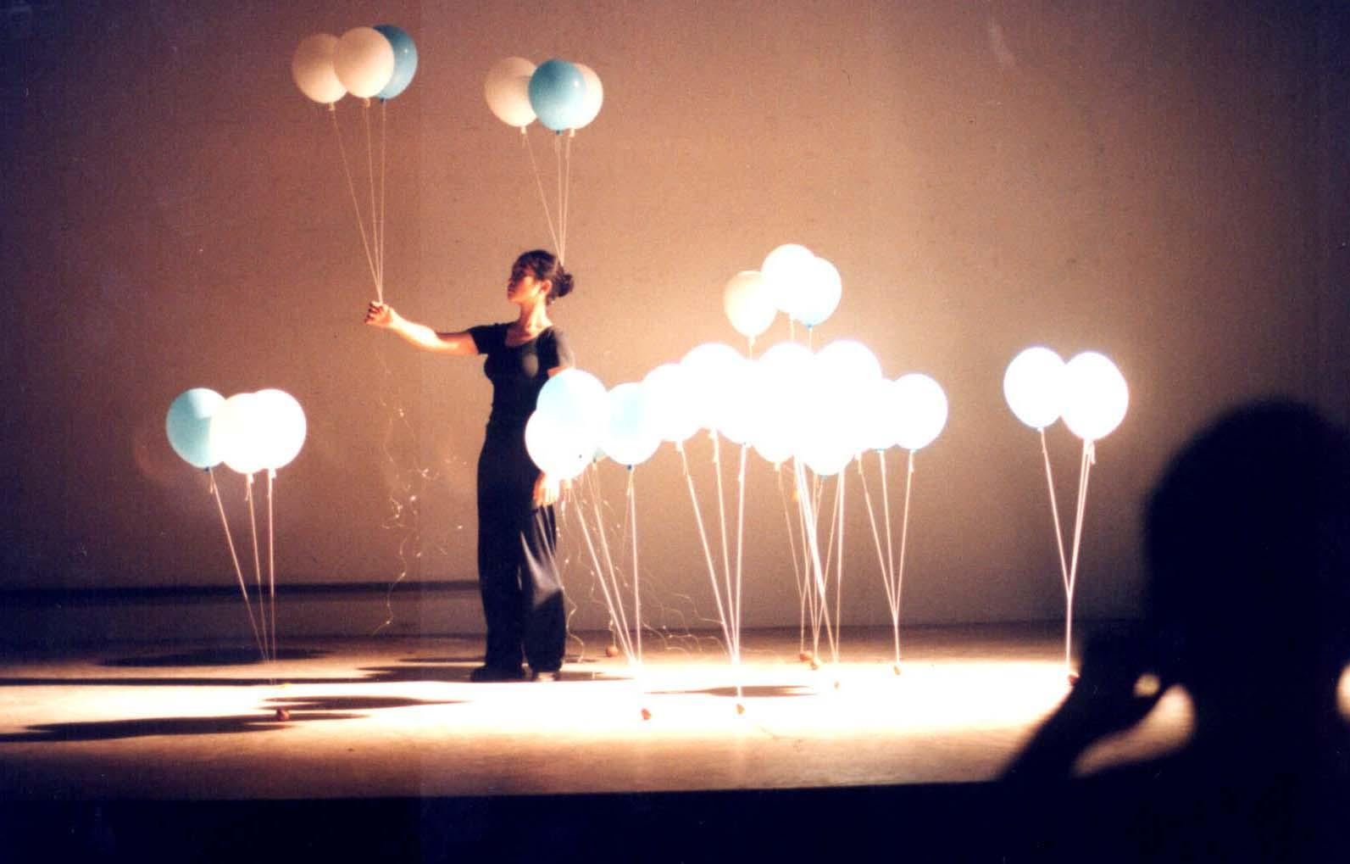
Ko Siu Lan, a sociologist turned artist from Hong Kong turned artist, presented the work deal with eggs and white & blue balloons. Eggs attached to the two balloons strings, as to support the egg when it drops, and the egg hold the balloon down. However, the artist let the balloon fly away by breaking the eggs herself. At the final act, she attached eggs to her whole body, intentionly broke all eggs by exercise sit-up actions.

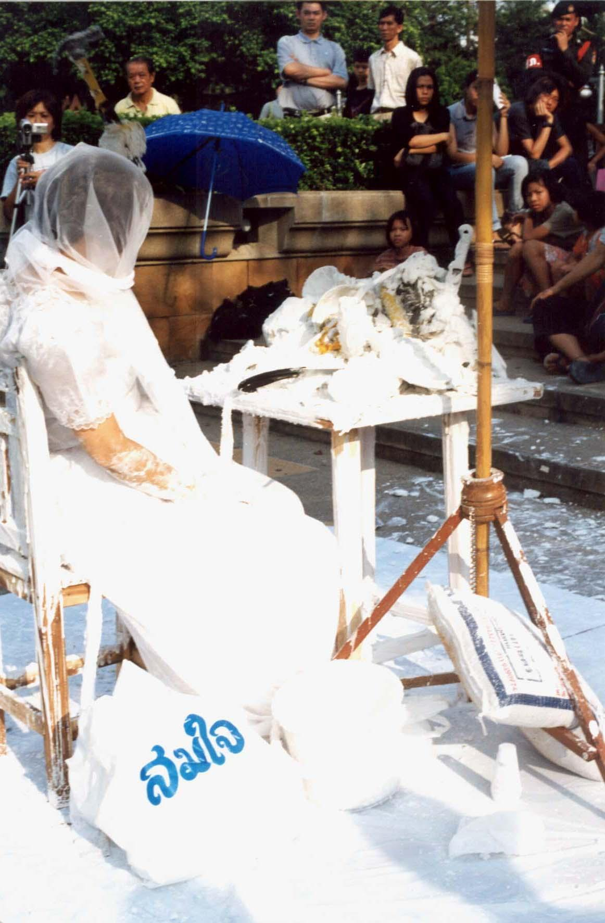

Fumiko Takahashi, Japan,
Asiatopia 4/2002,
Bangkok, 24 November 2002
Chiangmai 29 November 2002

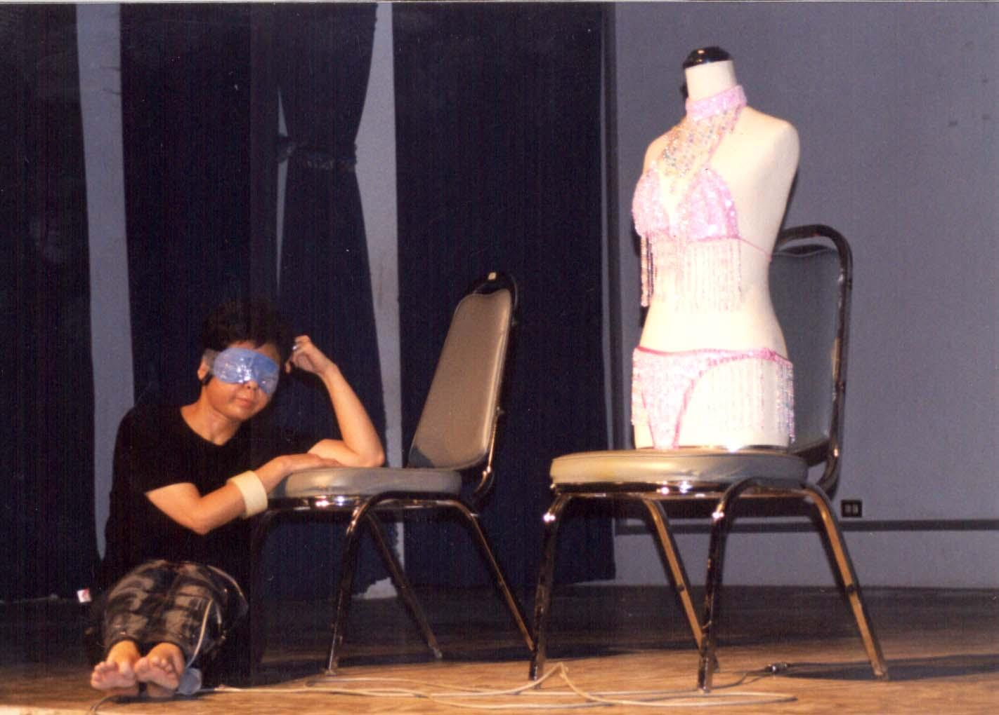
Fumiko Takahashi, a member of Japan’s Women Art Network, began her duration
performance by adding white plaster on all food, home & kitchen ware materials she gather on the small table in front of her. She wore white Bridal dress, and also cover her hand with white plaster. The process took more than an hour before the plaster gets harder, when she asked the audience to use hammer and saw to break the plaster and destroy the table.

Similar to Arai, Fumiko performance in Chiangmai was inspired by Siriporn action in a Patpong bar environment. Here Fumiko blind folded herself, and tied herself to a dummy which dressed in beautiful bikini. A blind folded woman struggling to find her way to the stage leading a dummy in bikini attached to her back.

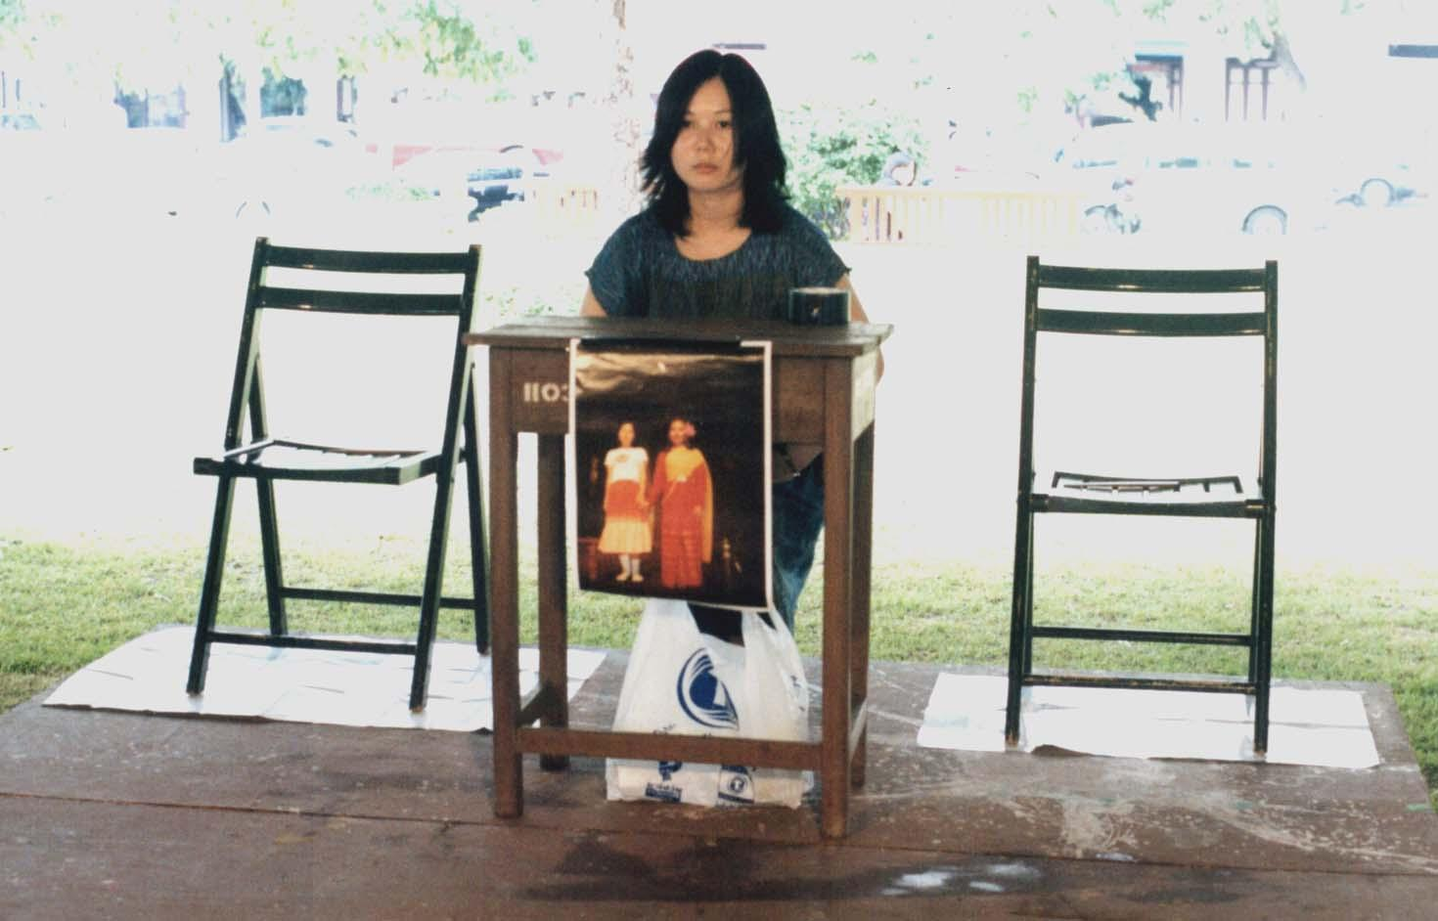

Tomoko Takahashi, Japan, Asiatopia 4/2002, 24 November 2002,Bangkok
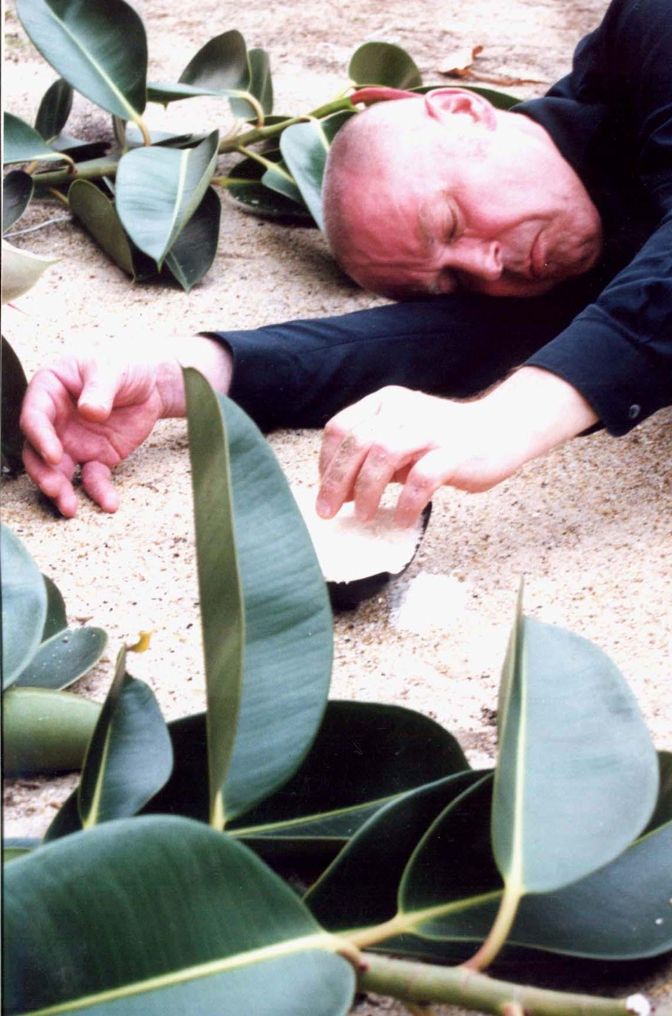
Boris Nieslony, showed the audience the back side of dead men photos, while his body try to interplet body position of the dead man’s face. The audience then recognize what was infront of the photo, when he laid down the photo on the ground. He then lie down on his side, nearby the photos, reaching his hand out to pick rice grain in a bag and put them to fill his ear’s hole. The simplicity non-action but create a very strong image that make people related of each images and little action appear in front of their eyes.

Jason Lim, from Singapore – an anti-performance/anti-social performance artist, who focuses his action of large amount of beer consumption at a limited time. He spill the beer, splash the beer to audiences, show an unpleasant action like a mad man. A few people recognized him, when he performed 3 years ago in Asiatopia 2/99, and commented that his performance this year was not so aggressive as it was before.

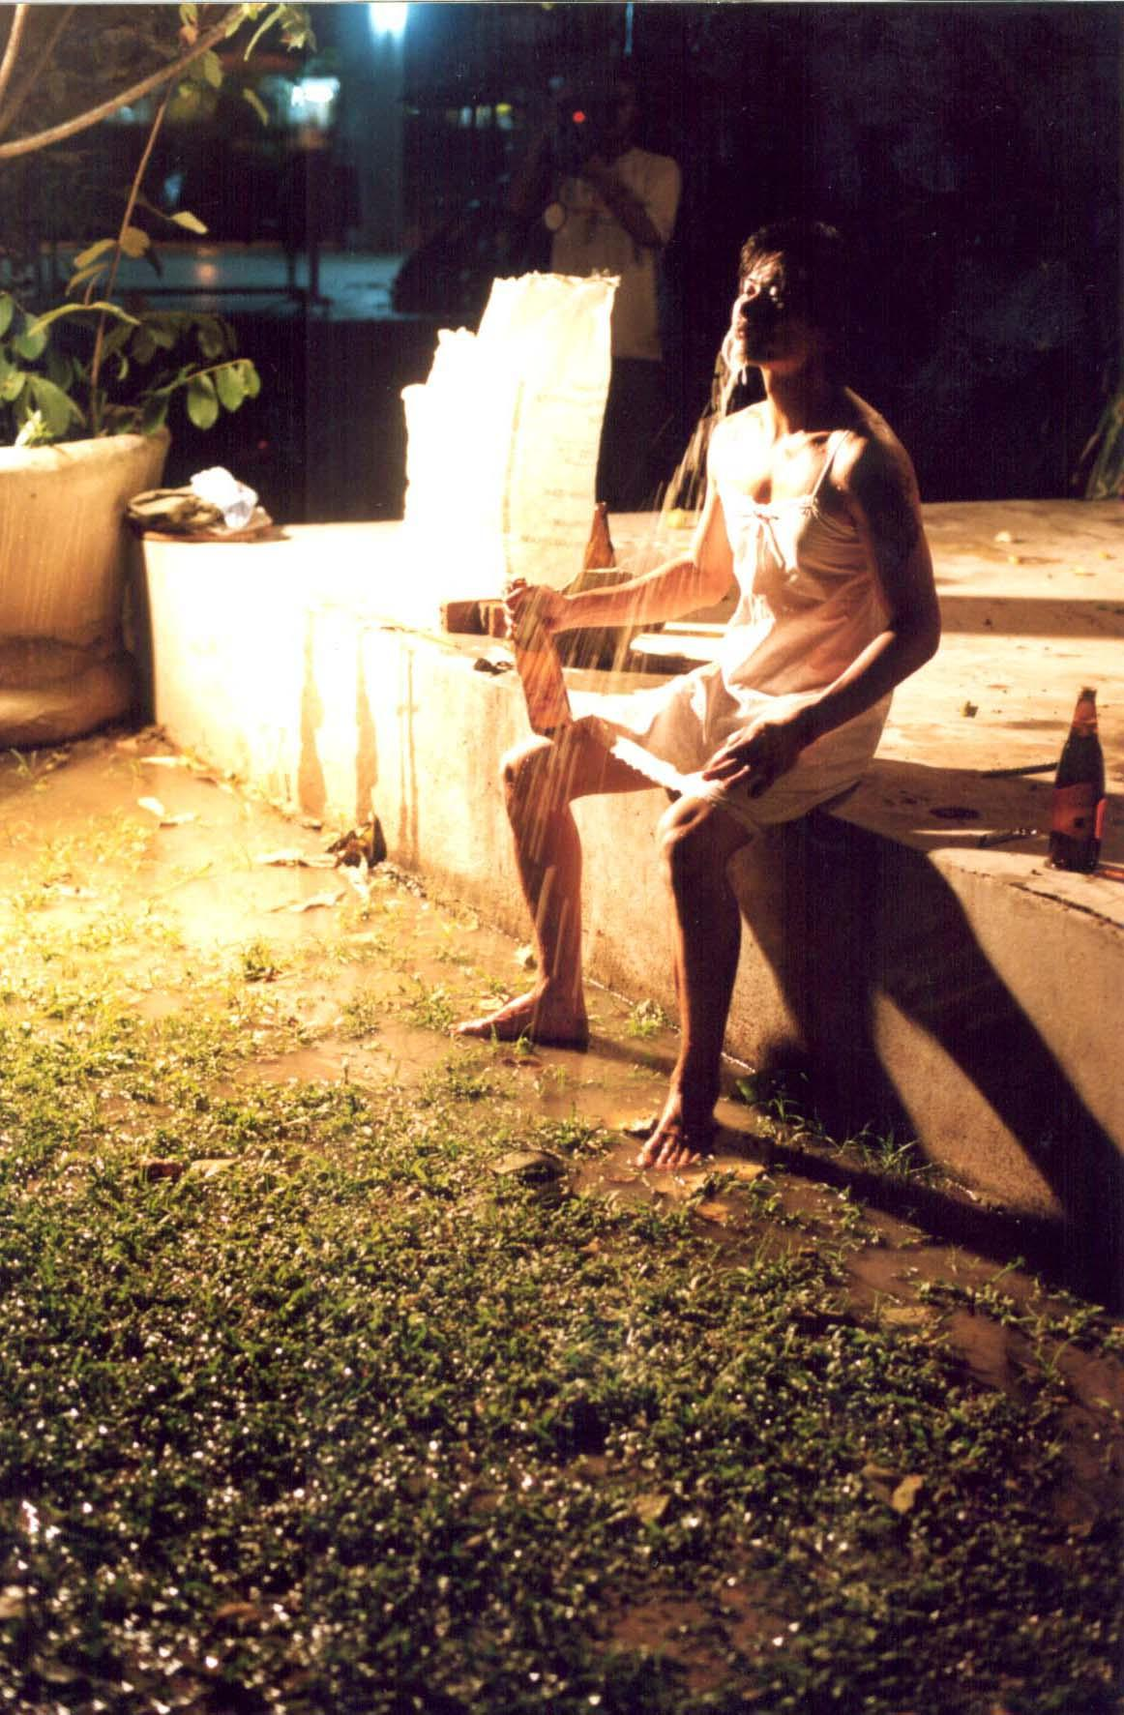
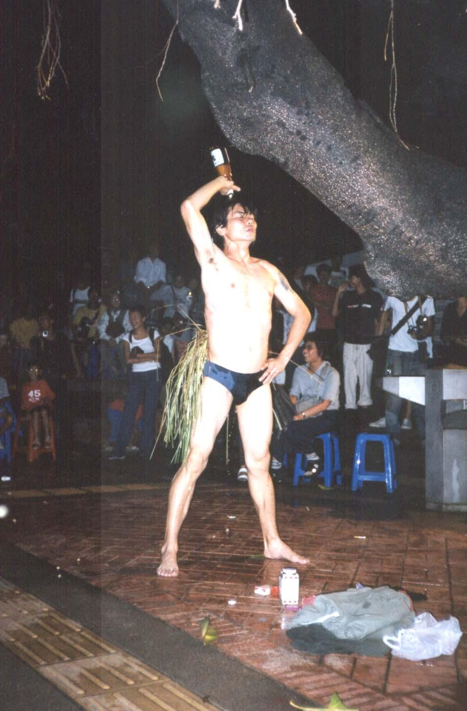

Asiatopia 4 in Chiangmai
In 3 days in Chiangmai there were 6 Thai performers participated including 10 international artists from Bangkok. They are:
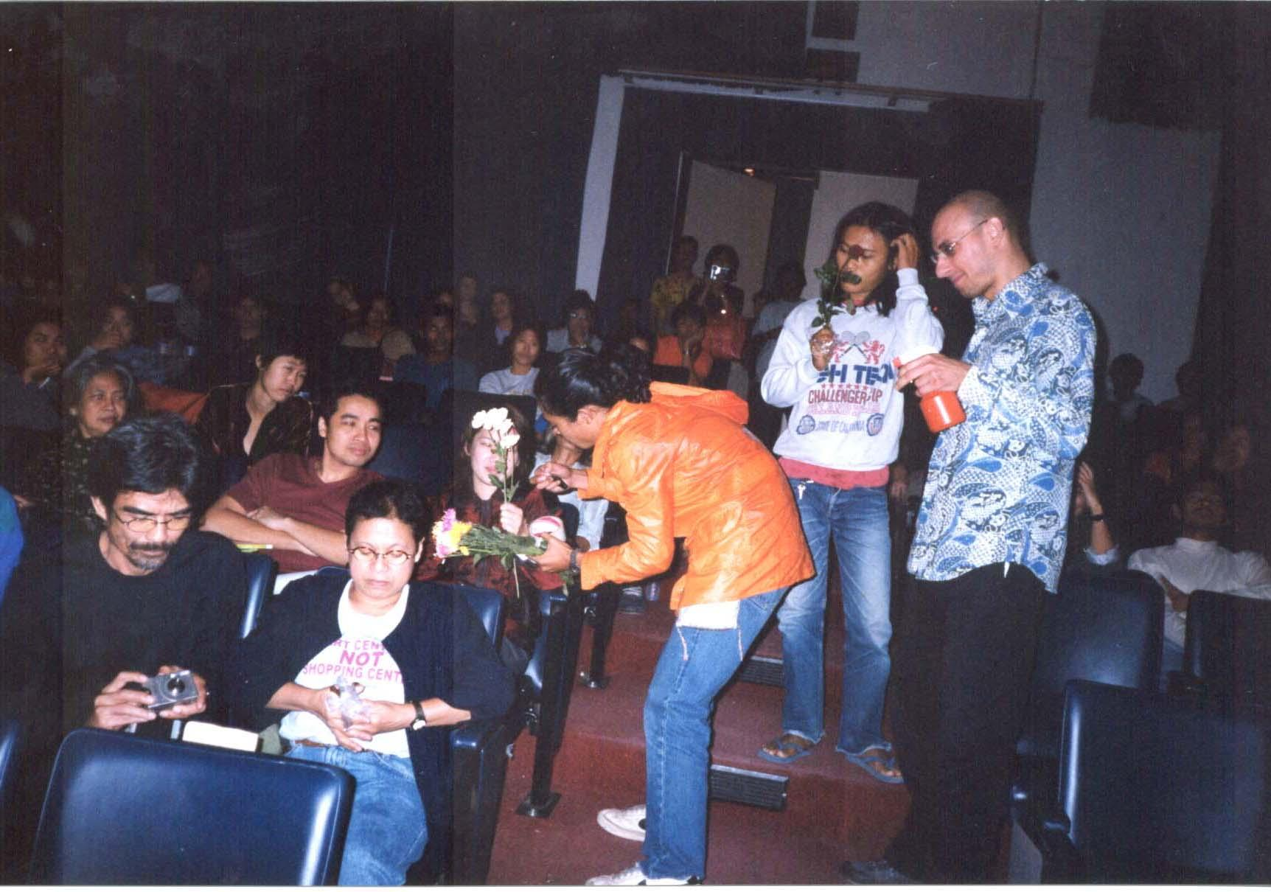
Kittipong Yaemsawai, a 4th year student of Fine Arts Faculty in Chiangmai University, has created a simple relationship between artist and audience. Though the whole actions were not linked to each other well and was unclear what he wants to accomplish. But his piece has a high potential to develop to a situation piece.

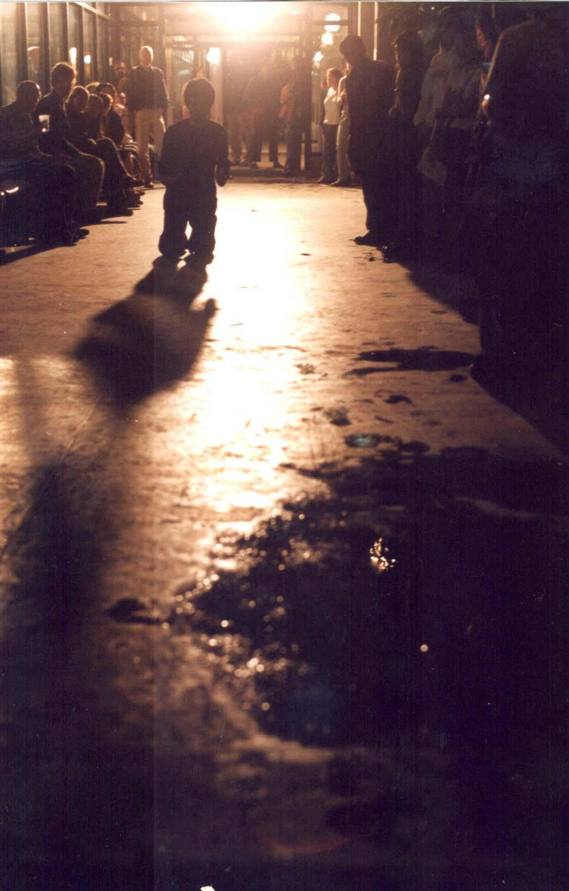
Chumpon Apisuk, a welknown Thai performance artist and an artistic director of Asiatopia, did a simple walk on his knee along the 70 yards long corridor of the art center from the entrance to the front hall of the auditorium. Holding a toy machine gun in his right palm, and Mr. Bean machanic toy on his left palm. When he arrived at the table set in center of the hall, he spit out tiny pink plastic soldiers out of his mouth, where he hid them all along the long knee march. He stood up introduce the toys as Bush and Bean, then asking a question directly to the intellectual community that – Are we reforming democracy or re-constructing fascism. He refered to his prior talk about the subject which related to some cencership of the art exhibited at this art center, and in relation to the government ‘reform’ programs.

Parawee Poopetch, young artist from Chiangmai, was one of the best piece at this event. Images he created by using dim lights and semi-transparency wax-head, was dramatically placed. The magical sound of one key piano played live, frozed the audience to their seat. He use stage lighting as if he is an experience theatre
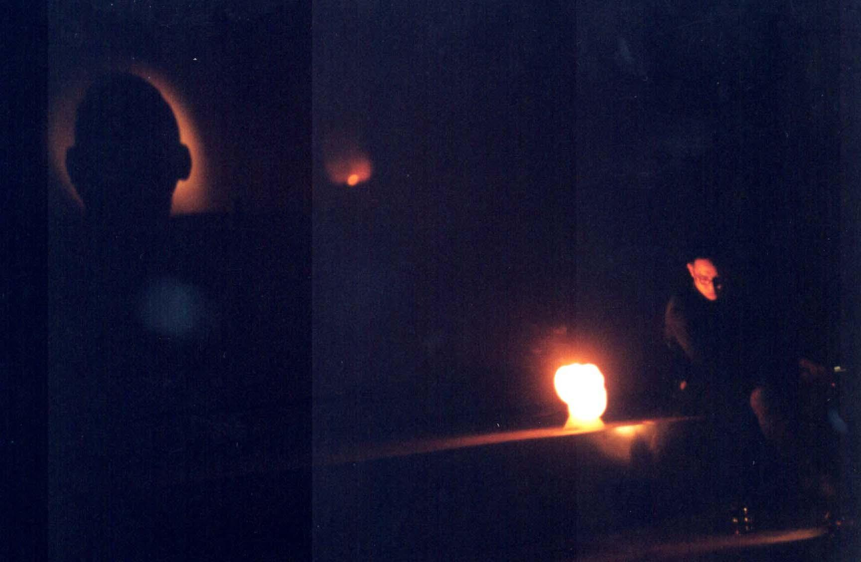director. He ended his piece by letting people to the ground outside the theatre, where water remain in the muddy ground after rainfalls, with a tiny paper boat. He let the paper boat moving in circle in the mud hole before he sank it with the weight of a tossed in coin.

Jirasak Saenpolasit, also a student from Chiangmai University, presented a powerful work, with energy and sound, created by simple action of hoe (farmer’s tool) digging the cement floor of the art center, aiming at a ceramic plate (food dish) placed at the center. He swang the hoe around hitting the cement floor from time to times, created a powerful noise which can make you shivering. He aggressively move closer the the ceramic piece, with an intention, until the end that the hoe hit the ceramic and broke it to pieces.

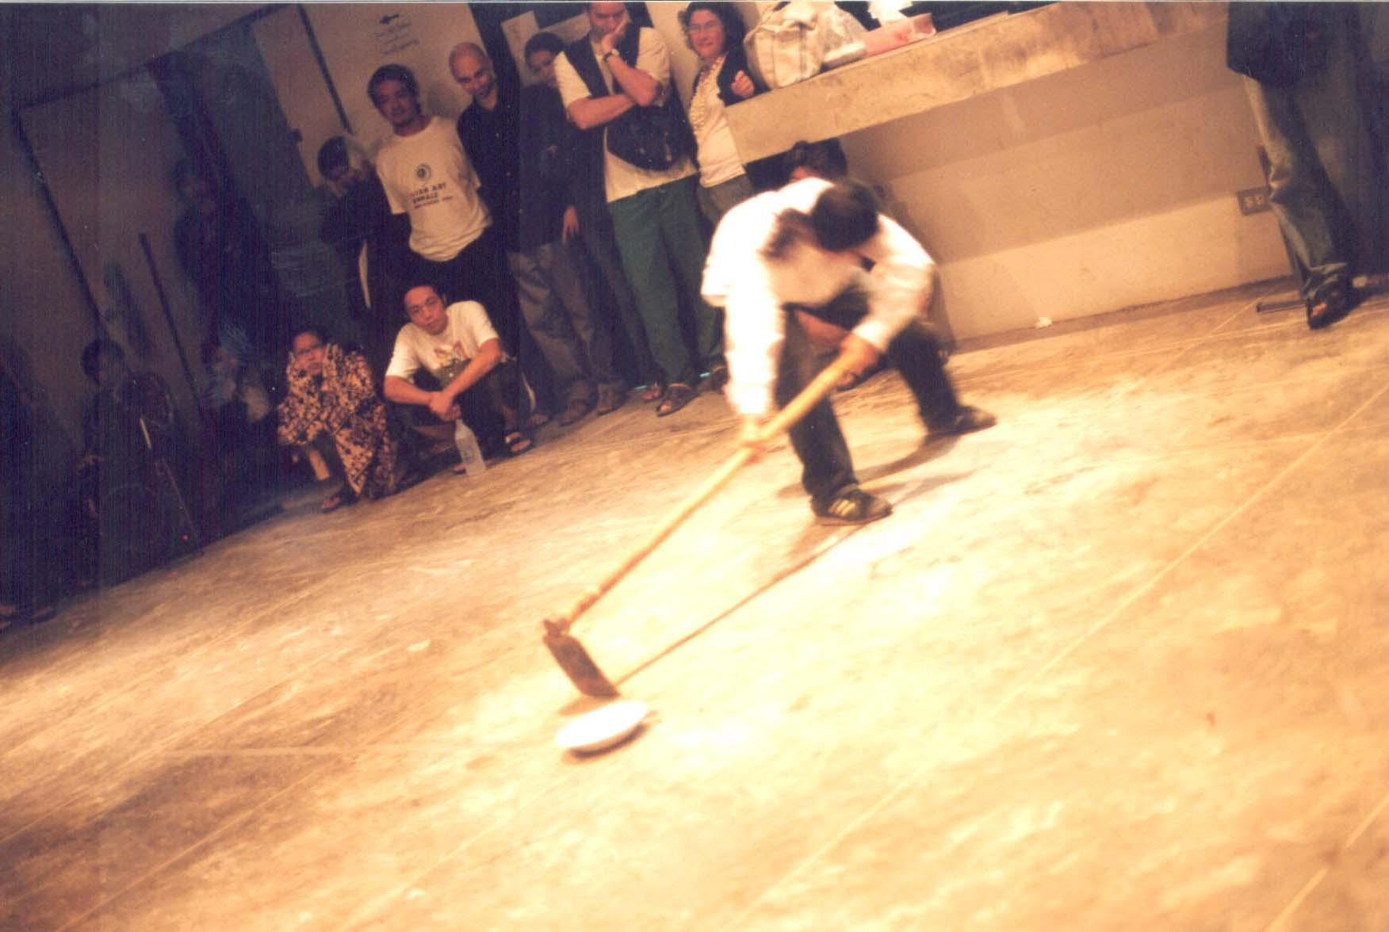
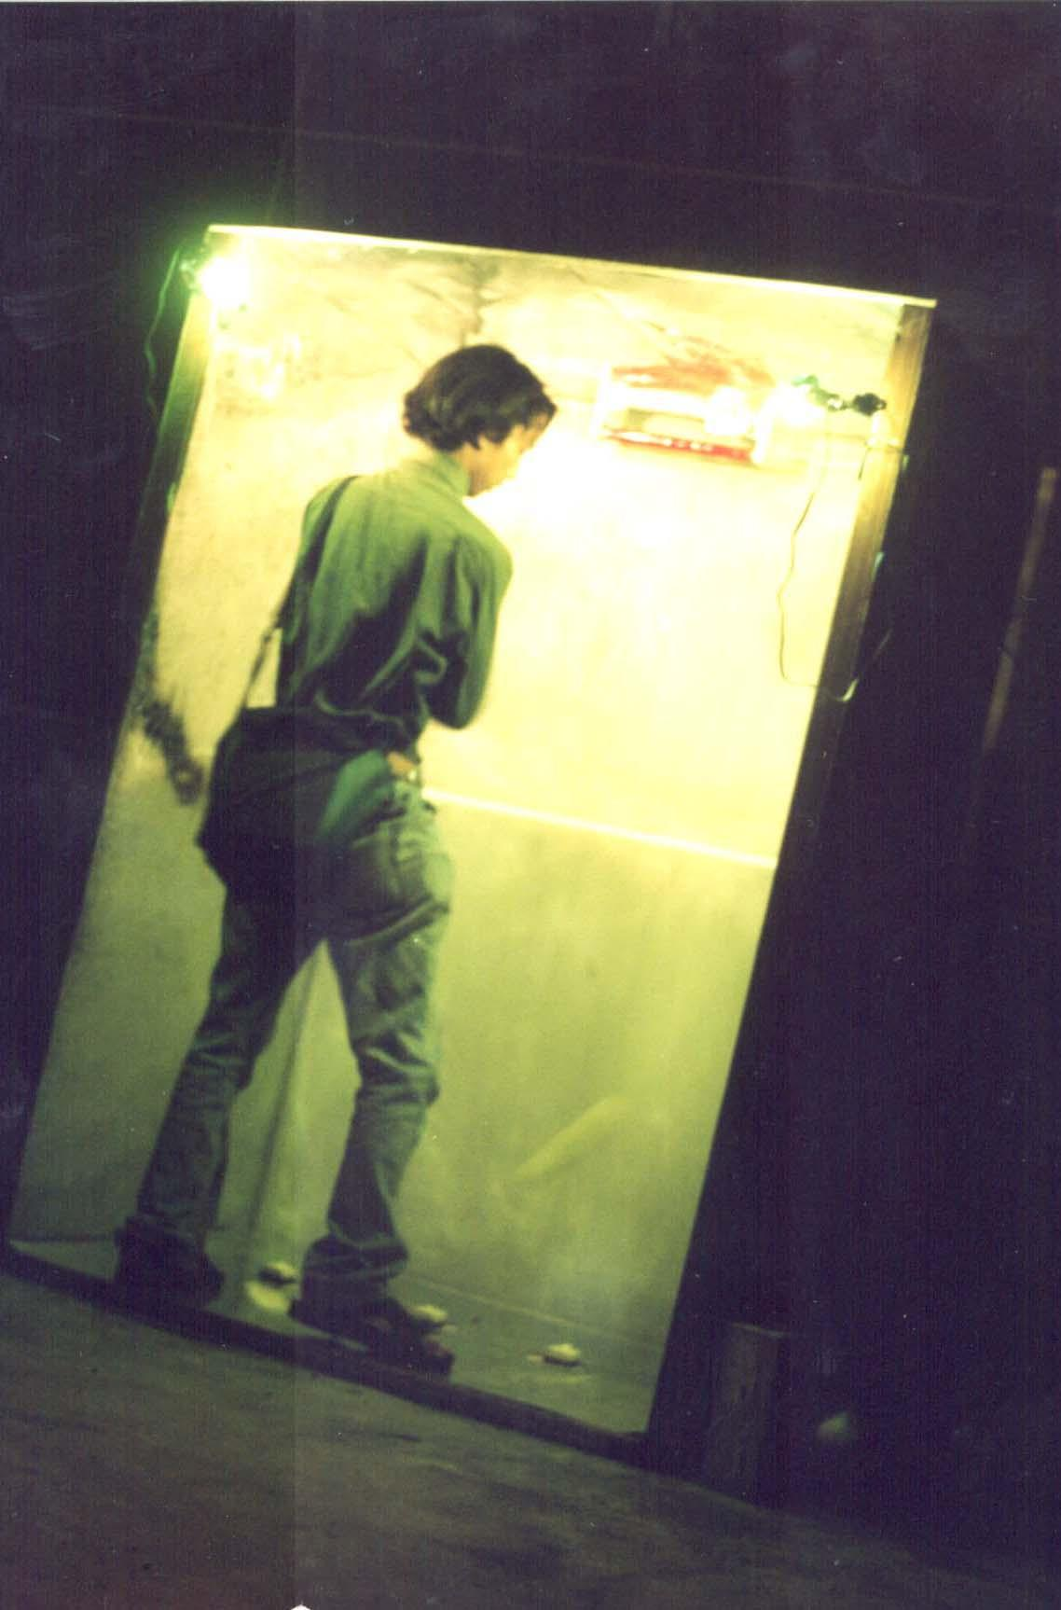
Suchart Panprapan, making a booth the size of public phone booth, with green and red electric light. It was not clear of his intention of the box. The action he asked participated audience was to throw the tennis ball and let it bounce in the box. He later use elctrict saw to destroy the box.

Paitul Promvijit, a poet and researcher at Social Research Institute, this is his
second time with Asiatopia. As one of the advocator for legalization of local rice spirit drink. He came out with entirely chained himself. He recited his poetry about all reasons we should have the rights to brew our own spirits, and ended by shooting imported beers bottles up the sky by local made fire crackers.

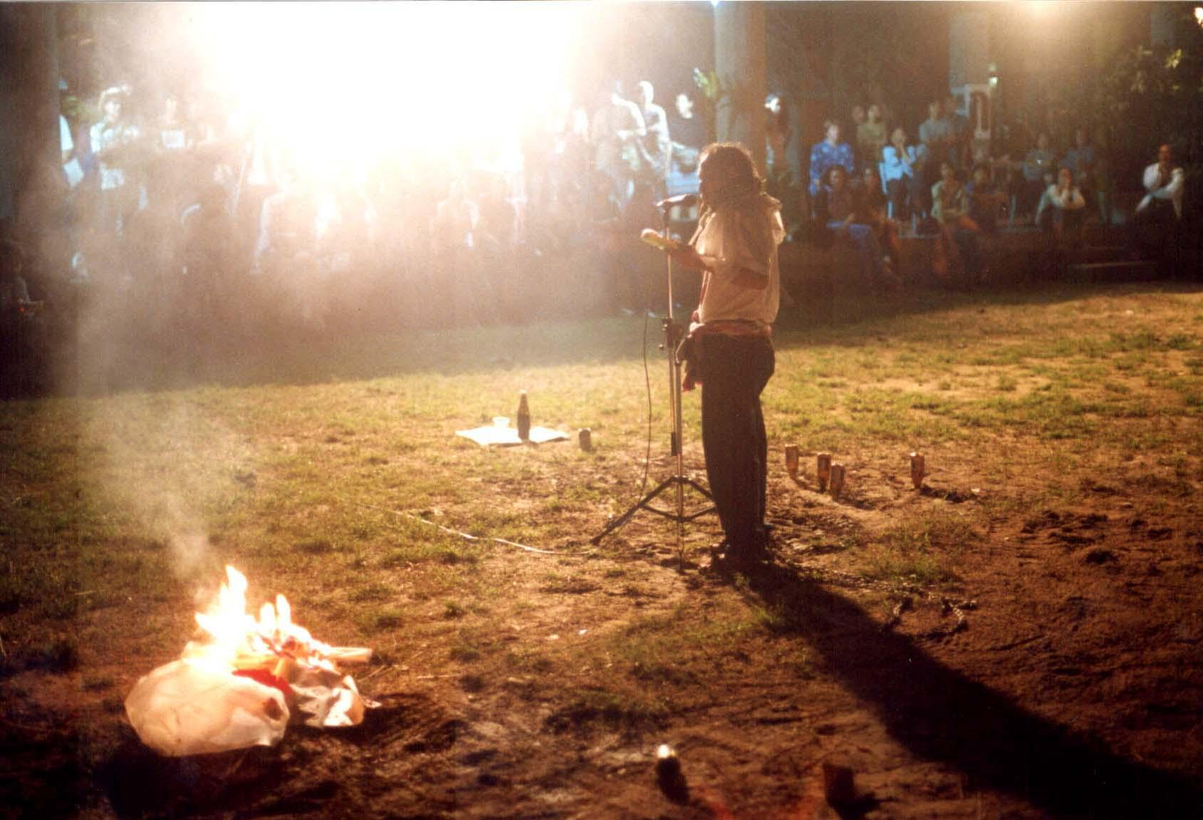
Paitul Promvijit, Thailand
Asiatopia 4/2002,
30 November 2002

In conclusion, …

We have noticed a stronger community for performance art in Thailand,
especially in Chiangmai, where art center has become a main community center of local art and intellectual community. Historically, Chiangmai has been a hub for contemporary culture and, performance artists community has developed and maintained its respective role in Chiangmai art scene since mid 80s. While Bangkok has become too big a metropolitan, and since
‘Bhirasri, institute of modern art has fallen in the 1988, community spirit
in Bangkok has moved on to scattered galleries and public events. The
lacking of a center in Bangkok makes cultural people work around alternative
spaces, and public parks and streets became main entertainment and cultural activities venue for its people. The public spaces as such, however, is unable to help strengthen community spirit, but only provides temporary
entertainment event..

Asiatopia, on the other hand, is not only a platform for international
performance showcase, but that the role of art festival is also to strengthen
the art community, provide chances for theoretical development, open
discussion to contextualize the arts. The art festival is a form of artist
conference.

One of the activities Asiatopia tries to develop is to provide lectures and
workshops by participants artists to art schools around Thailand. The
activities not only allow students to gain more experiences directly with
practitioners from different cultures and backgrounds, the direct contact
creates opportunity for art students to be involved and open themselves to
outside school activities. Asiatopia is an out-of-classroom workshop for art
students.

Another interesting idea developed during this year's event when our
festival in Chiangmai coincided with the NGO/community initiatives of
'legalize local rice liquer campaign' festival. The exchange with local
community initiatives introduce a new perspective to our future festival,
which may try to involve and/or in cooperation with grassroot community. The
idea is to broaden Asiatopia into more culture than just highlight the
art form. However, the idea needs to be further researched and discussed.

